8*8*8 3-DIMENSIONAL LED CUBE DISPLAY

Mr.Nikhil Gangwani, Ms.Mrunal Thengane, Ms.Shruti Mendhule

Fourth Year B.E.

Department of Electronics
K.DK.C.E, Nagpur.

Email:niks8983@gmail.com
mrunalthe@gmail.com
shrutimendhule@gmail.com

Abstract- This paper shows the methodology which consists of building a 3-dimensional LED array that will be able to display various graphics through the concept of persistence of vision. The array will also be sensitive to motion in three directions, allowing it to focus certain graphics to a targeted audience through motion detection. There will be several options for display including non-directional animations and direction focused graphics. We will be using infrared sensors to design and build a motion detection system that will be fed into our processor. The processor will, through several inputs, decide what graphic to present and will feed it to an FPGA. The FPGA will then process the necessary data and output to the 512 LEDs to be used in the 3D array.

Keywords- Infrared Sensors, Persistance of Vision, fpga, Multiplexing.

INTRODUCTION

This document conveys the design of a 3-dimensional LED cube. The LED is constructed as an 8*8*8 cube with 512, 3mm, RGB LEDs. The cube has 5 lights up features: each LED flashes in sequences, the cube lights up entirely, a plane is generated at the middle of the cube and is rotated and a central axis like a teeter-totter, the plane is tipped the other direction, and lastly a plane is generated and moved from top to bottom of the cube.

Here a 3D LED Matrix 8x8x8 Cube is pre-assembled , used for a 512 LED Cube. 64(8x8) LEDs are assembled into one layer and you only need to solder 8 layers into this LED cube.

CONCEPT USED

Persistence of vision:-

In this project we will exploit the persistence of vision. This phenomenon is a feature of the human eye and is responsible for the illusion that a movie is not composed by individual still images. All the animations are based on this biological dis-functioning of the human eye. If we can switch on and off the leds in a sufficiently quick time, (a few milliseconds) they will appear as if they were simultaneously on.

We use the persistence of vision because simultaneously switching all the cube leds on would require a very high electric current (in ampere). Actually, if we consider that the high brightness leds of this project require about 20 mA, we can calculate that 512 leds would require 10.24 A. This high current is hard to manage. So, what we do? We switch on a cube layer at each time! In this way the current consumption will never exceed 1.28 A (20 mA x 64 leds), which is easily supplied by a good voltage transformer. Let us suppose that we want to make the cube appear as completely switched on. To achieve that we simply have to switch on the different layers one by one at high speed. To a human eye the cube will appear as completely lighted.

Debugging:- SYSTEM DESCRIPTION
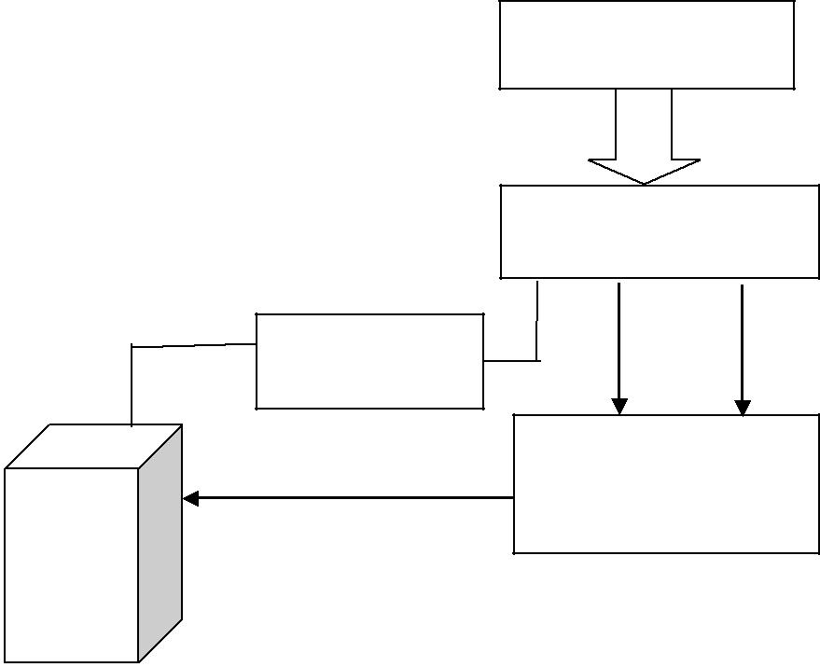

Debugging is a necessary process in almost any new software or hardware development process, whether a commercial product or an enterprise or personal application program. For complex products, debugging is done as the result of the unit test for the smallest unit of a system, again at component test when parts are brought together, again at system test when the product is used with other existing products, and again during customer beta test, when users try the product out in a real world situation. Because most computer programs and many programmed hardware devices contain thousands of lines of code, almost any new product is likely to contain a few bugs. Invariably, the bugs in the functions that get most use are found and fixed first. An early version of a program that has lots of bugs is referred to as "buggy."

Debugging tools (called debuggers) help identify coding errors at various development stages. Some programming language packages include a facility for checking the code for errors as it is being written.

CHARLIE MULTIPLEXING:-

Charlie multiplexing is a technique proposed in early 1995 by Charlie Allen at Maxim Integrated for driving a multiplexed display in which relatively few I/O pins on a microcontroller are used to drive an array of LEDs.

The method uses the tri-state logic capabilities of microcontrollers in order to gain efficiency over traditional multiplexing. Although it is more efficient in its use of I/O, there are issues that cause it to be more complicated to design and render it impractical for larger displays. These issues include duty cycle, current requirements and the forward voltages of the LEDSs.

Power Supply

Microcontroller

8 NPN

Transistors

8 Shift Resistors

8*8*8 3-D LED

Cube

An 8x8x8 LED Cube is built up with 8 LEDs layers with each layer contains 64 LEDs. All cathode legs of LEDs in a particular layer will be soldered together. While anode legs of LEDs in a particular layer will be connected to anode legs of another layer in such a way that an anode leg of a LED in the upper layer will be soldered to an anode leg of a LED just located below it in the lower layer for each of 64 LEDs during the stacking up of the LEDs layers to build up the LED Cube. Hence, it can be said that a 8x8x8 LED Cube is made of 8 “cathode” layers and 64 “anode” columns.

For each LEDs layers, their respective cathodes normally will be connected to 8 transistors (which are controlled by 8 I/O pins of a microcontroller) separately. The cathode for a particular LEDs layer can be activated (shorted to ground) by turn on the transistor connected to it. While, the 64 “anode” columns will be controlled by another 64 I/O pins of the microcontroller. Hence, to light out a particular LED of the LED Cube, just need to activate the “anode” column and cathode of the LEDs layer it belongs to while deactivating the rest of other LEDs layer cathodes and “anode” columns. Using the same concept, to light up whole LEDs of a particular LEDs layer, just need to activate all 64 “anode” columns and the cathode of that particular LEDs layer.

FURTHUR IMPLEMENTATIONS

- The controller will interface with computer software such as matlab. This would allow the user to easily plot 3d functions on the cube.

- The controller will have orientation modification capabilities on board. This would provide the user with the ability to zoom, shift or rotate the image.

- The controller can wirelessly communicate with other wireless devices (smart-phones, computers, etc.).

FUTURE SCOPE

1) Low-level (as opposed to application-level) pulse width modulation brightness control of the leds, with corresponding intensity variations on the svga output.

- Implementation of the bresenham line

drawing algorithm to projection angles other than 45°.

3) Display of 3d data stored on a compact flash card - may be used as initial conditions for cellular automata.

4) True 3d rendering (rather than orthographic projection) of the cube on svga output, rotatable in real time by user.

- Modification of the cube to increase

resolution/enhance visibility – use a larger

lattice spacing or smaller leds (ideally smt,

but this would require a new construction

technique).

CONCLUSION

There are two ways in which we can fashion the code to control the LEDs. The first would be to preprogram individual bits to be retrieved and outputted sequentially. This is the brute force method but it may prove easier than the others. The main issue however is memory allocation and size, for multiple graphics or the addition of new ones we will probably need to add external memory to process it. The second method which is the one we will attempt is to make code as intelligently as possible so that the designs can be created and output directly from the microprocessor, without other hardware required. This method may be slower but it would be more eloquent and require a physically smaller design. The best solution may be a combination of the two systems to achieve a maximum number of graphics possible.

REFERENCES

- James Clar,”3d display cube white”,

http://www.jamesclar.com/product/2005/3d

2)3D Led Cube by angel perez & robert regojo in

University of florida dated 25/4/2012.

- A volumetric 3d led display by david wyatt and lawrence wujanto.

- Fundamentals of digital circuits by A. Anand
kumar.

5)3D Led Cube Display by tyler draper & hailey parkin dated 5/3/2013.

