Marker-controlled watershed segmentation on MRI images
Bharati Dudhane, Kalyani Raut, Kalyani Shiwarkar & Pallavi Atram

(ELECTRONICS & TELECOMMUNICATION)

YCCE, Nagpur

Abstract— Segmentation is to subdivide an image into its constituent regions or objects. Segmentation should stop when the objects of interest in an application have been isolated. Image Segmentation is the partitioning of an image into meaningful regions that have strong correlation with objects or areas of the real world contained in the image. Segmentation accuracy determines the success or failure of computerized analysis procedure. The watershed transform has interesting properties that make it useful for many different image segmentation applications: it is simple and intuitive, can be parallelized, and always produces a complete division of the image. However, when applied to medical image analysis, it has important drawbacks (over segmentation, sensitivity to noise). This paper presents a robust procedure for segmentation and edge detection of MRI images based on marker controlled watershed algorithm. The efficiency and accuracy of the algorithm is demonstrated by the experiments on the MRI brain images. Experimental results presented in this paper are obtained by using MATLAB. In this paper medical image segmentation using marker controlled watershed segmentation is presented. Objective of this paper is segmenting the medical image using marker controlled watershed segmentation, and comparing the results of directly applying watershed transformation and marker controlled watershed transformation.

Keywords— Image segmentation, MRI image, Watershed segmentation, marker controlled watershed segmentation.

Introduction
A. The Watershed Transform
Segmentation refers to the process of partitioning a digital image into multiple segments (sets of pixels, also known as super pixels).Several methods and approaches are introduced into the area of segmentation among them a well known method is watershed transform. The watershed transform is a popular segmentation method coming from the field of mathematical morphology. The intuitive description of this transform is quite simple: if we consider the image as a topographic relief, where the height of each point is directly related to its gray level, and consider rain gradually falling on the terrain, then the watersheds are the lines that separate the “lakes” (actually called catchments basins) that form. Generally, the watershed transform is computed on the gradient of the original image, so that the catchments basin boundaries are located at high gradient points. Due to the number of advantages watershed transform has been widely used in many fields of image processing, including medical image segmentation, it is fast and it produces a complete division of the image in separated regions even if the contrast is poor, thus avoiding the need for any kind of contour joining. Several researchers have proposed techniques to embed the watershed transform in a multiscale framework, thus providing the advantages of these representations. Most important drawbacks of watershed transformation are as follows.

1. Over segmentation
When the watershed transform infers catchments basins from the gradient of the image, the result of the watershed transform contains a myriad of small regions, which makes this result hardly useful. The use of a marker image to reduce the number of minima of the image and, thus, the number of regions, is the most commonly used solution.

2. Sensitivity to noise
Local variations of the image can change dramatically the results. This effect is worsened by the use of high pass filters to estimate the gradient, which amplify the noise.

3. Poor detection of significant areas with low contrast boundaries
If the signal to noise ratio is not high enough at the contour of interest, the watershed transform will be unable to detect it accurately. Furthermore, the watershed transform naturally detects the contours with higher value between markers, which are not always the contours of interest.

This drawback is removed by using marker controlled watershed transform.

B. Marker Controlled Watershed Transform
An approach used to control over segmentation is based on the concept of controlled marker. The markers are connected component of an image. There are internal markers and external markers where internal markers are associated with object of interest and external markers are associated with the background. The watershed transform finds “catchments basins” and “watershed ridge lines” in an image by treating it as a surface where light pixels are high and dark pixels are low. One of the most important drawbacks associated to the watershed transform is the over segmentation that commonly results. Some modification is carried out via a mathematical morphology operation, geodesic reconstruction, by which the function is modified so that the minima can be imposed by an external function (the marker function). All the catchment basins that have not been marked are filled by the morphological reconstruction and so transformed into non minima plateaus, which will not produce distinct regions when the final watersheds are calculated. Segmentation using the watershed transforms works well if you can identify, or “mark,” foreground objects and background locations. Marker-controlled watershed segmentation follows this basic procedure:
1. Compute a segmentation function. This is an image whose dark regions are the objects you are trying to segment.
2. Compute foreground markers. These are connected blobs of pixels with in each of the objects.
3. Compute background markers. These are pixels that are not part of any object.
4. Modify the segmentation function so that it only has minima at the foreground and background marker locations.
5. Compute the watershed transform of the modified
Segmentation function.

II. PROPOSED WORK
In this section work done for processing brain image segmentation is explained. Firstly we have applied the watershed segmentation on the medical images but the results are not properly segmented; now mark the background objects using marker now apply watershed segmentation and compare the results.
The steps of the proposed system are shown in fig. 1,

Fig. 1: proposed system
Preprocessing of image: In this section the MRI brain image is given as input which is originally gray scale image and compute the gradient magnitude as the segmentation function where gradient is highest at the borders of the object and generally low inside the object, but it results into bad segmentation results. We will then use Marker controlled watershed segmentation in which the internal marker to distinguish the foreground of adjacent objects. A variety of procedures could be applied here to find the foreground markers which must be connected blobs of pixels inside each of the foreground objects. Here the method that is used is the use morphological techniques called “opening-by-reconstruction” and “closing-by- reconstruction” to “clean” up the image. These operations will create flat maxima inside each object that can be located using imregionalmax. Now you need to mark the background. In the cleaned-up image, the dark pixels belong to the background, so you could use a thresholding operation to mark the background objects. Now compute background markers. Now compute the watershed transform of the segmentation function. The function imimposemin can be used to modify an image so that it has regional minima only in certain desired locations. Here you can use imimposemin to modify the gradient magnitude image so that its only regional minima occur at foreground and background marker pixels.The background of the image will then be segregated from the foreground objects using the external markers. Finally we will aggregate the computed result of the watershed transform and examine the final image.

III. RESULTS
The results obtained by the proposed work are shown below in fig. from 2(a) to 2(e)

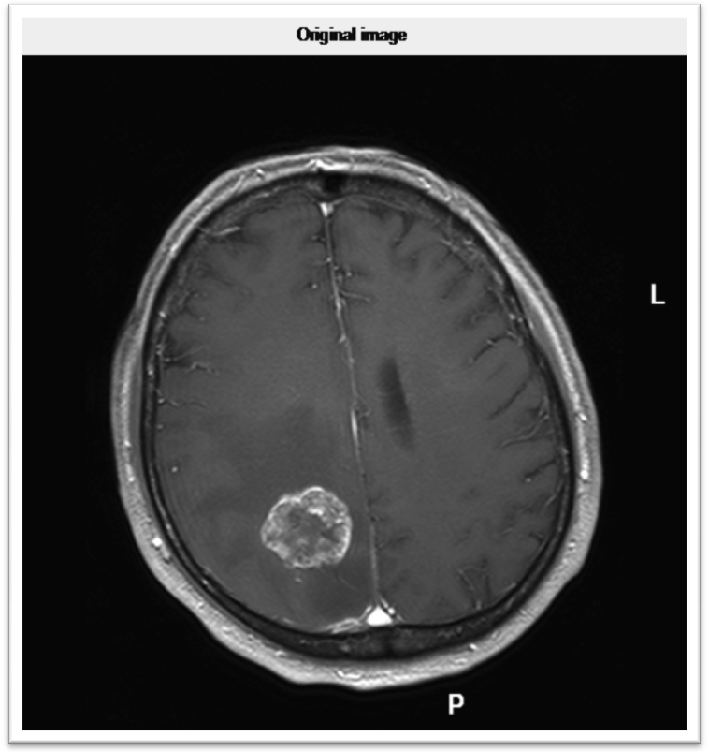

Fig. 2: (a). Original image

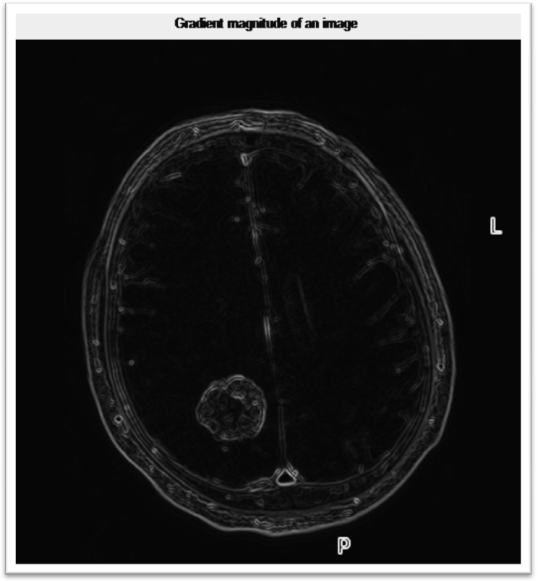

Fig. 2: (b).gradient magnitude of Original image

Fig. 2: (c).watershed transform of gradient magnitude

Fig. 2: (d).opening by reconstruction

Fig. 2: (d).closing by reconstruction

IV. CONCLUSION
This approach for segmentation of medical images can help in the proper detection of the region of interest and also can be very helpful for doctor’s diagnoses, medical teaching, learning and research. MRI scanned image of human brain was taken, processed through the watershed segmentation and obtained result was over segmented.
ACKNOWLEDGEMENT
We have great pleasure to express our most sincere regard & deep sense of gratitude to our guide Ms. Anuradha Muzumdar for her valuable guidance. We are thankful to our H.O.D. Dr.P.L.Zade sir other teacher of the Department of Electronics & telecommunication Engineering for their valuable suggestion & helping attitude.
REFERENCES

[1]. Ahmed EL ALLAOUI & M’barek NASRI, “Medical Image Segmentation By Marker Controlled Watershed & Mathematical Morphology”,(June 2012), Morocco

[2]. D. Goshal, P. Acharjya, “MRI Image Segmentation Using Watershed Transform”, (April 2012),Agartala

[3].Mandeep Kaur, Gagandeep jindal, “Medical Image Segmentation Using Marker Controlled Watershed Transform”,(4th Oct.-Dec. 2011), Dept.of CEC, Landran, Mohali, Punjab, India.

[4].Mrs. Kaur, G. Jindal, “Medical Image Segmentation using Marker Controlled Watershed Transformation”, (Dec. 2011), Punjab

