**Microcontroller-GSM-Irrigation Water Supply Monitoring-Control**

**Mayur S. Sathawane*, Shantaram K. Rewatkar\***

**Prof. Javed Khan®**

Guru Nanak Institute Of Engineering and Technology,

Department Of Electronics Engineering.

Kalmeshwar Road, Dahegoan, Nagpur. 441501

**ABSTRACT**

The purpose of this project is to monitor and control the water flow to an irrigation System using Mobile Phone. This can be achieved by the use of soil moisture sensor, which Senses the water content in the soil. This sensor output is given to a Microcontroller based Control system for further data processing.

The aim of this project is to provide an efficient solution for automatic control of irrigation

Motor with soil moisture sensor. Now a day’s technology is running with time, it completely occupied the life style of human beings. Even though there is such an importance for technology in our routine life there are even people whose life styles are very far to this well-known term technology. So it is our responsibility to design few reliable systems which can be even efficiently used by them. This basic idea gave birth to the project GSM controlled soil moisture sensor. Here the automation process is done through the micro controller based technology.

In our project we make use of one microcontroller, which is dedicated at the water pump. The microcontroller forms the heart of the device and there are also soil moisture sensors, which are meant for detecting the moisture in the soil. Also GSM modem which will operates the Soil moisture sensor. Here we are going to operate the soil moisture sensor. For this we will use GSM technology. To operate the sensor we should send a message to the GSM modem which one at the soil moisture sensor. That modem will receive the message it will sends the Information to the micro controller through decoder, the micro controller will operate the sensor i.e., ON/OFF. The sensor will operate the motor according to the quantity of moisture in the soil. Here we get the feedback of motor status i.e., ON/OFF in the form of message from the GSM Modem present at the motor end.

The design of this system is very much sensitive and should be handled with utmost care because the microcontroller is a 5 volts device and it is employed to monitor the house hold power consumption per day where it should be interfaced with a 240 volts energy meter. So every small parameter should be given high importance while designing the interfacing circuit between the controller and the water motor.

**\* Student member, IEEE, ® Project Guide.**

**1. INTRODUCTION**

Irrigation system is critical in the development of agriculture of every country. It has been established that efficient irrigation processes has the potential of literally doubling the amount of food a farm processes [1]. Integrating modern technologies in irrigation management systems is one of the ways of enhancing the irrigation processes to optimize the use of water, electric power consumption, and labour costs. The success of irrigation management systems however, depends on the timely application of the water required to meet the water needs of the crops. The timing for watering farmlands is also influenced by factors such as rainfall, soil moisture level, characteristics of the soil composition, and nature of crops. Another important factor that is critical to irrigation management system is the scheduling plan or timetable system, which is mostly developed to maximize crop production with minimal water wastage. Although modern irrigation techniques such as drip line and sprinkler systems [1, 2] have been introduced to improve farming activities, integrating modern technologies may further guarantee improvement in food security.

Regardless of the irrigation techniques used, in most developing countries however, many of the irrigation systems that are operated are often located further from the cities and towns with limited telecommunication infrastructure and high service cost. This somehow makes it difficult for most of the farmers to remotely carry out effective monitoring and control of the irrigation systems. With the emergence of wireless communication technology such as the GSM (global system for mobile communication) networks which is one of the most vital communication systems that is easily accessed globally with very low SMS (short message service) service cost, new approaches are being explored [3] to revolutionaries the operations of the irrigation systems.

Various attempts have been made over the past few years to integrate wireless communication technology in irrigation management systems to promote efficient farming activities and reduce water wastage [4-12]. Gautam et al [5] proposed an integrated GSM-Bluetooth technique for the control and management of the irrigation system. To facilitate watering, the system sets the irrigation time using the temperature and humidity data from the sensors and the type of crop. The authors used Bluetooth as a secondary means beyond the SMS to transit information to the user any time the user is located within the coverage range of the Bluetooth which eliminates SMS charges. In the work of Kim et al [9], a distributed irrigation system was discussed where a single board computer was used to control the solenoids of a group of nozzles in the network using wireless network and GPS (global positioning system). The conditions of the field were transmitted remotely to a central server using Ethernet radio. Zhou et al [8] also proposed a wireless sensor network based irrigation control system where the zigbee technology was used instead of the conventional wired connection to provide more flexibility in the coordination of the field data. In the work of Kalyan et al [11] a hybrid of wireless sensor and GSM was proposed. The authors used wireless sensor networks for the field conditions while the mobile phone was used to control the watering operation of the field. To implement the control of the watering, the microcontroller computed the number of missed calls from the user mobile phone to determine the type of operations to execute. In doing this, the microcontroller was coded to compute a number of missed calls to correspond to a particular instruction to be performed. A challenge with this system however, is the limited number of instructions that could be executed. There is also the additional problem for users to remember the number of missed phone calls that correspond to each instruction for execution.

In this work we describe a GSM based irrigation management system for remote monitoring and control of the irrigation system using SMS commands. The conventional wired communication link was used for the direct transmission of the field data to the microcontroller system for operation. The study employed and integrated three major systems: hardware system, communication system, and control system. The hardware system is driven by a microcontroller system which controls the system operation using control strategies implemented on the device. The communication system facilitates in-bound and out-bound communication for data transfer of the system elements of the hardware system and the user for control of the irrigation management system. The SMS gateway of the GSM network serves as the medium for the out-bound communication between the hardware system and the mobile phone of the user. The GSM based irrigation system will bring considerable benefits to user in terms of providing the platform to regularly monitor and manage the irrigation system using parameters such as soil moisture level, operational set points, scheduling plan, and rainfall information. A prototype controller system was implemented and tested for performance and functionality in a laboratory environment and a small field area.

**2. Overview of the irrigation controller system**

The general architecture of the implemented GSM-based irrigation controller system is shown in Figure 1 the design consists of three main systems: integrated hardware system, communication system, and control strategy. The integrated hardware system consists of power supply system, microprocessor system, sensing system, pump switching system, intrusion detection system, GSM communication module, and LCD display system. The communication system implements the communication protocol to facilitate data communication among the devices of the integrated hardware and also between the user and the controller system. The control strategy on the other hand is responsible for measures for operating the irrigation system. The operational logic for control of the irrigation system is implemented on the microcontroller. The controller system on initialization checks for the control information and scheduling plan. The sensing system, which is the front-end unit, checks and sends soil moisture readings in the form of voltage signals every 10 minutes to the microcontroller, which converts the analog signals into numerical repres entation for processing and transmission. The digital soil moisture data are temporally stored in the EEPROM of the microcontroller and then transferred every 60 minutes to the Sim Card storage space on the GSM module which is interfaced to the microcontroller. The microcontroller controls the functions of the various devices that are interfaced to it and also manages the communication protocols required to execute specific tasks. A 16 x 2 line LCD driver circuit it is interfaced to the microcontroller to monitor the soil moisture and operational conditions of the controller system. The GSM module also serves as the medium for system data transfer from the controller system to the user and also requests (conditions and operations) from the user to the controller system via SMS. To controller system is equipped with intrusion detection system interfaced to the microcontroller which generates alarm signal and transmitted to the user via SMS any time the

Controller system is opened or tampered with by unauthorized users.

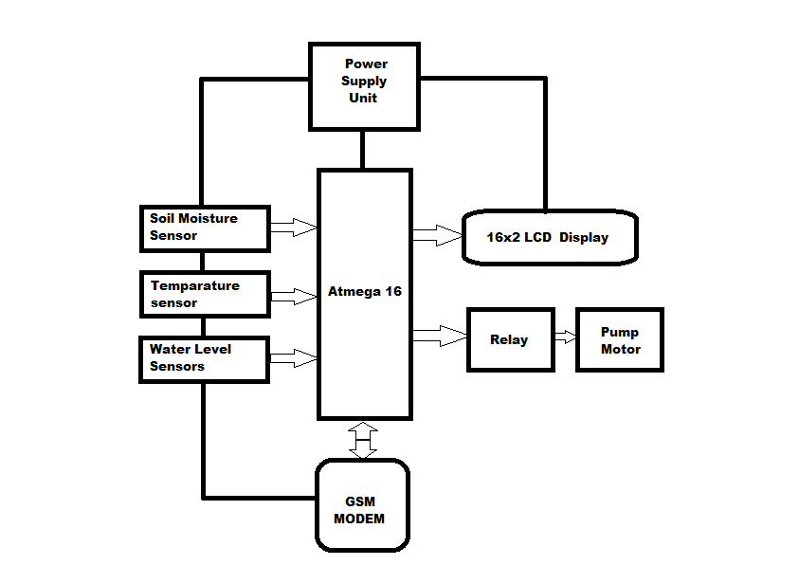

**Figure 1: Architectural diagram of the GSM based irrigation monitoring and control system.**

**3. Conclusion**

In this paper, implementation of a GSM based irrigation controller system for monitoring and control of irrigation systems using SMS technology was presented. This enables users to take advantage of the globally deployed GSM networks with its low SMS service cost to use mobile phones and simple SMS commands to manage their irrigation system. To demonstrate the functionality and performance of the controller system, the prototype was implemented and tested. Results showed that it will be possible for users to use SMS to monitor directly the conditions of their farmland, schedule the water needs of crops, automatically control watering, and set control operational conditions in accordance with the water needs of crops. This will help minimize over-watering and crop production cost. Further, it will help users to take advantage of the prevailing GSM networks to provide value added services.

**4. References**

[1] Kay, M., “Smallholder irrigation technology: Prospects for sub-Saharan Africa” International Program for Technology and Research in

Irrigation and Drainage, FAO, Rome, 2001, pp. 1–25.

[2] Fangmeier, D. D., Garrot, D. J., Mancino, C.F., Husman, S. H. “Automated irrigation systems using plant and soil sensors”, American

Society of Agricultural Engineers, ASAE Publication 04-90, 1990, pp. 533-537.

[3] Benzekri, A., Meghriche, K., and Refoufi, L., “PC-based automati on of a multi-mode control for an irrigation system” Proceeding s of

International symposium on industrial embedded systems, Lisbon, July 2007, pp. 310-315.

[4] Shinghal, K., Noor, A., Srivastava, N., and Singh, R., “Wireless sensor networks in agriculture for potato farming” International

Journal of Engineering, Science and Technology, Vol. 2, No. 8, 2010, pp. 3955-3963.

[5] Gautam, I., and Reddy, S. R. N., “Innovative GSM-Bluetooth based remote controlled embedded system for irrigation”, International

Journal of Computer Applications, Vol. 47, No. 8, 2012, pp. 1