“DESKTOP SPY”

Prachi Walke Priyanka Waghmare
prachi13991@gmail.com priyawagh2910@gmail.com
Sneha Meshram Rajashree Awari
Snehaz.meshram@gmail.com rajashreewawari@gmail.com
T.G.P.C.E.T T.C.P.C.E.T

Abstract- Spy Software (also called “Computer Monitoring Software”) is undetectable software the runs on a computer, and secretly records a computer user by capturing all keystrokes, websites visited, documents read, chat conversations, etc. Some of the more real life popular uses of such application are child Internet-monitoring, and employee monitoring, or simply making sure no one uses your computer improperly when you are gone. The level of monitoring done can vary from just logging all the key strokes of the user, to getting screenshots of the computer’s desktop, and all the way to making a full video recording of the user’s actions. It creates detailed reports for the software installer, which is hidden from the person being monitored. Desktop Spy secretly takes pictures of the given computer screen, records all applications loaded, web sites visited, chat conversations, E-mail activity, and anything else that is visible on the screen. You can take pictures of the entire screen or just of active Window and save the pictures in JPEG format. Desktop Spy has features to save images at folder, compress the images and send on specified email id at predefined time intervals.
Keywords- Monitoring, spy, screenshots,

1. INTRODUCTION
Spy Software (also called “Computer Monitoring Software”) is undetectable software the runs on a computer, and secretly records a computer user by capturing all keystrokes, websites visited, documents read, chat conversations, etc. Some of the more real life popular uses of such application are child Internet-monitoring, and employee monitoring, or simply making sure no one uses your computer improperly when you are gone.
The internet is full of ads for different types of tracking software to download for monitoring your family, friends, anyone who uses your computer after you’re gone, etc. With the Internet exposing the surfers to any type of information, including those inappropriate to minors or even illegal and abusive to all, the need for such programs increases and becomes a must-have software to any house hold today. The level of monitoring done can vary from just logging all the key strokes of the user, to making screenshots of the computer’s desktop on predefined typed words. Spying software can also be in the form of web based service. In this type of spying service, the owner is not required to physically access the monitored computer to view the recordings. Everything is saved and maintained on a web server.
Our project consists of building full applicable spying software with all common features (and more) included, such as: Recording key strokes, mouse movements and clicks, websites visited, programs visited and files changed and viewed, dates and times of different actions, making snapshots of the computer screen at pre-defined events. Any combination of the above is possible to define for a specific software run. Furthermore, we implemented a web server which can completely control the application that runs on a remote computer. We have such options as enable or disable our running application or close it completely; we can check if the user is currently working on the machine or not, send the log files created to our Email, or even instantly send the logs we choose to our computer. Furthermore, a technique for fast install of the software on any computer, also making it load on start-up was developed. In this scenario, you can install the application with a single click, making sure it starts running even after computer reboot.

1.1 SPYWARE
Spyware exists because information has value and is most often bundled as a hidden component of popular and free software widely available for download [1]. Some common examples of applications hosting spyware are file-sharing tools and instant messaging clients. Spyware is typically designed to collect user information usable for marketing campaigns, e.g., via toolbars, pop-up windows and spam E-mail messaging. Amazingly, close to 88% of consumer PCs was found to be infected by spyware and an average of 20 instances of spyware was found for every 1000th enterprise computer scanned in 2006 [2]. One report claims that the spyware industry earned over $2 billion distributing and installing software that monitored
and reported on its victims in 2004 [3]. The anti-spyware industry, on the other hand, “only” earned an estimated $100 million the same year although its revenue is projected to reach $1.2 billion by 2010.

1.2 HOW SPYWARE OPERATES
Depending on the goal of the information-gathering functionality of spyware, the nature of the gath-ered information varies among spyware programs. Some spyware programs only send the time ofuse and other statistical data. Other spyware programs that incorporate improved advertising corre-late the gathered data. In order to keep the gathered information linked to a specific installation, all the information sent to the spyware publisher needs to be uniquely identified. The unique identifier must be stored on the user’s computer. There are different methods for creat-ing the unique identifier. The two most commonly used methods are generating a Globally Unique Identifier (GUID) and storing a cookie on the hard disk during the installation of the spyware program. A GUID contains data that is unique to a computer's hardware. A cookie is the technical term for a file that contains data, which a specific program often uses. The data that a cookie
contains depends on the program that creates it. In the case of spyware, a cookie could contain uniquely identifiable data such as the user name, computer specifications, and installation version. Every time the spyware program sends information to the spyware publisher, the unique identifier is sent as well, allowing the spyware publisher to update the customer database. Figure 1 shows how the spyware publisher and the users are connected, and the data that is stored on each side of the connection.

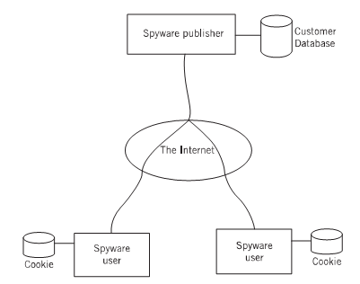
Fig 1: Connections & Stored Data

2. PROBLEM DEFINATION
In some scenarios, when you want to go outside and your desk top is at home, when you are out of station, you want to know what your employee is surfing on the internet, if you want to spy on your child’s activities that what he is browsing on the internet, what you will do? There is no way to know that what is being browsed on any desktop. If you want to know what somebody is doing on your desktop behind you, there is no option available which gives you the browsing history of any computer system. But here we provide you the solution Desktop Spy.

3. DESIGN AND IMPLEMENTATION

3.1 MODULES
The complete application is divided into three modules. The modules are
- Registry Helper
- CaptureTimerControl_tick
- MailSendTimer_tick
a) REGISTRY HELPER
The first module is registry helper. This module plays a significant role in the application as it registers our application in the computer registry. Once the application is registered in computer registry then there is no need to run our application every time the computer is started, instead it will run automatically. This module will use two registry keys viz. sub key and super key. This keys will get reference to Software\ Microsoft\ Windows\ Current Version with permission to write to it. Using these registry keys the application will be registered in desktop registry at the startup.

b) CAPTURETIMERCONTROL_TICK
The second module is Capture Timer Control_tick which is the base of the application. This module uses the timer control which will execute automatically at a particular time interval. This module will automatically capture the screenshots and compress it so that the image will not consume too much memory space. This module uses some predefined functions provided by C# to capture and compress the screenshots.

c) MAILSENDTIMER_TICK
This is the third module of the application. The mailSendTimer also uses a timer control. This module is used to compose an email and send it to administrators email ID. This will get executed implicitely at particular time interval according the timer setting. The mailSendTimer sets the SMTP path for sending email because it is simple and safe. The images are sent over internet as email content and not as an attachment. This will make the image viewing more simple.

3.2 DATAFLOW DIAGRAM:
Fig below shows the data flow diagram. The application is to be registered in operating system registry. Initially it is checked whether the application is registered or not. If yes, then control switches to captureTimerControl_tick module which uses the timer control which will execute automatically at a particular time interval. But if not registered then the registry has be done first.
The captured images are get stored in temp folder i.e the temporary folder. Then the mailing process starts. In mailing process the sender and receiver are registered by path .The mail which is sent from the sender gets received by the receiver. The screenshot of images are compressed and sent to the Administrator as a part of message and not as a attachment.

Fig 2: Dataflow Diagram

3.3 SCREENSHOTS

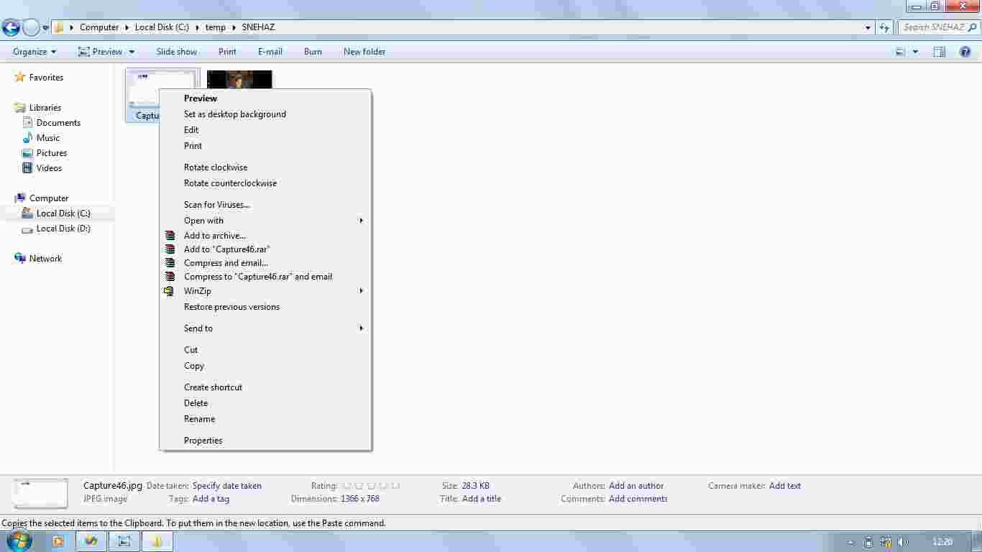

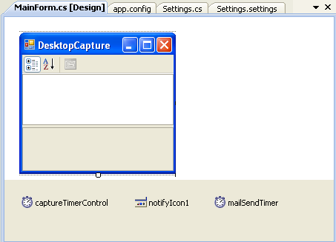

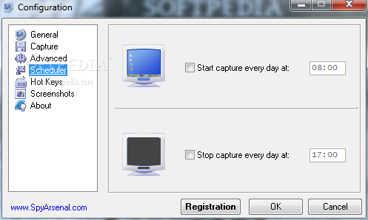

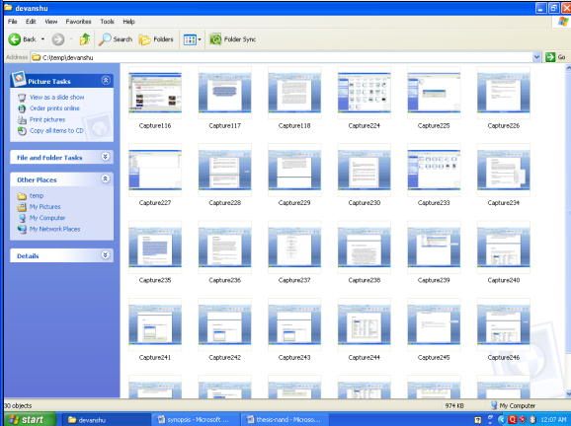

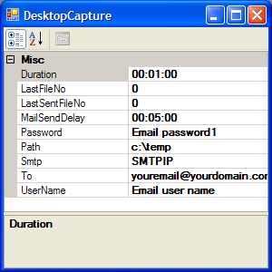

4. conclusion
Desktop Spy monitors the users activity by capturing the images of the screen and stores it in the folder specified by the administrator of the respective computer system. It also sends the captured images through an e-mail to the administrator by compressing them internally. It sends the images as a part of message and not as an attachment.

References
[1] Saroiu, S., S. D. Gribble, and H. M. Levy, “Measurement and Analysis of Spyware in a University Environment”, In Proceedings of the 1st Symposium on Networked Systems Design and Implementation, 2004.
[2] State of Spyware Q2 2006 – A Review and Analysis of the Impact of Spyware on Consumers and Corporations,
Webroot Software, Inc., 2006.
http://h30307.www3.hp.com/pdf/SOS_Q206_USA.pdf

[3] State of Spyware Q1 2005 – A Review and Analysis of the Impact of Spyware on Consumers and Corporations,
Webroot Software, Inc., 2006.
http://whitepapers.zdnet.co.uk/0,1000000651,260134901p,00.htm

[4] Zhang, X., “What Do Consumers Really Know About Spyware?”, Communications of the ACM, 48(8), ACM Press, New York City, NY, USA, 2005, pp. 44-48.

[5] Fox, S., “Spyware – The Threat of Unwanted Software Programs is Changing the Way People use the Internet”, Pew Internet and American Life Project, 2005.
http://www.pewinternet.org/pdfs/PIP_Spyware_Report_July_05.pdf

[6] Robertsson, B., “Five Major Categories of Spyware”, Consumer Web Watch, October 21st, 2002.
http://www.consumerwebwatch.org/dynamic/

[7] McCardle, M., “How Spyware Fits into Defence in Depth”, SANS Reading Room, SANS Institute, 2003.
http://www.sans.org/rr/papers/index.php?id=905

[8] Townsend, K., “Spyware, Adware, and Peer-to-Peer Net-works: The Hidden Threat to Corporate Security”, PestPatrol, 2003.
http://www.pestpatrol.com/Whitepapers/CorporateSecurity0403.asp

