Encryption -Secure Communication Using Public Key Infrastructure via TCP/IP Network Protocol

Abstract- The prototype only covers the transmitting and receiving chat messages between two parties (client and server).Each message, it should be able to decrypt the cipher text back to the original plaintext. This thesis actually is just a beginning step to discover the PKI system. It concentrates on the study of the PKI concept generally and the RSA algorithm specifically. It can be a stepping stone to go further and deeper in the world of information security, focusing on encryption within PKI environment.

Introduction
In this project Encryption is the conversion of data into a form, called a cipher text that cannot be easily understood by unauthorized people. Decryption is the process of converting encrypted data back into its original form, so it can be understood.
The use of encryption/decryption is as old as the art of communication. In wartime, a cipher, often incorrectly called a "code," can be employed to keep the enemy from obtaining the contents of transmissions. (Technically, a code is a means of representing a signal without the intent of keeping it secret; examples are Morse code and ASCII.) Simple ciphers include the substitution of letters for numbers, the rotation of letters in the alphabet, and the "scrambling" of voice signals by inverting the sideband frequencies. More complex ciphers work according to sophisticated computer a algorithm that rearranges the data bits in digital signals.
In order to easily recover the contents of an encrypted signal, the correct decryption key is required. The key is an algorithm that "undoes" the work of the encryption algorithm. Alternatively, a computer can be used in an attempt to "break" the cipher. The more complex the encryption algorithm, the more difficult it becomes to eavesdrop on the communications without access to the key.
Encryption/decryption is especially important in wireless communications. This is because wireless circuits are easier to "tap" than their hard-wired counterparts. Nevertheless, encryption/decryption is a good idea when carrying out any kind of sensitive transaction, such as a credit-card purchase online, or the discussion of a company secret between different departments in the organization. The stronger the cipher – that is, the harder it is for unauthorized people to break it – the better, in general. However, as the strength of encryption/decryption increases, so does the cost.
In recent years, a controversy has arisen over so-called strong encryption. This refers to ciphers that are essentially unbreakable without the decryption keys. While most companies and their customers view it as a means of keeping secrets and minimizing fraud, some government’s view strong encryption as a potential vehicle by which terrorists might evade authorities. These governments, including that of the United States, want to set up a key-escrow arrangement. This means everyone who uses a cipher would be required to provide the government with a copy of the key.
Decryption keys would be stored in a supposedly secure place, used only by authorities, and used only if backed up by a court order. Opponents of this scheme argue that criminals could hack into the key-escrow database and illegally obtain, steal, or alter the keys. Supporters claim that while this is a possibility, implementing the key escrow scheme would be better than doing nothing to prevent criminals from freely using encryption/decryption.

Problem Definition
Existing System:
In the existing system, the encrypted key is send with the document .If the key is send with document, any user can view the encrypted document with that key. It means the security provided for the encryption is not handled properly.
And also the Key byte (encrypted key) generate with random byte. Without the user interaction the Key byte is generated.
Some of the drawbacks are:
1. Lack of security.
2. Key byte is generated without user interaction.

Proposed System:
To overcome all the problems in the existing system, we develop an “Encryption -Secure Communication Using Public Key Infrastructure via TCP/IP Network Protocol” to ease the operation.
A system is required which is being capable of elimination all the problems and become useful to users and thus the new system is derived. Here, User can set the byte of key manually.
Some of the benefits are:
1. Security is enhanced in well manner.
2. Users set the byte key manually.

Cryptography
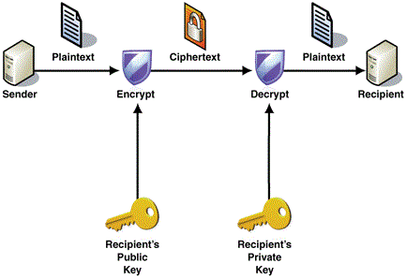

TCP/IP Network Protocol
- TCP/IP-A highly standardized protocol used widely on the Internet.
- There are four layers of the TCP/IP reference model.

Application

Host-to-Host

Internet
Network Access

Public Key infrastructure
Services
- Secure communication.
- Authentication - Ability to verify the identity of an entity.
- Confidentiality - Protection of information from unauthorized disclosure.
- Data Integrity - Protection of information from undetected modification.
- Non-repudiation - Prevention of an entity from denying previous actions.
- Key establishment.

RSA Algorithm
- Key generation
  - Generate two large primes p and q ; compute n=p*q
  - Find e,d such that e*d = 1 mod (p-1)(q-1)
- To encrypt a message M the sender:
  - Obtain public key of recipient PU={e,n}
  - Compute C = Me mod n, where 0 ≤ M < n
- To decrypt the cipher text C the owner:
  - Uses private key PR={d,n}
  - Computes M = C^{d} mod n
- Note that message M must be smaller than the modulus n otherwise, hybrid encryption:
    - Generate random symmetric key r
    - Use public key encryption to encrypt r
Use symmetric key encryption under r to encrypt M.

Working
Project Modules:
  - Login Form-
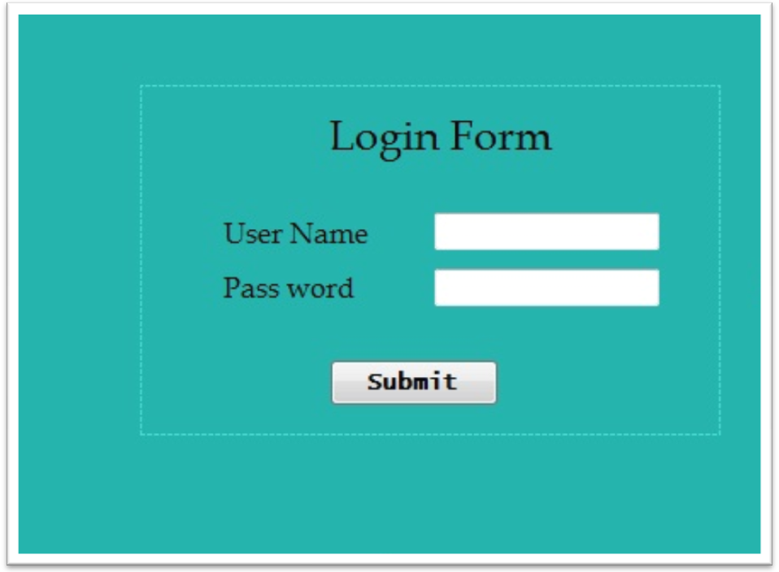

  - Key generator-
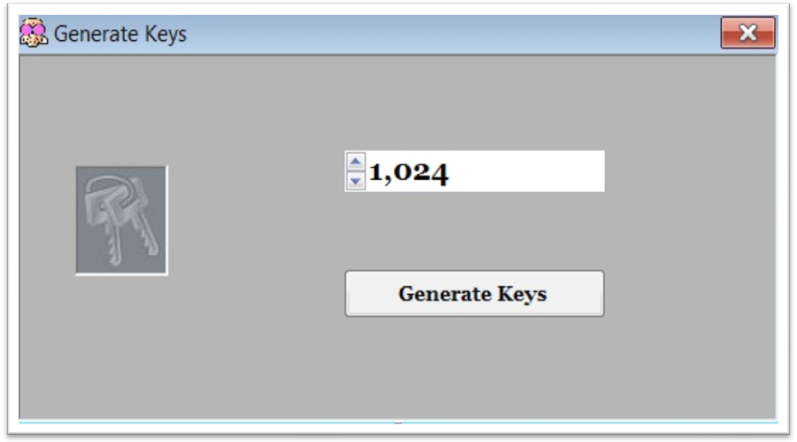

  - Main Form-
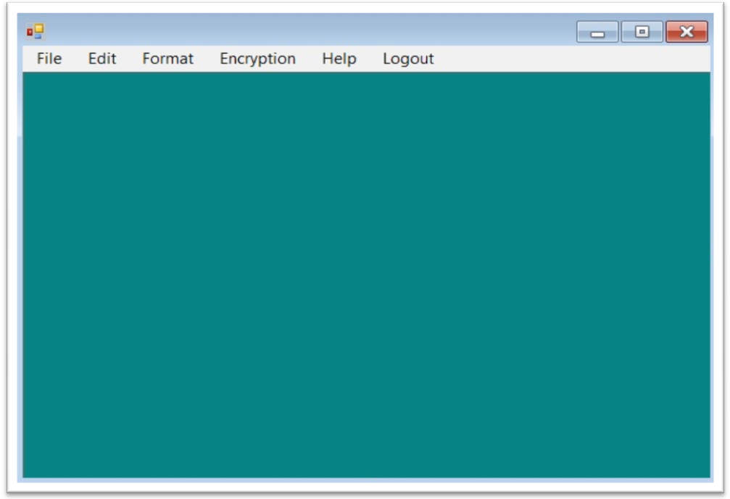

Advantages
  - Security is enhanced in well manner.
  - Users set the byte key (encrypted key) manually.

Disadvantages
  - Receiver should have his private key for decryption.
  - The PKI system is very complex and complicated.

System Specification
Hardware Requirements
- System : Pentium IV and Later.
- Hard Disk : 40 GB or Above.
- Ram : 256 MB and Above.

Software Requirements
- Operating system : Windows XP Professional.
- Technology : Visual Studio .Net 2005.
- Coding Language : C#.

Conclusion
- What we did:
- We manage to overcome the problems in existing system by increasing security.
- Most Company/Customer can use it as means of increasing security and minimizing fraud.
- What remains to be done:
- Increase security level
- We can use better PKI for increasing security.
- Better PKI increase more complexity.
- This can be a stepping to go further focusing on encryption within PKI environment.

References
Books
- Cryptography Decrypted by H. X. Mel, Doris M. Baker
- C# Network Programming by Richard Blum.
- PKI: Implementing & Managing E-Security by Andrew Nash.
- TCP/IP Sockets in C#: Practical Guide for Programmers (The Practical Guides) by David Makofske, Michael J. Donahoo and Kenneth L. Calvert.
- Applied Cryptography: Protocols, Algorithms, and Source Code in C# by Bruce Schneier.
- TCP/IP Illustrated: The Protocols by W. Richard Stevens.

Web Sit
- http://en.wikibooks.org/wiki/Cryptography/RSA
- www.infibeam.com/Books/Computers/Cryptography
- https://www.goodreads.com/shelf/cryptography
- http://msdn.microsoft.com/vstudio/encrypt-and-decrypt-a-string-in-csharp
- http://www.protocols.com/pbook
- http://compnetworking.about.com/cs/basictcpip
- http://searchsecurity.techtarget.com/definition/RSA

