**Design of Automatic Tyre Inflation System**

Hemant Soni, Ashwin Kherde, Saurabh Relkar.

Instructor :- Prof. P. R. Gajhbhiye1 and Er. S. D. Thakre2

1Professor, 2Assistant Prof.

Department Of Mechanical Engineering

KDK College of Engineering, RTM Nagpur University, Nagpur, India

**ABSTRACT**

Driven by studies that show that a drop in tire pressure by just a few PSI can result in the reduction of gas mileage, tire life, safety, and vehicle performance, we have developed an automatic, self-inflating tire system that ensures that tires are properly inflated at all times. Our design proposes and successfully implements the use of a centralized compressor that will supply air to all four tires via hoses and a rotary joint fixed between the wheel spindle and wheel hub at each wheel. The rotary joints effectively allow air to be channeled to the tires without the tangling of hoses. With the recent oil price hikes and growing concern of environmental issues, this system addresses a potential improvement in gas mileage; tire wear reduction; and an increase in handling and tire performance in diverse conditions. In this paper we have taken into consideration design aspects of the ATIS.

**INTRODUCTION**

In ancient time, after the discovery of wheel by man, it has been used extensively for various purposes and it is vital part of human life for ages. These wheels runs human life faster and faster with new technology and one such technology is on board air inflation system used in automobiles. Tyre is the second-highest cost for the automobile industry. This leads us to the condition that we should have regular attention towards the tyre of the vehicle.

This system(ATIS) helps to keep free from regular attention towards tyres and hence it reduces time of the person. Luxury cars and military vehicles are already using this system but the car of a common man don’t have this system. Due to its low cost of production, a normal person can afford to have it installed in his car.

**CONCEPT**

Automatic Tyre Inflation System simply works on the same principle as onboard or stationary tyre inflation syaytem works. This system uses compressor to get the air from atmosphere, compress it and deliver it to the tyre for inflation. It has given the name automatic because it automatically checks the tyre pressure using the pressure gauge fitted there and if tyre is underinflated then the compressor starts to deliver air to inflate the tyre. The switching of the circuit will take place using electronic circuits.

**DESIGN OBJECTIVES**

**1. Ability to Provide Proper Tire Pressure**

The ideal functional objective of our design is its capability to adjust the pressures in all four tires of a passenger vehicle to obtain the proper pressure for varying road/driving conditions.

**2. Ability to Provide Automatic System**

A third objective is to provide all of the said benefits to the user through an automatic system, thus minimizing user intervention. Specifically, it is desired that the system automatically increase

tire pressures for the given road conditions. However, since this objective is closely linked with the ideal objectives in maintaining the proper tire pressure, and thus unattainable due to time constraints, this objective will not be pursued.

**3 Low Cost Device**

For both the customer and end user (vehicle owner), it is imperative to keep the price of the device as low as possible. . Considering the potential benefits and cost savings that this design has to offer and the prices of optional equipment for passenger vehicles with similar complexity, the target price range for this device has been identified as Rs 3000 - 5000. This is the price for both the OEM and vehicle owner, assuming that the OEM does not mark up the price. In addition, this price range should be able to support the costs of components of the system, manufacturing, and any necessary installation.

**Electronic Requirements**

**1. Microcontroller ATMEGA 16:**

ATmega16 is an 8-bit high performance microcontroller of Atmel’s Mega AVR family with low power consumption. Atmega16 is based on enhanced RISC (Reduced Instruction Set Computing) architecture with 131 powerful instructions. Most of the instructions execute in one machine cycle. Atmega16 can work on a maximum frequency of 16MHz.



ATMEGA 16 devices are available in 40-pin

* It is 8-bit Microcontroller
* System is RISC Architecture
* It has Small set of Instruction set
* It has 131 powerful Instructions
* Compatibility avail 28/40 Pin Ics
* Operating Speed Max 16 MHz, Voltage 2-5.5 v
* Memory: Flash Program-16KB, RAM-1 KB, EEPROM Data Mem- 512 Bytes
* Low power, High speed Flash/EEPROM Technology
* It has on chip Timers. 2 Timers are avail
* It has in built Analog to Digital Converter, USART, Analog Comparator, SPI JTAG e
* In built Multiplexer availability for signal Selection
* It has serial as well as Parallel Communication facilities
* In built Capture, Compare and Pulse width modulation
* It has four 8 bit Ports designated as PORT A, PORT B, PORT C, PORT D for Internal and External usage.

**2. L293D Motor Driver IC:-**

L293D IC is basically used for driving the inductive loads like DC motors, stepper motors, and relays. It is a 16 pin DIP IC .It will simply amplify the logical input combinations from the microcontroller IC to drive the inductive loads like DC motor in our case.

With the help of L293D IC we can drive two motors simultaneously at a time. It has four I/P pins and four O/P pins for controlling the devices by using microcontroller. For a single motor the combinations of two I/P are used for taking the I/P from the microcontroller and after amplification the corresponding two O/P combinations are connected with motor.

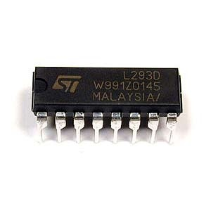

**3. 7805 Voltage Regulator IC:-**

It is a three pin IC used as a voltage regulator. It converts unregulated DC current into regulated DC current.

It has given name as 7805, in which last two digits 05 certainly shows that it converts the given voltage into 05V.

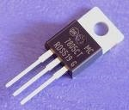

**4. Relay signal controller:-**

Relays are simple switches which are operated both electrically and mechanically. Relays consist of a n electromagnet and also a set of contacts. The switching mechanism is carried out with the help of the electromagnet. The main operation of a relay comes in places where only a low-power signal can be used to control a circuit. It is also used in places where only one signal can be used to control a lot of circuits.

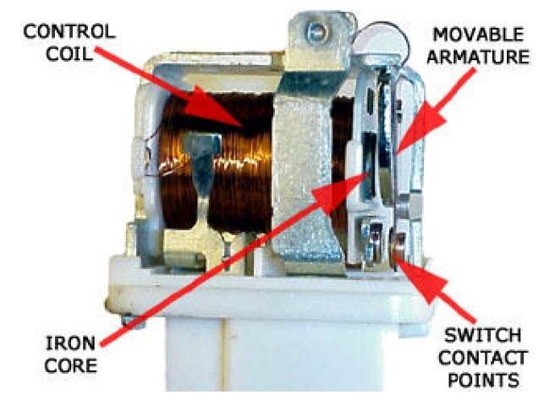

**Engineering Analysis:-**

**1. Complete V-Belt Design :-**

Using Design Data Book By **B. D. Shiwalkar**

**Given:** Rated Torque, TR= 40 kg-cm

TR=4 N-m

Speed Of Motor, N1 =1000 rpm

Speed Of Wheel, N2=333.33 rpm

**For Rated Power (PR):**

PR = 2πN1*TR/60

=2π*1000*4/60

PR=418.879 W = 0.419 KW

**For Design Power (Pd):**

Pd= PR*K1

Where K1= Load Factor

For Electric Motor to Line Shaft

K1=1.10

Pd=0.419*1.10

Pd=0.461 KW

Now for selection of belt designation.

As Pd Lies in Range i.e. 0.35-3.5 KW

We Select Belt Designation As ‘A’.

For ‘A’ Type Belt (Table no.)

Nominal Width, W=13mm or ½ in

Nominal Thickness, t=8mm or 5/16 in

Recommended min. Pulley dia., D1=75mm or 3 in

Max. No. Of strands =6

Bending Stress Factor, Kb=17.6*103

Centrifugal Tension Factor, Kc=2.52

**Now For Pitch Line Velocity, (VP)**

Vp= πD1*N1/60

=π*75*1000/60*1000

Vp= 3.927 m/sec =235.61 m/min

**Now For Dia. Of Driven Pulley, D2**

In ‘V’ Belt Slip is Negligible Because of Wedging Action

So,

πD2*N2=πD1*N1

D2=75*1000/333.33

D2=225 mm =9 in

**Now For Belt Tensions, F1&F2**

F1-F2=Pd/Vp =0.461*103/3.927

F1-F2=117.392 N ... (1)

Again We Have,

F1/F2= eμθ*cosec(α/2)

Where, μ= Coefficient of Friction=0.3 usually

θ= Angle of Lap on Smaller Pulley= π- (D1-D2)/C

C= Centre Distance Between Pulleys

=D1+D2=300 mm

θ= π-(225-75)/300

θ= 2.642 rad

α= Groove Angle= 38ͦ

F1/F2=e0.3*2.642*cosec(38/2)=11.41

F1=11.41*F2

Therefore Putting This Value in eq. (1) We Get,

F1=128.671 N

F2=11.277 N

**Now For Power Rating Per Belt,**

W=(Fw-Fc)*( eμθ*cosec(α/2)-1/ eμθ*cosec(α/2))*Vp

Where,

Fw= Working Load=( Nominal Width)2=132

= 169 N

Fc= Centrifugal Tension= Kc*(Vp/5)2

=2.52*(3.927/5)2

=1.554 N

W=(169-1.554)*( e0.3*2.642*cosec(38/2)-1/e0.3*2.642*cosec(38/2))*3.927

W=412.976 N=0.413 KW

Therefore,

**No. Of Strands=Pd/Power Rating**

=1.116=1

But Max. No. Of Strands=6

**Therefore Design Is Safe**

**Now for Length of Belt (L),**

L=π/2*(D1+D2)+2C+(D1-D2)2/4C

=π/2*(225+75)+2*300+(75-225)2/4*300

L=1089.989 mm= 1.09 m

**Now For Larger Pulley Design,**

For ‘A’ Designation Belt,

Length Of Pitch, lp=11 mm

Pitch Width, b=3.3 mm

Pitch Height, h=8.7 mm

Pitch, e=15 mm

Half Pitch, f=9 to 12 mm

Min. Pitch Dia., Dp=125 mm For α=38ͦ

**Width of Pulley Rim, bp**

bp=(No. of Strands-1)*Pitch+2*Half Pitch

=(2-1)*15+2*11

bp=22 mm

**For Other Pulley Details,**

For Diameter D2=225

As D2˃150 mm

So Arm Type Construction is Required

For D2=225 mm &Width= 22 mm

No. of Arms=4

No. of sets=1

**Now For Design of Smaller Pulley,**

Designation Parameter Are Same

For Dia. D1=75 mm

We Select Web Construction

**2. Speed Of Tyre:-**

From Design Data Book By. Dr. B. D. Shiwalkar

Given, For V-Belt Drive

RPM of motor (N1) = 1000 rpm

Diameter of pulley on motor shaft (D1) =3 inch

Diameter of pulley on wheel axle (D2) =9 inch

Radius of tyre (R) = 0.3 m.

From formula,

N1D1= N2D2

1000 * 3 = N2 * 9

N2 = 333.33 rpm.

V= (R*2πN)/60

= (0.3*2π*333.33) /60

=10.472 m/s.

Hence, Speed of tire = 37.7 km/hr.

**Working Flow Diagram:-**

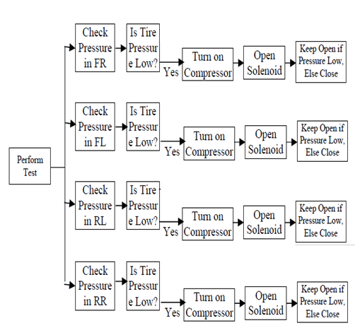

**Conclusion:-**

The dynamically-self-inflating tire system would be capable of succeeding as a new product in the automotive supplier industry. It specifically addresses the needs of the consumers by maintaining appropriate tire pressure conditions for:

• Reduced tire wear

• Increased fuel economy

• Increased overall vehicle safety

Because such a product does not currently exist for the majority of passenger vehicles, the market conditions would be favorable for the introduction of a self-inflating tire system. Through extensive engineering analysis, it has also been determined that the self-inflating tire system would actually function as desired. In particular, the product would be capable of:

• Providing sufficient airflow to the tire with minimal leakage

• Withstanding the static and dynamic loading exerted on the rotary joints.

**References:-**

[1] “How Self-Inflating Tires Work.” Obringer, Lee Ann.

[2] “Keep Your Tires At Proper Inflation.” Doran Mfg Llc.

[3]“Dynamically-Self-Inflating Tire System” Michael Alexander, Anthony Brieschke, Jonathan Quijano, and Lau Yip. Department of Mechanical Engineering University of Michigan, December 12, 2006

[4] **“**Effects of Tire Inflation Pressure on Wheel’s Road Life and Vehicle Stability.*”* John Woodrooffe, Roaduser Research: Norm Burns Saskatchewan Highways and Transportation. January 12, 2007

[5] **“**Testing Of Centralized Control System of Inflation Pressure” Simion Popescu, Sorin Boruz, Mihnea Glodeanu, Tudor Alexandru, Florin Loghin

[6] “Effects of Central Tire Inflation Systems on Ride Quality” B.T. Adams ,*, J.F. Reid , J.W. Hummel ,

Q. Zhang , R.G. Hoeft.