**Introduction of Spray Painting Robot**

Krunal Hedaoo,Anand Dongare, Raman Arekar

**Instructor** :-Dr.A.V.Vanalkar

Department Of Mechanical Engineering

KDK College of Engineering,

RTM Nagpur University, Nagpur, India

**ABSTRACT**

Wall painting as well as inspection works for structures, so far,have been performed manually through use of scaffolds or gondolasprovisionally built all around the subject wall, which, therefore, havingraised many problems such as high personal risks, unclean workenvironments, etc.. The wall painting robot developed this time canperform, as moving attracted on a wall as being pre-programmed, notonly general type of coating in a single color through use of spray gunsmounted on the arm but also picture painting in multiple colors based onpicture data incorporated in the robot controlling computer. An improved type of the above, can perform not only the originalfunctions but also various other works on a wall such as wall cleaningand tile separation sensing through changing of an attachment.

As this system is easy in handling, it is applicable to various worksfor a wide range of structures without limiting work subjects.

**INTRODUCTION**

Now a day, the use of technology has increased quite a lot in various aspects of life. The technological development has reduced the human efforts in different ways. Every complex work is completed very quickly and efficiently with the use of technology.In this project, we are trying to reduce the human efforts involved in painting different things by using a working robot.The spraypainting robot can be used for

painting purpose very effectively and efficiently with less manpower.Spray painting is an important process in the manufacture of many durable products, such as automobiles, furniture and appliances.

The uniformity of paint thickness on a

productcan strongly influence the quality of the product. A spray gun is the basic and the most important part of any spray painting robot. Therefore, the gun trajectory planning is critical to achieve the uniformity of paint thickness and has been an active research area for many years.

**CONCEPT**

Spray painting is a painting technique where a device sprays a coating (paint, ink, varnish, etc.) through the air onto a surface. The most common types employ compressed gas—usually air to atomize and direct the paint particles. Spray guns evolved from airbrushes and the two are usually distinguished by their size and the size of the spray pattern they produce. The spray gun has a nozzle, paint basin, and air compressor. When the trigger is pressed the paint mixes with the compressed air stream and is released in a fine spray. It involves the development of a robot that can be used for working in both horizontal & vertical direction, for spray painting.

The feed rate of nozzle is varied according to the thickness of the layer of paint required and surface to be painted. Speed reducing gear system incorporated with motors is required for maintaining proper angular displacement of the robotic arms.

**OBJECTIVES**

* To reduce the human effort in painting by the use of technology.
* To paint different surfaces or wall effectively and efficiently in less time.
* To improve human safety by eliminating work on the scaffolds.
* To obtain a uniform layer of paint on the surface of the material.
* To reduce the wastage of paint while painting.
* To construct a robot using a light weight and tougher material for easy transport and durability.

**COMPONENTS**

1. **SPRAY GUN**

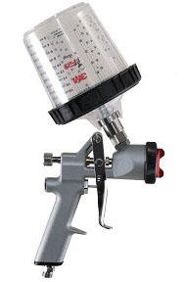

•Step-less jet width control that adjusts spray pattern

•Fluid control adjustment

•Air regulator with gauge provides smooth consistent air flow

•1.3mm fluid nozzle for very fine media like Urethane &Color Hi-Viscosity

•High quality stainless steel nozzle

•Aluminum alloy body construction

•Aluminum paint cup

•0.6liter (600cc) cup capacity

•4.5 cubic feet per minute (CFM) air consumption

•Operation pressure: 40 psi

•Working pressure: 10 psi

•Black nickel finish

**Air gun spraying**

This process occurs when paint is applied to an object through the use of an air-pressurized spray gun. The air gun has a nozzle, paint basin, and air compressor. When the trigger is pressed the paint mixes with the compressed air stream and is released in a fine spray.

[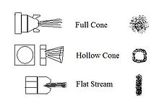](https://en.wikipedia.org/wiki/File:Air_gun_sprays.JPG)

1. **RACK AND PINION**

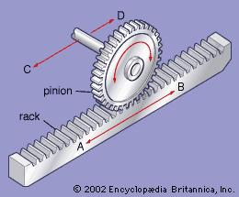

Rack and piniongears are used to convert rotation into linear motion. The flat, toothed part is the rack and the gear is the pinion. A piston coaxial to the rack provides hydraulic assistance force, and an open centered rotary valve controls the assist level. A rack and pinion gears system is composed of two gears. The normal round gear is the pinion gear and the straight or flat gear is the rack. The rack has teeth cut into it and they mesh with the teeth of the pinion gear.

A ring and pinion gear is the differential's critical point of power transfer. A ring and pinion gear set is one of the simplest performance modifications that can be performed on a vehicle. The most common reason to change ring and pinion ratios from the original equipment is to retain power when bigger tires are put on a vehicle. The torque can

be increased by a ratio change when there is enhanced pulling or higher take off power from a dead start. A well designed mechanism such as the rack and pinion gears save effort and time.

1. **DC MOTOR**

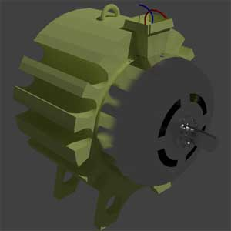

This DC or direct current motor works on the principal, when a current carrying conductor is placed in a magnetic field, it experiences a torque and has a tendency to move. This is known as motoring action. If the direction of electric current in the wire is reversed, the direction of rotation also reverses. When magnetic field and electric field interact they produce a mechanical force, and based on that the working principle ofdc motor established.The direction of rotation of a this motor is given by Fleming’s left hand rule, which states that if the index finger, middle finger and thumb of your left hand are extended mutually perpendicular to each other and if the index finger represents the direction of magnetic field, middle finger indicates the direction of electric current, then the thumb represents the direction in which force is experienced by the shaft of the dc motor.

Structurally and construction wise a direct current motor is exactly similar to a DC generator, but electrically it is just the opposite. Here we unlike a generator we supply electrical energy to the input port and derive mechanical energy from the output port.

**CONCLUSION**

Trend of structures seems to be shifting from the age of mass supply to the age of stock adjustment, where the renewal market serving for maintenance improvement in function of existing structures isexpected to expand in future. Spray Painting Robot aims to automate and improve in efficiency a series of renewal works by adding, through changing of an attachment, new functions for cleaning, tile separation sensing and repair work to the original functions of picture painting in a single and multiple colours. In future, we would like to expand applications of Spray PaintingRobot, notlimiting to outer walls of a structure, even to civil structures like dams and bridge piers.

**REFRENCES**

* [www.ehow.com](http://www.ehow.com)
* [www.robotics.com](http://www.robotics.com)
* [www.howstuffworks.com](http://www.howstuffworks.com)
* [www.machinetoolhelp.com](http://www.machinetoolhelp.com)
* “Development of Wall Painting Robot”Takuya Gokyu, Masayuki Takasu, **Sumio Fukuda**Tokyu Construction Co. Ltd.1-16-14 Shibuya-ku , Tokyo, Japan
* “Design and Analysis of Direct Drive Robot” Jaydeep Roy and Randal Goldberg Department of Mechanical Engineering

John Hopkins University

* “Heterogeneous Modeling& Design of a Robot Arm Control System” Antonio Yordán-Nones

University of Puerto Rico, Mayagüezdjstone@caribe.net