**High Speed Micro milling of difficult to cut metals: open challenges and issues**

1. **Akarsh Singh**
2. **Lokesh Sharma**
3. **Pranav Vijayvergiya**

**Guided by**

**Prof. Ramesh Singh**



Abstract

Metallic materials can be easily cut. The ease with which a metal can be cut depends on the machinability as a material property. In general sense a material is highly machinable when satisfactory parts can be made from it at low cost, with minimum difficulty. Moreover difficult to cut materials such as cast iron, Titanium, or sandwich materials, Inconel alloys, and organic matrix composites are more extensively used in different mechanical industrial field’s .Cutting this type of materials needs tools which are very costly and also the process requires specialized fluids. Ultimately the process becomes extremely costly and also fluids used are not environmental friendly and can lead to serious damage to the environment. Bulk metallic glass an emerging class of amorphous alloy possesses high strength, hardness, fracture toughness, and fatigue. High speed micro milling of this difficult to cut material which is a thin workpiece can minimize the above disadvantages over a large extent. Moreover today the advantages and applications of BMG in fields like mechanical and biomedical and lot many gives a clear view to use the material to study and characterize the mechanical properties in high speed micro milling. The major challenge in high speed micro milling is in designing the fixture.

CHAPTER 1

INTRODUCTION

* 1. **Introduction to Micro milling and High Speed Micro milling**

Micro-milling is an operation to manufacture net-shaped small parts offering alternative to other micro manufacturing processes. It is a flexible method of fabricating three-dimensional (3-D) features including micro molds/dies and fully functional metal devices specifically with recently developed miniature machine tools. The fundamental difference between micro-milling process and conventional milling processes arises due to scale of the operation, while they are kinematically the same. The difference between them is that the ratio of feed per tooth to radius of the cutter is much greater in micro-milling than conventional milling. But this often leads to error in predicting the force as a small run out of the tool tip in microns lead greatly to the accuracy of the end milling operation.

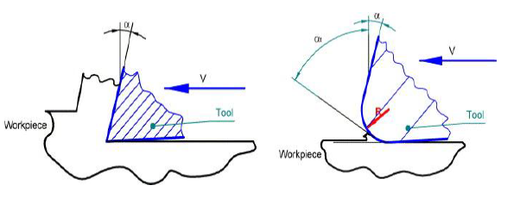

Fig 1 Difference between Macromilling and Micromilling

CHAPTER 2

**2.1 Introduction of the problem undertaken in this project**

The primary objective of this goal is to examine the highspeed micromilling performance of bulk metallic glass with more accentuation on Ultra Precision Micromilling machine. Optimization of various parameters for study of high speed micromilling on Bulk metallic glass like spindle speed, depth of cut, feed per tooth and appropriate tool selection etc. To study the machining effects such as the type of burr formation, chip formation .The measurement of cutting forces at different speeds. Comparison of the experimental forces with the mathematical model.

**2.2 Why Bulk Metallic Glass :**

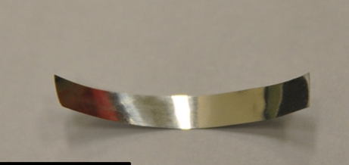

Image1: Workpiece Bulk Metallic glass

BMG was selected as the work piece due to its following properties:

* **Strength** – stronger than metallic crystals (2-3 times)
* **Toughness**- much more than the ceramics
* **High strain limits** (Hookean elasticity)

These are a new revolutionary field of structural materials with combination of strength, ductility, and toughness.

**USE**

* Some of the current usage of BMG is in springs, golf clubs, optical devices, cell phone cases, biomedical implants, sporting equipment etc.
* The unique chemistry of BMGs make them ideal material for application typically held by **polymers**

**2.3 The major challenges working with BMG:**

The major challenge was with the thickness of the work piece .The thickness of the BMG used was only 0.035mm which is extremely thin as shown in the image above. The major challenges while working with a thin work piece involves machining induced stress, deformation and fixturing difficulties.

The Challenges we have worked on this project are:

1) Design an appropriate fixture of aluminium for bulk metallic glass so that it will not move while machining

2) Appropriate tool selection which was 400 um tungsten carbide for cutting

3) Design a Mathematical model using MATLAB for the comparison of experimental cutting forces with theoretical forces by graphs of force vs angle of cutting teeth from vertical (immersion angle)

**2.4 Literature review of existing work done in that area**

The literature review study gave a brief overview on the other methods like turning, drilling on BMG. But as this is an emerging and high speed micro milling literature was few.

The experiments for calculating cutting forces involved during the micromilling were performed on materials like aluminium and steel but not on Bulk Metallic Glass.

Mohammad Malekian, Simon S. Park and Martin B.G came up with the formula for radial and tangential cutting forces in micromilling .

dFr,s= [Krc h(θi(z)) + Kre] dz

dFt,s= [Ktc h(θi(z)) + Kte] dz

where, h(θi(z))= feed rate as a function of theta

dz=depth of cut

Krc =radial cutting coefficient

Ktc =tangential cutting coefficient

Kre =radial edge coefficient

Kte=tangential edge coefficient

CHAPTER 3

Brief Description of the Experimental Procedures

**3.1 Machining of Bulk Metallic glass**

The work piece material selected was Bulk Metallic glass (Co75 Si 15 B10) of thickness 35μm for micro milling. The slot milling experiments were conducted to investigate the mechanics of high speed micromilling on Co- based BMG and to examine the machining effects like burr formation, chip formation after the process. The test was conducted at different feed rates with a constant feed. The tool selected for the test was a 400micron 4 flute end mill.

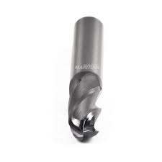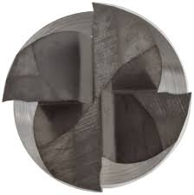

|  |  |
| --- | --- |
| Workpiece Material | Bulk Metallic glass (Co75 Si 15 B10) |
| Workpiece thickness | 0.035mm |
| Tool used | Tungsten carbide 0.04mm 4flute end mill |
| Testing Speeds | 60k,80k and 100k rpm |
| Depth of cut | 0.02mm |

|  |  |  |
| --- | --- | --- |
| Speed (rpm) | Feed (micron/flute) | Feed rate |
| 60,000 | 0.5 | 2 |
| 1 | 4 |
| 1.5 | 6 |
| 80,000 | 0.5 | 2.6 |
| 1 | 5.3 |
| 1.5 | 8.0 |
| 1,00,000 | 0.5 | 3.3 |
| 1 | 6.0 |
| 1.5 | 1.0 |

**3.2 RESULTS OBTAINED:**

|  |  |  |  |
| --- | --- | --- | --- |
| RPM\feed(μm) | 0.5 | 1 | 1.5 |
| 60000 | 439.5937 | 433.6534 | 417.3167 |
| 80000 | 442.5648 | 442.6115 | 438.1234 |
| 100000 | 464.8407 | 448.504 | 460.3856 |

In μm

Feed (micron/flute)

**Conclusion**: The slot width increases with the increase in rotational speed which can be easily seen from the graph above. This may be due to the error in the rotation of the axis. With high speed the error in the rotation increases.

**3.3.1 SEM Images after high speed micro milling**

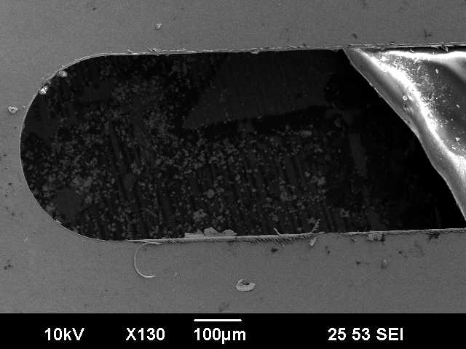 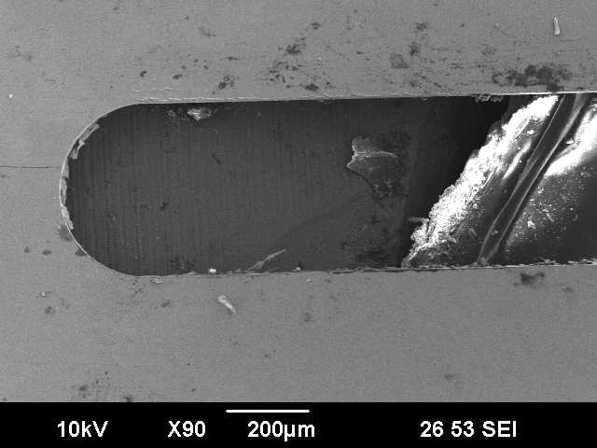

At 60,000 rpm At 80,000 rpm

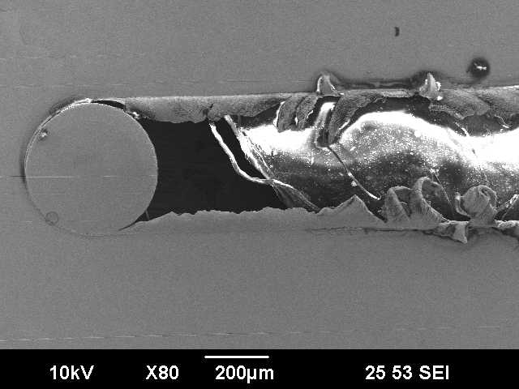

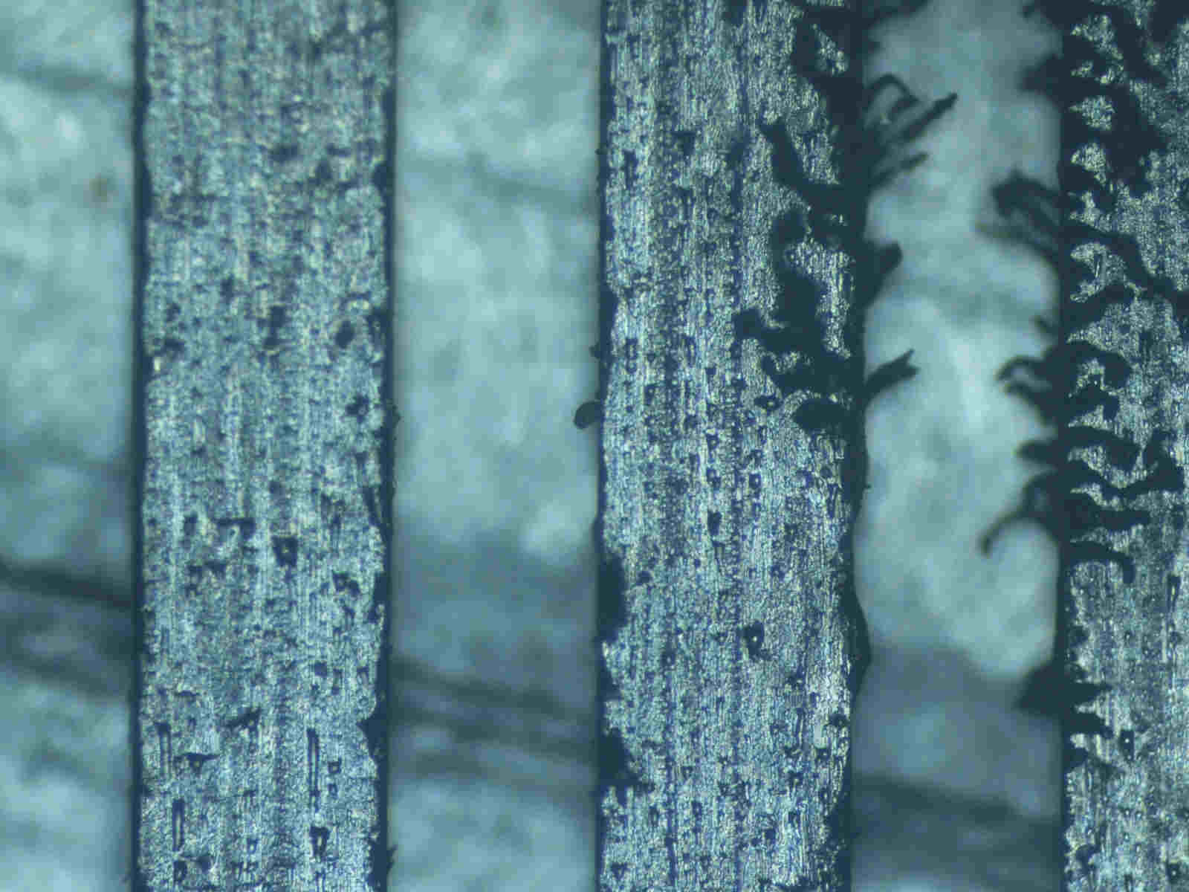

At 100,000 rpm General Slotting Pattern

**Conclusion:** The slotting was done and studied under the scanning electron microscope and we found out that as the rotation of the tool increases the burr/ chip formation increases . Also the measured slot width came out to be greater in higher rotation speed

**3.3.2 Types of chips and burr observed in SEM**

80,000 1.5micron/flute

80,000 1.5micron/flute

Burr roll over type

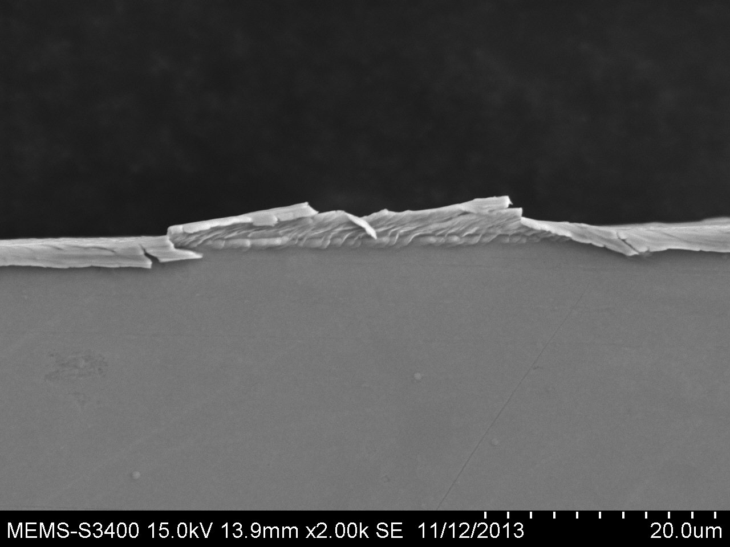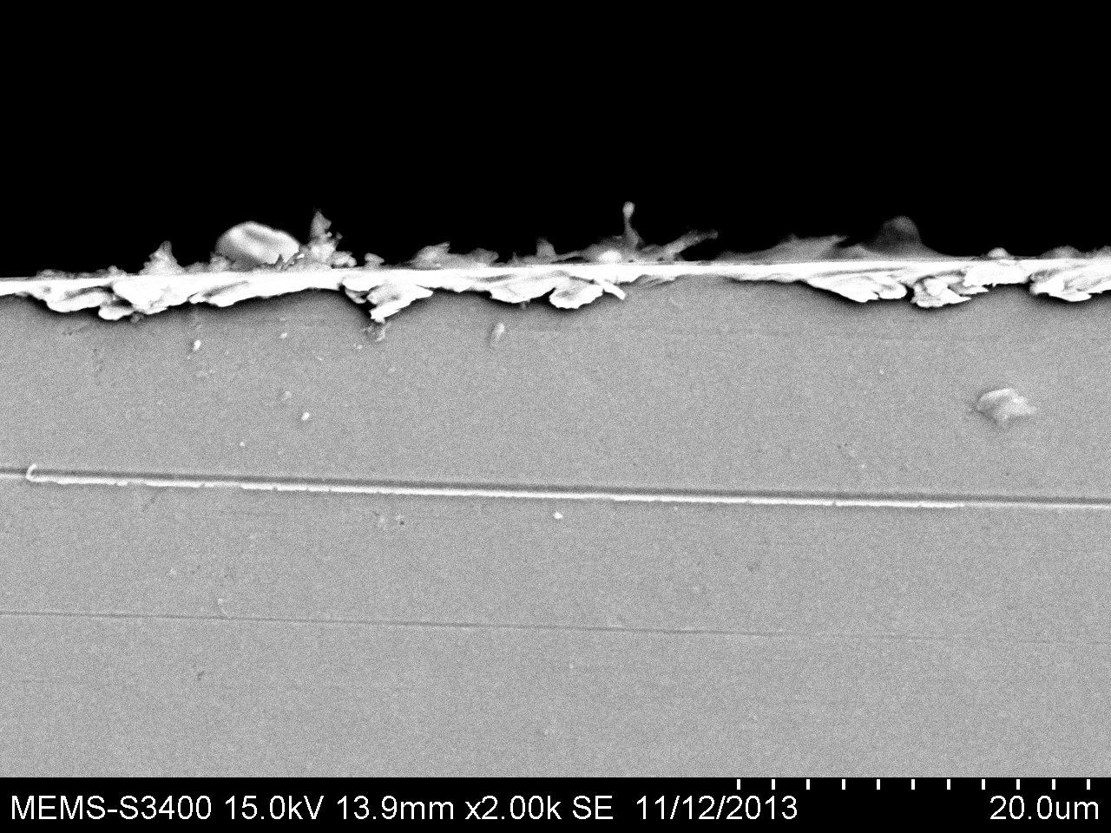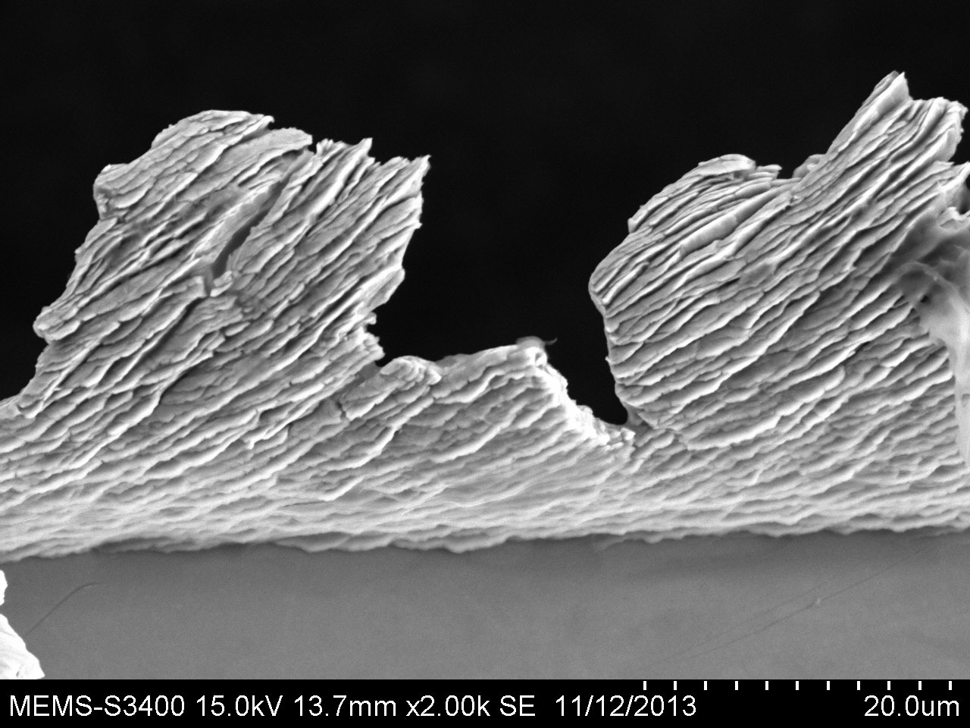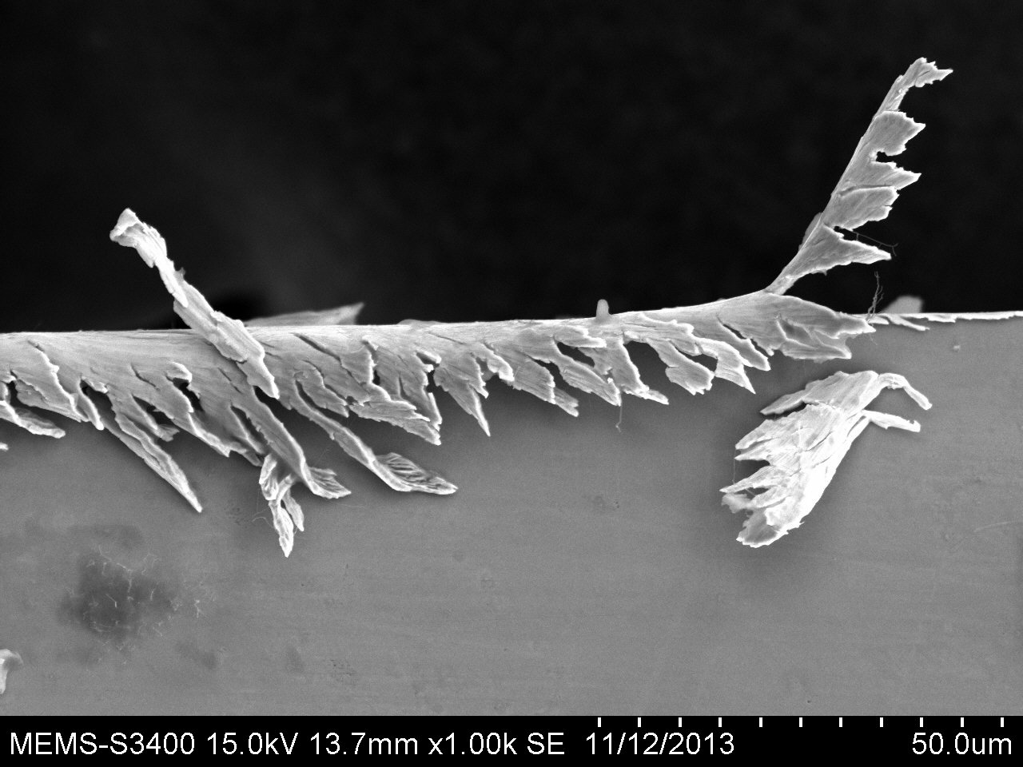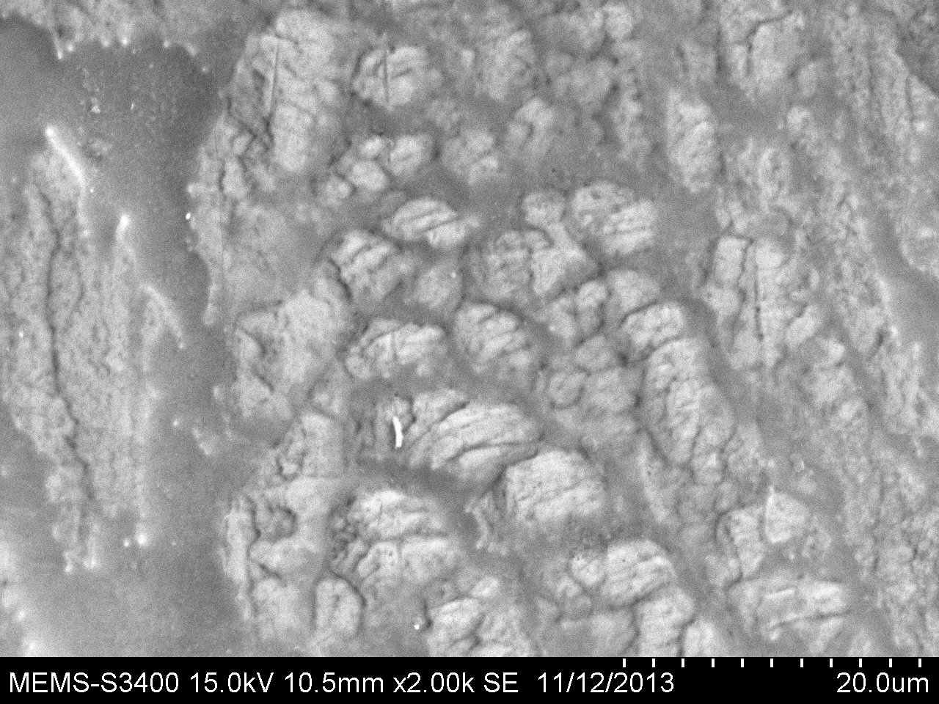

80,000 1.5micron/flute

60,000 1.5micron/flute

Bare BMG

**Observation**

* We observed that in 60,000 1.5 micron/flute formations of chips took place and when further studied bands were appearing on the surface of the chip.
* In 80,000 1.5 micron/flute Burr was observed with roll over type structure.

**3.4 Force Measurement in Micro Milling**

Force measurement was done for the sample BMG for 9 different cases and observed the readings and compared with the mathematical modeling.

Steps involved were:

* Making the fixture for thin BMG sample
* Micro milling the sample for 9 different values of RPM and feed
* The reading were collected using a dynamometer and with the help of amplifier the signals were amplified and we got the readings.

Our experimental sample are-

|  |  |  |  |
| --- | --- | --- | --- |
| Speed | Feed | Feed rate | Dept. of cut |
| 60000 | 0.5 | 2 | 20μm |
| 60000 | 1 | 4 | 20μm |
| 60000 | 1.5 | 6 | 20μm |
| 80000 | 0.5 | 2.7 | 20μm |
| 80000 | 1 | 5.3 | 20μm |
| 80000 | 1.5 | 8 | 20μm |
| 100000 | 0.5 | 3.3 | 20μm |
| 100000 | 1 | 6.7 | 20μm |
| 100000 | 1.5 | 10 | 20μm |

On these readings the experiment was performed.

**3.5 Mathematical Modeling**

We did mathematical modeling of the force on the micro milling of BMG sample in MALAB and compared it with the experimental results.

The modeling was done for the Radial and Tangential force.

dFr,s= [Krc h(θi(z)) + Kre] dz- Radial Force

dFt,s= [Ktc h(θi(z)) + Kte] dz- Tangential Force

These are the radial and tangential components of the cutting force

We calculated the cutting force in x and y direction by each of the 4 teeths using a matlab code and added these 4 forces to get total force.

Code:-

ktc=3650;

krc=2420;

kte=.9;

kre=.7;

n=4; % no. of teeths

h=.0000010; %feed

%z=.0002;

t=25:pi/200:5000; % theta varying from 0 to 5000 degree

z=0; % depth of cut

Fx=0; % Total force in x direction

Fy=0; % Total force in x direction

for j=1:201;

z=z+.0000001*(j-1);

Frs=(krc*h+kre)*z; % radial force

Fts=(ktc*h+kte)*z; % tangential force

for i=1:4;

thetai=t*pi/180+(i-1)*2*pi/n;

Fxi=Frs*sin(t*pi/180+(i-1)*2*pi/n)+Fts*cos(t*pi/180+(i-1)*2*pi/n); % Force in

x direction by teeth i

Fyi=Frs*cos(t*pi/180+(i-1)*2*pi/n)-Fts*sin(t*pi/180+(i-1)*2*pi/n); % Force in

y direction by teeth i

end

Fx= Fx+Fxi;

Fy=Fy+Fyi;

end

plot(t,Fx,'r', t,Fy);

Some Graphs:

Comparison of Experimental and theoretical Forces Fx and Fy

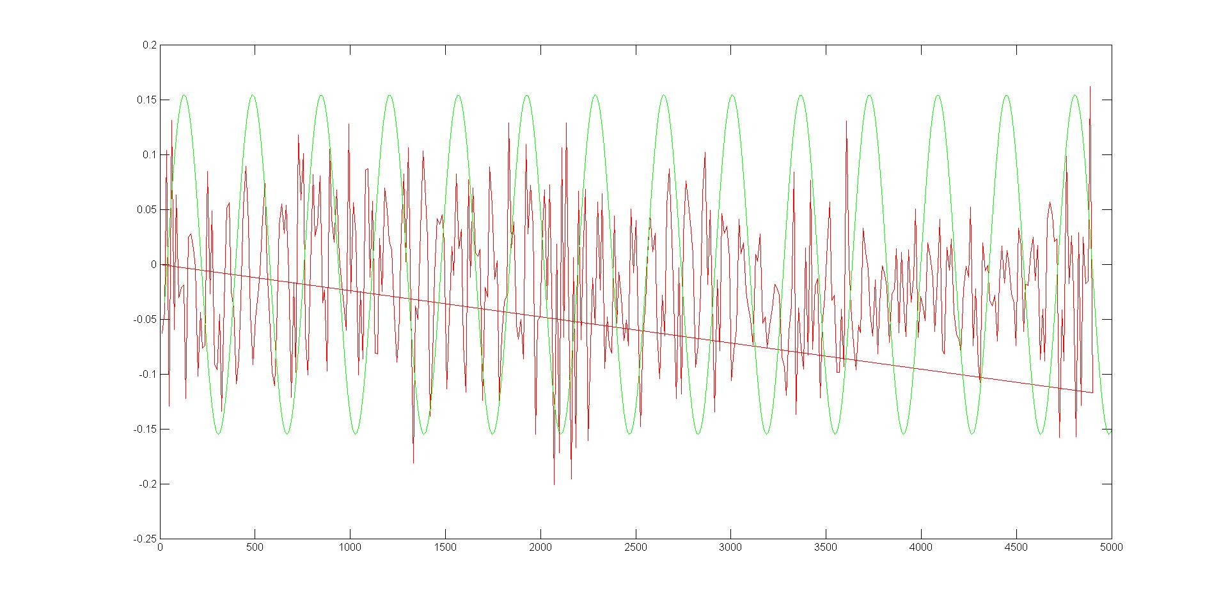

Force = Fx at 60,000 rpm and 0.5 feed

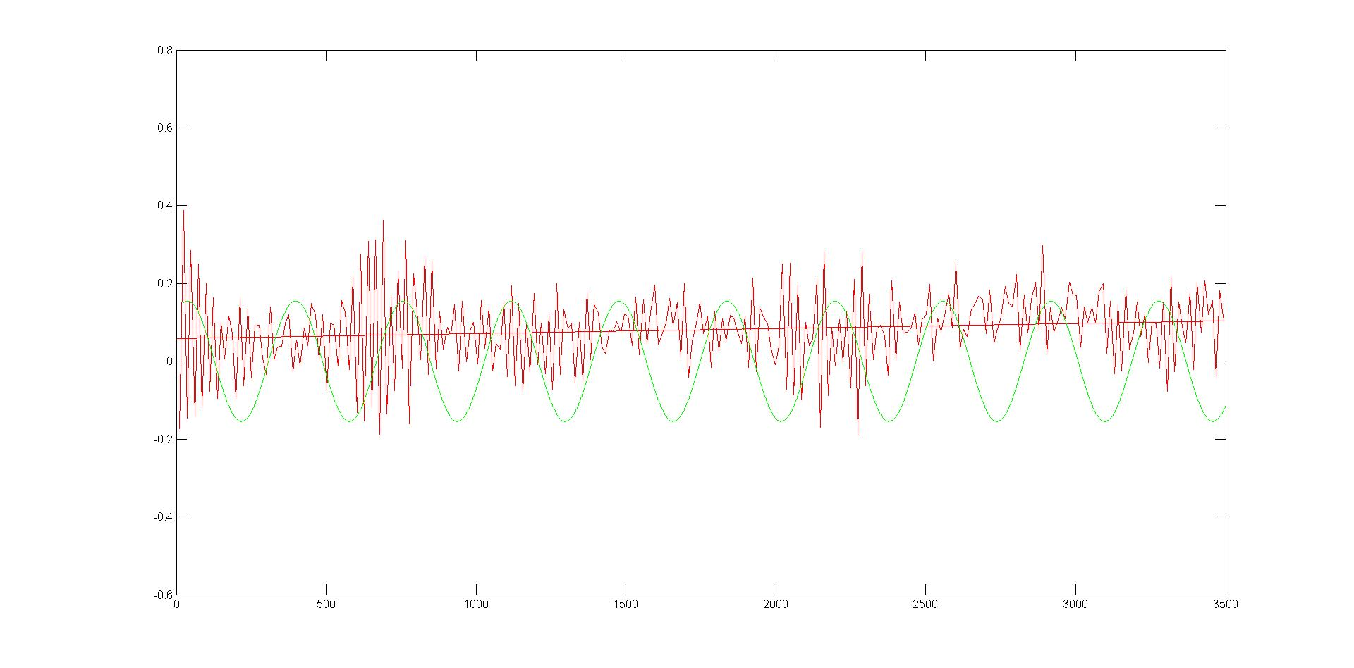

Force- Fy at 60,000 rpm and 0.5 feed

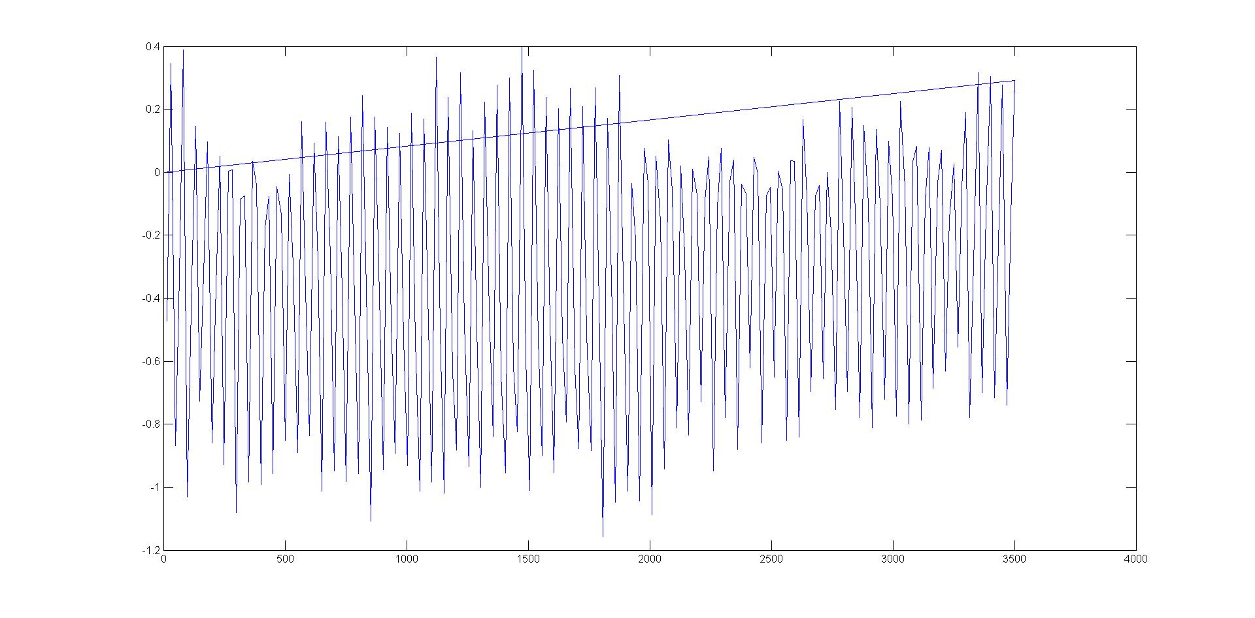

Fx at 80,000 rpm and 1 feed

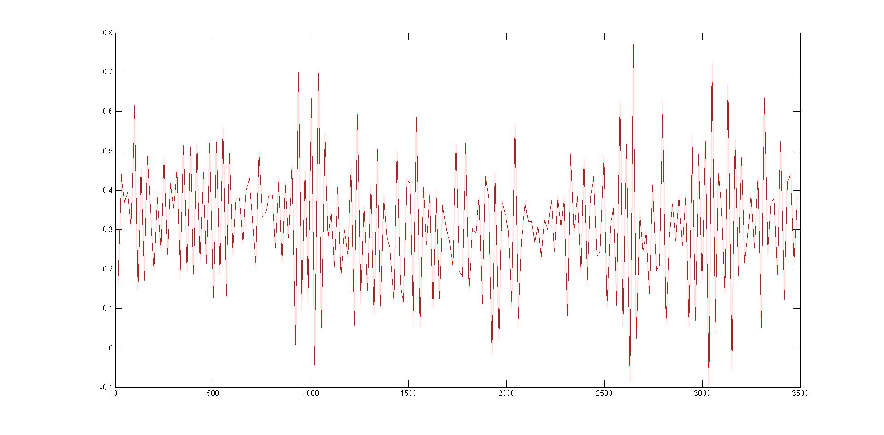

Fy at 80,000 and 1 feed

**Conclusion-** Force increases with increase in rotational speed (rpm). These can be easily seen from the graph. Also the comparison between the experimental and the theoretical can be seen to be nearly same.

CHAPTER 4

**Results and discussions**

1. Designed a fixture of Aluminium for holding the Bulk Metallic Glass during the cutting process
2. After performing cutting operation on BMG using micromilling machine with depth of cut of 20 microns we compared the experimental cutting forces in x and y direction at different RPM and at different feed rates and we found that

As RPM of tool increases cutting forces in x, y and z direction also increases

As feed rate increases cutting forces in x, y and z direction also increases

i.e F(60,000) < F(80,000) < F(100,000)

here F is the force and 60,000 , 80,000 , and 100,000 are the RPM of tool which we had taken

also F(.5um) < F(1um) < F(1.5um)

here .5um, 1um, 1.5um are the feed we have taken

1. We also compared the experimental and mathematical modeled cutting forces by plotting graphs of forces in x and y direction versus immersion angle which is angle between cutting teeth and vertical and we found that the modeled graph was like a sine curve and experimental graph also takes the similar shape with slightly less amplitude
2. We observed our BMG specimen after machining under scanning electron microscope for analyzing its width and burr characteristics and we found that the width of slots made at different RPM were greater than 400um which was the diameter of our tool and also this width increase with increase in RPM and surface roughness also increases with RPM

CHAPTER 5

**Potential Outcome of the Project**

1. We successfully performed the micromilling of Bulk Metallic Glass for studying the forces involved in the cutting process as BMG is a very important and useful material which has a growing scope in future and in the field of optical devices, cell phone cases, biomedical implants, sporting equipment
2. We obtained the cutting forces in x, y and z directions at different feed rates and at different RPM and understood the dependence of these cutting forces on feed rate and RPM
3. We draw the theoretical graphs for the cutting forces in x and y directions using the radial and tangential force equations by writing a code in matlab so that we can compare the experimental force graphs
4. By comparing the graphs of experimental forces and theoretical graphs we found that there nature and amplitudes are same. Hence we verified the existing force model with experimental force measurements of Bulk Metallic Glass
5. As BMG is the new revolutionary field of structural materials exploiting the properties of BMG is very important in today’s world. The micromilling force measurement methods applicable on other metals are applicable on BMG too

**References**

1. Mohammad Malekian, Simon S. Park, Martin B.G., International Journal of Machie tools and Manufacture
2. T. Ozel, X.Liu and A. Dhanorkar, Rutgers university, New Jersey, Microlution Inc., Chicago
3. Sciencedirect.com