Personal 3-Dimensional Printer

An Attempt at economic middle class 3d printer

Mohit D. Wasnik1 *,* Sushma Y. Rahangdale2, Dipali A.Bhure3, Lokesh M Gaidhane,4 Pawan M. Burade.5*(Author)*

Mechanical Engineering

MPCE,Bhilewada

Bhandara (Mah.) India - 441904

Mohit.wasnik132@gmail.com

Rahangdalesushma99@gmail.com

Lgaidhane@gmail.com

*Abstract*—This paper has its main focus on a technology thats growing very fast and swift. 3D printing though existing since 1986, it was never close to become “Personal”. The reprap movement after 2010 made it possible but still it was beyond our reach. Thus a small effort to make existing open-source designs more affordable yet maintaining decent quality that can compete to many high-end machines.

*Index Terms*—3D, personal, open-source, affordable, insert.

# I.Introduction

The personal 3D printers of today most often build things from plastic using a process called fused ﬁlament fabrication (FFF). Plastic ﬁlament is heated and extruded from a nozzle like a tiny and precise hot injector while the machine draws out 3D objects layer by layer. As one layer of plastic is laid on top of another, they fuse together, and, when cooled, form a solid and durable plastic part. This technology has been around for about 25 years and used in the design and engineering industries for everything from designing parts for cars to designing baby toys.

Whilst the real quest was how to make 3D printers more personalized and yet affordable answer came out as an project called [[1]](http://en.wikipedia.org/wiki/RepRap_Project#cite_note-1) “RepRap” (short for *replicating rapid prototyper*) . Developed by Dr. Adrian Bowyer at Bath University, is the 3D printer that started it all in 2007. The ﬁrst RepRap named Darwin, was a 3D printer capable (at least in theory) of reproducing itself by printing the parts needed to make a new one

Due to the self-replicating ability of the machine, authors envision the possibility to cheaply distribute RepRap units to people and communities, enabling them to create (or download from the Internet) complex products without the need for (distributed manufacturing)[3] including scientific equipment.[4][5] They intend for the RepRap to demonstrate evolution in this process as well as for it to increase in number exponentially.[6][7] A preliminary study has already shown that using RepRaps to print common products results in economic savings, which justifies the investment in a RepRap.[8]

Even though above said justified it still lacked enough affordability to reach to middle class Indian families. Hence an open-source machine design was carefully selected and assembled to test and reduce overall cost structure to mere 20-23k.

# II.What is 3d Printing?

3D printing maybe called as Printing Off-the-Paper. Its an additive manufacturing process where a three dimensional object is created by laying down successive layers of material. The path of these layers is characterised by path of nozzle travel. The travel path is determined via G-codes written by software type called “Slicer”. These softwares slice the 3d model into layers which are later laid on. After a post-processing the object is ready to use.

# III.How does a 3d printer works

To create something with a 3D printer, a user begins either by scanning an existing object with a 3D scanner to obtain the needed speciﬁ cations or by generating the specs in a 3D model- ing application. The speciﬁcations are then sent to an extrusion printer, where plastic ﬁlament or other material is used to create the three-dimensional model one layer at a time. As the material is extruded from the nozzle of the printer, the software controlling the machine moves either the platform or the nozzle itself such that the material is deposited in a succession of layers to create the object. Often, the completed object is a single color, but print- ers are now available with two nozzles for dual-color prints. Printing can take a few minutes for a small object the size of a keychain or several hours for larger, more complicated objects.

# IV.elementary parts and mechanism

Central to a 3D printer is the idea of a Cartesian robot. This is a machine that can move in three linear directions, along the x-, y-, and z-axes, also known as the Cartesian coordinates. To do this, these 3D printers use small stepper motors that can move with great precision and accuracy—usually 1.8 degrees per step, which translates to resolutions in the fractions of a millimeter range through the unique way that these stepper motors are controlled called micro-stepping. The movement, torque and motor behaviour is keyfacor in successful output.

Thus to handle so specialised electronic circuit board is fabricated, which is just like mobile circuit its called as EEPROM boards (Electricaly Erasable Read Only Memory ). This device stores settings and values for 3d printing machine as well as controls the motors. This board is an interface betwwen computer and machine. Position or co-ordinate of printer is defined by current position of thermoplastic extruder above printbed of set dimensions. The extruder moves along 3 axes as fast as possible with GT2 timing belts and pulleys aided with 608zz bearing along with smooth rods working through LM8UU linear ball bearings.

# V.Thermoplastic extruder & Filament

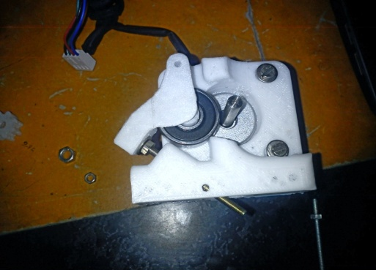With our Cartesian system providing accurate linear positioning, we needed an extruder capable of laying down thin strands of thermoplastic—a type of plastic that will soften to a semiliquid state when heated.While a fabrication of such an extruder is not easy task but thanks to reprap community with available parts and an off-shelf 0.3mm nozzle head we assembled type of extruder called direct drive extruder. Hence thereby totally eliminating any presence of big gears to produce errors like backlash, meshing noise and many such.

**Figure 5-2 : Molecular PLA**

**Figure 5-1: Direct Drive Extruder**

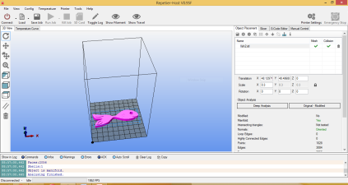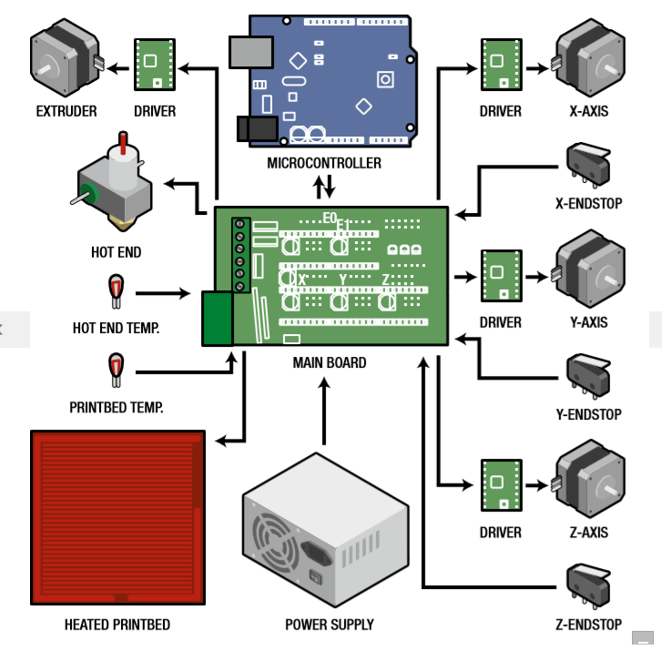Figure 5-1 shows extruder used. This design uses MK7 stainless steel gear procured from [*makemendel.com*](http://makemendel.com/mechanical-parts/ssmk7-drive-gearmk7-drive-gear)*.* The filament is held tight between gear and 608zz bearing working as *idler*. The tiny teeth of mk7 then push up or down as Nema17 motor used for extruder takes its steps.

**Figure 6-1 : Repitier host screenshot**

**Figure 6-3 : Electronics map of 3D printer**

Filament used is PLA (Poly-lactic Acid). The molecular structure is as in figure 5-2. PLA is preffered for its low temperature requirements, absence of need of using any extra agents to make it stick to build surface and its cost (1 kg @ **INR**1400). The properties of PLA can be summerised as follows:

Nozzle temperature : 160-220°C

Printing Surface : Paper tapes laid flat.

Envionmental : Biodegradable

# VI.Software, 3d Designs and calibration

As mentioned everything in this project is open source and softwares are not exception to that.

The primary software used is [*Repitier-Host*](http://www.repetier.com/download/) which comes with in-built *slicer* program called *SLIC3R.* The software handles how all three axes going to move from its manual control panel as well as shows Nozzle temperature in Run time. The slicing pattern is also shown in its 3d-configuration view along with sliced G-code.

The process of making 3D model to object in hand is called *workflow*.The workflow can be demonstrated as in figure 6-2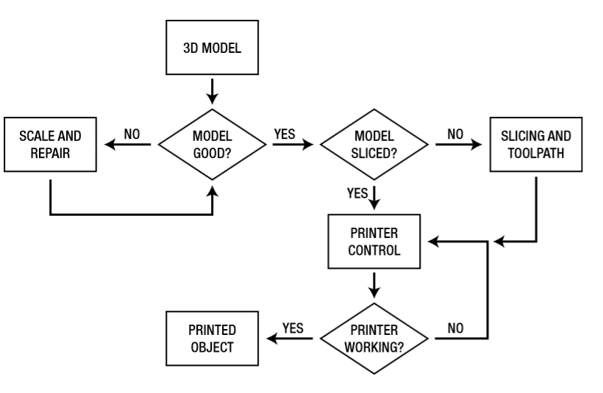

**Figure 6-2 : 3D printer workflow**

The workflow would not be possible without crucial elements like electronics which essentially includes control circuit or motherboard, Power supply Unit and wire extentions. To minimise cost we concentrated on salvaging parts like power supply unit from like old pc units. But could not help motherboard which makes up for most of the part of cost- a compromise made for quality and control. The electronics can be summerised from figure 6-3. In this 3D printer electronic map, we can see how each of the different parts of the electronics system interconnect, with arrows representing the direction of control from one component to the next. Central to the electronics platform is a controller main board that connects all the different hardware needed by a 3D printer to the microcontroller; it is essentially the brain of the entire system. To switch the high current associated with the printbed and extruder heaters, the main board will have specialized switching hardware rated for the necessary maximum loads. Most electronic main boards have the capability of reading resistive-based temperature sensors called thermistors.

The main board also forms the power hub to the whole system, taking in a high current power source and distributing power to the other systems as needed. Finally, the main board will also need to interface with the endstop limit switches on each of the axes to allow the printer to locate its print head prior to a print job. The microcontroller, found on the main controller, is a small, simple computer that runs specialized code called ﬁrmware to allow it to read and interpret sensors like temperature sensors and limit switches, as well as controlling motors using motor drivers and switching high loads using high current transistors called MOSFETs. Most of the electronics packages for personal 3D printers use the Arduino microcontroller. An open-source hardware design, the Arduino ecosystem promotes the use of its hardware in other platforms so that developers can use Arduino’s C-based programming language across several different electronics platforms.

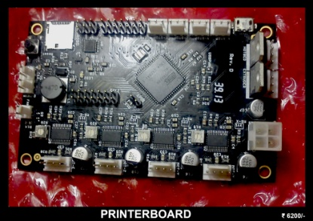The newest single-board electronics solution for personal 3D printers is the Printrboard, shown in Figure 6-4. It was developed by the team working on the Printrbot series of entry-level 3D printers and we incorporated it in this project. The features for the Printrboard include the following:

•Four non-replaceable onboard stepper drivers

•Two high-power switched loads rated at 30 amps for the extruder and printbed

**Figure 6-4 : Printrboard**

•One low-power switched output for the cooling fan

•Three endstop and one emergency stop connection

•Two thermistor connections

•Single power input of 12 to 20 volts

•Onboard microcontroller with integrated USB and onboard MicroSD

Unique to the Printrboard is the onboard microcontroller that features integrated USB, allowing the Printrboard to communicate with the host computer at a much faster native speed. This prevents any pauses that might happen during a print whenever the computer sends commands to the controller, a problem that affects print quality.its inpensive pre-assembled. If such a board be fabricated woulld leave lot of scope for unspeakable errors one of which is damaging all the motors in machine.Thus it was best suited to purpose to get it preassembled.

Firmware is specialized code needed to interpret commands send to the board. The better interpretation better the quality. Thus after extensive followup we chose [Marlin]((https:/github.com/ErikZalm/Marlin)). Marlin is designed for some of the more standard platforms like RepRaps and Ultimakers. Its been seeing a lot of development and developed by top-notch developer AND its Open-source.This includes a better interpretation of acceleration that uses a look-ahead feature to anticipate the upcoming moves to prevent any unnecessary stopping in midprint.

Marlin also supports printing true arcs and information display through an external LCD. The following is a summary of its features:

•Acceleration with look-ahead to keep speeds fast with arc acceleration planning

•Temperature oversampling for more accurate readings

•PID temperature control with automatic PID tuning

•Early LCD display and SD card support.

The calibration for movement of axes is done via careful calculations of different parameters.

A reference point was taken with most probable value for each motor

# VII. Upgrades to reduce cost but increase quality

This project is variant of Brook Drum’s Printrbot Jr.

The original design had many subtle flaws that affected the print quality. So does the design files.

Although in this project we incorporated acrylic design, it wasn’t really a necessity. Thus if acrylic replaced by Wood, then we save more money.

The original design used 5/16”-18 imperial coarse leadscrew. We replaced it with Metric M5 lead screw that’s almost less than half the price of original one. This enabled more precision over Z-axis thus finer clarity and quality.

The calibration is done via a base formula applied at each axis (except Z-axis)

$$\frac{Steps}{mm}= \frac{motor steps per rev X Driver Microstep}{Belt Pitch X Pulley Number of teeth}$$

We used NEMA 17 motors and calculated Steps to be taken by motor its supposed to be taken for given distance. That said

for 100mm motor must move 100mm, thus for GT2 timing belt of pitch 2 and 20 tooth timing pulley,

The configuration is same for both X and Y axis. Thus following value suits both.

$$\frac{Steps}{mm}= \frac{200X 16}{2 X 20}=80.00$$

This value is input to the marlin firmware with

*M92 X80 Y80*

Similar steps were taken for extruder motor for length of filament extruded for given command. The Calculation for Z-axis is done by using *RepRap Calculator3.*

# VIII. Conclusion

Although a work in progress this paper sheds light on reduced costings and near future possibility of 3D printer as an aid to educational system, engineering but more a personal fabricator where one can, quote, “Print the ideas” .We still aiming to lower cost to nearly 16-20,000 and dream to see people here at India, middle class, thinking to give a thought like they did in early 2000 for computers.

# Acknowledgment

There are so many people without whom this paper would be just as futile as any blank one. If anyone deserves our appreciation is our families, kind house-owners, teachers and specially our Guide Mrs. Reena Majumdar, who stood beside us in our good and bad.

Finally I express my acknowledgement to maker world, those talented artists, makers, technicians, testers who developed and maintain several open designs to their best. And I thank you to read through to this end. Any Critical constructive comments are welcome. Thank You!

# References

1. ones, R., Haufe, P., Sells, E., Iravani, P., Olliver, V., Palmer, C., & Bowyer, A. (2011). Reprap-- the replicating rapid prototyper. Robotica, 29(1), 177-191

2.  J. M Pearce, C. Morris Blair, K. J. Laciak, R. Andrews, A. Nosrat and I. Zelenika-Zovko, "[3-D Printing of Open Source Appropriate Technologies for Self-Directed Sustainable Development](https://www.academia.edu/1507915/3-D_Printing_of_Open_Source_Appropriate_Technologies_for_Self-Directed_Sustainable_Development)",*Journal of Sustainable Development* **3**(4), pp. 17-29 (2010)

3. Pearce, Joshua M. 2012. “[Building Research Equipment with Free, Open-Source Hardware.](http://www.sciencemag.org/content/337/6100/1303.summary)” *Science* **337** (6100): 1303–1304.[open access](http://mtu.academia.edu/JoshuaPearce/Papers/1867941/Open_Source_Research_in_Sustainability)

4. Brain evans ,Practical 3D printers (the science and art of 3d Printing), first edition 27-48

5. Excell, Jon. ["The rise of additive manufacturing"](http://www.theengineer.co.uk/in-depth/the-big-story/the-rise-of-additive-manufacturing/1002560.article). The engineer. Retrieved 2013-10-30.

6.  ["3D Printer Technology – Animation of layering"](http://www.createitreal.com/index.php/en/3d-printer/48). Create It Real. Retrieved 2012-01-31

7. www.3ders.org (2012-09-25). ["Casting aluminum parts directly from 3D printed PLA parts"](http://www.3ders.org/articles/20120925-casting-aluminum-parts-directly-from-3d-printed-pla-parts.html). 3ders.org. Retrieved 2013-10-30.

8.  ["RepRap—the Replication Rapid Prototyper Project, IdMRC"](http://www.bath.ac.uk/idmrc/themes/projects/amps/AMPS-Project-RepRap.pdf). Retrieved 2007-02-19.

9.  Christian Baechler, Matthew DeVuono, and Joshua M. Pearce, “[Distributed Recycling of Waste Polymer into RepRap Feedstock](http://dx.doi.org/10.1108/13552541311302978)” *Rapid Prototyping Journal,* **19**(2), pp. 118-125 (2013). [open access](http://www.academia.edu/2643418/Distributed_Recycling_of_Waste_Polymer_into_RepRap_Feedstock)

10. Sells, E., Smith, Z., Bailard, S., Bowyer, A., & Olliver, V. (2009). Reprap: the replicating rapid prototyper: maximizing customizability by breeding the means of production. Handbook of Research in Mass Customization and Personalization.

### 11. Stett Holbrook, “Printing the world on your desktop Make:Ultimate Guide to 3D Printing 2014 **, *make****zine.com/volume/guide-to-****3d****-****printing****-2014/*‎,

”