**“STUDY ON LEAKAGE IN RADIATOR OF INDIAN RAILWAY WAG-9 ENGINE”**

**Gaurav Kothe01) ,Rakesh Tonde02) ,Shirdhar Kapse03) and Sarang Nipane04)**

Mechanical Engineering Department, Madhukarrao Pandav College of Engineering,Bhandara.

**Now a days, demand for more powerful engines in smaller hood spaces increases very fast. Radiator is an important unit for all types of locomotive engines. It can be installed in any type of engine or a device which produces heat during work period like IC engines of trucks, cars and also in railway engines.**

**As with effective cooling the radiator have various problem like oil leakage due to its complicated design.**

**Our paper “STUDY ON LEAKAGE IN RAIDATOR OF INDIAN RAILWAY WAG-9 ENGINE” mainly focuses on the thermal design and analysis of leakage in radiator.**

**INTRODUCTION**

When hot coolant is pumped into the radiator, it is brought in contact with a large volume of air, causing a transfer of heat from the coolant to the air. Forced into the radiator’s inlet tank, it filters through tiny heat conductive tubes in the core on its way to the outlet tank. Two types of radiator designs are used down flow and cross flow.

|  |
| --- |
| **Down flow**—.It's high profile limits its use in The low profile front vehicle air flow dynamics, It is still popular with heavy equipment manufactures. A conventional vertical-flow design, the expansion (inlet) tank is located at the top of the core and connected by a flexible hose to the coolant outlet housing on the engine. Coolant passes from the inlet tank and down through the core to the bottom (outlet) tank, also connected by a flexible hose to the pump inlet port. This permits coolant circulation through the radiator when the thermostat is open. The outlet tank on automatic-transmission-equipped engine contains a heat exchanger or transmission oil cooler unit through which automatic transmission fluid is circulated for cooling. |
| **Cross flow**—The most common among modern vehicles. Turn the conventional down flow radiator on its side and you have the cross flow design. With the header tanks on each side (instead of top and bottom), the coolant travels horizontally instead of vertically. The header tank fitted with the radiator cap is the outlet tank, equivalent to the lower tank of the down flow design, and contains a transmission fluid oil cooler on automatic-transmission-equipped models. The cross- flow design has two distinct advantages: it permits the use of a lower styling profile and reduces pressure against the radiator cap, which prevents the cap from blowing” if a blockage occurs and the radiator overheats.  **HISTORY**  Radiators are simple heat exchangers which distribute the heat by natural air circulation (very little heat is transferred through radiation - despite the name). 80 or so years ago most radiators were made from cast iron - now they are mostly made from pressed steel; few are made from aluminum.  Manufacturers all produce data sheets showing the output of their radiators and many software companies (and radiator manufacturers) produce simple software so you can calculate radiator size. Normally manufacturers' data sheets will quote radiator output when there is a temperature difference(water to air)of 50 °C.  Where the temperature differs from this correcting factors are necessary to determine actual output and therefore size. So, for instance, if a radiator is required which will run at a lower temperature than normal, its size must be increased to compensate. Radiators can be single panel or double panel and with, or without, fins (right). Doubling up the radiators and adding fins increases output without increasing the amount of space taken up by the radiator.  **CONSTRUCTION**  Core is made from copper or aluminum. Core consists of many rows of tubes with thin fin attached. Copper Flanges on each tank allow for attaching the rad hoses. Cross-flow rods have one tank at each side .Down-flow rads have one tank on top and one at the bottom. |

**PROBLEM IN RADIATOR**

The main problem associated with radiators is leaking. Leaks must be properly repaired quickly as engine damage can occur with overheating. Leaks can be caused by age, corrosion, road debris damage and/or collision. Sometimes it may suffer from clogging.

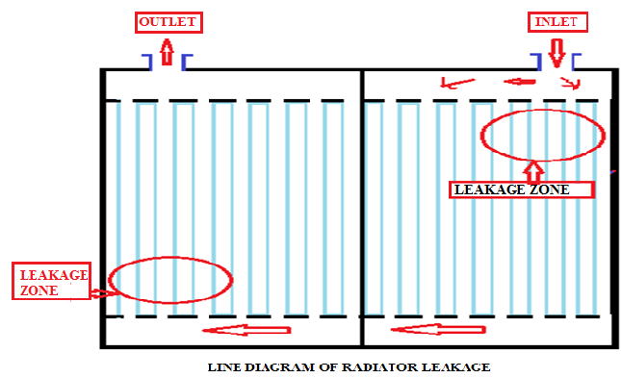

**REASONS FOR LEAKAGE**

The first and most important problem for leakage is the inlet pressure at inlet is more than what we required. As the engine is swiss made hence the climatic condition where the engine is design is much more different than where it is being used so the working temperature for radiator is high hence the leakages is occurring. Due to the increase in working temperature the density of transformer oil is varied. Hence it is increasing the impact pressure of oil on the fins which directly affecting the strength of the fins. Hence these are the major causes for the leakage in radiator.

**GRAPHS SHOWING THE CLIMATIC DIFFERENCE**

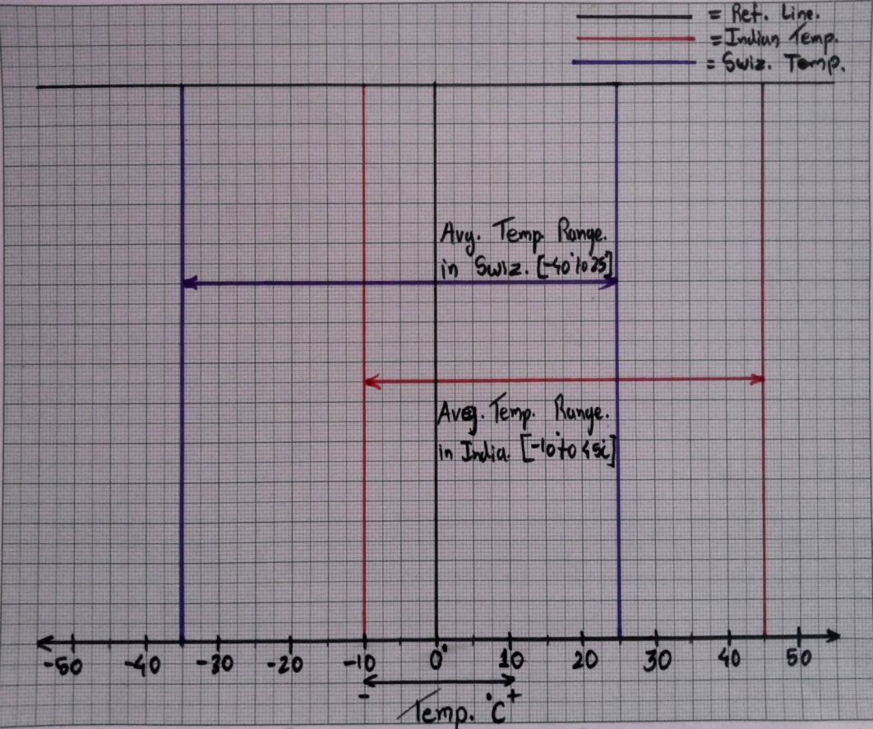

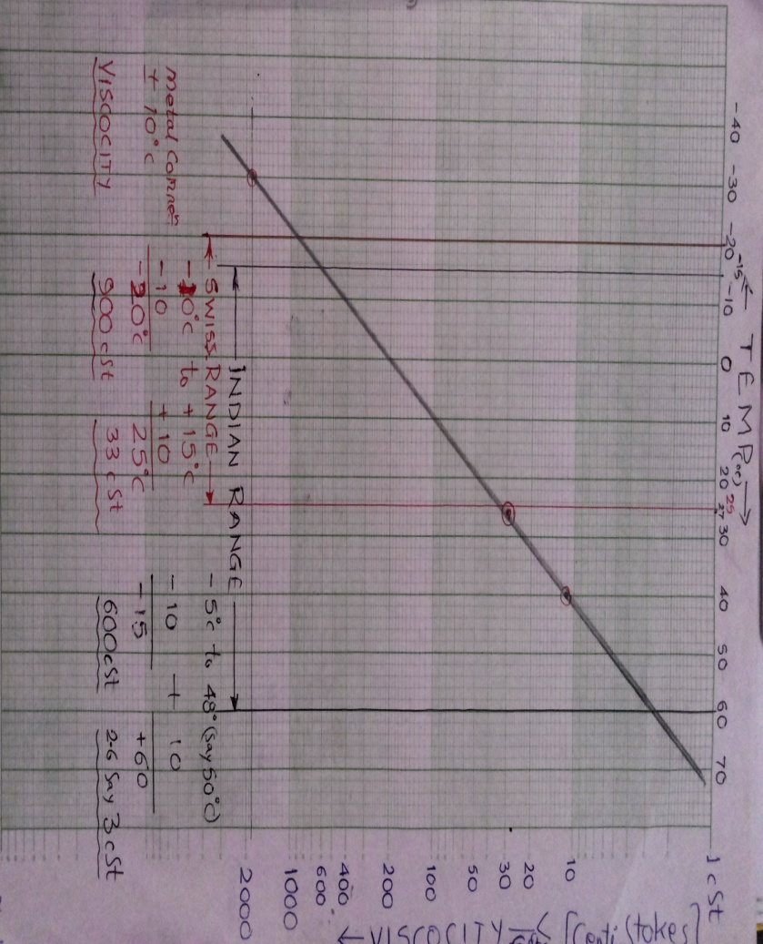

**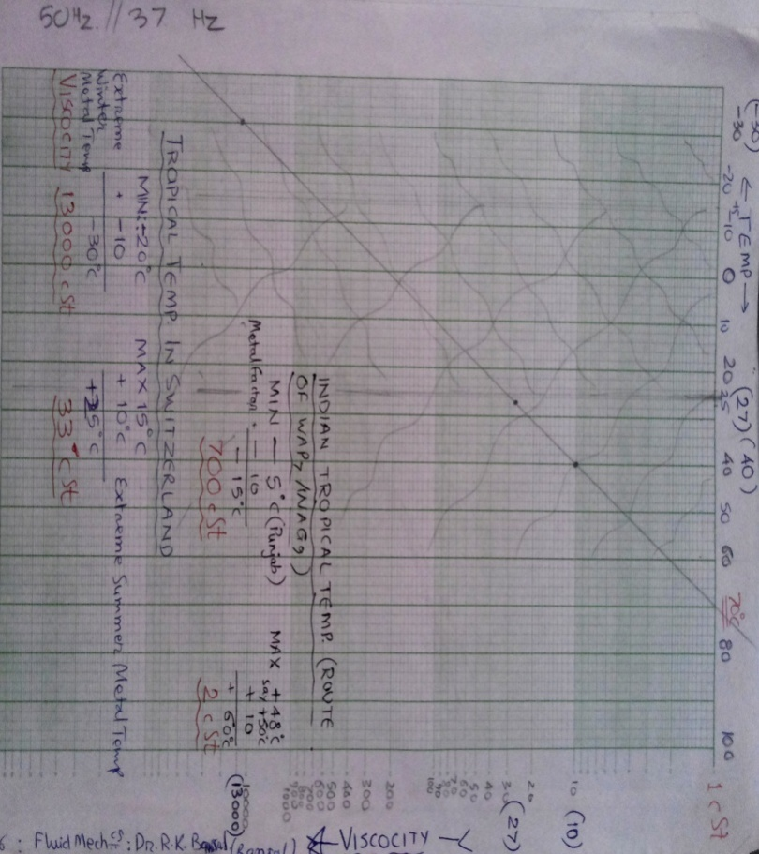  
 SECOND PROBLEM**

Keeping in view of Indian Tropical Conditions, especially in Summer, it has been observed that instead of cooling, this radiator outlet is either showing the same temperature or higher than at inlet. Some typical observations made in shed are as under-

|  |  |  |
| --- | --- | --- |
| MONTH | INLET TEMP ( In Degree Celsius ) | OUTLET TEMP ( In Degree Celsius) |
| JAN’ 13 | 33 | 33 |
| MAR’13 | 44 | 44 |
| MAY’13 | 54 | 57 |
| JULY’13 | 38 | 38 |

During loco tractive effort, the temp. rise will be much more high.

**REMEDY**

LONG TERM REMEDY :

So, after realising this problem, the design parameters were analysed and accordingly compared with the Annex. I. It is revealed that, these parameters are not favouring for a radiator but prone to be as for a heat regenerator.

Hence the matter may please be studied carefully & re-design, if necessary.

SHORT TERM REMEDY :

Statistics of failures of Equipment Temp. High due to oil overheating & Valve Set failures associated with MPH make wise, ( Ref. Annex. II), shows that the majority of the failures are belongs to the MPH of (i) Samal Harand (Modified) and, (ii) Flowell, & a very few or nil cases belongs to (iii) Plummetz & (iv) Samal Harand (Un-modified) . So, keeping in view of the % of pressure of MPH of failed locos, a benchmark of 50-52 % of pressure may be considered & accordingly necessary changes in software may please be carried out. Moreover, a change in minimum pressure value of 47 % may also please be reduced to 40 % accordingly.

This remedy will also reduce the Radiator leakages considerably.

**REFERENCES**

* V. Ganesan, “Internal combustion engines” reference 4th edition2012, pg.no 401
* R. K. Rajput, “Thermal Engineering” reference 8th edition2012 pg no.1518
* J. P. Yadav, “Study and performance Evaluation of Automotive Radiator”2011,vol 2,issue 2
* [www.wikipedia.com/radiator](http://www.wikipedia.com/radiator)
* [www.howstuffworks.com/locomotiveradiator](http://www.howstuffworks.com/locomotiveradiator)