HYDRAULIC HOSE TESTING BENCH

Nilesh Garghate
Department Of M. Tech. (M.E.D.)
K. D. K. College Of Engineering, Nagpur.
Nileshgarghate175@gmail.com +91 9503151475

ABSTRACT

In this world for lifting heavy load or doing any heavy work, we want to do it easier ,for that generally use hydraulic system, which are discussed in this paper, The using various mechanism, various types of oil, and hydraulic system. In this hydraulic system one of main part is hydraulic hoses. This hoses are break down at working area due to high pressure and other conditions. How does test the various hoses at different pressure and other conditions by using hydraulic hose test bench and how is working, all are discuss in this paper. In this system, the various equipment and different stages are involve.

This paper discuss the all about hydraulic hose testing bench and the various types of equipments and all the stages of testing bench and its working, its benefits to world, saving of money and time.

1. INTRODUCTION

Hydraulic systems can generally be broken down into two types of systems based upon the primary application. For example, on an earthmoving machine, the primary objective of the hydraulic system is to transmit power efficiently to the various circuits of the machine in an orderly fashion. On the other hand, a machine tool application is primarily concerned with speed, accuracy, and stability of the hydraulic systems. While every system is probably some compromise between these applications, due to space and time limitations, this paper will concentrate upon the hoses of the hydraulic system.

The hydraulic hose pipe test bench is capable to check the maximum pressure capacity of hose pipe. It required the some part that we have study in this parts in this paper.

2. HYDRAULIC SYSTEM

Hydraulics is the science of transmitting force and/or motion through the medium of a confined liquid. In a hydraulic device, power is transmitted by pushing on a confined liquid. The transfer of energy takes place because a quantity of liquid is subject to pressure.

Hydraulics is used to do work in the same way as a lever or gear does work. All of these systems transmit energy or force. Because energy cannot be created or destroyed, these systems only redirect energy to perform work and do not create more energy. Work is the amount of force applied and the distance over which it is applied. Force is power working against resistance; it is the amount of push or pull exerted on an object needed to cause motion. We usually measure force in the same units that we use to measure weight: pounds or kilograms. Pressure is the amount of force exerted onto a given surface area. Therefore, pressure equals the applied force (measured in pounds or kilograms) divided by the surface area (measured in square inches or square centimeters) that is receiving the force. In customary English units, pressure is measured in pounds per square inch (psi). In the metric system it can be measured in kilograms per square centimeter, but the preferred metric pressure measurement unit is the Pascal. The pressure of a liquid in a closed system such as a brake hydraulic system is the force exerted against the inner surface of its container, which is the surface of all the lines, hoses, valves, and pistons in the system. Pressure applied to a liquid exerts force equally in all directions. If the hydraulic pump provides 100 psi, there will be 100 pounds of force on every square inch of the system. When pressure is applied to a movable output piston, it creates output force. If the system included a piston with an area of 30 square inches, each square inch would receive 100 pounds of force. This means there would be 3,000 pounds of force applied to that piston. The use of the larger piston would give the system a mechanical advantage or increase in the force available to do work. The multiplication of force

Figure 1:- Fluid can transmit motion through a closed system.

through a hydraulic system is directly proportional to the difference in the piston sizes throughout the system. By changing the sizes of the pistons in a hydraulic system, force is multiplied, and as a result, low amounts of force are needed to move heavy objects. The mechanical advantage of a hydraulic system can be further increased by the use of levers to increase the force applied to a piston.

2.1 Hydraulic Pressure, Force, and Motion

Although the force available to do work is increased by using a larger piston in one cylinder, the total movement of the larger piston is less than that of the smaller one. When output force increases, output motion decreases. If the 10- square-inch input piston moves 2 inches as it applies 50 psi to the 100-square-inch output piston, that output piston will move only 0.2 inch as it applies 5000 pounds of output force .The ratio of input motion to output motion is the ratio of the input piston area to the output piston area, and you can use this simple equation to calculate it: The result from dividing the area of the input piston (A1) by the area of the output piston is multiplied by the stroke of the input piston or

(A1 ÷ A2) × S (the input stroke) = M (the output stroke) or
If the output piston is larger than the input piston, it exerts more force but travels a shorter distance. The opposite also is true. If the output piston is smaller than the input
piston, it exerts less force but travels a longer distance. Apply the equation to the 5-square-inch output piston in Figure

In this case, the smaller output piston applies only half the force of the input piston, but its stroke (motion) is twice as long. These relationships of force, pressure, and motion in a brake system are easily observed when you consider the force applied to the master cylinder’s pistons and the resulting brake force and piston movement at the wheels. Wheel cylinder pistons move only a fraction of an inch to apply hundreds of pounds of force to the brake shoes, but the wheel cylinder piston travel is quite a bit less than the movement of the master cylinder piston. Disc brake caliper pistons move only a few thousandths of an inch but apply great force to the brake rotors. This demonstrates how the use of hydraulics provides a mechanical advantage similar to that provided by the use
of levers or gears. Although hydraulic systems, gears, and levers can accomplish the same results, hydraulics is preferred when the size and shape of the system are of concern. In hydraulics, the force applied to one piston will transmit through the fluid, and the opposite piston will have the same force on it. The distance between the two pistons in a hydraulic system does not affect the force in a static system. Therefore, the force applied to one piston can be transmitted without change to another piston located somewhere else. A hydraulic system responds to the pressure or force applied to it. The mere presence of different-sized pistons does not always result in fluid power. The force or pressure applied to the pistons must be different in order to cause fluid power. If an equal amount of pressure is exerted onto both pistons in a system and both pistons are the same size, neither piston will move; the system is balanced or is at equilibrium. The pressure inside the hydraulic system is called static pressure because there is no fluid motion. When an unequal amount of pressure is exerted on the pistons, the piston receiving the least amount of pressure will move in response to the difference between the two pressures. Likewise, the fluid will move if the size of the two pistons is different and an equal amount of pressure is exerted on the pistons. The pressure of the fluid while it is in motion is called dynamic pressure.
Figure 2 :- As output force increases, output travel (motion) decreases.

3. HYDRAULIC HOSE TESTING BENCH

It is system based on hydraulics. In this system, the hydraulic hoses, cylinders and pumps can be check by using hydraulic hose testing bench. It required different types of hydraulic component and hydraulic fluid for its construction and working.

3.1 Different component In Hydraulic Hose Test Bench :-

- RESERVOIR
- PUMPS
- D.C.VALVES
- PR. CONTROL VALVES
- NON RETURN VALVES / CHECK VALVES
- FLOW CONTROL VALVES
- ACTUATORS
- ACCUMULATORS
- FILTERS

3.1.1 RESERVOIR:-

All hydraulic systems require a reservoir to store fluid and to provide a constant source of fluid for the system. A reservoir stores a liquid that is not being used in a hydraulic system. It also allows gases to expel and foreign matter to settle out from a liquid.
A rule of thumb is that a reservoir's size should be two to three times a pump's output per minute.

3.1.2 PUMPS:-

Hydraulic pump is heart of hydraulic system. Its to convert mechanical energy into hydraulic energy by pushing the hydraulic fluid into the system.

Pump is an energy conversion element, which receives energy form the prime mover (generally an electric motor or engine), and impart it to fluid. Most of hydraulic pump receive fluid form reservoir and pump it to loaded actuator to perform work.
It is of different types of pump generally used as follows
- Gear pump :- a) External gear pump
b) Internal gear pump

- Vane pump :- a) Constant displacement vane pump
b) Variable displacement vane pump

- Piston pump :- a) Radial piston pump
b) Axial piston pump

- Screw type pump
- Ball piston pump

3.1.3 CONTROL VAVLES:-

Control of fluid power is necessary to make the fluid power adaptor for use of consumer. The form of fluid power leaving the pump may not be the same as demanded by the consumer (cylinder or motor) hence, the control valves come into action to modulate the form of fluid power to make it applicable to the consumer.

It is of three types of control valves as follows
- Pressure control valve :- It maintain the desire level in the various parts of the circuit.
- Flow control valve :- It is used to regulate the floe of fluid in a hydraulic system.
- Direction control valve :- It is used to provide link between various parts of hydraulic system by means of connecting, disconnecting and changing flow direction, with such valves direction of pressure effect or the volumetric flow can be modified, consequently the operation of various consumer system (such as cylinder or hydraulic motors) can be control.

3.1.4 ACTUATOR:-

Hydraulic actuator also called consumers, are the element of hydraulic system, which transform the hydraulic energy into useful work. Hydraulic in its application is generally concerned with, moving gripping, lifting and rotating motions with force. Devices that actually achieve this objective called actuators.
It is of two types
- Linear actuator :-Linear actuator convert hydraulic energy into straight-line motion. They include various types of hydraulic cylinders.
- Rotary actuator :- rotary actuator converts hydraulic energy into rotational motion. They may further divided as limited rotation actuator and hydraulic motor. Limited rotary actuator transmit a part of full rotation, where as the hydraulic motors are the hydraulic equivalent of electric motors, which ,may be unidirectional or bi-directional.

3.1.5 ACCUMULATOR:-

The purpose of accumulator is to store hydraulic energy in the form of pressurized fluid. Provided by the pump, and later provided it to the system whenever needed. Accumulator are simple devices that store energy in the form of fluid under pressure. Because of there ability to store excess energy and release it when needed, accumulator are useful tool in developing efficient hydraulic system.
It is of three types
- Weight loaded accumulator
- Spring loaded accumulator
- Gas loaded accumulator

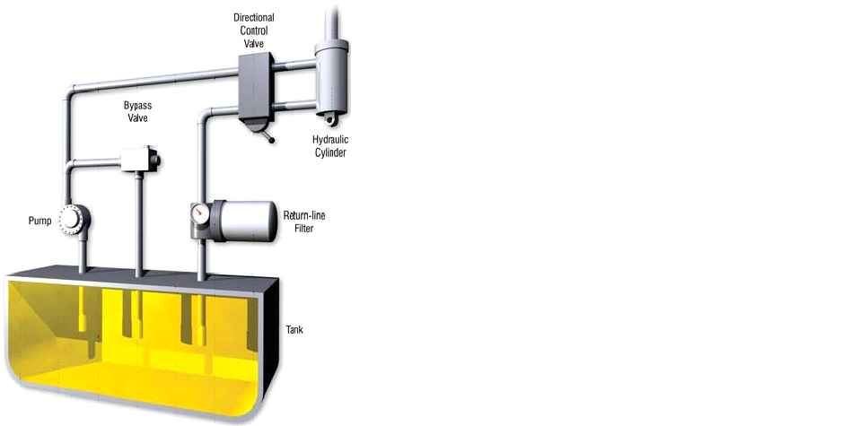
Figure 3:- Fig. shows all basic of component hydraulic system

3.1.6 FILTERS AND STRAINERS:-

Hydraulic filters and strainers are used to remove the contaminating particles from the hydraulic system. Filter are used to remove smallest particles of foreign matter from the hydraulic fluid. Large particles are remove from strainers. An ideal filter would be one, which would remove all foreign matter in the oil and yet permit the full volume of oil demanded by the pump to flow without any restriction, over a reasonable service period. This would ensure cavitationless pump performance over the expected service life.
It is of two types
- Surface type filter
- Depth type filter

4. ADVANTAGES AND BENIFITES:-

- It is more beneficial in coal mine and power plants.
- It reduces time.
- It save money.
- Indirectly increases production in coal mine.
- Minimum employee required.
- It can apply at the work area.
- It is easy to handle.
- Easy in working.
- It is safe for handling.
- Less skilled worker can operate easily.

5. CONCLUSION:-

The purpose of this paper was to discuss the development of hydraulic systems for machine tool applications. The costs of a development program have spiraled to a level where only the companies who can develop products effectively and efficiently will survive to do business in the future. In the past, hydraulic system development has meant that the system would be created from experience and knowledge. From the schematic it was necessary to procure or manufacture the components and assemble the system before any laboratory test could be conducted to either confirm or deny the excellence of the design. If the system performs satisfactorily, and incurs minimum costs the first time it is assembled, then there is nothing wrong with this design approach.

However, all too often the system does not perform the way it was intended or it costs far too much. Then the design must be altered and reassembled in order to determine if the alterations have succeeded in producing the optimum system. Companies can no longer afford such costly and time consuming practices.

The hydraulic system is known from long time and it is effective for heavy load. Hydraulic system required hoses to circulate fluid in the system in certain pressure, at high pressure and due changing environment conditions, the hoses get burst or fail, at that time company loss money and time also, for reducing that defect, before assembling hoses to the system that can be check into the hydraulic hose test bench and then assemble to the system.

REFFERENCES:-

1. Sameer Shaikh and Iliyas Khan, Hydraulic & Pneumatics Fluid power, R. K.
Publications.

2. E-Book, Basic Hydraulic system theory.

3. Dr. Ing T. Hong, P.E. , Dr. Richard K. Tessmann, P.E. “Computerized Design
Analysis of Machine Tool Hydraulic System Dynamics” An FES/BarDyne 1996,
Technology Transfer Publication, #11.

4. Dr. Richard K. Tessmann, P.E “Qualification of Hydraulic Fluid through Pump
Testin” An FES/BarDyne 1996, Technology Transfer Publication, #7.

5. A Textbook of “Hydraulic System Modeling and Simulation” by E. C. Fitch and I.T.
Hong.

