**DESIGN AND FABRICATION OF PEDAL OPERATED AIR COMPRESSOR FOR MULTI-PURPOSE APPLICATION**

Nehal.B.Shendea, ER.V.D.Dhopteb,

a Projectee Department of Electrical Engineering, KDKCE, Nagpur

b Professor Department of Electrical Engineering, KDKCE, Nagpur

**ABSTRACT**

Energy is the indivisible part of our living, with the even increasing the cost and decreasing sources of conventional energy like fossil fuels, finding the alternative non conventional energy sources is the need of present time. Apart of other renewable energy resources human power is one of the effective and alternative resources available since ancient time. The human being delivered their energy from calorific contains of foods they eat. A person can generate four times more power (1/4 HP) by pedalling than by hand cranking. At the rate of ¼ HP, continuous pedalling canbe done for only short periods, about 10 minutes. However, for around 60 minutes but power capability can be depend upon age [1-2]. A healthy male can only reliably maintain the high-power range of around (250 watts and above of mechanical power). The relation of human pedal power produced with respect to time is presented in Table-1 pedalling at half this power (1/8 HP) can be sustained.

INTRODUCTION

In this mechanism the conventional electric motor has been replaced by bicycle pedals which operates an piston cylinder mechanism to produce compressed air.This compressed air is used for multi-purpose operation.

Compressed air is widely used as a power source in industry, to power tools, in many types of conveyors, in manufacturing and converting processes , and in filtration, refrigeration, and aeration processes. Compressed air is often manufactured on site, while other utilities such as electricity, natural gas, and water are often purchased from outside the industrial facility. The cost of its production is often not clear. A common perception is that the compressed air is free. No. The using compressed air is about 10 times the cost of using another utility such as electricity, because of the inefficiencies of the motor and drive, the compressor itself, leaks in the system, air pressure reductions, and the inefficiencies of the device or process where the compressed air is applied.

The function of a compressor is to take a definite quantity of fluid (usually a gas, often air) and deliver it at a required pressure.

Reciprocating type -low mass flow rate and high pressure ratioRotary type –high mass rate but low pressure ratio. One of the factors used to designate compressor power is motor/drive engine horsepower. However, this isn't the best indicator. You really need to know the amount of air the compressor can deliver at a specific pressure

**LINE DIAGRAM**

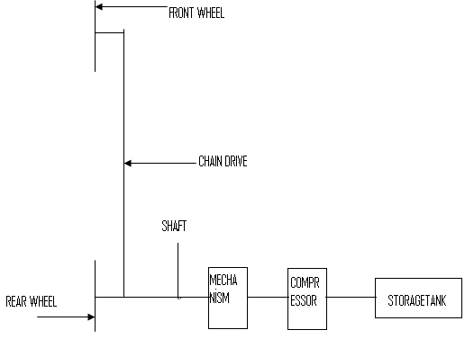

**Fig:- Line Diagram of Pedal Driven Compressor**

**CLASSIFICATION OF COMPRESSORS**

**Types of Compressors:-**



**Compressors can be classified in the following different ways**.

**(a) Based on principle of operation:**

Based on the principle of operation compressors can be classified as.

(i) Positive displacement compressor.

(ii) Non-positive displacement compressors.

In positive displacement compressors the compression is realized by displacement of solid boundary and preventing fluid by solid boundary from flowing back in the direction of pressure gradient. Due to solid wall displacement these are capable of providing quite large pressure ratios. Positive displacement compressors can be further classified based on the type of mechanism used for compression. These can be

(i) Reciprocating type positive displacement compressors

(ii) Rotary type positive displacement compressors.

Reciprocating compressors generally, employ piston-cylinder arrangement where displacement of piston in cylinder causes rise in pressure. Reciprocating compressors are capable of giving large pressure ratios but the mass handling capacity is limited or small.

Reciprocating compressors may also be single acting compressor or double acting compressor. Single acting compressor has one delivery stroke per revolution while in double acting there are two delivery strokes per revolution of crank shaft. Rotary compressors employing positive displacement have a rotary part whose boundary causes positive displacement of fluid and thereby compression. Rotary compressors of this type are available in the names as given below:

(i) Roots blower

(ii) Vane type compressors

Rotary compressors of above type are capable of running at higher speed and can handle large mass flow rate than reciprocating compressors of positive displacement type.

Non-positive displacement compressors, also called as steady flow compressors use dynamic action of solid boundary for realizing pressure rise. Here fluid is not contained in definite volume and subsequent volume reduction does not occur as in case of positive displacement compressors. Non-positive displacement compressor may be of ‘axial flow type’ or ‘centrifugal type’ depending upon type of flow in compressor.

**Based on number of stages:**

Compressors may also be classfied on the basis of number of stages. Generally, the number of stages depend upon the maximum delivery pressure.

Compressors can be single stage or multistage. Normally maximum compression ratio of 5 is realized in single stage compressors. For compression ratio more than 5 the multistage compressors are used.

Type values of maximum delivery pressures generally available from different type of compressor are,

(i) Single stage Compressor, for delivery pressure upto 5 bar.

(ii) Two stage Compressor, for delivery pressure between 5 to 35 bar

(iii) Three stage Compressor, for delivery pressure between 35 to 85 bar.

(iv) Four stage compressor, for delivery pressure more than 85 bar

**(c) Based on Capacity of compressors :**

Compressors can also be classified depending upon the capacity of Compressor or air delivered per unit time. Typical values of capacity for different compressors are given as;

(i) Low capacity compressors, having air delivery capacity of 0.15 m3/s or less

(ii) Medium capacity compressors, having air delivery capacity between 0.15 to 5 m3/s.

(iii) High capacity compressors, having air delivery capacity more than 5 m3/s

**(d) Based on highest pressure developed:**

Depending upon the maximum pressure available from compressor they can be classified as low pressure, medium pressure, high pressure and super high pressure compressors. Typical values of maximum pressure developed for different compressors are as under:

(i) Low pressure compressor, having maximum pressure up to 1 bar

(ii) Medium pressure compressor, having maximum pressure from 1 bar to 8 bar

(iii) High pressure compressor, having maximum pressure from 8 to 10 bar

(iv) Super high pressure compressor, having maximum pressure more than 10 bar.

**RECIPROCATING COMPRESSORL:**

Reciprocating Compressor has piston cylinder arrangement as shown

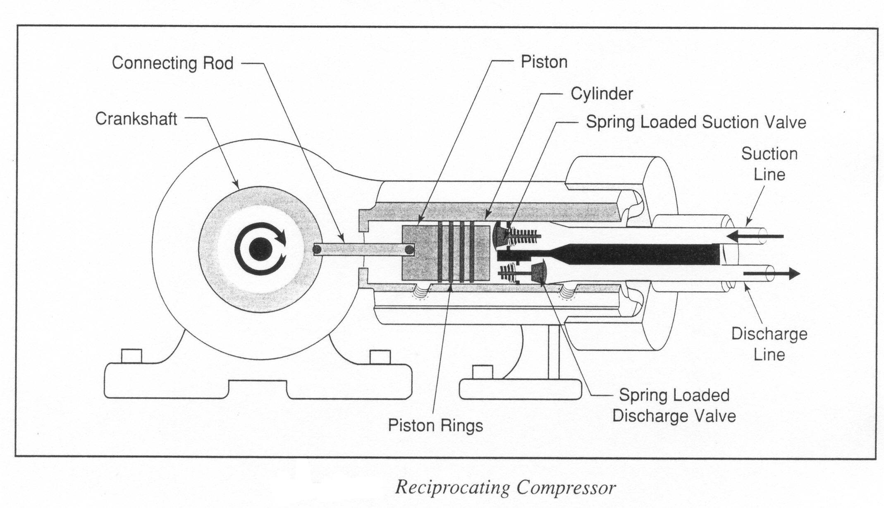

**Reciprocating Compressor**

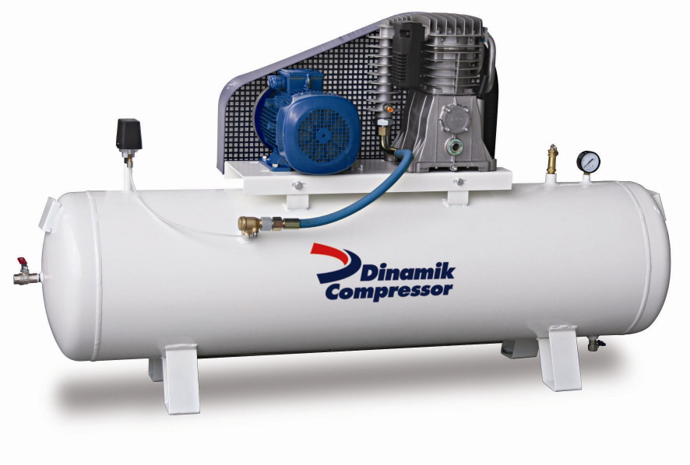

Reciprocating Compressor has piston, cylinder, inlet valve, exit valve, connecting rod, crank, piston pin, crank pin and crank shaft. Inlet valve and exit valves may be of spring loaded type which get opened and closed due to pressure differential across them. Let us consider piston to be at top dead centre (TDC) and move towards bottom dead centre (BDC). Due to this piston movement from TDC to BDC suction pressure is created causing opening of inlet valve. With this opening of inlet valve and suction pressure the atmospheric air enters the cylinder.

Air gets into cylinder during this stroke and is subsequently compressed in next stroke with both inlet valve and exit valve closed.

Both inlet valve and exit valves are of plate type and spring loaded so as to operate automatically as and when sufficient pressure difference is available to cause deflection in spring of valve plates to open them. After piston reaching BDC it reverses its motion and compresses the air inducted in previous stroke. Compression is continued till the pressure of air inside becomes sufficient to cause deflection in exit valve.

At the moment when exit valve plate gets lifted the exhaust of compressed air takes place. This piston again reaches TDC from where downward piston movement is again accompanied by suction. This is how reciprocating compressor. Keeps on working as flow device. In order to counter for the heating of piston-cylinder arrangement during compression the provision of cooling the cylinder is there in the form of cooling jackets in the body. Reciprocating compressor described above has suction, compression and discharge as three prominent processes getting completed in two strokes of piston or one revolution of crank shaft.



**APPLICATION:-**

1. AS ELECTRICITY SAVING DEVICE
2. FOR INFLATING THE AIR IN VEHICLE TUBES
3. FOR SPRAY PAINTING
4. FOR CLEANING PURPOSE
5. FOR BLOW PERPOSE

**ADVANTAGES**

1. NO NEED OF ELECTRICITY
2. COMPARATIVELY LESS IN OPERATIONAL COST
3. PORTABALITY
4. VERSATILE
5. COMPRESSIBILITY

CONCLUSION

The flexibility of Compressed air is more than any . Full capacity is available just few minutes after start-up. In this mechanism the conventional electric motor has been replaced by bicycle pedals which operates an piston cylinder mechanism to produce compressed air.This compressed air is used for multi-purpose operation. also on the demand side.

**REFERENCES**

1. S.G.Bahaley, Dr.A.U.Awate, S.V.Saharkar[“Performance Analysis of Pedal Powered Multipurpose Machine”[2],](Research%20papers/combo%20pedal%202.pdf) International Journal of Engineering Research & Technology (IJERT), ISSN: 2278-018,Vol. 1 Issue 5, July - 2012
2. Bílek, O.; Lukovics, I. Finite Element Model of Dynamics with in Highspeed Grinding Process. // Academic Journal of Manufacturing Engineering, 2009 , 6-11. ISSN 1583-7904.
3. Ivandic, Z.; Ergic, T.; Kljajin, M. Welding robots kinematic structures evaluation of based on conceptual models using the potential method. // Tehnicki Vjesnik-Technical Gazette, 16, 4(2009), pp 35-45.
4. Ergic, T.; Ivandic, Z. Ultra-light telescopic crane/platform mechanisms feature analysis. // Tehnicki Vjesnik-Technical Gazette, 16, 4(2009), pp. 87-91
5. Rao, J. S.; Dukkipati, R. V. Mechanism and Machine Theory. / New Age International Ltd. Publisher, (1992), 22-71. ISBN 81-224-0426-X
6. David Gordon Wilson “UNDERSTANDING PEDAL POWER” ISBN: 0-86619-268-9 [C] 1986, Volunteers in Technical Assistance” Technical paper 51 VITA 1600 Wilson
7. Boulevard USA.
8. EJ Yerxa Taylor & Francis “Occupational science: A new source of power for participants in occupational therapy‟-Journal of Occupational Science ISSN 1442-7591 Volume: 13, Issue: 1, April 1993 pp254-259.
9. Jon Leary “Putting Research into Practice: From a Steel City Drawing Board to the Heart of the Maya” The University of Sheffield-EWB-UK National Research Conference 2010,19