**DESIGN & FABRICATION OF HYBRID TORQUE BICYCLE (FLYWHEEL BICYCLE)**

Gagandeep Singh Multani, Abhishek Kukundkar, Amit Dhande

Instructor :- Prof. P. R. Gajhbhiye1 and Er. N. R. Meshram2

1Professor, 2Assistant Prof.

Department Of Mechanical Engineering

KDK College of Engineering, RTM Nagpur University, Nagpur, India

1. **ABSTRACT**:

A flywheel is an inertial energy-storage device. It absorbs mechanical energy and serves as a reservoir, storing energy during the period when the supply of energy is more than the requirement and releases it during the period when the requirement of energy is more than the supply.A flywheel is a rotating mechanical element which is used to store energy of rotational form. Flywheels have aconsiderable moment of inertia, & thus it resist changes in rotational speed.

*“Kinetic energy is roughly equal to mass times velocity squared. So doubling mass doubles energy storage, but doubling the rotational speed quadruples energy storage.”*

The implication of this statement is that high speed flywheels are superior to low speed designs. The truth is that this statement misses several important facts about the physical limitations faced by flywheel designers and is thus not sufficient for even the most basic comparison of flywheel designs.

The above statement is based on the equations for energy storage of a body of mass (m) which is moving in a straight line with a velocity (v).

E= ½ mV2

We are planning for that, the amount of energy from the bicycle when the rider needs to slow down. The energy stored in the flywheel can be used to bring the cyclist back up to cruising speed. In this way the cyclist recovers the energy normally lost during braking. In addition to increased energy efficiency, the flywheel-equipped bicycle is more fun to ride since the rider has the ability to boost speed. The flywheel bicycle model is shown in figure 1. For transmitting the from rear wheel to flywheel we are using a larger sprocket and various mechanisms like chain and sprocket, Ratchet and Pawl mechanism, clutch etc.



Fig. 1- KERS BICYCLE

1. **INTRODUCTION**:

Before discussing the any about the kinetic energy recovery system we have first discussed and understand the various types of kinetic energy recovery system existing today. There are following types of recovery system generally mostly used today,

1. Mechanical Energy Recovery System
2. Electrical Energy Recovery System

These are three basic energy recovery systems we are used today’s days.

1. Mechanical Kinetic Energy Recovery System (MKERS):

Now a days the Mechanical type KERS now implemented to most of SUV’s. The power produced by the engine or vehicles is losses whilebreaking, this power is recovered by applying other accessories with the engine, and via some energy storing devices these powers is recovered mechanically.Our KERS bicycle is works on this MKERS principle.

1. Electrical Kinetic Energy Recovery System(EKERS):

This Kinetic Energy Recovery System is a mechanical type of energy recovery system which mainly recovers the mechanical energy. The energy is recovered by using the energy storing devices such as the *Flywheel*. The main difference between them is in the way they convert the energy and how that energy is stored within the vehicle. Battery-based electric KERS systems require a number of energy conversions each with corresponding efficiency losses. On reapplication of the energy to the driveline, the global energy conversion efficiency is 31–34%.

In this System we are recover the Heat Energy in the form of Electrical energy by using mechanical energy generated by engine while deceleration. Deceleration Energy Recovery system is a technology that charges the vehicle batteries in a concentrated manner using the electrical power generated when the vehicle decelerates, enabling a reduction in electrical power generation in different driving conditions such as idling, acceleration, cruise, etc. This approach has the effect of reducing the load on the engine, improving fuel economy, and reducing CO².

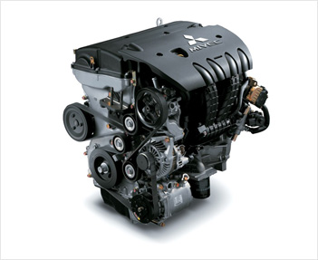

Fig. 2 Thermal Energy Recovery System

The process of HRES is shown in the block diagram in the figure 3.

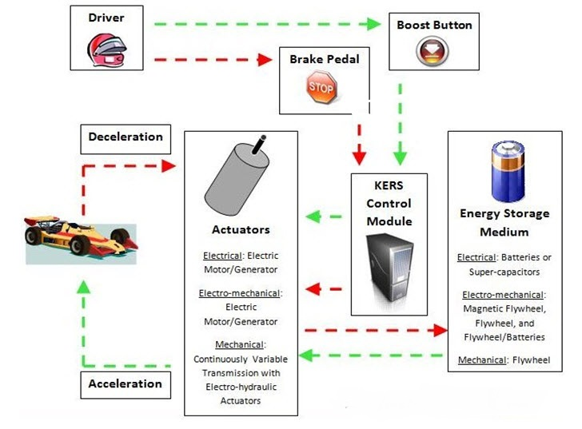

Fig. 3 Block Dig. Of Electrical KERS

1. **MOTIVATION:**

In 2011, Maxwell von Stein, a student at Cooper Union, added a flywheel and a continuously variable transmission to his bike for his senior project.1 He used a car flywheel he found that weighs 15 pounds. His idea won him the Nicholas Stefano Prize, which is Cooper Union’s award for superior mechanical engineering design. He also gained quite a bit of notoriety on various biking websites and was featured in NPR’s weekly segment, “Science Friday.”2 This idea of adding a flywheel to a bicycle is very appealing because it can increase the efficiency of what is already considered a very efficient machine. The only concern with Mr. von Stein’s design is that his flywheel is very heavy. It was made for a car, so an extra 15 pounds would hardly be significant in such a heavy vehicle. However, when 15 pounds are added to a bike it makes a significant difference in the additional work it takes to accelerate the bike. Mr. von Stein estimated that the additional weight adds about10% more weight to the system, and he also estimated the peak efficiency gain from his flywheel is 10%. This means at its peak, the flywheel is only making up for the efficiency lost by its additional weight. If the flywheel was optimized for the different design requirements of a bike, it could increase the efficiency of a bike in more significantly.



Fig. 4Maxwell von Stein’s Flywheel bicycle

A flywheel can temporarily store the kinetic energy from the bicycle when the rider needs to slow down. The energystored in the flywheel can be used to bring the cyclist back up to cruising speed. In this way the cyclist recovers theenergy normally lost during braking. In addition to increased energy efficiency, the flywheel-equipped bicycle is morefun to ride since the rider has the ability to boost speed. The flywheel bicycle model is shown in figure 4.

1. **KERS BICYCLE WORKING:**

While breaking the cycle the whole kinetic energy is losses in the form of heat and friction. Either applying breaks we are using here clutch mechanism. When we applying the clutch the energy from the rear wheel is transmitted to the flywheel via chain and sprocket mechanism, due to this the flywheel charged and starts rotating and cycle being slow down.When we want to boost our cycle we again applying a clutch and then the energy of flywheel is again transmitted via clutch mechanism.

1. **TRANSMISSIONS:**

In the case of the bicycle chains and sprockets are used to deliver the power from the crank to the back wheel. The relative size of the sprockets will determine how quickly the wheels spin relative to the crank. Chain drive is also used to transmit power between the flywheel and the bicycle. In Mr. von Stein’s flywheel bicycle, he used a continuously variable transmission to connect the crank.1 A continuously variable transmission is a device that changes the radius the chain rests on to continuously change the gear ratio. This allows the rider to shift the transmission from allowing the crank to spin quickly to allowing the flywheel to spin quickly. The mathematics of the gear ratio will be discussed in the next section. A variable transmission would suffice for the purposes of the flywheel. This would mean the flywheel has a fixed number of gear ratios it can switch between, much like bicycles that have more than one speed. The premise for a variable transmission is still the same as it is for the continuously variable; the gear ratio will switch between the crank spinning quickly and the flywheel spinning quickly. The design of the transmission is the limiting factor for the speed of the flywheel, and will largely determine how efficient the flywheel system is. Inefficiencies in the transmission as well as speed and torque limitations caused by the transmission will by and large outweigh any theoretical limitations of the flywheel.

1. **DESIGN REQUIREMENT:**

To design the prototype of our project we are considering the following design aspects,

* **Storing of Energy at the time of breaking**

This is the main objective and 1st need of rider and whole attention is focussed to satisfy this need.

* **Energy Recovery**

The system is works in such a way that it enables to recover the energy to start up device again. So transmission system should be capable to doing this task. Hence we are using here chain drive to do this task.

* **Compact and able to fit**

We are dealing with such confined spacing within the bicycle, hence our whole attention is on that point that whole accessories along with flywheel able to fit on such confined space.

* **Light Weight and Effective**

Our whole prototype must be light weight and portable and able to store the much more amount of energy within flywheel.

* **Good Stopping Range**

The stopping range is important because this product needs to be usable in real life situations. This component

can be optimized to have the shortest stopping distance using dynamic analysis.

* **Good stopping force**

The force required to stop is dependent on the stopping range and the comfort levels of the rider. It is alsorelated to the possible flywheel features.

* **Inexpensive and affordable**

Product must be profitable and affordable.

* **Safe And Eco-friendly**

Product must be eco-friendly and safe to use.

* **Economical**

The product economical and the products for this design must be cheaply available.

* **Reliable**

The product should be reliable and easy to used and work normally as work before the cycling process.

* **Manufacturability**

The tool should be easy to manufacture and economical to produce with a low cost.

• **Aesthetically pleasing**

The product should have an attractive and pleasant look because looks will persuade the rider.

* **Modular**

Having a device that can be adapted to existing bicycles is essential to be added to the existing ones so that it’seasier to adopt. This also can reduce other types of manufacturing costs.

**• Should not hinder normal riding**

To have a successful accessory for a bicycle, the ride should not feel a noticeable change in the riding performance or in the normal riding motion. A device that impedes the normal riding experience would be considered undesirable.

* ** Controlled release**

The energy that is released back to the user must be done in a safe and manageable fashion. This can be aconsideration after the prototype is completed.

1. **FABRICATION PROCESS**
2. *Frame Modification*

It is the first step in the fabrication process. The frame has to be modified by adding steel tube. One end has to be welded at the handle end and the other at the rear wheel centre. The frame should have enough strength so as to carry the flywheel and the additional forces that comes to play. The modification should not hinder normal riding. Also the modified frame should have enough space in order to accommodate flywheel and clutch assemblies. This is shown in figure 5 below.

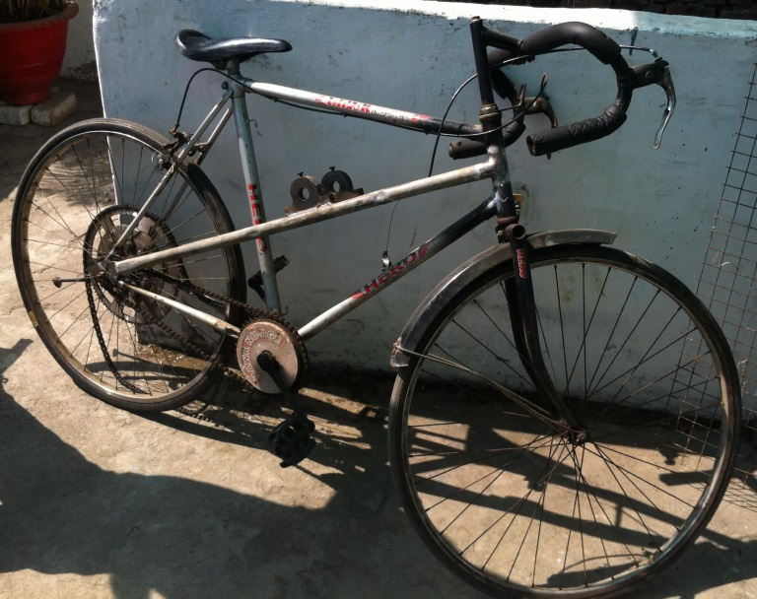

Fig. 5 Frame Modified

1. *Flywheel*

The flywheel has to be bored centrally in order to place a ball bearing so that flywheel can rotate over the axle. Also flywheel has to be selected so that the selected weight does not affect the bicycle physics and riding performance of the rider. The performance of KERS system mainly depends upon the flywheel selection. For clutch accessories there should be provisions in the flywheel which is used to deliver and release energy from flywheel. The works done on flywheel is shown in figure 6 below.

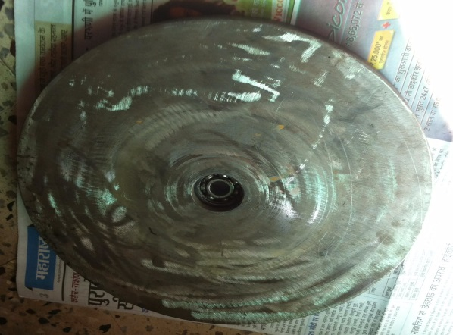

Fig. 6 Flywheel

1. ***Clutch***

A clutch has to be provided so as to control the power delivery and release from the flywheel. This can be achieved byproviding a clutch plate that is linearly moved to and fro by applying a lever mechanism incorporated with a springassembly for providing return mechanism. Linear clutch movements have to be made possible. For this purpose twocylindrical rods can be used. One end of the each rod was variably cut. This variable length is female part of another.One part of this is fixed near the frame side. This can be achieved by welding the part. Another part is made rotatory.This part can be rotated by applying force on it from lever via cable. This moves only partially over fixed one andfirstly this is hold in position by a spring arrangement.

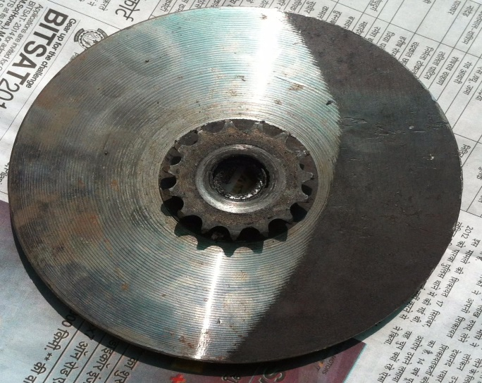

Fig. 8 clutch with smaller sprocket

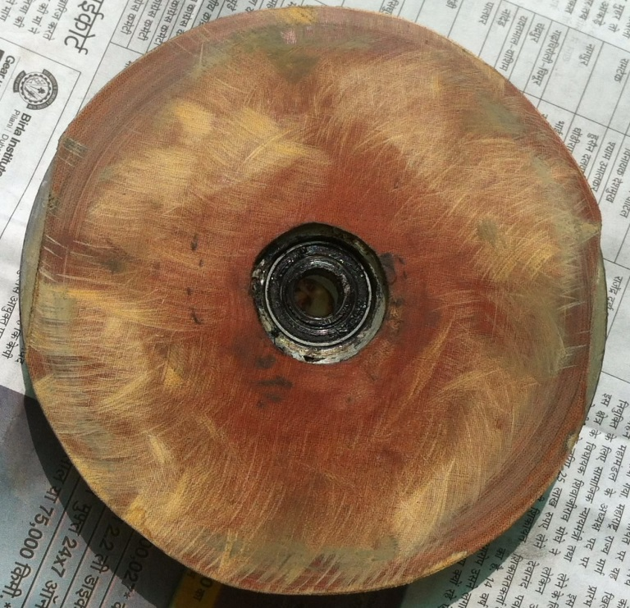

Fig. 9 Friction plate

1. ***Axle***

The axle has to be made so as to carry the flywheel and clutch units. The flywheel can be inserted after bearing is added to it and if variable diameter is provided on axle within mid-point the flywheel can be made to be inserted from one end and it automatically locks in the middle of the axle over which it rotates. Also the clutch units sequentially clutch plate and the fixed and moving rods along with its mechanism can be mounted over the axle. The provision for axle placement is provided in the modified frame. The axle should withstand the forces coming to play.

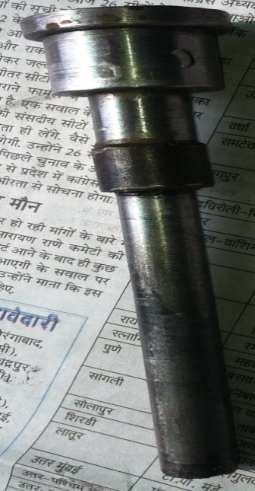

Fig. 9 Axle

1. ***Sprocket***

Two sprockets have to be used. The gear ratio is to be taken in to account here. One sprocket with higher number of teeth is to be selected and other having lesser number of teeth. The larger sprocket is to be placed at the rear wheel end and smaller sprocket at the axle end. This is to ensure that we can provide larger flywheel rotations so that energy storage increases.

The following flow chart showings the steps involved in fabrication process.

Fig. 5 Fabrication flowchart

1. **THEORY OF CALCULATION**
2. ***Rotational Energy***

The energy stored in a flywheel is its rotational kinetic energy,

$E_{k}=\frac{1}{2}Iꙍ^{2}$……. (1)

Where,

“I” is the moment of inertia

“ω” is the rotational velocity (rpm)

Moment of inertia,

**I**=𝑘𝑚𝑟2…… (2)

Where,

“k” is inertial constant (depends on shape)

“m” is mass of the disc

“r” is the radius

$E_{k}=\frac{1}{2}kmr^{2}ꙍ^{2}$…… (3)

1. **RESULT AND ANALYSIS**

The flywheel bicycle increases efficiency on rides where the rider slows often. The additional weight is outweighed by the ability to recover energy normally lost during braking. Thus the addition of extra weight does not make it difficult for the rider. Also clutch provided helps in deciding the time period of activity. The overall result is that KERS system is efficient in storing the energy normally lost in braking and returns it for boosting.

1. **Weight And Performance**

Normally energy stored in the flywheel is directly proportional to the weight and radius. Hence increase in weightproves to improve the performance. But as we know that the maximum safe weight that can be used is limited due toframe properties and rider compatibility. And also after some extent the radius can’t be increased and the energystorage thus seems to be limited to some particular extend. This is also because of the fact that the total running speedis being reduced due to weight. Energy storage capacity increases with increase in weight but limitation seems to be thespeed driving the flywheel. And performance of system is directly linked with the energy stored. Thus a graph can beplotted between performance and weight. Optimum value lies between 5 and 8 kg.

Thus from equation (3)Ekis directly proportional to the mass of the disc. The flywheel and transmission add weight to the bicycle. The increased weight will add to the energy required toaccelerate the bicycle and to ride it uphill. However, once the rider has provided the energy to reach a cruising speed,the flywheel reduces the energy cost of slowing down from this speed since it aids in subsequent acceleration. Roadsare optimal environment for the flywheel bicycle because it’s flat and there are lots of reasons for the cyclist to slowdown. The performance versus weight graph is shown in figure 6 and the comparison of weight of ordinary andflywheel bicycle is shown in figure 7 below.



Fig.6 Performance versus Weight



Fig. 7 Weight Comparison between Flywheel Bicycle And Conventional Bicycle

**B. Comparison Analysis**

Comparison is made between conventional bicycle and the KERS bicycle. The major things looked up was velocity,kinetic energy and pedal power input. The velocities of both seemed to be similar but the distance covered by flywheelis somewhat greater. A graph velocity versus time between both bicycles can be plotted. Next is the kinetic energytaken in to account. The flywheel has an extra kinetic energy that is being stored and hence from conventional bicycleflywheel bicycle is having an additional kinetic energy of flywheel. Graph connecting kinetic energy and time can beplotted. Now pedal power is taken to account. The flywheel bicycle has additional acceleration that is being boosted upby the flywheel acceleration. Hence conventional bicycle pedaling power can be achieved by less effort in case offlywheel bicycle. A graph can for pedal power input versus time.

A side-by-side comparison, shown in figure, of the flywheel bicycle and a conventional bicycle during a ride cycleillustrates how the flywheel bicycle saves energy. Once at cruising speed the riders of both bikes reduce speedtemporarily and return to the cruising speed three times before coming to a stop. This frequent deceleration andacceleration is typical of a rider riding through red lights where he/she must slow for crossing traffic. Duringdeceleration, the rider on the conventional bicycle applies the brakes to reduce speed, while the rider on the flywheelbicycle shifts the transmission to charge the flywheel. In both deceleration stages, the kinetic energy of the bike isreduced, but on the flywheel bike, the energy is transferred to the flywheel. The pedal power input is plotted for bothriders. Both input pedal power to overcome the same drag force, shown in blue. In order to return to cruising speed,the rider on the conventional bike needs to input pedal power to accelerate, shown in green. However the rider on theflywheel bike can transfer energy from the flywheel back to the bike by shifting the transmission to boost the bike. Therider of the flywheel bike doesn’t need pedal power to accelerate! The sum of the drag and acceleration power isshown in grey. The area of this sum of pedal power input is the total pedal energy input since energy is the integral ofpower over time. Hence, the rider on the flywheel bicycle uses less energy than the rider on the conventional bike. Thisis depicted in figure 8 below.



Fig. 8 Ride Cycle comparison between flywheel bicycle and conventional bicycle

**C. Overdrive Test**

This test was carried out to find out how much pedalling power can be saved by having KERS bicycle. This was doneby riding the bicycle on a slope and initial pedalling was given same and noted down the distance at which the bicyclestops when flywheel is not being connected. Then taken 10 m back point from the stopping distance. The experimentwas again done by riding cycle with flywheel coupled from 10 m side and noted down the extra distance that wascovered by the bicycle. The result was tabulated. The values reveal a total gain in energy of about nearly 10 per cent.Thus flywheel bicycles can help in reducing the overall pedalling power by 10 per cent used in overdrives.

**CONCLUSION**

KERS system used in the vehicles satisfies the purpose of saving a part of the energy lost during braking. Also it can beoperated at high temperature range and are efficient as compared to conventional braking system. The results fromsome of the test conducted show that around 30% of the energy delivered can be recovered by the system. KERSsystem has a wide scope for further development and the energy savings. The use of more efficient systems could lead

to huge savings in the economy of any country. Here we are concluding that the topic KERS got a wide scope inengineering field to minimize the energy loss. As now a day’s energy conservation is very necessary thing. Here weimplemented KERS system in a bicycle with an engaging and disengaging clutch mechanism for gaining much moreefficiency. As many mating parts is present large amount of friction loss is found in this system which can be improved.Boost is reduced because of friction. Continuously variable transmission can be implemented to this system whichwould prove in drastic improvement in energy transmissions.

REFERENCES

[1] Siddharth K. Patil., “Regenerative Braking System in Automobiles”, International Journal of Research in Mechanical Engineering&Technology vol.2, pp.45-46,2012.

[2] Chibulka.J.,“Kinetic Energy Recovery System by means of Flywheel Energy Storage”, Advanced Engineering Vol. 3,No. 1, pp. 27-38,1998.

[3] S.J.Clegg, “A Review of Regenerative Braking System”, Institute of Transport Studies, University of Leeds, Working paper of 471, 1996.

[4] SaharatChanthanumataporn, SarawutLerspalungsanti and MonsakPimsarn, “Design of Regenerative Braking System for an electric vehiclemodified from used car”, Second TSME International Conference on Mechanical Engineering, 19-21 Oct, 2011.

[5] Dr.IqbalHusain, “Electric and hybrid Vehicles: DesignFundamentals”, CRC press, Taylor and Francis Group, USA,2012.

[6] Gao, Y., Chen , L., Ehsani, M.,“Investigation of theEffectiveness of Regenerative Braking for EV and HEV”,SAE Paper 1999-01-2910,1999.

[7] John M. Miller , “Propulsion Systems for Hybrid Vehicles”, Institute of Electrical Engineers, UK,2004.

[8] Chen, J-X , Jiang, J-Z. Wang, X-J.,“Research of Energy Regeneration Technology in Electric Vehicle”, Shanghai University Press, Vol. 7, No2, pp.25-36,2008.

[9] Papalambros, P.Y., and D.J. Wilde , “Principles of Optimal Design”, 2nd Ed. Cambridge University Press, New Your, NY,2010.

[10] http://whizzards-magazine.blogspot.com/2011/08/flywheel-bicycle-with-regenerative.html

[11]http://www.sciencefriday.com/video/08/12/2011/boost-your-bike.html

[12]Genta, G., *Flywheel Energy Storage: Theory and Practice of Advanced Flywheel Systems*, Cambridge, England, Butterworth & Co., 1985

[13]Caprio M., Murphy B., Herbst J, “Spin Commissioning and Drop Tests of a 1300kW-hr Composite Flywheel”, Austin, Texas, Ninth International Symposium on Magnetic Bearings, 2004

[14] Monroe, Tom, *Clutch & Flywheel Handbook*, Tuscon, AZ, H.P. Books, 1977

[15] Formula1.com

[16]http://www.williamshybridpower.com/technology/the_flywheel/

[17] “Reinventing the Wheel”, *The Economist”*, Dec. 2011 (no cited author)

[18] Taylor, John, *Classical Mechanics*, University Science Books, 2005

[19] “Allowable Stress and Factor of Safety”, University of Maryland lectures, http://arch.umd.edu/Tech/Tech_II/Lectures/Allowable%20Stress%20&%20Factor%20of%20Safety.pdf

[20] Giles, J.G., *Gears and Transmissions*, London, England, Iliffe Books, 1969

[21] Jones, David, “The Stability of the Bicycle”, American Institute of Physics, *Physics Today 23*, 1970

[22] Shigley, Joseph, Mitchell, Larry, *Mechanical Engineering Design*, fourth edition, New York, NY, McGraw-Hill Book Company, 1983

[23]“Elastic Properties and Young’s Modulus for Some Materials”, *Engineer’s Toolbox*, 2011

