**TITLE OF PAPER**

**“DESIGN AND FABRICATION OF AMPHIBIOUS VEHICLE”**

**GUIDED BY:- Dr.A.V.VANALKAR**

**PRESENTED BY**

**Er. KHEMHAND M. KAPGATE, Er.TUSHAR S. MANE**

**ABSTRACT**

The project “Design and Fabrication of Amphibious Vehicle” is about human powered vehicle which is capable of meeting the ever increasing fuel demands and exercise requirements which is the prime need in today’s world. The amphibious name reflects the ability to survive on both land and water. It is a vehicle which does not need electricity or fuel. It is designed to run on land as well as to float on water. The main requirement of this vehicle is human power given through the sprocket-chain system.

The propeller is used to move it forward in water. In order to gain stability and low centre of gravity in front of turbine three wheels cycle design was chosen. To give a comfortable seating position to the rider the “Recumbent” frame design is selected. The materials used for the project are wood, mild steel and Thermocol. For safety purpose, high ground clearance is given to the model.

Every aspect of design, fabrication and safety has been discussed and studied. The small scale static model has been fabricated to get the details of the factors responsible for the improper working of this model.

For braking on land conventional “ANCHOR” brake is used while for braking on water reverse pedaling is used.

The Thermocol is stacked with the help of wooden framing and is wrapped in plastic sheet.

Thorough and complete analysis is done keeping the various input and output parameter is presented in form of tables and figures and graph. Constant endeavors had been made to accomplish increased efficiency based on analysis of details obtained.

**INTRODUCTION**

The aim was to build a bike that could go in both land and water, with changeover in between. This means that the bike should be able to be cycled on the road, down the slipway and onto the water, without having a lengthy stop in-between and move any buoyancy aids.

An amphibious vehicle (or simply amphibian), is a [vehicle](http://en.wikipedia.org/wiki/Vehicle) or [craft](http://en.wikipedia.org/wiki/Craft_(vehicle)), that is means of transport, viable on land as well as on water – just like an [amphibian](http://en.wikipedia.org/wiki/Amphibian).

This definition applies equally to any land and water transport, small or large, powered or unpowered, ranging from amphibious [bicycles](http://en.wikipedia.org/wiki/Bicycle), [ATVs](http://en.wikipedia.org/wiki/All-terrain_vehicle), [cars](http://en.wikipedia.org/wiki/Automobile), [buses](http://en.wikipedia.org/wiki/Bus), [trucks](http://en.wikipedia.org/wiki/Truck), [RVs](http://en.wikipedia.org/wiki/Recreational_vehicle), and [military vehicles](http://en.wikipedia.org/wiki/Military_vehicle), all the way to the very largest [hovercraft](http://en.wikipedia.org/wiki/Hovercraft). Classic [landing craft](http://en.wikipedia.org/wiki/Landing_craft) are generally not considered amphibious vehicles, although they are part of [amphibious assault](http://en.wikipedia.org/wiki/Amphibious_assault).

Nor are [Ground effect vehicles](http://en.wikipedia.org/wiki/Ground_effect_vehicle), such as [Ekranoplans](http://en.wikipedia.org/wiki/Ekranoplan). The former do not offer any real land transportation at all – the latter (aside from completely disconnecting from the surface, like a [fixed-wing aircraft](http://en.wikipedia.org/wiki/Fixed-wing_aircraft)) will probably crash on all but the flattest of landmasses An amphibious vehicle (or simply amphibian), is a [vehicle](http://en.wikipedia.org/wiki/Vehicle) or [craft](http://en.wikipedia.org/wiki/Craft_(vehicle)), that is a means of transport, viable on land as well as on water – just like an [amphibian](http://en.wikipedia.org/wiki/Amphibian).

**DEFINITION**

Land and water transport, small or large, powered or unpowered, ranging from amphibious [bicycles](http://en.wikipedia.org/wiki/Bicycle), [ATVs](http://en.wikipedia.org/wiki/All-terrain_vehicle), [cars](http://en.wikipedia.org/wiki/Automobile), [buses](http://en.wikipedia.org/wiki/Bus), [trucks](http://en.wikipedia.org/wiki/Truck), [RVs](http://en.wikipedia.org/wiki/Recreational_vehicle), and [military vehicles](http://en.wikipedia.org/wiki/Military_vehicle), all the way to the very largest [hovercraft](http://en.wikipedia.org/wiki/Hovercraft). Classic [landing craft](http://en.wikipedia.org/wiki/Landing_craft) are generally not considered amphibious vehicles, although they are part of [amphibious assault](http://en.wikipedia.org/wiki/Amphibious_assault).

Nor are [Ground effect vehicles](http://en.wikipedia.org/wiki/Ground_effect_vehicle), such as [Ekranoplans](http://en.wikipedia.org/wiki/Ekranoplan). The former do not offer any real land transportation at all – the latter (aside from completely disconnecting from the surface, like a [fixed-wing aircraft](http://en.wikipedia.org/wiki/Fixed-wing_aircraft)) will probably crash on all but the flattest of landmasses

Apart from the distinction in sizes mentioned above, two main categories of amphibious vehicle are immediately apparent those that travel on an air-cushion ([Hovercraft](http://en.wikipedia.org/wiki/Hovercraft)) and those that don't. Amongst the latter, many designs were prompted by the desire to expand the off-road capabilities of land-vehicles to an "all-terrain" ability, in some cases not only focused on creating a transport that will work on land and water, but also on intermediates like ice, snow, mud, [marsh](http://en.wikipedia.org/wiki/Marsh), [swamp](http://en.wikipedia.org/wiki/Swamp) etc. This explains why many designs use [tracks](http://en.wikipedia.org/wiki/Tracked_vehicle) in addition to or instead of wheels, and in some cases even resort to [articulated](http://en.wikipedia.org/wiki/Articulated_vehicle) body configurations or other unconventional designs such as [screw-propelled vehicles](http://en.wikipedia.org/wiki/Screw-propelled_vehicle) which use auger-like barrels which propel a vehicle through muddy terrain with a twisting motion.

**HISTORY**

Some of the earliest known amphibious vehicles were amphibious carriages, the invention of which is credited to the notorious Neapolitan Prince [Raimondo dweSangro](http://en.wikipedia.org/wiki/Raimondo_di_Sangro) of Sansevero or [Sir Samuel Bentham](http://en.wikisource.org/wiki/Sir_Samuel_Bentham) (1781).

The first known self-propelled amphibious vehicle, a steam-powered wheeled dredging barge, named the Orukter Amphibolos, was conceived and built by [United States](http://en.wikipedia.org/wiki/United_States) inventor [Oliver Evans](http://en.wikipedia.org/wiki/Oliver_Evans) in 1805, although it is disputed to have successfully travelled over land or water under its own steam.

Although it is unclear who (and where and when) built the first combustion-engined amphibian, in all likelihood the development of powered amphibious vehicles didn't start until 1899. Until the late 1920s the efforts to unify a boat and an [automobile](http://en.wikipedia.org/wiki/Automobile) mostly came down to simply putting wheels and axles on a boat hull, or getting a rolling [chassis](http://en.wikipedia.org/wiki/Chassis) to float by blending a boat-like hull with the car's frame (Pohl, 1998). One of the first reasonably well documented cases was the 1905 amphibious petrol-powered carriage of T. Richmond (Jessup, Iowa, USA). Just like the world's [first petrol-powered automobile](http://en.wikipedia.org/wiki/Benz_Patent_Motorwagen) (1885, Carl Benz) it was a three-wheeler. The single front wheel provided direction, both on land and in the water. A three-cylinder petrol combustion-engine powered the oversized rear wheels. In order to get the wheels to provide propulsion in the water, fins or buckets would be attached to the rear wheel spokes. Remarkably the boat-like hull was one of the first integral bodies ever used on a car (Pohl, 1998).

Since the 1920s development of amphibious vehicles greatly diversified. Numerous designs have been created for a broad range of applications, including recreation, expeditions, search & rescue, and military, leading to a myriad of concepts and variants. In some of them the amphibious capabilities are central to their purpose, whereas in others they are only an expansion to what has remained primarily a watercraft or a land vehicle.

**PRINCIPLE**

The amphibious bicycle comprises a conventional bicycle modified with two extra attachments attached to it that enables it to run on both water and land. The first attachment consists of four rectangular floats, which support the bicycle while moving in water. These rectangular floats are in two pairs and each pair is attached to the front and rear wheel of the bicycle with a piece on either side of the wheel. These floats can be folded when the bicycle runs on land. These floats are lightweight and hence the cyclist does not feel any extra burden.

The other attachment comprises the fan blades attached in a radial manner on the spokes of the rear wheel. When the cyclist pedals the bicycle in water, the blades attached to the rear wheel also rotate and force the water to be pushed backwards thus enabling the bicycle to move forward. The blades are arranged in such a fashion that it can be driven in the reverse direction as well.

A unique attachment retrofitted to a conventional bi-cycle to make it amphibious. It is an ergonomically designed, low cost, manually operated transport vehicle with capacity to transport one person (rider). The bicycle has capabilities of having front and backward movement in water.

Riding the bike on land is no problem if you put the floaters far enough in front and behind the pedals. Then, it is just a matter of getting used to the additional structures on the bike.

The figure below shows the buoyancies effect and helps to understand the floating concept very easily. The main focus is not HOW THE BODY FLOATS? But is WHEN IT FLOATS?

The body only floats the equal and opposite reactive force acts on it. The equal and opposite force is termed as BUOYANCE force or generally and commonly known as UPTHRUST. The up thrust is the only balancing force which is required and available over the water surface for any physical object to float.

Higher the density of fluid easier is to float but density of water is 1000 while that of Cast Iron is 7200 it’s oblivious that the body will sink. So to keep it floating the design should be re thought of.

The floating also depends on the resistive or exposed area which is present, for example probability of floating of a flat member is always higher as compared to the shaped edged objects.

**WORKING**

The general drafted view is given below.

The figure shows the detailed power transmission system and the mechanism involved in the full project. The overview also gives the effect of the peddling on different systems and mechanisms.

From the starting point to the end point the whole transmission is human powered only. The main advantageous feature is the system is no expertise is required to the operator. Even the child who knows to ride a cycle can operate the vehicle.

As soon as the operator starts peddling the muscle power is converted into mechanical work of rotating nature. The sprocket starts to rotate, and the chain moves over it. The chain passing from front sprocket moves over the idler wheel and finally to the rear sprocket. The rear axle is mounted with two sprockets which are welded together with two strips (permanent type). The figure below shows the exact arrangement of the sprockets over the rear axle. The main purpose of this is to get the REVERSE MOTION in the water. The reverse paddling does not solve the problem since the reverse paddle only rotates the sprocket but no motion is transferred similar as in case of regular bicycles. So here an extra arrangement is provided in the split chain type. The second sprocket on the rear axle drives the propeller which in turn makes the vehicle to ride over the water surface. The reverse motion of the propeller also acts as the brakes in the water surface.

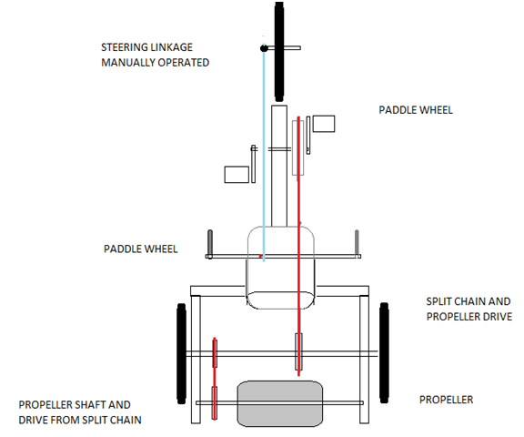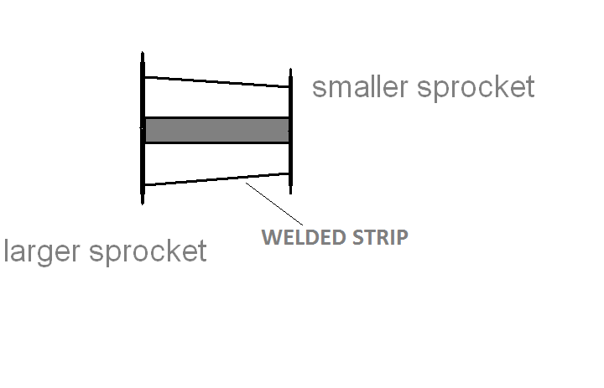 The float is the extended surface which helps the vehicle to float on the water. The float is made of dense foam type structure. The adhesives are used so no collapse occurs will operation.

**Power Transmission System**

**PARTS AND THEIR SPECIFICATIONS :- ( Based on selective Assembly)**

* **Sprockets:-**

Main sprockets :- Diameter = 180mm Teeth = 45, Module = 4mm.

Rear sprockets:- Diameter = 120mm,

Teeth = 24, Module = 5mm.

Idler and propeller transmission sprockets:- Diameter = 72mm,

Teeth = 18, Module = 4mm.

**Bearing :-**

Ball bearing: - Inner Diameter = 22mm,

Outer Diameter = 44mm.

* **Chain:-**

Main transmission chain: - Length = 2700mm,

Pitch = 15mm.

Propeller transmission chain: - Length = 975mm,

Pitch = 15mm.

* **Propeller :-**

Weight = 5Kg

Total outer diameter = 600mm,

Total inner diameter = 320mm,

Propeller blade 410 x 140 x 2

No. Propeller blade = 5

Angle of Propeller blade = 72 degree.

* **Propeller Shaft:-**

Inner diameter = 18mm,

Outer diameter = 22mm,

Length = 875mm.

* **Axel Shaft:-**

Diameter = 25mm,

Length = 1200mm.

* **Total Dimensions:-**

2545mm x 1200mm.

* **Chassis:-**

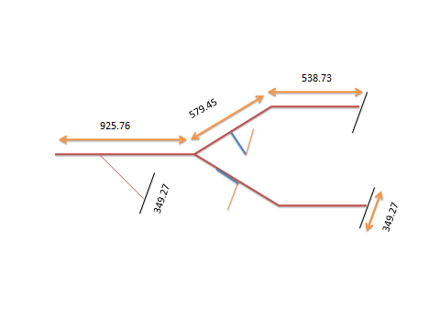

**4.1Frame with dimension**

**CONCLUSION**

There are many gadgets designed for moving on water surfaces. Some of them are very efficient but very few have the capacity to move both on water and land. Many of the existing systems require advanced machinery and fuel to maintain them on water. Our proposed model is a very low cost and efficient system which achieves the same using human energy. The system currently lacks safety systems and hence is suitable only for shallow water lakes and   
ponds.

The prototype design does not include any safety instruments and hence is suitable for shallow water lakes and ponds only. The effect of strong water waves also could not be estimated in this project. We hope to include these improvements in a later model. On firm, flat ground, a 70 kg person requires about 30 watts to walk at 5 km/h. That same person on a bicycle, on the same ground, with the same power output, can average 15 km/h, so energy expenditure in terms of kcal/(kg·km) is roughly one-third as much. Generally used figures are

* 1.62 kJ/(km∙kg) or 0.28 kcal/(mi∙lb) for cycling,
* 3.78 kJ/(km∙kg) or 0.653 kcal/(mi∙lb) for walking/running,
* 16.96 kJ/ (km∙kg) or 2.93 kcal/ (mi∙lb) for swimming.

Amateur bicycle racers can typically produce 3 watts/kg for more than an hour (e.g., around 210 watts for a 70 kg rider), with top amateurs producing 5 W/kg and elite athletes achieving 6 W/kg for similar lengths of time. Elite track sprinters are able to attain an instantaneous maximum output of around 2,000 watts, or in excess of 25 W/kg; elite road cyclists may produce 1,600 to 1,700 watts as an instantaneous maximum in their burst to the finish line at the end of a five-hour long road race. Even at moderate speeds, most power is spent in overcoming the aerodynamic [drag](http://en.wikipedia.org/wiki/Drag_(physics)) force, which increases

**FUTURE SCOPE**

Even great concepts have developing scopes. The modification and ever changing design is the point of subtle condition. The modification generally widens the scope and makes a concept more universal and hence the utilization in the masses is easier. The future implementation on a larger scale makes the unit cost extremely attractive. The awaited model which can maneuver both in land and clear waters without any change over may become the future transport without any questions.

The future asks for a better transport with minimum or absolutely no carbon emission or in other words ecofriendly and multi utility is the most important point to be considered of. The continuous increasing carbon percentage in the environment is making it un breathable for all the biotic elements dwelling in it.

The human if not capable of driving the vehicle by its own power suppose in the case of a disability the vehicle can be transformed into an electrically driven amphibious vehicle so the concept is not just limited to the average human or athletes only.

The water sports and transport can be reframed. A total new look can be achieved so that the attractiveness and charmed can reignited in water transport.

The use of motor say electric drive and use of some battery for storage medium can increase the utility.

**REFERENCES**

1. South Hampton university yearly magazine, article 17 page no. 83-84 year 2006-2007.
2. Amphibious vehicle studies: J. Kotik. Trg Inc., Melville, N.Y.   
   Journal of Terramechanics, Volume 4, Issue 3, 1967, Page 71.
3. Efficient alternate transportation Spill Science & Technology Bulletin, Volume 1, Issue1, September1994, Pages79-84 Mac W. McCarthy, John McGrath
4. <http://www.gutwin.org/mt/snow/archives/2005/04/from_earth_to_e_1.html>.
5. <http://forums.autosport.com/lofiversion/index.php/t91874.html>.
6. Nadel, Ethan R.; Bussolari, Steven R. (2000). ["The Physiology of Human-Powered Flight"](http://books.google.com/books?id=_IuGSCUhWoEC&pg=PA942). In Shephard, Roy J.; Åstrand, Per-Olof. Endurance in Sport. Encyclopedia of Sports Medicine. **II** (2nd Ed.). Oxford, UK: Blackwell Science. pp. 942–4. [ISBN](http://en.wikipedia.org/wiki/International_Standard_Book_Number) [0632053488](http://en.wikipedia.org/wiki/Special:BookSources/0632053488). Retrieved 22 November 2011.
7. <http://www.exploratorium.edu/cycling/humanpower1.html>
8. HPV's Across America: RAAM Tests More Than Technology <http://www.adventurecorps.com/when/raam/1989raam1.htm>
9. Science of Cycling: Human Power: page 1
10. Theory of machines by Khurmi and Gupta
11. Design data book by B.D. Shiwalkar