**WORKING OF ENERGY EFFICIENT WATER COOLER** DEVENDRA KAMTHE1 **,** SAGAR JAIN2, NEERAJKUMAR GUPTA3, AMOL KAMBLE4 Department of Mechanical Engineering, K.D.K.C.E Nagpur

Guided by- S.K.Choudhary

***Abstract***

In the torrid heat of the summer the need of cold water is demand of every person. However, people know that as summer comes it requires erratic power supply for satisfying there need. Water coolers are expensive and require electricity. Existing water- cooling solutions for public consumption at a particular capacity may require high power to operate and employs compressors that circulate harmful refrigerants for cooling. Many Innovators are trying to develop a water cooler, which provides cool water, consumes less energy, must work on solar PV and does not require much maintenance.

***Introduction***

In the summer the atmospheric conditions is very hot and every one required cooled water and cooled air .The cooled water is demanded of every person to drink chill water is like a supplementary to our body which plays an vital role to keep our body healthy. So many number of water cooler are present in the market, but they are more costly, consume more electricity and it uses refrigerant for cooling of water which has very bad effect on environment they are polluted the atmosphere that’s why we introduce energy efficient water cooler.

The energy efficient water cooler has very low cost; consume less electricity and environment friendly water cooler. It is based on the principal of cooling tower and earthen pot. It cools the water by evaporation. The evaporation based on temperature and humidity. Water passes through cotton string covered copper coils, which are continuously being moistened by a dripper. A small fan, mounted on roof top facilitates the air circulation and evaporation of water from the cotton string on the coil cools the water inside. It reduces the temperature of input water by 8 to 10 degree centigrade depending upon the external temperature and humidity. It also has an in-built filter that provides clean and hygienic water. The use of copper tubes for flow of water has health benefits too.

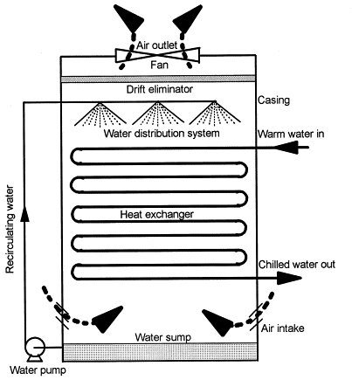

Fig. Cooling tower

***Design & fabrication***

***Component***

The main component of the natural efficient water cooler is as follows.

* Steel water drum
* Copper tube coils
* Steel rectangle hollow bar frame
* Fan
* Cotton cloth
* Puff insulation
* Capillary tube
* Duct

***Construction***

The material use for the construction of frame is mild steel rectangular hollow rod and they are fabricated with help of welding. The construction of frame is robust to support the load of water drum and load of duct. The duct is attached to the frame. The platform is made for the mounting of water drum. The copper tube coil is made up with the help of a coiling process. The cotton cloth is wound on the copper tube coils and then this coil is attached to the water drum , one end of coil is connected to the upper side of water drum ,and one end connected to the bottom side of the drum. The whole coil section is mounted inside the duct. A small capillary are attached to the drum for dropping the water on copper tube. A small fan is attached on the upper side of duct, due to which the high velocity air come in contact with the copper tube. The puff insulation is provided on the outer side of the water drum, to resist the heat flow from outside to inside.

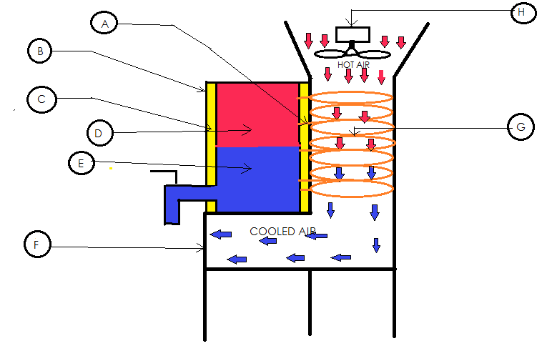

Fig. Natural efficient water cooler

A-Capillary tube

B-Steel water drum

C-Puff insulation

D-Hot water

E-Cold water

F-Air duct

G-copper tube coil

H-Fan

***Working principal***

The working principal of energy efficient water cooler is based on the cooling tower and earthen pot. An energy efficient water cooler is equipment used to reduce the temperature of water stream by extracting heat from water and emitting it to the atmosphere. Water cooler make use of evaporation, where by the water is evaporated in to a moving air stream and discharged in to the atmosphere. The heat required for evaporation of water is gained from the water which is inside the tube. The heat transfer from the pipe is by conduction and convection. The water from the drum is passes through capillary which has inside diameter of 1.5mm, this water is dropped on the copper tube coil on which the cotton cloth is wounded, and due to the use of cotton cloth on copper tube is to hold the water which is passes from the capillary. A small fan is use to increase the velocity up to 12.25 m/sec of the air which is entering in to a duct. The air has property to absorb the water up to its saturation condition. In the summer the water particle present in to the air is not more, so that when these airs come in contact with the copper tube coil and air get absorb the water and water is evaporated from the surface of the coil. The water present in to the air is in the form of superheated steam. The heat required for superheat the steam is extracted from the water which is flow inside the copper tube. The heat rejected by the water and the temperature of water is reducing from 80c to 100c. The heat is rejected from the water by two mode first is conduction and second is convection. The air which is passes over the coil humidified and due to increasing in humidity the temperature of air is reduce and this air is further use for the cooling of room, therefore it is a multipurpose type water cooler, which is gives cooled water as well as cooled air. The reason for using the copper tube coil for circulating the water is that, the thermal conductivity of the copper is 401 w/m k. This is more than any other material, that’s why we use the copper coil for circulating the water in the energy efficient water cooler. The water is continually flow from the tube with the help of a siphons effect, in the siphon effect the flow of water is take place due to temperature effect, there is no required the pump for circulation of water and these effect is use in natural efficient water cooler. The siphon effect is the density difference, in which the hot water low density due to which the hot water is flow upward of the water drum and cooled water has high density so, it will flow bottom of water drum, like that the water is flow from the tube and the water is cooled and then these water is use for the drinking purpose.

***Specification of energy efficient natural water cooler***

***Water drum***

|  |  |
| --- | --- |
| Capacity of water drum | 20 lit. |
| Diameter of water drum | 289mm |
| Length of water drum | 609mm |
| Thickens of insulation | 10mm |

***Copper tube coil***

|  |  |
| --- | --- |
| Length of copper tube | 19.68m |
| Inner diameter of copper tube | 6mm |
| Thickness of copper tube | 1mm |
| Number of coils | 30 turns |

***Fan***

|  |  |
| --- | --- |
| Speed of fan | 1300rpm |
| Diameter of fan | 180mm |

***Capillary tube***

|  |  |
| --- | --- |
| Inner Diameter of capillary tube | 1.5mm |

***Conclusion***

* Our water cooler uses electricity only for operating the fan since it is more efficient than the conventional water cooler which requires comparatively more electricity.
* Fan used in our water cooler can also be operated by using battery thereby making it portable and easy for use in rural areas.
* Since the water vapour cools the air coming out from the fan, it can be used for cooling purposes.
* The water coming from the tube has medical advantages by virtue of material of the tube which is copper.
* It will be multipurpose equipment, as it provides both cool water and also purify it due to use of copper.
* And it also keeps the temperature of room at desirable condition as it can also be used as an air cooler.
* Thus it will save more money to be spent for a water cooler, a purifier, and air cooler.
* This will be easily affordable for common mass people.

***Reference***

* http//Invention of modern drinking water fountains.htm
* Text book of “**THERMAL ENGINEERING**” by **R. K. RAJPUT**; Eight Edition; Laxmi Publication (P) Ltd.
* Text book of “**HEAT AND MASS TRANSFER**” by **R.K.RAJPUT**; published by S. Chand & Company Ltd. (An ISO 9001 : 2008 Company)
* **Heat and Mass Transfer** – **D. S. Kuma**r.
* Arvindbhai Patel “National Innovation Foundation – India.”
* http/ water cooler problems - no-spill design causing spills/watercooler-Askmetafilter//.html
* http/ how-we-use-to-do-it//.html
* Http/ Airtek.com

|  |
| --- |
|  |