“Design, Fabrication and Performance of Solar Tunnel dryer”
Saket Gijre¹ Shahbaaz Haque² Surabhi Karanjawala³
¹ Final year, Mechanical department, KDK college of Engineering, Nagpur
² Final year, Mechanical department, KDK college of Engineering, Nagpur
³ Final year, Mechanical department, KDK college of Engineering, Nagpur
saket.gijare@gmail.com
___________________________________________________________________________

Abstract- India being an Agricultural country, there is a huge market for dried food products. Drying of food products is done conventionally by placing them directly beneath the sun by natural convection. We are trying to improve this orthodox method of drying by using Solar Tunnel Dryer.[5]
A lot of hygienic and environmental factors are responsible for obtaining the desired product. Hence, production by this orthodox method reduces the quality of the product[1]. The food products dried outside gets contaminated in many ways viz. Dust, Pollution, insects, weather etc.
The present paper aims to maintain the quality and the nutrient values of the product after drying in the Solar Tunnel Dryer so as to overcome the disadvantages of present system.[8]
Keywords: solar, tunnel, dryer, fabrication, solar models, food products drying, ANSYS analysis.
I. INTRODUCTION
The work of this paper is explained in following steps:
- Designing of Solar Tunnel dryer.[6]
- Analysis of the model for various boundary conditions.
- Formulating various fabrication details.
- Fabrication of the model.
- Testing and validation of model.
- Conclusion.

II.DESIGN OF SOLAR TUNNEL DRYER
Base Frame of the Solar Tunnel Dryer is fabricated with metal rods of square c/s and welded together as shown in figure 1.
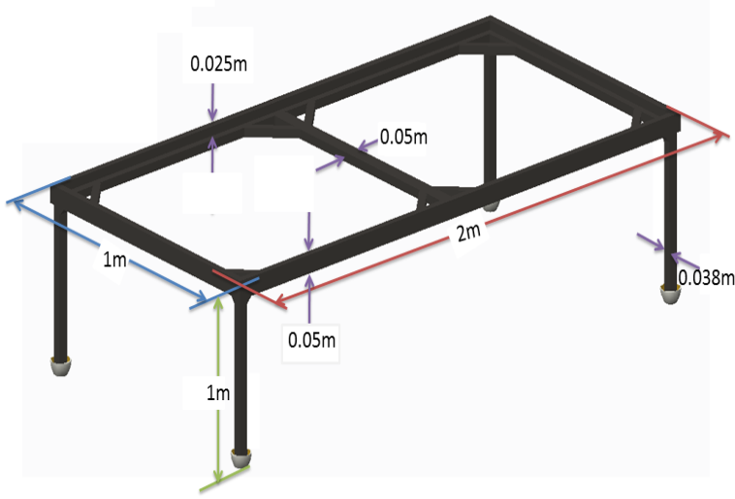
Figure. 1
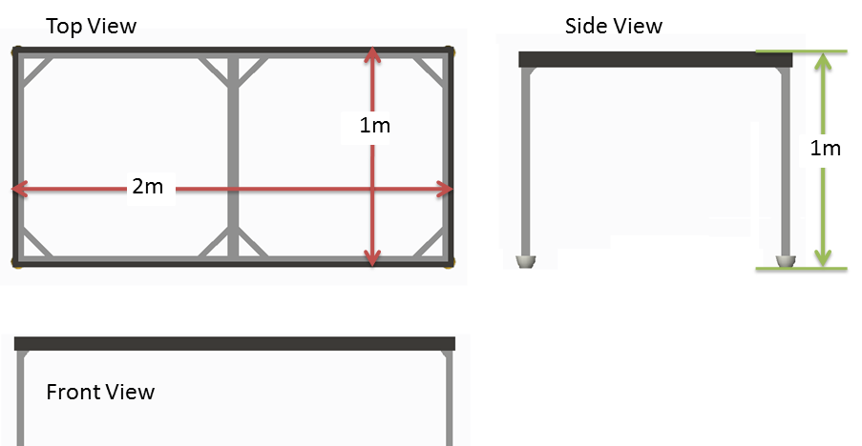
Figure. 2
The next step is to place wooden sheets (bison boards) on top of the table.
Next we place black metal Sheets over the wooden planks. In one of the sheet, Holes as shown are cut out which acts as the source of air inside the tunnel.
These holes are covered with Net to avoid insects from entering the tunnel.
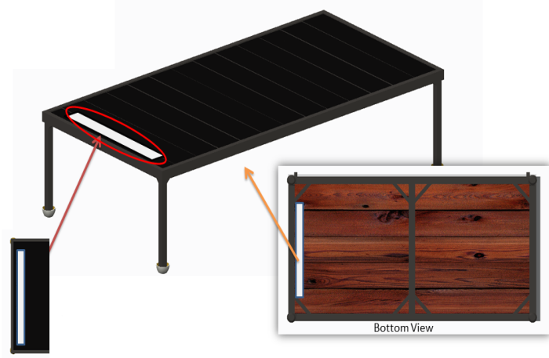
Figure. 3
An Arched cage frame is fabricated and welded over the Base frame. Welding support structure is also placed on two sides as shown. Material Used for weld strips is flat Steel Strip 1” wide, 1/4th “thick.
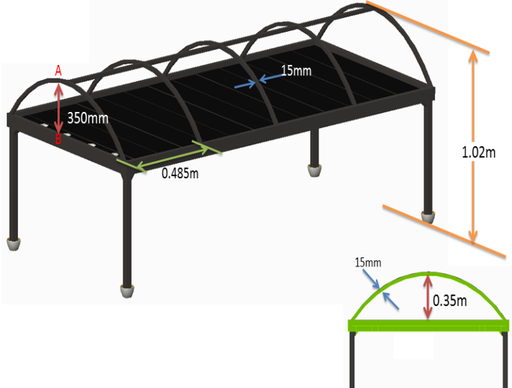
Figure. 4
The next step of designing is covering the cage with glazed transparent plastic sheet.
Here, on Side A-A’, the Plastic sheet is Glued (permanently fixed).
The other end of the sheet B-B’ is fixed on a rod as shown.
Exhaust Fans are then installed for convection through the tunnel.
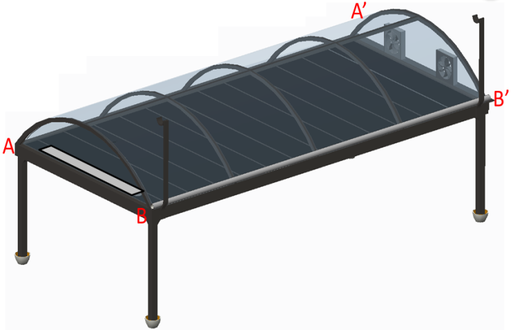
Figure. 5
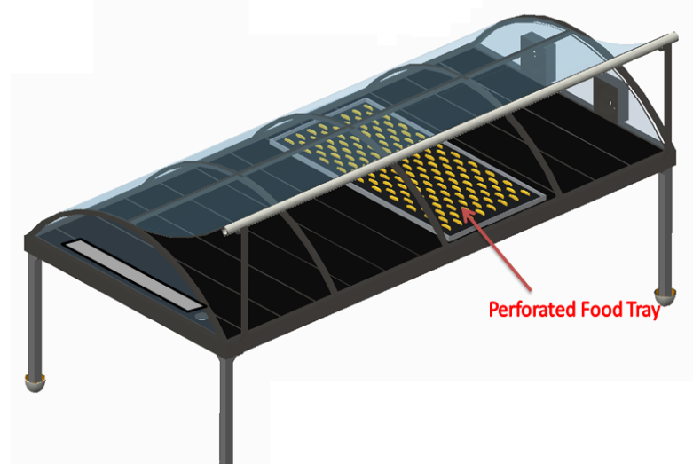
Figure. 6 Solar Tunnel Dryer when Open & a tray containing food product.

III. WORKING
- Once the Food to be dried is placed inside the Solar Tunnel dryer, the Dryer is closed.
- The Black metal sheets will absorb heat and since the tunnel is covered, like greenhouse effect, the temperature inside the tunnel will start increasing.
- When exhaust fans are started, the air is taken from the vents. This air gets hot inside the tunnel.
- Once the product is dried, the tunnel is opened and product is removed.

IV. DESIGN CALCULATIONS
- The Area of the Solar Tunnel Dryer is 2 meter².
- The size of the Tunnel Dryer was determined based on the preliminary investigations and was found to be 4Kg /meter² (tray loading).
- The Tray is of size 900mm x 500mm = 0.45 meter², hence the tunnel dryer can dry products up to 1.8kg per tray.
- Hence total quantity of product that can be dried is 7.2kg.
Determination of Surface Temperature
1) Area of Air Vent
A= lxb =0.885x0.0403
A = 0.0362 m²
2) Perimeter of Air Vent
Perimeter (P)= 2(l+b)
=2(0.885+0.0403)
P = 1.852 m
D_{h} = 4A /P = 4x0.0362 / 1.852
D_{h}= 0.0781 m
3) Now, to Calculate Reynolds Number (Re)
Re= (C x Dh) / v
Where C = Velocity of air (Assumed to be 1m/s)
v = Kinematic Viscosity
Mean Fluid Temperature of Air
T_{f} = (T_{o}+T_{i})/2
= (70+30)/2
= 50 ºC
v = 17.95*10⁻⁶ m²/s
Pr = 0.696 (where Pr. = Prandtl Number)[9]
k = 0.02826 (where k = Thermal Conductivity; W/mK)[9]
Therefore,
Re = ( 1x0.0781 )/ 17.95x10⁻⁶
Re = 4350.975
Re > 2300
i.e. Flow is Turbulent
4)To Calculate Nusselt Number (Nu)
By Dittus-Boelter Equation,[9]
Nu=0.023 Re^{0.8} x Pr^{0.4}
hence,
Nu = 16.204
Now,
Nu = ( h x D_{h} )/k
16.204=(hx0.0781) / 0.02826
h= 6.8 W/m²K

5)To Calculate Surface Temperature ( Ts )
We know,
Q= h. As (Ts-Ta)
Where, Q= Heat Supplied
h= Convection Coefficient
Ts= Surface Temperature
Ta= Ambient Temperature
As = Area of Tunnel Dryer Plate
Area of Tunnel Plate = 2 x 1 = 2 m²
To Calculate Q, ie, Heat Supplied,
Q = q x A
Where q= Heat Flux incident on Tunnel Dryer.
In Nagpur, The Heat Flux incident is of range 400 to 800 W/ m² during summers.
Hence We consider q = 400 W/ m²
Hence, Q = 400x2
= 800 W
Therefore,
Substituting Values in formula Q= h. As (Ts-Ta)
800=6.8x2x(Ts-30)
Ts = 88.82 ºC
Hence, calculations show that if the Ambient Temperature (Ta) is considered as 30 ºC and Outlet Temperature (To) as 70 ºC, the solar Tunnel Dryer will achieve a surface temperature around 88 ºC.

Calculations for Force, and Pressure.
To carry out the Structural Analysis, Force and Pressure is required.
We know,
W = F = m x g
Where, F = Force ; N
m = Mass of product ; kg
g = Acceleration due to gravity ; m/s² ( g=9.81m/s² )
The Solar Tunnel Dryer can dry products upto 7.8kg. Hence, calculating for 8kg,
F= 8x 9.81
F= 78.48 N
Also, Pressure P = F/A = 78.48 / 2 = 39.24 N/m²
P= 40 Pa

V. THERMAL AND STRUCTURAL ANALYSIS

To carry out analysis of the design, ANSYS Workbench 13 was used.
The red part in figure 7 indicates the intensity of temperature. The maximum temperature reached by the tunnel is 88.33ºC.
The software provided same output of maximum temperature as calculated in the design procedure.
In the same way, a structural analysis is performed on ANSYS’13 to check the structural stability of the design. The blue color of entire design indicates that the design is structurally safe.
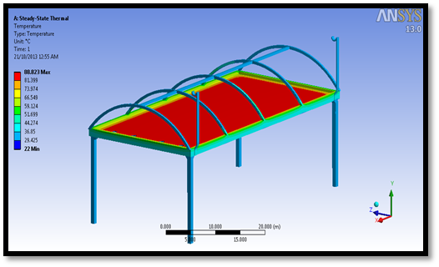
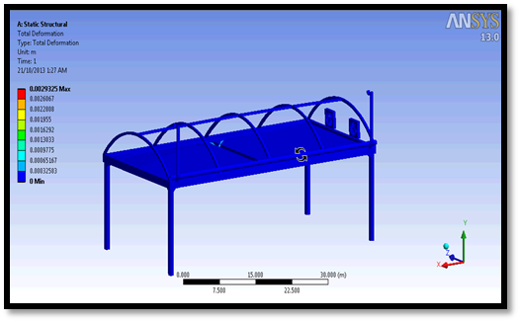
Figure. 7 & Figure. 8

VI. ADVANTAGES OF THE MODEL

- The design for solar tunnel dryer is found to be structurally stable.
- The Model can be completely dismantled and can fit into a small space.
- The Model is Light in design, 2 persons can assemble and disassemble it.
- The Plastic sheets used is commonly available in the market and can be easily replaced.
- Electrical earthing is done which will prevent the model from damages due to lightening.
- Legs of the frame are foldable, and can be easily transported.

- ACKNOWLEDGMENT

We would like to extend our gratitude to Prof. V.P. Katekar, senior faculty, SB Jain Institute of Engineering and Technology, for his constant help, support and timely inputs on solar tunnel dryer and concepts of free and forced convection.

- REFERENCES

- J. Agric. Food. Tech., 1(5) 50-58, 2011 © 2011, TextRoad Publication, ISSN 2090 – 424X. Journal of Agriculture and Food Technology.

- Iranian Journal of Chemical Engineering Vol. 6, No. 3 (Summer), 2009, IAChE On Effect of Time and Temperature on Moisture Content, Shrinkage, and Rehydration of Dried Onion.

- Solar drying of agricultural products: A review A.A. El-Sebaii a, S.M. Shalabyb
  - Department of Physics, Faculty of Science, King Abdulaziz University, P.O. Box 80203, Jeddah 21589, Saudi Arabia
  - Department of Engineering Physics and Mathematics, Faculty of Engineering, Tanta University, Tanta 31111, Egypt

- Hany S. EL-Mesery and Gikuru Mwithiga ; African Journal of Agricultural Research Vol. 7(30), pp. 4284-4296, 7 August, 2012
  - DOI: 10.5897/AJAR11.2065
  - ISSN 1991-637X ©2012 Academic Journals

- Design and Construction of A Solar Dryer for Mango Slices EL- Amin Omda Mohamed Akoy a, Mohamed Ayoub Ismail b, El-Fadil Adam Ahmed c and W. Luecke d.
  - Dept. of Agric. Eng., Faculty of Agriculture, University of Zalingei, Zalingei, Sudan.
  - Dept. of Agric. Eng., Faculty of Agriculture, University of Khartoum, Khartoum, Sudan.
  - Energy Research Institue, Ministry of Science and Technology, Khartoum, Sudan
  - Institute of Agric. Eng.,University of Göttingen, Göttingen, Germany

- Hernandez, J. A.; Pavon, G. and Garcia, M.A. (2000). Analytical solution of mass transfer equation considering shrinkage for modeling food-drying kinetics. Journal of food engineering, 45(1): 1-10.

- Sodha, M. S.; Bansal, N. K.; Kumar, A.; Bansal, P. K and Malik, M. A. (1987). Solar crop drying. Vol. I and II. CPR press, Boca Raton, Florida, USA.

- Berinyuy, J. E. (2004). A solar tunnel dryer for natural convection drying of vegetables and other commodities in Cameroon. AMA, 35(2): 31-35.

- Heat and Mass transfer data book by C.V.Kothandraman and Subramnyam page no. 126, 34

