**TO INCREASE THE STABILITY OF A TRACTOR BY INCREASING THE ADHERENCE WEIGHT**

**Ashish Dewangan, Kunal Shahu Guided By: - Mr.Prabhat Giri**

**Mr. Prabhat Giri (Associate Professor,Department of Mechanical Engineering, Rungta College of Engineering and Technology,** [**giri_mech@rediffmail.com**](mailto:giri_mech@rediffmail.com) **, mob: 9229433675)**

**Ashish Dewangan (Department of Mechanical Engineering, Rungta College of Engineering and Technology,**[**ashish008z@gmail.com**](mailto:ashish008z@gmail.com)**, mob: 7415811438)**

**Kunal Shahu (Department of Mechanical Engineering, Rungta College of Engineering and Technology,** [**kunalshahu.rcet@gmail.com**](mailto:kunalshahu.rcet@gmail.com)**, mob: 7879132790)**

**Abstract:**

**According to the (NIOSH) National Institute for Occupational Safety and Health, many people per year are killed as a result of agricultural tractor rollovers, runovers, entanglements, etc .Rollovers account for more than half of these fatalities, despite decades of effort by tractor manufacturers and farm safety professionals to eliminate these tragedies. Approximately 85 percent of all tractor rollovers are side rollovers. Driving too close to an incline or embankment, driving too fast when negotiating a curve, driving the tractor with a loaded front-end loader in the raised position, uneven braking while traveling at high speeds, and losing control of the tractor due to excessive load on the drawbar are the major causes of side rollovers. Studies show that when tractor speed is doubled, the danger of rollover is increased four times. Rear rollovers are particularly dangerous because they happen so quickly. Operators have no time to react to avoid being injured or killed. Center of gravity must lie inside the stability baseline area. From the time the tractor begins to rollover, the incident can take as little as 1.5 seconds. This can be prevented by increasing the weight on front wheel axel. We find that this can be done by using water filled tyres on front wheel and for further increasing the weight we can use magnesium chloride (MAG) as a additive. MAG can increase the weight of water filled the tyre about 20%, also it is a good antifreeze mixture which proved to be useful if we use water filled tyre along with MAG in low temperature zone.**

***Keywords*:Side rollover; Rear rollovers; Entanglements; Drawbar; Runovers**

**INTRODUCTION**

No other machine is more identified with the hazards of farming as the tractor. Nearly 50% of tractor fatalities come from tractor overturns tractors are used for many different tasks. Because the tractor is a versatile machine, operators sometimes stretch the use of the tractor beyond what the machine can safely do.

*How Tractor Overturns*

Centre of gravity (CG). A Centre of gravity is the point where all parts of a physical object balance one another. From figure1 shows that the CG is inside a tractor’s stability base line. Drawing a line to connect all the wheels of the tractor as the wheels set on level ground forms a tractor stability base line. There are two very important points about tractor CG and stability base line:

* The tractor will not overturn if the CG stays inside the stability baseline
* The CG moves around inside the baseline area as we operate the tractor shown in figure 2.

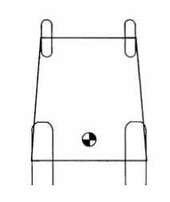

Figure 1: Stability baseline

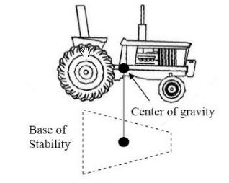

Figure 2: Stability baseline showing CG

**SIDE ROLLOVERS**

Gravity and centrifugal force are the two major forces involved in a sideways rollover. Backflips are produced through rear axle torque and drawbar leverage.Several concepts need to be understood in order to manage the hazard of tractor rollovers and backflips. Sideways rollovers occur most commonly when traversing a steep slope or cornering too sharply at speed. Two concepts which are useful in understanding sideways rollovers are the relationship between the tipping of the tractor and itsCentre of gravity together with the amount centrifugal force developed during cornering.

The tipping axis is the line that a tractor will pivot about during tipping if driven over a steep enough slope. This is more easily understood if we look at the crawler tractor. The tipping axis on a crawler tractor is at the outside edge of the track. The tipping axis of a 2WD and 4WD tractor is more complicated. This is because the front axle is attached to the tractor chassis by a central pivot point. Thus, as the tractor tips, it has two tipping axes.

The most important one is in a line from the outside edge of the rear wheel to the central pivoting point of the chassis. This axis line continuous to where the axle hits the chassis when the tipping axis moves to the outer edge of the front and rear wheels. When the tractor reaches this second axis, it is usually past the point of no return. The Centre of gravity is the point where all parts of the tractor balance one another. If a tractor could be suspended from the Centre of gravity it would be perfectly balanced. The position of the Centre of gravity will change if any implements are added, removed or change position. If a bucket is raised, it will raise the Centre of gravity and the bucket is lowered, the Centre of gravity will also be lowered. Thus, the Centre of gravity moves toward the weight change. The Centre of gravity is normally located in the vicinity of the gearbox in the mid-line of the tractor. The Centre of gravity is useful for assessing the stability of a tractor when combined with the tipping axes. If a plumb bob(a weight on the end of string) is suspended from the Centre of gravity, it will demonstrate its position in relation to the tipping axes. As the Centre of gravity is raised, it takes a lesser slope to the breach the tipping axes. Once the Centre of gravity lies outside the tipping axes, a rollover is inevitable. Centrifugal force is introduced when a tractor is cornering. This force tends to pivot the tractor on its outside wheels during cornering. This pre-disposes the tractor to a rollover. An example of centrifugal force is the force that pushes you to the outside of the car when going around a corner. The faster you go, the greater the force. The centrifugal force (mv2/r) varies according to the weight of the tractor, the speed and the turning angle. The force will increase as the angle of turn becomes sharper. Halving the radius of the corner will double the centrifugal force similarly, doubling the speed from 5 km/h to 10 km/h would increase the centrifugal force four times (22= 4). Tripling the speed from 5 km/h to 15 km/h would increase the force nine times (32=9).

Centrifugal force is a factor contributing to a tractor upsets on flat ground. It is also important when operating on slopes. When a tractor is turning on slopes. When a tractor is turning on slopes its Centre of gravity may be approaching its tipping axes, and it may only require a small amount of centrifugal force to cause a rollover. There has often been contention about the correct direction to turn when crossing a hill slope. Remember that when the direction of turning is being discussed with reference to slopes, none of the turns should be sharp. Rather, they should be veering off in an uphill or downhill direction. If the turn is too sharp, there will be large centrifugal forces involved.

**BACK FLIPS**

The second type of rollover is backflip. In these scenario, there are Two forces in action. This are rear axle torque and drawbar leverage. Rear axle torque is the transfer of energy between the engine and rear wheels of a tractor. It occurs when pinion gear in the differential meshes with the crown wheel of the axle. Thus, the pinion which is driven by the engine applies a rotational force to the wheels via the crown wheel. This may be described as the rear axle rotate with respect to the chassis pulling a heavy load. If axle rotation is prevented as in the case where the tyres are stuck (e.g. in a bog, frozen to the ground or if the load is very heavy), the rotational force moves the tractor backwards around the rear axle, lifting the front wheels off the ground. Since a tractor’s Centre of gravity is closer to the rear axle then the front axle, it may only have to rear to an angle of 70degrees for the Centre of gravity to pass outside the rear tipping axis. This is located between the contact patches of the rear wheels.

A backflip can happen in as little as ¾ of a second. At this speed, there is little chance that the driver wheel will be able to take evasive action. There are many circumstances where the reaction time may be even less than ¾ of a second. This can occur when the Centre of gravity is already approaching the rear tipping axis, for example, when the rear wheels of the tractor are stuck in a bog. Practices which involve rear axle torque reactive force acting to cause a backflip include:

* Driving off in low gear but with high engine speed.
* Attempting to drive the tractor forward when the wheels are unable to move forward.
* Rapid engagement of the clutch of the tractor.
* Rapid acceleration, particularly when driving uphill four wheel drive tractors are less susceptible to backflips as they have more weight over the front axle than a two wheeldrive and the torque is applied to both front and rear axles.

However, once the front wheels lift off the ground, there is essentially no difference between the two types of tractor. This also applies to front wheels assist tractors. Care must be taken when ascending hills that the correct gear is selected before the commencement of the climb. If the driver has to stop during the climb, it requires only a small amount of rear-axle torque from the jerking of the clutch to cause the tractor to flip due to the other instability factors introduced by the slope. If a hill is very steep, the tractor should be reversed up the hill and then when coming down, it should be driven slowly forwards in low gear. Low gear should be selected before you start down the hill. If the tractor is pulling a heavy load uphill, the combination of the slope and drawbar leverage makes it more likely that the tractor will flip. In that case, front-end weights should be added to the tractor and the drawbar set in its longest and lowest position. Rear-wheel weights or tyre-ballast should be added to counterbalance front attachments such as spray tank or front-end loader. Drawbar leverage describes the force which tends to pull the tractor rearwards when it is towing or pulling an object. The magnitude and its effect on tractor stability will vary according to a number of factors including the weight, draft, hitching point used, resistance to movement and angle of pull tractors are specifically designed to pull objects from the drawbar and this should be strictly adhered.

When an object is being pulled, the pulling force involves both a horizontal and vertical component this may be equated to an angle of pull. The angle of pull in a downwards direction results in a transfer of weight from front of the tractor to the rear. Many backflips are caused by the driver hitching the load too high. Common examples are the top link of the 3-point linkage and the axle housing. The tractor is hitched most safely, when hitched to the drawbar. Care must be taken when pulling loads uphill even when appropriate hitching methods are used. This is because of the close proximity of the Centre of gravity to the rear tipping axis. Thus, only a small amount of force would be required to cause a backflip. If the tractor is not hitched in a safe manner, the angle of pull may not be safely reduced before the tractor overturns. This means that the Centre of gravity would have moved outside the rear tipping axis. The axle load-bearing capacity of a tractor must be taken in to account when looking at the factors which can lead to attract or rollover.

The weight of the load carried by the tractor combined with that of the tractor make up the gross vehicle mass. Where front-mounted lifting attachments are attached to a tractor, drivers need to be aware of the load-bearing limit on the tractor axle and ensure those limits are not exceeded. If a loader is overloaded, the weight vehicle mass will be entirely on the front axle and can lead to a backflip. Check their recommended load limits in the driver’s manual. If you are still not sure, ask the tractor distributor.

The recommended limits allow you to maintaining control of the equipment. Excessive axle-bearing loads lead to costly repairs, and may cause you to lose control of the tractor. The risk of tractor rollover or backflip is increased by axle failure.

*Preventing Rollovers*

Tractor design features are available that reduce the risk of rear rollovers. Some features come standard on new tractors, while others are optional to be employed in specific circumstances to maintain proper weight balance. This includes rear wheel weight, tyre ballast, front-end weights and fixed drawbar height. To reduce the risk of a rear rollover, tractor operators should:

* Keep front-end loader buckets low when pulling rear mounted loads.
* At front-end weights when raising heavy rear mounted equipment.
* Backup steep hills and driving forward down steep hills.
* Hitch loads only to the drawbar and never hitch loads above the draw bar

*Preventing Side Rollovers*

Today, tractor manufacturers attempt to prevent side rollovers through design features and tractor options that widen the base of stability and lower the tractor’s Centre of gravity. Some of these features include:

* Wide front-end design versus narrower tricycle- typed designs.
* Adjustable rear wheel width and dual wheel tractors.
* Wide tyres.
* Ability to lock brakes together.
* Fixed drawbar height.

To reduce the potential of a side rollover, tractor operator should:

* Drive at appropriate speeds.
* Set wheel tread as wide as possible.
* Stay away from steep slopes, ditches, and embankments.
* Keep front-end loader buckets low during transport or when turning.
* Lock brakes together when travelling at high speeds.
* Drive forward down steep slopes and backup them slowdown when pulling rear- mounted equipment.

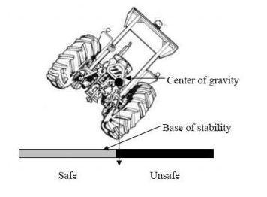

Figure 3: Side rollover

**BALLASTING**

Ballasting is weight added to the tractor for the purpose of improving tractors performance. Depending on the field condition and the drawbar requirements of the operation, the tractors unballasted weight may actually heavier than the optimal weight. Agricultural tractor ballasting recommendations have evolved over years.

In the early 1970’s, John Deere published a slide rule (OBM-20R2) to calculate recommended tractor weight based on available power and speed of operation.

In the 1980’s NIAE developed a similar formula (Dwyer, 1984: Gee-clough et al, 1982) relating weight, power and speed of operation to the size of tyre and ballasted weight.

Recent traction test and working with the revised Barixius (1987) traction equations (for radial-ply tyres) have led to a better understanding of variables involved and provided a technical basis for recommendations that have been in use for a number of years.

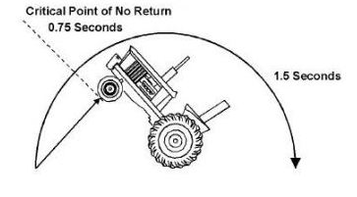

Figure 4: Rear rollover

Dwyer (1984) stated that “ for a surprisingly wide range of tyres and soil conditions it has been found that tractive efficiency reaches a maximum at a coefficient of traction of about 0.4”. The relationship for weight, power, and speed is:

$$\frac{\left(weight\right)(speed)}{power}= \frac{WS}{P}= \frac{TE}{NTR}$$

Where, T = traction efficiency

NTR = net traction ratio

GTR= gross traction ratio

$\frac{W S}{P}= \frac{k}{GTR}$

Table 1- Logical values of “k”

|  |  |  |  |
| --- | --- | --- | --- |
| Units | m/s | Mph | Km/h |
| Kg/KW | 106 | ----- | 383 |
| lb/hp | ----- | 375 | 630 |

For all practical purpose assuming GTR=0.45.

**CENTRE OF GRAVITY OF TRACTOR**

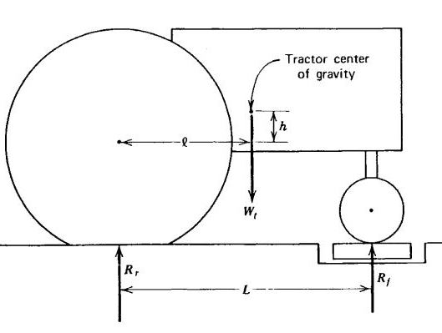

Figure 5: Showing Centre of Gravity 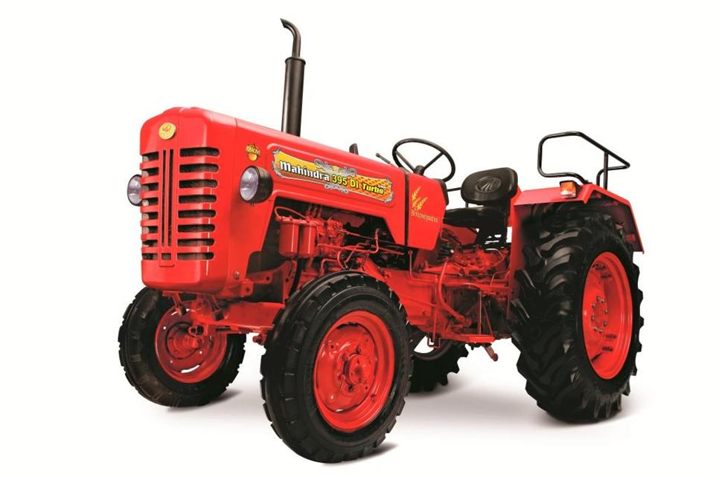

Figure 6: Tractor

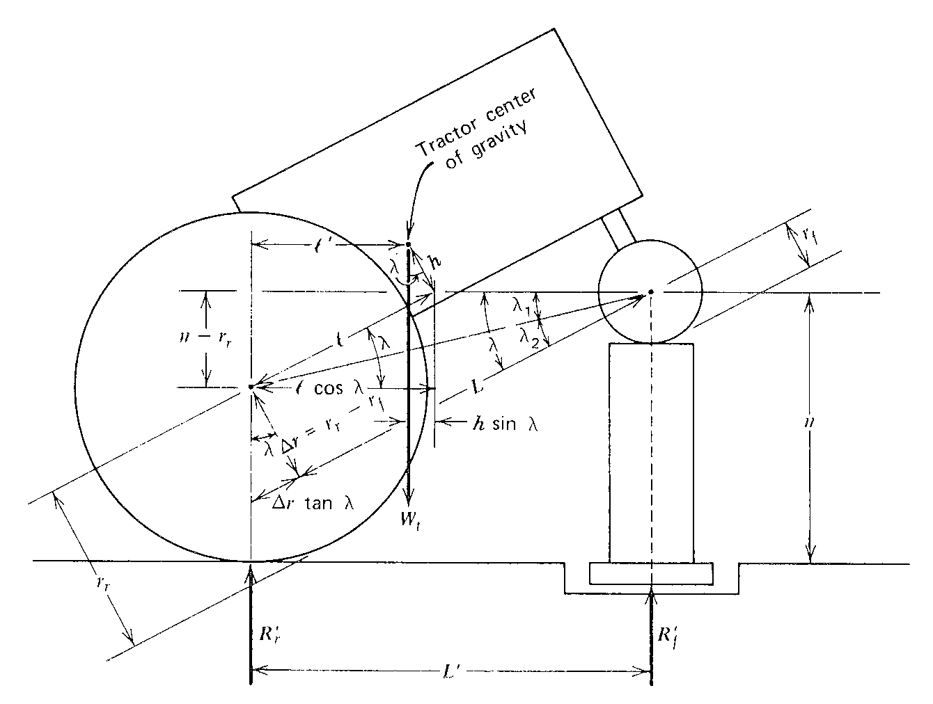

Figure7: Centre of gravity of tractor

Determination of Centre of gravity:-

$$Z_{cg}=\frac{W_{t}l-{R'}_{f}L}{W_{t}tanλ}-\frac{{R^{'}}_{f}Δr}{W_{t}}+Δr$$

Wt = Weight of tractor

l = Centre of gravity in x-direction

R’f = Reaction of front wheel

L = Wheel base

Δr = Difference of radius of front and rear wheel

**MAG FOR TYRE BALLASTING**

Liquid ballast in tractor and heavy equipment tyres is widely used to replace cast iron weights to increase the performance of farm and construction equipment. Using the tyre ballast is important for a number of reasons:

* Increased traction
* Increased tractor life
* Increased tyre life
* Greater fuel economy
* Greater convenience

MAG is 20% heavier than plane water while water weights approximately 8.3lb./gallon, a 22% MAG solution weights approximately 10.0lb./gallon. The use of MAG as a ballast increases the drawbar pull further.

Table: 2 volume and weight are based on 100% fill with a 22% solution of MAG for radial tyre and tyre bearing varying loads, a 75% fill is recommended.

|  |  |  |
| --- | --- | --- |
| Tyresize | Gallons of  standard solution | Weight  added to tyre(lb.) |
| 20.50-25 | 124 | 1240 |
| 21.00-24 | 160 | 1600 |

**CONCLUSIONS**

Our main objective in this paper is to provide stability to a tractor by increasing the adherence weight as well as shifting the centre of gravity in horizontal and vertical directions. We mainly focused on increase the adherence weight by increasing the weight by using water filled tyres in front wheel rim, weight can further be increased by mixing MAG in water which increases the weight of water approximately by 20%. for eg: one gallon of water weights about 8.3lb after adding MAG the weight increases up to 10*lb*.

**REFRENCES**

WC Harshman, AM Yoder, JW Hilton and DJ Murphy, “Tractor stability”, The Pennsylvania State University. Reviewed by TL Bean and D Jensen, The Ohio State University and S Steel, National Safety Council. Version 4/2004.

Erlich, M. Driscoll, T. Harrison, J. Frommer, M. & Leigh, “Tractor Rollovers”, work related Agricultural fatalities in Australia. 1982-84 Scandinavian Journal of Environmental Health. 1993. 19 pp162-67 .

David W.Smith,”Safe Tractor Operation”, Extension Safety Program AgriLIFE EXTENSION Texas A&M System.

TOTAL ICE CONTROL Dead Sea works potash house, POB 75, Beer Sheva 84100 Israel