Abstract :-

India is a land of agriculture which comprises of small, marginal, medium and rich farmers. Small scale farmers are very interested in manually lever operated knapsack sprayer because of its versatility, cost and design. But this sprayer has certain limitations like it cannot maintain required pressure; it lead to problem of back pain. However this equipment can also lead to misapplication of chemicals and ineffective control of target pest which leads to loss of pesticides due to dribbling or drift during application. This phenomenon not only adds to cost of production but also cause environmental pollution and imbalance in natural echo system. This paper suggests a model of manually operated multi nozzle pesticides sprayer pump which will perform spraying at maximum rate in minimum time. Constant flow valves can be applied at nozzle to have uniform nozzle pressure.

Keywords:Back pain, constant flow valves, drift, multinozzle pesticides sprayer pump, small; marginal; medium farmer.

Introduction :-

Agriculture plays a vital role in Indian economy. Around 65% of population in the state is depending on agriculture. Although its contribution to GDP is now around one sixth, it provides 56% of Indian work force [10]. Table 1 shows that share of marginal and small farmer is around 81% and land operated is 44 % in 1960-61. As far as Indian scenario is concerned, more than 75 percent farmers are belonging to small and marginal land carrying and cotton is alone which provide about 80 % employment to Indian workforce. So any improvement in the productivity related task help to increase Indian farmer’s status and economy. The current backpack sprayer has lot of limitation and it required more energy to operate. The percentage distribution of farm holding land for marginal farmers is 39.1 percentage, for small farmers 22.6 percentage, for small and marginal farmers 61.7 percentage, for semi-medium farmers 19.8 percentage, for medium farmers 14 percentage and for large farmers 4.5 percentage in year 1960-61.Table 1 clearly explain that the maximum percentage of farm distribution belonged to small and marginal category.

Fig I Percentage-wise Land distribution from 1960 to 2003



Fig I shows that percentage of the marginal, small and semi medium farmers is about 92.15 %, which states that growth of these farmers require advanced equipment which will work faster than existing one.

Design requirement :-

The Indian farmers (small, marginal, small and marginal, semi-medium) are currently using lever operated backpack sprayer. A backpack sprayer consists of tank 10 -20 liter capacity carried by two adjustable straps. Constant pumping is required to operate this which result in muscular disorder[1].Also, the backpack sprayer cant maintain pressure, results in drifts/dribbling[9].Developing adequate pressure is laborious and time consuming.[13].Pumping to operating pressure is also time consuming[6]. Moreover, very small area is covered while spraying. So, more time are required to spray the entire land. Back pain problems may arise during middle age due to carrying of 10-20 liter tank on back. Presently farmers are using knap-sack sprayer for spraying pesticides on crops in their farms which costs for Rs 1800-4500/-.Pesticides are diverse and omnipresent[5].This sprayer has a wide limitations and thus farmers can use the other sprayer also like bullock driven sprayer pump and tractor mounted sprayer. Cost of bullock driven is about Rs 28000/-[7]. But though this these sprayer has high advantages but are not affordable by farmers of developing nation .So, it’s a need to find out a golden mean among these. The height factor also play a key role in spraying .For cotton, about 5 to 6 times spraying of pesticides is done. Cotton is one of the important commercial crops grown extensively in India. Over 4 million farmers in India grow cotton as their main source and income & livelihood. The textile sector, which is primarily based on cotton fibre, is the largest employer & income provider in India, second only to agriculture. It employs close to 82 million people – 35 million in textile & 47 million in allied sector .

Development of Model :-

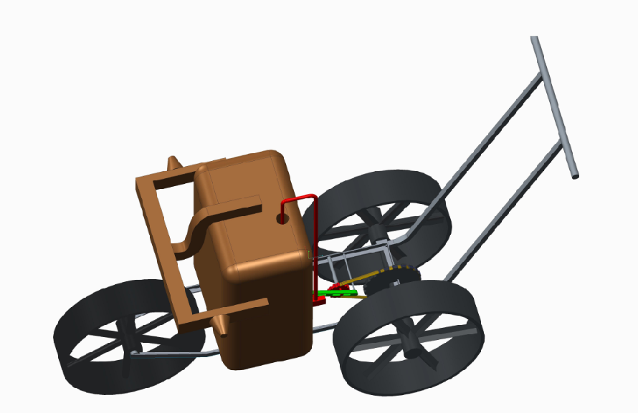

Working :-

This pump just required a push as input for its operation. A sprocket will be attach to the rear wheels of model by which a roller chain is attached which will transfer motion to a smaller sprocket. Then through slider crank mechanism this rotary motion will be converted into reciprocating motion. Then a reciprocating pump will be driven using this reciprocating motion.

Conclusion :-

The suggested model has removed the problem of back pain, since there is no need to carry the tank (pesticides tank) on the back. As suggested model has more number of nozzles which will cover maximum area of spraying in minimum time & at maximum rate. The c.f. valves can also be applied which help in reducing the change of pressure fluctuation and c.f. Valves helps to maintain pressure.

Proper adjustment facility in the model with respect to crop helps to avoid excessive use of pesticides which result into less pollution. Imported hollow cone nozzles should be used in the field for better performance. Muscular problems are removed an there is no need to operate the lever. This alone pump can used for multiple crops .

References :-

[1]Application technology: Problems and opportunities with Knapsack sprayer, Including the cf valves or Constant Flow Valves.- David McAuliffe and Vanessa P. Gray

[2] Journal of arboriculture weed control in landscape plantings1 by J.F. ahrens april 1981 vol. 7, no. 4.

[3] Backpack Sprayer-Modified for small farm Crop Protection-Rutgers Snyder Research & Extension Farm Staff–Edited by John Grande and Jack Rabin.

[4] To Spray or Not to Spray: Pesticides, Banana Exports, and Food Safety John S. Wilsona Tsunehiro Otsuki*,b a b Development Research Group (DECRG), World Bank, 1818 H Street NW, Washington, D.C. 20433, USA March 2002.

[5] Farmers understanding of pesticides safety labels and field spraying practices. By Oluyede Clifford Ajayi and Festus K. Akinnifesi_Scentific Research and Essay Vol (2), pp.204-210, June 2007 ISSN 1992-2248@2007 Academic Journals

[6] Wilcoz. M. 1969. A sprayer for application of small amounts of herbicides to flats. Weed Sci. 17:263-264

[7] Performance evaluation of bullock drawn sprayers for cotton crop-m. Veerangouda, k. V. Prakash, jag jiwan ram and g. Neelakantayya

[8] Designing, construction and evaluation of tractor-back sprayer with Variable Rate Technology (VRT) by using aerial maps information Mehrdad Fouj Lali1, Parviz Ahmadi Moghadam2 1 msc in Mechanics of Agricultural Machinery, Urmia University, Iran 2 Assistant Professor in Mechanics of Agricultural Machinery, Urmia University, Iran.

[9] Effect of the Constant Flow Valves on Performance of Pesticide Sprayer by A. R. Tahir, F .H .Khan, A. A. Khan 1560-8530/2003/05-1-49-52 International Journals of Agriculture and Biology

[10] Maharashtra Progressive Agriculture – A new Horizon –Confederation of Indian Industry

[11] Modification of a knapsack sprayer for more efficient use j. Founk

[12] Small farmers in India-Challenges and opportunities- S.Mahendra Dev-

[13] Modification of a Knapsack Sprayer for more efficient use- J.Founk Research Station, Agriculture Canada, Harrow, Ontario NOR.