Forced air induction in automobiles
STUDY OF FORCED AIR INDUCTION TECHNIQUES

Shantanu Pardhi
Dept of mechanical engineering
K D K College of Engineering
Nagpur, India
shantanupardhiimspeed@gmail.com

Abstract— This technical review paper gives information about the fundamentals and the advanced application of ‘Forced Air Induction’ techniques used in automobiles engines today. The paper goes through various primitive and modern ways viz. Supercharging, Turbocharging and Ram Air induction used to increase automobile engine performance by forced air induction. Their different modes and forms of application have also been studied broadly. The science behind these techniques like compressor mapping and present day development in this field such as Heat Energy Recovery System(HERS) and others have also been briefly discussed.

Introduction

In today’s world advancement in transportation field has lead to the creation of different problems. Problems based on the way of use, availability of fuel, manufacturing materials, size, type of terrain for use, climatic conditions and others are proposing challenges onto the Designers and manufacturer to create better automobile product that fulfills the needs of the modern world. Use of technology and advanced phenomenon is being done extensively onto this sector to achieve great heights. Use of different ‘Forced Air Induction' techniques onto the engines to develop more performance at the cost of lesser inputs in terms assembly size, materials, fuels etc is a great example of the advancement being made today in this field.

Forced air induction in automobiles
Today vehicles need to produce more power under constrains of weight and space. Also this has to be done in under minimum possible engine size and under highest possible fuel economy. It becomes difficult to make vehicle engines that operate with good output at higher altitude working conditions. It is seen that 3% of Horsepower drop occurs in general for every 1000 feet rise in altitude in normally aspirated vehicles. These constrains have made achieving higher performance from vehicle engines very difficult. Thumb rule says that an efficient engine produces 1 horsepower per cubic in. A very powerful engine for its size produces more than 100hp for 1000cc. To achieve this level of performance and minimize related problems the use of ‘Forced Air Induction’ techniques is done. Forcing more air + fuel mixture into the engine to increase the pressure in its intake manifold, bmep (break mean effective pressure) in cylinders thus developing more torque at the crankshaft and more power

is the fundamental behind ‘Forced Air Induction’ technique. If an engine is forced air induced then 30 to 60 % more power will be produced than in case of natural aspirated engine. In force air induction the measurement of increase in pr. (boost) is done in engine intake manifold or at other crucial places and is measured in ‘pounds per sqr Inch’ psi. The following are various types of forced induction techniques in use

1. Supercharging
2. Turbocharging
3. Ram air induction

Supercharging
In supercharging Rotational power from the crankshaft is used in via fan belt to run an air pump which sucks more air from atmosphere and provides it to the engine at high pressure. Superchargers have to work at very high rotations of 100000 rpm, the use of gearing is done to achieve this. Refer Fig1. Supercharging an engine drinks in more power produced by the engine to run as compared with the turbocharging so it is not conventionally used to increase mileage in automobiles but only for power output. Loss of power in supercharger is known is parasitic loss of power. This loss occurs during its running when working at very low or high pressure, low or high rpm. Bypass valve and magnetic clutch are used to prevent it. Also in superchargers power is provided throughout the rpm (rev) band thus making more power available at any given rpm of the engine without any lag. Supercharged vehicles are not much affected by high altitude working conditions. Supercharging is used in sports or luxury vehicles as it can increase the power output and mileage is not of much importance here. The use of supercharging is also done in major proportions on racing and high speed applications where instantaneous power is required.

- Advantages: Instantaneous higher power available on giving more gas, Easier phenomenon to build and install.
- Disadvantages: Although it boosts power output it also takes a lot of power directly from the crankshaft about as high as 40%so even if the boosted power obtained is 80%the new overall output will still be 140% and not 180%. It is big and heavy in construction as compared to other alternatives so acquires more space and needs modifications in the engine bay.
- Attachments: Blowers, intercoolers, modified exhaust system, cooling agent injectors, pressure gauges, bypass valve and magnetic clutches. 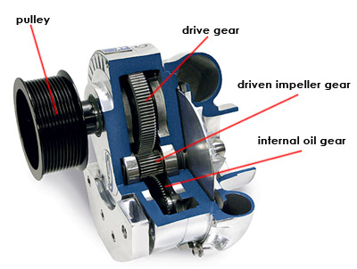
Fig 1. GEARING ATTACHMENT IN SUPERCHARGERS

Types of superchargers in general use:-
There are two main types of supercharging used in I C engines. These are either positive displacement type or dynamic type. In positive displacement supercharging a constant pressure is obtained at all engine rpm and in dynamic supercharging an increase in pressure with increase in engine rpm is found. Today there are four main supercharging devices in common use. These are as follows:

- Root type supercharger
The roots supercharger is a positive displacement supercharger that has two rotors that are of equal size and run at the same speed as they are meshed together with gearing. These rotors are inside a casing and are ellipsoidal in shape so as they work together air gets trapped between them and is pressurized and forced out of the casing at the end into the intake manifold. These superchargers work at as high as 12 psi pressure. It is generally mounted on the engine on top of the manifold. Refer Fig 2.

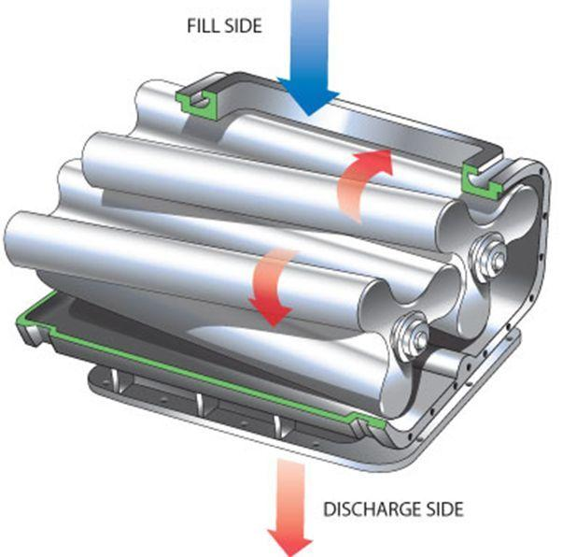
Fig 2. ROOTS SUPERCHARGER

- Centrifugal supercharger
Refer Fig 3.A centrifugal supercharger is a dynamic type supercharger in its functioning. In this device air enters at the center of the impeller and is forced outwards as the supercharger works. Air moves onto diffuser blades which are also rotating and then moves through the casing which is involute in shape and causes high pr. increase and then pressurized air is further supplied to the intake manifold of the engine. It runs with the engine by a fan belt connection and the actual blades in the casing run at as high as 80000rpm so this is achieved by some sort of gearing.
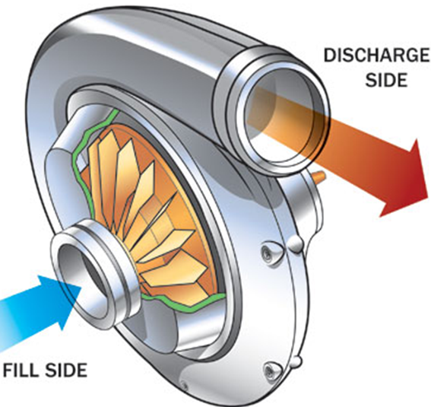
Fig 3. CENTRIFUGAL SUPERCHARGER

- Sliding vane type supercharger
Sliding vane supercharger is a Positive displacement type device. It consists of a set of vanes that are fitted inside the supercharger casing and are mounted on a drum. These are spring loaded and so as the drum is rotated by the engine the vanes always stick with the inner walls of the casing. As the air enters due to suction created by the vanes it moves along a path whose crossection decreases. The vanes do not let the air escape so it decreases in volume and so its pressure increases at the exit. Refer Fig 4.
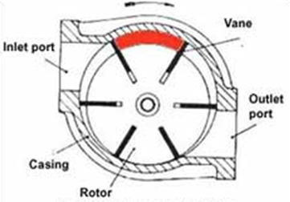
Fig 4. SLIDING VANE SUPERCHARGER
- Screw type supercharger
The screw supercharger is a positive displacement supercharger that has two screw shaped rotors that are of equal size and run at the same speed as they are meshed together with gearing. These rotors are inside a casing and are threaded in shape so as they work together air gets trapped and is pressurized and forced out of the casing at the end into the intake manifold. It is generally mounted on of the engine on top of the manifold. It is similar in construction to the root type supercharger. The only difference is in working where speed of rotations and pressure differences vary. Refer Fig 5.

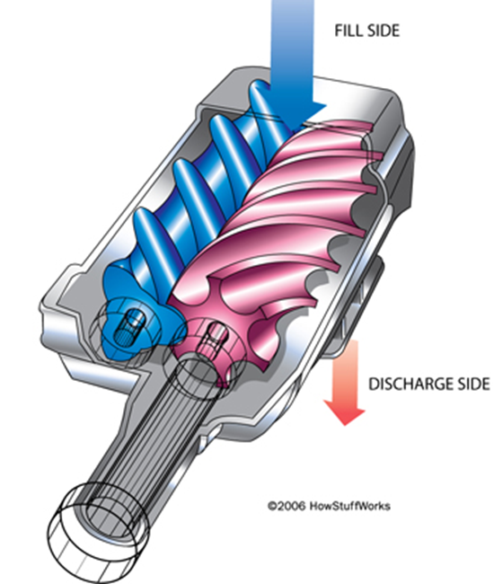
Fig 5. SCREW SUPERCHARGER

Turbocharging
As the efficiency of the supercharged system was low the use of a new technique was done to replace it .Turbocharging was invented by Alfred Buchi in 1903. The use of pressure and heat energy in kinetic form from exhaust gases is done in a turbine to further rotate a compressor to provide more fresh air pressure at the intake manifold ,thus providing more air + fuel mixture into the engine increasing bmep in the cylinders and generating more power output. The turbine and compressor are both fitted on the same shaft that runs on bearings. They both have their own casings and air enters the compressor from the center and leaves towards the casing ends and it works oppositely in case of the turbine. The bearings (fluid, ball or suspended) may be oil dipped with separate oil pump or may be cooled by the engine coolant system. A waste gate is provided along the turbine (exhaust side) that regulates the air flow (pressure) and thus the working of the device. Waste gate is controlled by on board computer (ECM) through boost control solenoid. When the throttle is closed and the pressure is not decreased then it slows down the blower, producing a lot of lag, if throttle is opened again. So a Relief valve (compressor bypass valve or BOV Blow Off Valve) is also fitted that controls the intake side of turbo compressor in case of very high pressure, thus relief valve and waste gate together try to tackle the problem of turbo pressure lag. For the power produced by the engine, turbocharger drinks lesser amount of power for running than supercharger.
Turbochargers in today’s world find a vast application from heavy load carrying vehicles to racing applications to high fuel economy vehicles and so on. In economy vehicles smaller engines can be installed in place of standard engines and still same power output can be obtained as and when needed and can be run for the rest of the time (idling or cursing) at much increased fuel economy as compared to standard engines. Turbochargers are used in both petrol and diesel engines. It is easier to run with a diesel engine as increased air flow would throw in more amount of air which would increase compression ratio which would help the diesel engine run more smoothly. This is not the case with petrol engines where increased flow and compression ratio could create the problem of detonation or could cause major damage to the system. So even today we find very little examples of turbocharging in petrol vehicles except of sports applications. The use of turbocharging is done in diesel powered load carriers as they have to run under some determined rpm band and constant break power so smaller engines can be used, increasing the mileage. It helping in increasing engine output, also used in hilly areas where the air is thinner and so lesser air is available to run the engine at good power outputs.

In turbocharging the pressure developed by the blower by extracting rotating power from the exhaust gases depend upon the behavior of the engine. As gases come into play there is sluggishness in the response as increase in rpm does not directly change the power output. This is known as turbo lag.
Apart from this turbochargers have no other significant losses, so they drink in lesser power than the supercharger taking into the consideration the increment in performance obtained. Turbocharged vehicles are not much affected by altitude rise in their working conditions. Turbochargers run at higher than 100000 rpm. Refer Fig 6.

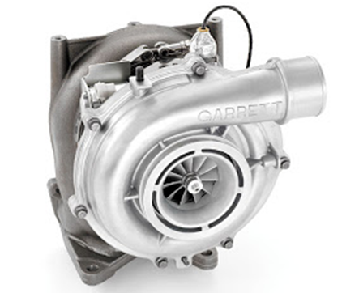

Fig 6. TURBOCHARGER UNIT

Advantages: Provides more boost as compared to the amount of energy taken from the engine in comparison to others alternatives. Require lesser space for assembly and is lighter in construction.
Disadvantages: It has a lot of lag while working (as the throttle is put on it takes time to run and runs for sometime at lower boosts).Slightly less durable as compared to supercharging. More complicated in construction and working.
Attachments: Intercoolers, waste gates, compressor bypass valve, BOV blow off valves, Relief valves.
As an e.g. of what turbocharged engines can really do we have Rod Miller’s turbo charged Toyota Celica, that has a 2.1 lit 4 cylinder engine and manages to produce a hp rating of 1000 plus with a torque rating of 745 Nm which is amazingly high for the given engine size. Now this vehicle is not a totally acceleration or top speed oriented vehicle but is a race vehicle that is used in various hill climbing racing events so it also does handle well and the engine is not supposed to be run for few seconds or minutes but actually has to perform throughout the race. It held the record for the fastest hill climb at the famous ‘pike’s peak’ race for over 13yrs.

Different forms of Turbocharging:-
- Single unit turbocharger
This is normal turbocharging with one unit consisting of a turbine and a blower with their housings, a shaft in between and a pair of ball bearings. Refer Fig 7. A waste gate is used attached to the turbine housing that regulates the pressure of waste gases and forms a bypass incase the pressure in the turbine section gets too high. It was used in primitive applications of the subject with German car makers being the very first of the applicators such as BMW and Porsche. The problem with this technique is the occurrence of a lot of pressure lag when engine is running at lower rpm or specially when just starting to accelerate. So pressure gauges were provided and even today this system is used which reads the boost in psi. There working was naturally first used in petrol engines running at higher rotations as compared to diesel engines which would run on the basis of mainly low end torque output.

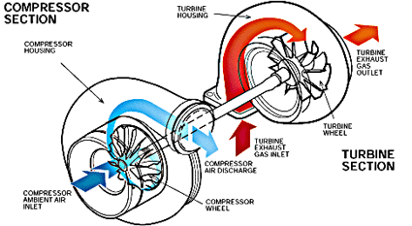

Fig 7. BASIC WORKING OF TURBOCHARGER

- Twin scroll Turbocharging
In this technique the turbine housing consist of two scrolls or volutes that together work on a single turbine wheel. In a general 4 cylinder engine instead of combining the four ports into a single exhaust manifold , two manifolds are made by combining the exhaust of middle two ports together (cylinder 2 and 3)and end ports (cylinder 3 and 4) together. The two exhaust manifolds are separately feed into turbine housing to the two scrolls.
Now we know that the firing order for a four cylinder engine is 1-3-4-2. So after cylinder 1, 3 would fire, then 4 and finally 2 and this cycle will be constantly repeated. In exhaust stroke from the first cylinder a certain amount of exhaust at high pressure is left as the valve opens and the piston goes up. In the manifold in this wave of exhaust coming out from the cylinder after a peak of the high pressure exhaust flow a small crest of low pressure exhaust occurs immediately. Refer to Fig 8. If in this case just after the high pressure peak of first cylinder, exhaust is given out by the other cylinder then peak of the second cylinder exhaust pressure wave would coincide with the crest of the first one. This would decrease the peak exhaust pressure and in a cycle in general overall exhaust pressure will be reduced that was responsible for running the turbine.
By dividing the manifolds this effect is eliminated as immediate pressure waves of exhaust from individual cylinder do not coincide as they travel alternately through separate manifolds.
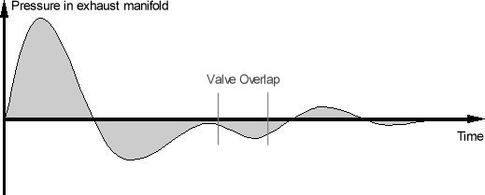
Fig 8. EXHAUST PRESSURE WAVE

The exhaust gases will meet only together in the turbine wheel after entering from separate scrolls.
Also by using twin scroll one manifold can be made to feed exhaust to a smaller scroll that generally acts at the upper portion of the turbine wheel near the exducer (From cylinder 2 and 3) thus giving high response at low speeds and reducing lag. The other manifold feeds exhaust to the bigger scroll which works at the base of the turbine wheel near the inducer thus giving good boost at higher rpm. Refer Fig 9.
Thus overall performance of the arrangement is improved. 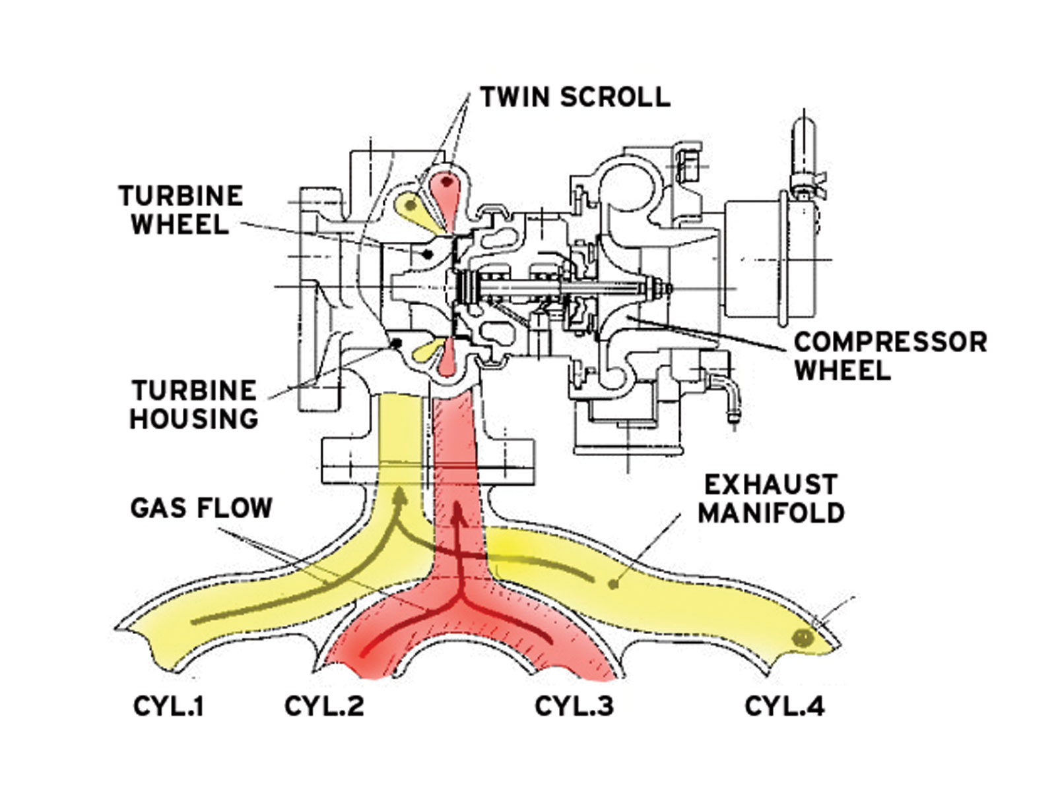
Fig 9. TWIN SCROLL TURBOCHARGING

- Twin turbocharging
In turbocharging instead of using a single unit of turbine and blower, two separate units that have their own exhaust side and pumping systems are used. These are also sometimes coupled together to run in synchronization. The given set of cylinders of the engine is run in two sets by these two units. Refer Fig 10. Twin turbocharging is not generally used for inline format engines. Its use is made generally in V or W or boxer engines. It is also though sometimes used in inline engines with more than 4 cylinders. It is used extensively in high performance sport vehicles. The advantage of using two smaller turbo units instead of a single big turbo is that the pumping that was to be done by this big turbo is now done by two much smaller units together, so although two turbo units together produce the same boost they still do not form as much pressure lag at the same or lower rpm or working conditions. Thus still more power can be generated while working in any type of condition by reducing the problem of turbo lag to a great extent. Generally in V engines separate bank of cylinders are run by separate turbo units.

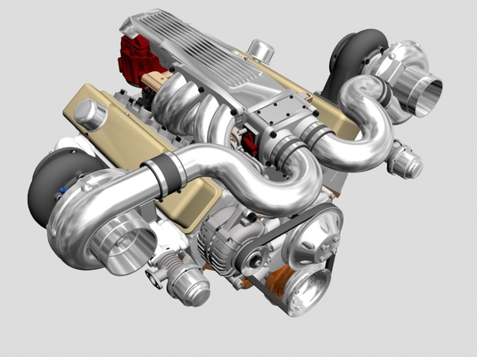

Fig 10. TWIN TURBOCHARGED ENGINE

A great example would be the engine of the koenigsegg Agera hypercar from sweden that generates 1200hp from a 5 lit V8 engine which is today the most downsized engine in the world for a production vehicle.

- Multiple unit turbocharging
In some special cases of really high demand of horsepower and torque a number of turbo units are applied onto the same engine .Either there are those many number of banks such as in the case of Bugatti Veyron hypercar where 4 turbo units run a W 16 cylinder engine with each unit running a bank. Again more power output was possible with its 8 lit engine where in if a single unit was to be used the performance obtained would had been much lesser and under different constrains as also a lot of lag would had been produced. A version of this vehicle develops 1200 hp and is the world’s fastest production car for now.

- VGT (Variable Geometry Turbine) Turbocharging
In this case of turbocharging the problems of sluggish output due to turbo lag has been reduced to a considerable extent. In this either the amount of exhaust flowing in the turbine is changed by varying the cross section of the intake or the type of flow velocity or angle is changed and maintained inside the turbine according to the working conditions. Refer Fig 11. In the second case the vane angle of stationary blades placed outside the turbine wheel is changed for maintaining a turbo lead for the compressor at all working rpm ranges by varying flow velocity and angle of incidence upon the turbine wheel and hence the lag approximately never occurs. This gives high output at any working conditions and so much higher overall performance is achieved. No waste gate is needed with VGT variable geometry turbocharger. It is controlled by the ECM unit. XUV 500 and Hyundai Verna are some examples.
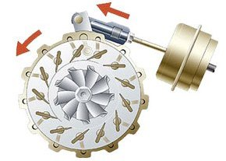
Fig 11. VARIABLE GEOMETRY TURBOCHARGER TURBINE VANE ARRANGEMENT

- VGC (Variable geometry compressor)+ VGT
Sometimes a similar arrangement of moving vanes is provided in the compressor to maintain the flow of intake air at proper pressure to achieve highest intake discharge. This along with the (VGT variable geometry turbine) arrangement is used to get the best possible results.

- Dual stage Turbocharging
This technique is generally used for diesel engines that are low reving so the amount of exhaust gases are low which are not sufficient to spool or run a large turbocharer which will be required when the engine isrunning at higher rpm.
Refer to Fig.12 here 2 sets of turbochargers are used where a smaller turbocharger runs at lower rpm thus greatly reducing the turbo lag and improving response and output at low rpm.A larger turbocharger is used when the engine runs at higher rpm where the requirement of more amount of intake air is present at higher boost by using the higher amounts of exhaust gases that are available at at those rpm.In the mid rpm range both the turbochargers run togeather where the bigger turbocharger provides for precompression and the smaller turbo does the main compression
A set of bypass valves are used on the intake and exhaust side to manage and run the whole arrangement effectively. . In some cases three turbochargers have also been used on a single engine. One such example is BMW M550d.

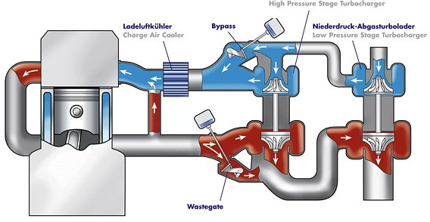

Fig 12. DUAL STAGE TURBOCHARGING

How to choose the right turbo for the application?

COMPRESSOR MAPPING
The compressor mapping helps us to decide if what model (size) of turbocharger would be best suited for our given engine for the desired output expected. Different companies supply various models of turbochargers at both OEM (production) and aftermarket level for different engine based applications. These turbochargers come with their compressor maps which are to be analyzed with respect to the given engine, the power demand and then the best possible option is to be selected accordingly.
- Compressor map
The compressor map consists of:-
Air discharge, W_{a}- on the X-axis in terms of weight per minute (lb/min) or in terms of volume flow per minute (m^3/min) or cfm (cubic feet/min).
Pressure ratio- on the Y axis represents ratio of boosted air (compressor outlet pressure) P_{c2} to inlet air pressure P_{c1} Pr.ratio=P_{c2}/P_{c1}
Efficiency islands-are placed one inside the other with highest efficiency island in the center representing how much of work was actually converted into pressure energy and how much of it was lost as heat.
Speed lines- Are curved lines that represent the turbocharger’s working speed, placed along with the efficiency islands.
Choke line-Line on the right hand side of the efficiency islands which decides the upper limit of flow. Beyond this line the compressor would begin to choke with inlet air. The running speed increases and efficiency falls rapidly beyond the choke line. It means that the turbocharger falls very short for the given engine arrangement beyond this line.
Surge line-Line on the left hand side of the efficiency islands which represents lower limit of flow beyond which flow instability occur. After this line working speed of the turbocharger will drastically reduce. If operation is done for long time in surge bearing failure could occur. Region after this line represents that the turbocharger is too large for the given engine arrangement to run.
- Terminology and estimation
A/R ratio: Is the ratio of Area of cross section of volute in the compressor to the radius (distance between the center of the compressor and the center of volute).It determines the amount of air that can pass or that can be pumped through the given compressor. Larger the A/R ratio more is its flow capacity and vice-versa.
Trim: It is the ratio of areas to describe both the turbine and compressor housing wheel performance.
Trim= (Inducer dia.)²/(Exducer dia.)² x 100( in mm).
- Things to find out
- 1.Actual discharge of air –W_{a}
- 2.Boosted pressure P_{c2} to meet the horsepower expected.
We need to know:-
- Engine displacement in cubic inch,
- Power output expected in hp,
- Max rpm at which the power output is expected,
- Ambient conditions of the setup (pressure and temperature).
Things to estimate-
- η_{vol}: Volumetric efficiency of the engine (generally 95-99% for 4 valve and 88-95% for 2 valve setup).
- T_{m} : Inlet air temp in degree Fahrenheit.
- bsfc (Brake specific fuel consumption) in lb/hp*hr.
(It takes approx.. 1lb/min to support 10 flywheel hp.)
- Formulae
W_{a}= hp x A/F x (bsfc/60) -(1)

P_{c2}= [W_{a} x R x (460 + T_{m} )]/ [η_{vol} x (N/2) x V_{d}] -(2)
Here,
W_{a} is in lb/min
R is gas constant=639.6
V_{d} is engine displacement in cubic inch.
P_{c2} calculated is absolute. For boost pressure by the compressor,
Boost pr. = P_{c2}-P_{c1.}
P_{c2(actual)}= P_{c2}+ P_{losses} (in piping and manifold)
P_{c1(actual)}= P_{atm}- P_{losses}(in intake and air filter)
Calculate the values of W_{a} in lb/min and Pr. ratio (P_{c2(actual)} / P_{c1(actual}) and plot them on X and Y axis respectively. Then make vertical and horizontal lines from these points into the map. The point at which these lines intersect is the point representing the working conditions of the given setup for the turbocharger unit whose map is being studied. Plot this point on various maps and choose the one on which the point lies on high valued efficiency island.
If we continue straight towards left till the surge line the point of intersection on the surge line will represent the point at which the turbocharger will spool up and begin to help engine generate power. W_{a} for this point will be the discharge at which the turbo will begin to work or spool up. From this value of W_{a} and formula (2) from above keeping other values constant we can find the engine rpm at which the turbo will start creating positive boost and thus power.
Generally if by compressor mapping a turbocharger suits a given engine application there is no need to have analysis upon the turbine side as it is designed to work with the flow accordingly.
Thus according to the type of application, demand of power whether at lower or higher rpm, type and size of engine etc. the correct turbocharger unit for the application is chosen by the help compressor mapping.
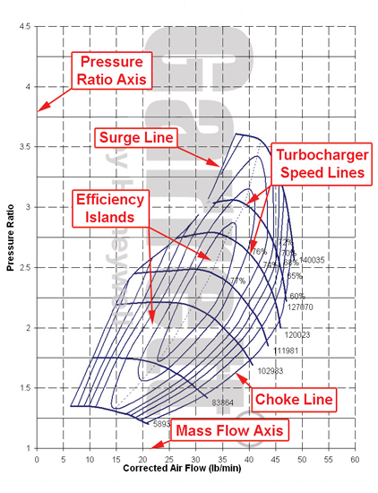
COMPRESSOR MAP

- HERS (Heat Energy Recovery System)
In this system the turbo lag is reduced and its response is greatly increased by using a MGU (motor generator unit). It is coupled to the shaft of the turbocharger via gearing or directly. When accelerating the MGU works as a motor spooling the the turbocharger quickly thus increasing response and reducing lag. When decelarating the turbo tends to keep on moving faster and not reducing its speed quickly thus producing turbo lag when reaccelerating again. To reduce the turbo speed the MGU works as a generator thus braking the speed and generating electricity which will further be used by the MGU to speeden up the turbo when accelerating.
The MGU is connected to the battery and controller where it stores and uses electricity from and from where it recieves the comands to work from.

This kind of system of turbocharging is being currenly used for the 2014 formula 1 engines which are coming out to be the most efficient gasoline power plants with upto 35% overall efficiency.

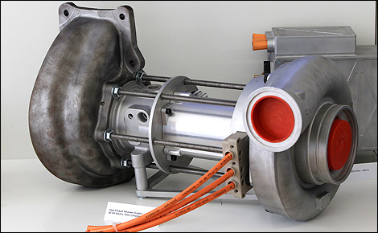
Fig 13. HEAT ENERGY RECOVERY SYSTEM

Failures in turbochargers:
1. Whooshing sound in turbo due to bearing failure or leakages is common.
2. Excessive oil consumption in turbo due to leak into the blower or turbine from turbo bearings leading to blue smoke.

Ram air induction
DIRECT AIR INDUCTION (DAI)
In this case air is forced into the engine cylinders through the fueling system by increasing static air pressure in the intake manifold of the engine. Drawing air in from a varied section air intake that decreases speed of dynamic air to increase its pressure is done. As the vehicle is moving at respectable speeds air is moving in backward direction against its body. Refer Fig 14. Providing ducts or scoops along the body to take this air into the intake manifold with great pressure thus thrusts respectable more air +fuel mixture into the air box, making the engine generate much higher torque and power is ‘Ram Air induction’. The box outside the manifold that collects this air and increases pr. is known as air box. No use of engine power is done to force air into the engine in this system so it is a very efficient way of increasing engine output.

- Advantages: There is no actual power needed to drive the system thus more power can be extracted from the engine in all. Going faster gives in more boost thus more power which is actually needed at higher speeds to accelerate.
- Disadvantages: The amount of boost developed is not much as compared to other options so increment in power under very ideal conditions is not more than 8 to 10% in comparison to the actual power of the engine. It does not provide any increment at medium or lower travelling speeds.
- It is used in very high performance automobiles such as racing cars, super bikes, as it requires the vehicle to go at very high speed. It has been used in formula 1 racing and in other racing sports.

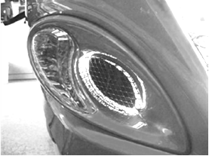

Fig 14. AIR INTAKE SCOOP FOR RAM AIR INDUCTION FROM SUZUKI HAYABUSA

Intercooling
In Forced Air Induction air temperature increases due to which increases combustion temperature and so the risks of detonation increase in the engine. Even after boosting more air into the engine by turbocharging or supercharging, still some constrains come into play upon the amount of air that can be pumped in the engine because as the air gets compressed it becomes hot, so comparatively lesser amount of air can be

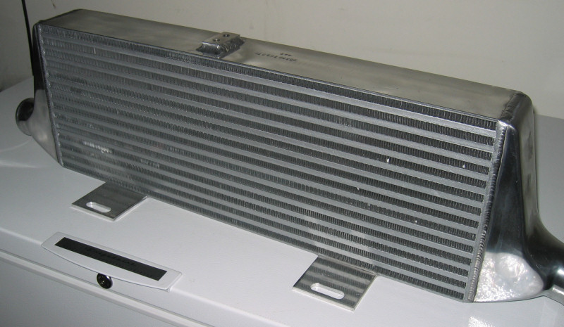
Fig 15. AN INTERCOOLER

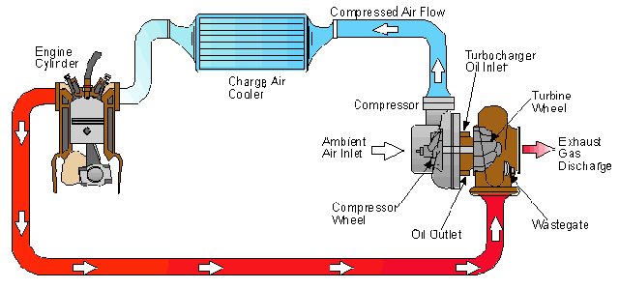
Fig 16. INTETRCOOLER ARRANGEMENT

pumped into the engine cylinders as hot air has more volume and is difficult to compress. Also this air would be much difficult to work upon in the compression stroke of the engine so more amount of work would be wasted to operate. To lessen or avoid this problem the use of intercooling is done. Refer Fig 15. In this use of air cooled radiators (intercoolers) is done that use atmospheric air to cool the boosted intake side air to make it cooler and easier to compress. Refer Fig 16. This process leads to higher overall output from the engine as more air + fuel mixture is forced and lesser amount of work is wasted in the compression stroke in the engine. Also lesser amount of work is needed to run the very blower that forces air into the engine. Thus an intercooled force induced engine performs better in overall as compared to a non intercooled engine. Increase in power by cooling air is found in general to be 1 % for every 10 deg Fahrenheit. Intercoolers may be air cooled or sometimes even water cooled depending upon the cooling medium used. Intercoolers may be classified as Front Mounted Intercooler (FMC), Side Mounted Intercooler (SMC) and Top Mounted Intercooler (TMC) depending upon the position in which they are fitted in the engine bay.

TURBOCHARGER+SUPERCHARGER+ INTERCOOLER
In this special modern case of ‘forced air induction’ the use of a turbocharger and a supercharger is done together with an intercooler to get the maximum performance in terms of both mileage and power output. Supercharger runs at lower rpm and is operated by attaching or detaching it with the help of a clutch from the engine. At higher rpm the use of the turbocharger is done to force more air into the engine at high pressure. The air network is operated by means of valves and
clutch run by the ECM with respect to the running situation of the engine. Refer Fig 17.

Golf GTI mk6 from Volkswagen uses a 1.4 lit engine is used to produce 170 Ps of power which would require a 2.3 lit normally aspirated engine to produce in ideal conditions and it
does it almost throughout the rpm (rev) range. The Mileage obtained is also 20% better.

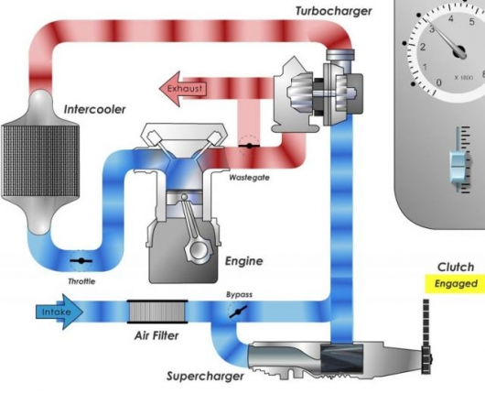

Fig 17. TURBOCHARGER+SUPERCHARGER+ INTERCOOLER

NOTE: In forced air induction the Cylinder heads are restricted with small valves or ports. The turbocharging or supercharging quickly provides boost. By increasing the size of valve the turbo or supercharged engine can be made to produce more power.
In installing of forced air induction with bigger variations in working air pressures, if first fueling system then the device and then engine are fitted, intake pr. will need to be regulated but if first device then the fueling system and then engine is fitted no pr. regulation will be needed.

AKNOWLEDGMENT

I would like to thank,
Dr C. C. Handa,
HOD Mechanical department,
K D K College of Engineering
for his support and encouragement which has helped me completing this technical paper successfully.

REFERENCES

[1] Automotive Mechanics by Croose and Anglin
[2] Automotive Engines Automobile by S Srinivasan
[3]Automotive Engine Theory and servicing by James D halderman Chase D michell Jr.
[4] Internal Combustion Engines by V Ganesan
[5] Automobile Engineering by Dr. Kripal Singh
[6]www.wikicars.org
[7]blogs.howstuffworks.com
[8]www.turbo.com
[9]www.Images-Google.images.co.in
[10]www.Images-turbomagazine.com
[11]www.gizmag.com
[12]www.rricketts.com

[13]Internal Combustion Engines by Dr. V. Yadav.

[14]www.turbobygarrett.com

