**KINETIC ENERGY RECOVER SYSTEM**

Tushar Kondalkar**,**

Priyadarshini Bhagwati College of Engineering, Nagpur

Email:-Tusharkondalkar@rocketmail.com

***Abstract-----*KERS is a technology which is in its infancy, but once it has developed sufficiently, it could be one of the best things to have happened in the automobile world. KERS stands for Kinetic Energy Recovery System. Basically, its working principle involves storing the energy involved with deceleration and using it for acceleration. That is, when a car breaks, it dissipates a lot of kinetic energy as heat. The KERS system tries to store this energy and converts this into power that can be called upon to boost acceleration.**

**Keywords-**

**K.E-Kinetic Energy**

**KERS-Kinetic Energy Recovery System**

**MGU-Motor Generator Unit**

**CVT-Continuously Variable Transmission**

**F1-Formula one**

I. INTRODUCTION

At the present state of research, there are two ways in which KERS can be implemented. Energy can be stored as mechanical energy (as in a flywheel) or as electrical energy (as in a battery or super capacitor). The electrical system uses a motor-generator incorporated in the car’s transmission which converts mechanical energy into electrical energy and vice versa. Once the energy has been harnessed, it is stored in a battery and released when required. **[1].** The introduction of Kinetic Energy Recovery Systems (KERS) is one of the most significant technical introductions for the Formula One Race. Formula One have always lived with an environmentally unfriendly image and have lost its relevance to road vehicle technology. This eventually led to the introduction of KERS. **[5]**

KERS is an energy saving device fitted to the engines to convert some of the waste energy produced during braking into more useful form of energy. The system stores energy produced under braking in a reservoir and then releases the stored energy under acceleration. The key purpose of the introduction was to significantly improve lap time and help overtaking. **[3]** KERS is not introduced to improve fuel efficiency or reduce weight of the engine. It is mainly introduced to improve racing performance. KERS is the brainchild of FIA president Max Mosley. It is a concrete initiative taken by F1 to display eco-friendliness and road relevance of the modern [F1cars](http://blog.carazoo.com/2008/01/indian-f1-challenger-to-be-unveiled.html). It is a hybrid device that is set to revolutionize the Formula One with environmentally friendly, road relevant, cutting edge technology.**[1]**

II. WHAT IS KINETIC ENERGY (K.E)

Kinetic energy is the energy of motion. If a body is in motion it has kinetic energy but if a body is not moving, its kinetic energy is zero. Mathematically kinetic energy is defined as:

Untitled-1

Where:   
M = mass of the body in motion  
V =linear velocity of the body **[5]**

Normal brake operation

In general, to slow down a moving vehicle or bring it to a stop the friction brakes are pressed. The vehicle is decelerated by converting the kinetic energy of the vehicle into heat at the surface of the brakes which is then given up to the air flowing over the brakes. That is, there is a conversion of kinetic energy into heat energy, but in this process the heat energy is lost and is not recoverable**. [5]**

III. COMPONENT OF KERS

* Electric motor-generator

An electric motor positioned between the fuel tank and the engine is connected directly to the engine crankshaft to produce additional power.

* KERS control unit

A KERS control box monitors the working of the electric motor when charging and releasing energy.

* High voltage lithium –ion batteries

High voltage lithium-ion batteries used to store and deliver quick energy.

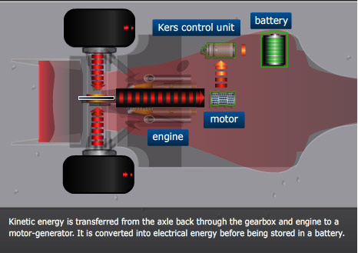

IV. PRINCIPLE & WORKING

* Energy cant be created or destroyed , but it can endlessly converted **[5]**

V. WORKING

KERS is a collection of parts which takes some of the kinetic energy of a vehicle under deceleration, stores this energy and then releases this stored energy back into the drive train of the vehicle, providing a power boost to that vehicle. For the driver, it is like having two power sources at his disposal, one of the power sources is the engine while the other is the stored kinetic energy**. [1-5]**

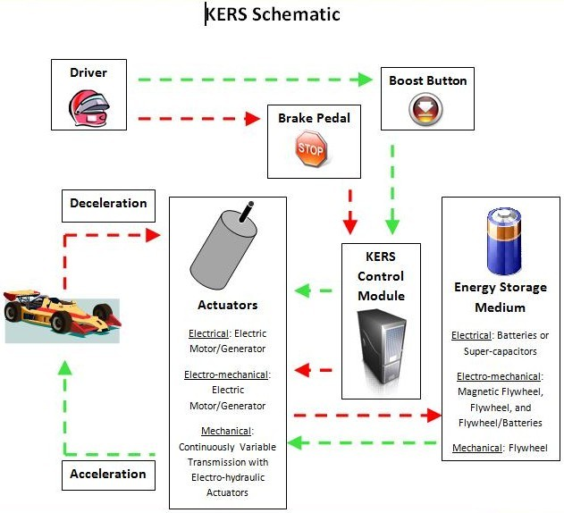

VI. TYPE OF KERS

There are two basic types of KERS systems:

* Electronic
* Electro-Mechanical

The main difference between them is in the way they convert the energy and how it is stored within the vehicle.

VII. ELECTRONIC KERS

In electronic KERS, braking rotational force is captured by an electric generator unit (MGU) mounted to the engines crankshaft. This MGU takes the electrical energy that it converts from kinetic energy and stores it in batteries. The boost button then summons the electrical energy in the batteries to power the MGU. The most difficult part in designing electronic KERS is how to store the electrical energy. **[1-6]**most racing systems use a lithium battery, which is essentially a large mobile phone battery. Super-capacitors can also be used to store electrical energy instead of batteries; they run cooler Batteries become hot when charging them so many of the KERS cars have more cooling ducts since charging will occur multiple times throughout a race. Super-capacitors can also be used to store electrical energy instead of batteries; they run cooler and are debatably more efficient. **[6]**

VIII. ELECTRICAL STORAGE SYSTEM

The well documented electrical hybrid systems utilize chemical batteries as the storage medium and electric motor / generator systems as the energy transfer and control media **[3]**. KERS components for battery storage systems are: Electric Propulsion Motor /Generator, Power Electronics – Inverter, and the Quad Flywheel Storage **[3] [7]**. Electric Propulsion Motor and Generator in one are also known as a MGU – Motor Generator Unit **[7]**. Capacitors are fundamental electrical circuit elements that store electrical energy in the order of microfarads and assist in filtering. The main function of a capacitor is to charge or discharge electricity **[1]**. Super-capacitors have special features such as long life, rapid charging, low internal resistance, high power density, and simplecharging method as compared to capacitors and batteries **[2]**

IX. ADVANTAGE OD ELECTRONIC KERS

* The electric systems allow the teams to be more flexible in terms of placing the various components around the car which helps for better weight distribution which is of vital importance in F1.
* The specific energy of Lithium-ion batteries in comparison is unrivalled as they can store considerably more energy per kg which helps reduce the size of RESS.**[3-6]**

X. ELECTRO-MECHANICAL KERS

The Electro-Mechanical KERS is invented by Ian Foley. The system is completely based on a carbon flywheel in a vacuum that is linked through a CVT transmission to the differential. With this a huge storage reservoir is able to store the mechanical energy and the system holds the advantage of being independent of the gearbox. The braking energy is used to turn the flywheel and when more energy is required the wheels of the car are coupled up to the spinning flywheel. This gives a boost in power and improves racing performance**. [4]**

In electro-mechanical KERS energy is not stored in batteries or super-capacitors; instead it spins a flywheel to store the energy kinetically. This system is effectively an electro-mechanical battery.**[2]** Therefore, the flywheel spins very fast to speeds of 50,000 - 160,000 rpm to achieve sufficient energy density. The flywheel in this system is a magnetically loaded composite (MLC). The flywheel remains one piece at these high speeds because it is wound with high strength fibers. The fibers have metal particles embedded in them that allow the flywheel to be magnetized as a permanent magnet. The flywheel will perform similarly to an MGU**. [4-2]**

XI. MECHINICAL STORING SYSTEM

The mechanical hybrid utilizes a rotating mass (or flywheel) as the energy storage device and a variable drive transmission to control and transfer the energy to and from the driveline **[4].** The transfer of vehicle kinetic energy to flywheel kinetic energy can be seen as a momentum exchange **[4]**. Energy is drawn from the vehicle and supplied to the flywheel. In doing this, the speed of the vehicle reduces, (effectively this is braking), whilst the speed of the flywheel increases **[5]**. At the start of braking the vehicle has a high speed and the flywheel a low speed, giving a certain gear ratio between them **[5].** At the end of braking the vehicle has a low speed, and the flywheel a high speed, so the ratio of speeds has changed **[4]**. Examination of the energy transfer shows that the ratio between vehicle speed and flywheel speed necessarilychanges continuously during the energy transfer event **[5]** .Flywheel based mechanical hybrid systems are not new – systems have previously been developed by the Technical University of Eindhoven and Leyland Trucks amongst others and indeed it is possible to ride on a Flywheel powered tram from Stourbridge junction in England – and a flywheel based system is not without areas requiring focus (most notably the failure modes of the rotating mass and the method of control and transmission of the energy to and from the flywheel.) **[4].** It has been put into use for Formula 1 cars since the year 2009 **[4] [5] [1]**

XII. ADVANTAGE OF ELECTRO-MECHANICAL KERS

* The specific power of flywheels in comparison is much greater than that of batteries.
* The energy lost during transfers amongst the system components is relatively less due to high efficiency.
* The flywheel system can deliver almost the entire amount of energy stored in it, repeatedly without any decline in efficiency.
* The mechanical system does not need to be replaced as its life cycle is as good as that of the car.**[4-2]**

XIII. APPLICATION

* This system is used in F1 car racing for increase overtake during formula one race, as the boost button provides extra power .**[2]**
* In effect, the KERS has also used to act as a defensive tool to block a faster car , inhibiting overtaking**[2-3]**

XIV. CONCLUSION

* The invention of KERS has proved that it is very useful to store the wastage kinetic energy and reuse it for the boosting the speed of the car
* Apart from increasing overtaking the main purpose of introducing KERS was to challenge the best engineers in the business to develop innovative ideas that would directly benefit the mainstream motor industry. Given the resources and pace of developments in F1,
* The Kers systems produced by the teams would have taken the car manufacturers much longer to develop. Both the types of KERS can be retrofitted in cars albeit with minor modifications. Given the current trend of engine downsizing they can add substantial amount of performance to the car without affecting the engine and average. The mechanical system is more efficient than the electrical systems that use inefficient batteries which make them more likely to be induced in cars in the near future. The flywheels used in F1 cars were pretty powerful though they will be modified to suit real world situations which will be capable of storing 75kW and weigh about 35-40kg which compared to current battery systems is half the weight as seen in.

XV. ADVANTAGE

* High power capability.
* Light weight and small size.
* Long system life.
* Completely safe.
* A truly green solution.
* High efficiency storage and recovery.
* Low parasitic losses.
* Low embedded carbon content

XVI. REFERENCES

1. wikipedia.Kinetic_energy_recovery_system
2. www.formula1.com
3. www.gizmag.com/formula-one-kers/11324/
4. www.f1fanatic.co.uk/2009/01/11/kers-explained-how-a-mechanical-kinetic-energy-recovery-system-works
5. Chibulka J., “Kinetic Energy Recovery system by means of Flywheel Energy storage device,” Advanced Engineering, vol.27-38, 2009.
6. www.f1fanatic.co.uk/2009/01/11/kers-explained-how-a-electronicl-kinetic-energy-recovery-system-works