**FABRICATION OF ADJUSTABLE MULTI NOZZLE SPRAYER PUMP**

**SUBMITTED BY**

**Ashish R. Dahiwale Rushikant A. Nerkar**

DEPARTMENT OF MECHANICAL ENGINEERING MADHUKARRAO PANDAV COLLEGE OF ENGINEERING ,BHANDARA

rushikantnerkar16@gmail.com

**ABSTRACT**

India is a land of agriculture which comprises of small, marginal, medium and rich farmers. Small scale farmers are very interested in manually lever operated knapsack sprayer because of its versatility, cost and design, but this sprayer has certain limitation like it cannot maintain required pressure. It lead to problem of back pain. However this equipment can also lead to main application of chemical and an effective control of target pest which leads to loss of pesticides due to dribbling of drift during application. This phenomenon not only add to cost of production but also cause environment pollution and imbalance in natural pesticides sprayer pump which will perform spraying at maximum rate in minimum time. Constant flow valves can be applied at nozzle to have uniform nozzle pressure

**keywords :** nozzle, rocker spray, chain sprocket arrangement, hose pipe , wheels.

**INTRODUCTION**

Agriculture plays a vital role in Indian economy. Around 65% of population in the sate is depending on agriculture. Although its contribution to GDP is now is now around one sixth, it provides 56% of Indian work force. The share of marginal and small farmer is around 81% and land operated is 44% in 1960-61. As far as Indian scenario is concerned, more than 75% farmer are belongs to small and marginal land carrying and cotton is alone which provides about 80% employment to Indian workforce. So any improvement in the productivity related task help to increase Indian farmers status and economy. The current backpack sprayer pump has lot of limitation and it required more energy to operate. The % distribution of farm holding land for marginal farmers 39.1 % for small farmers 22.6% , for small and marginal farmers 61.7% for semi medium farmers 19.8% for medium farmers 14% and for large farmers 4.5% in year 1960-61. It clearly explain that the maximum % of farm distribution belonged to small and marginal category.

**DRAWBACKS IN EXISTING SPRAYER PUMPS**

The Indian farmers are currently using lever operated backpack sprayer. A backpack sprayer tank 10-20 liter capacity carried by two adjustable strap. Constant pumping is required to operate this which result in muscular disorder. Also, the backpack sprayer can’t maintain pressure, results in drift/dribbling. Developing adequate pressure is laborious and time consuming. Pumping to operating pressure is also time consuming. Morever, very small is covered while spraying. So, more time are required to spray the entire land. Back pain problems may arise during middle age due to carrying 10-20 litres tank on back.

**OBJECTIVES**

1. To eliminate the problem of back pain due to the carry the tank(pesticides tank) on the back
2. To cover maximum area of spraying in minimum time & at maximum rate
3. To minimize the fertilizer droplet from the nozzle
4. To spray the fertilizer effective in congested space
5. To adjust model with respect to crop. To avoid excessive use of pesticides.

**LITERATURE REVIEW**

While much of modern agriculture is based on mass mechanized production, advances in sensing and manipulation technologies may facilitate precision autonomous operations that could improve the crop yield and quality while saving energy, reducing manpower, and being environmentally friendly. Agriculture is the backbone of human civilization. It evolved with human history whereas in the righteous book; Al-Quran there are verses of agriculture significance invariably in many societies agriculture integrates into various socio-religious practices. Refer to Imam Nawawi on Kitab Sahih, the best work or effort for the human being is agriculture. In Malaysia, agriculture was, and is always an important government agenda to ensure the country’s food security for all the people (Mohd *et al*., 2008)

Site–specific targeted spraying can lead to reduced pesticide application thereby, improving sustainability and overcoming environmental concerns, reducing material costs and human labor, and diminishing medical hazards. Currently, spraying in vineyards is conducted homogenously along the rows, without considering areas with low foliage density or gaps between the grapevines. Estimates indicate that 10-30% of the pesticide agents can be reduced by using smart sprayers targeted towards foliage only (Hanks, 1996).

Typically, foliage spraying is done by using boom that covers its entire height. The spraying boom is dragged along the row and sprays the entire foliages. While spraying is done non-selectively, spraying the grape clusters is done in one row of two ways. Often, a human carries a portable sprayer and sprays the plants individually. This operation is very time consuming and labor intensive.

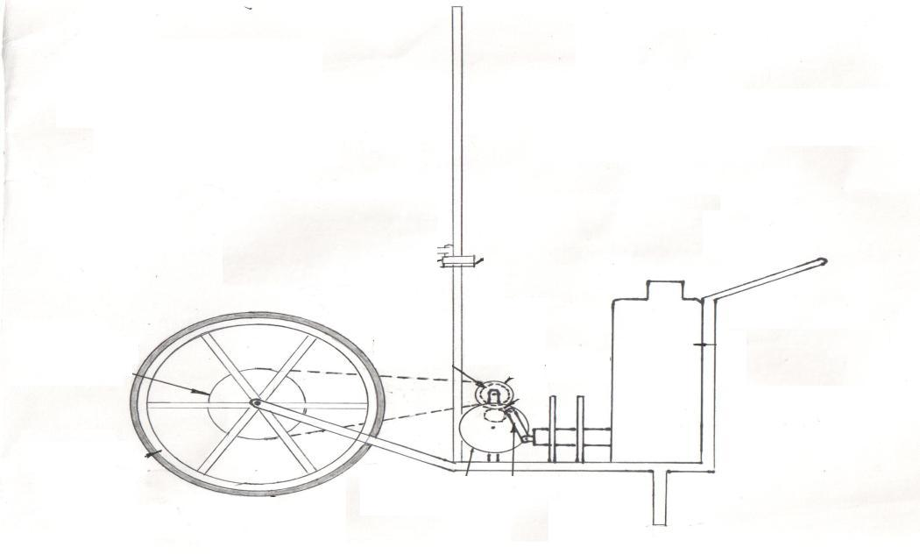

**Figure 1. Diagram of proposed model**



**Figure 2. PRO-E Design**

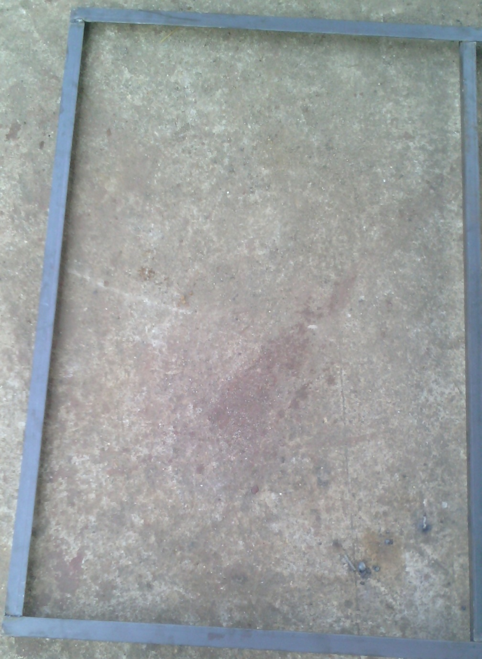

**Figure 3. Chassis**

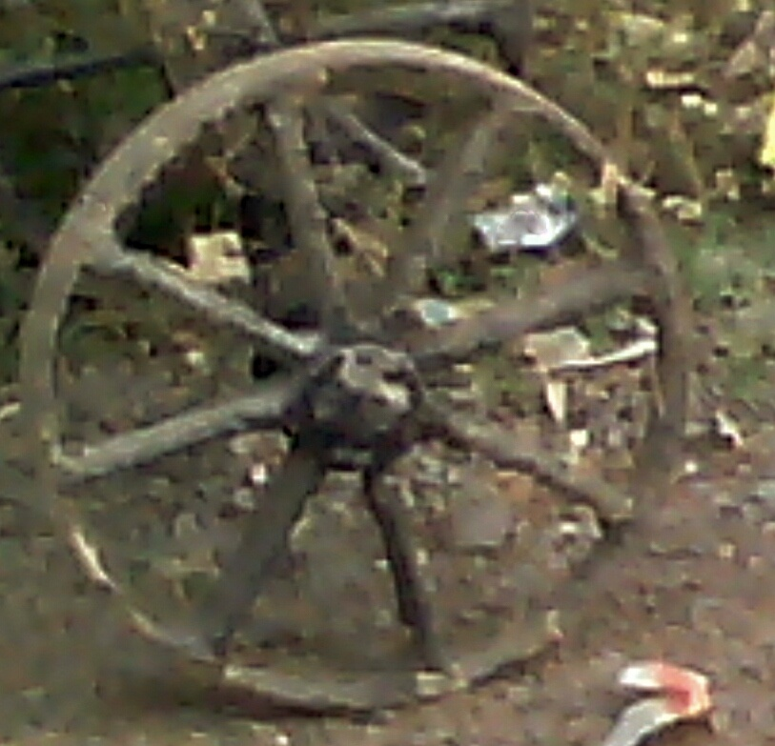

**Figure 4. Wheel**

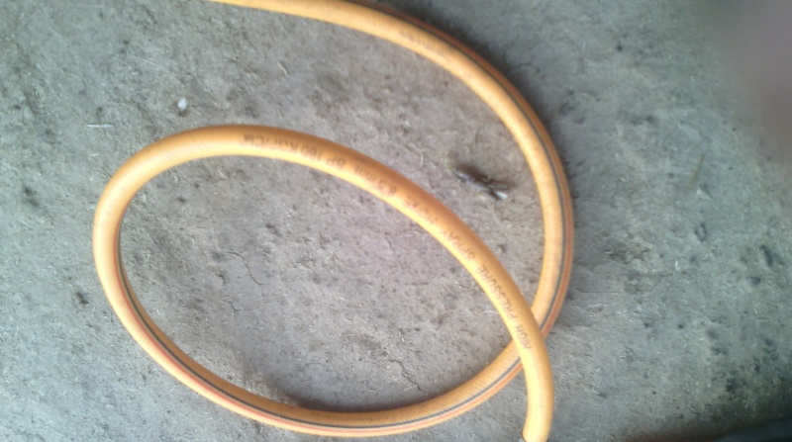

**Figure 5. Hose pipe**

**WORKING**

The working of this manually operated multi nozzle pesticides sprayer pump is based on the principles of motion transmission due to chain and sprocket arrangement and plunger cylinder arrangement. The operator stands behind the trolley. He will grab the handle and lift it and push the trolley forward. As sprocket is mounted on same shaft of wheel, it also rotates in counter clockwise direction.This motion is transferred to freewheel via chain drive arrangement. Freewheel,thus also starts rotating in counterclockwise direction. As freewheel and big spur gear are mounted on same shaft, it also starts rotating in anti clockwise direction. This will rotate small spur gear in clockwise direction. This will rotate small spur gear in clockwise direction as it is externally meshed with it. Due to this, the disc start rotating which give motion to link as it is fixed on the disc. The plunger is attached to disc via link. The plunger got motion due to this which stimulates pesticides to come outside via six nozzles

**CONCLUSION**

1.The suggested model has removed the problem of back pain, since there is no need to carry the tank (pesticide tank) on the back

2. As suggested model has more number of nozzles which will cover maximum area of spraying in minimum time & at maximum rate

3. The c. f. valves can also be applied which help in reducing the change of pressure fluctuation and c.f. valves help to maintain pressure

4. Proper adjustment facility in the model with respect to crop helps to avoid excessive use of pesticides which result into less pollution

5. Imported hallow cone nozzles should be used in the field for better performance

6. Muscular problem are removed and there is no need to operate the lever

7. This alone pump can used for multiple crop.

**REFERENCES**

1.Application technology; Problems and opportunities with Knapsack sprayer ,Including the cf constant Flow Valves:-David McAuliffe and Vanessa P.Gray

2.Journal of arboriculture weed control in landscape plantings by J.F. Ahrens April 1981 vol.7, no. 4.

3.Backpack Sprayer- Modified for small farm Crop Protection-Rutgers Snyder Research & Extension Farm Staff-Edited By John Grande and Jack Rabin

4.To Spray or Not to Spray: Pesticides,Banana Expo

rts, and Food Safety John S.Wilsona Tsunehiro Otsuki*, b a b Development Research Group (DECRG), World Bank 1818 H Street NW, Washington,D.C.20433,USA March 2002.

5.Farmers understanding of pesticides safety labels and field spraying practices. By Oluyede Clifford Ajayi and Festus K.Akinnifesi_Scientific Research and essay Vol (2) , pp.204-210, June 2007 ISSN 1992-2248@2007 Academic Journals

6. Wilcoz. M. 1969. A sprayer for application of small amounts of herbicides to flats. Weed Sci. 17:263-264