EXPERIMENTAL SET UP OF INTEGRATED BAMBOO PROCESSING MACHINE AND PERFORMANCE

¹Amar Gajbhiye, ²Akash Matthamwar, ³Rahul kumbhare

¹ Student, Dept. of Mech. Engg., K. D. K. College of Engineering, Nagpur, India
^{2,} Student. Dept. of Mech. Engg, K. D. K. College of Engineering, Nagpur, India
^{3,} Student, Dept. of Mech. Engg, K. D. K. College of Engineering, Nagpur, India

Email: ¹amar.amargajbhiye@gmail.com, ²akashmatthamwar@gmail.com

ABSTRACT
Bamboo is one of the oldest building materials used by mankind . The bamboo culm, or stem, has been made into an extended diversity of products ranging from domestic household products to industrial applications. Examples of bamboo products are food containers, skewers, chopsticks, handicrafts, toys, furniture, flooring, pulp and paper, boats, charcoal, musical instruments and weapons. In Asia, bamboo is quite common for bridges, scaffolding and housing, but it is usually a temporary exterior structural material.
Genaraly different types of machines are use in different industries like bamboo cross cutting machine, bamboo splitting machine, knot removing machine, bamboo slicing mchine, bamboo stick making machine, bamboo stick sizing machine, bamboo stick policing machine.
The main objective of this work shows the development of experimental set up of integrated bamboo processing machine with a capability of doing two operations in a single unit.

Key words: Bamboo, Slicing, Sticks.

- INTRODUCTION
Bamboos are a unique group of giant arborescent grasses in which the woody culms arise from underground rhizomes. They are shrubs and have tree-like habit; their culms are erect and sometimes climbing. It is the fastest growing plant on this planet. Bamboos are characterized by woody, mostly hollow culms with internodes and branches at the culms nodes. India is the second richest country in terms of Bamboo genetic diversity with a total of 136 species under 75 genera. It encompasses about 8.96 million hectares of forest area, which is equivalent to 12.8 per cent of the total forest cover of the country.
Bamboo is considered for its strength, which depends upon the species, climatic factors and the moisture content. Bamboo is strong, though not stronger than the timber of Sal or Teak. Seasoning is essential prerequisite for maintaining the appearance and strength of bamboo products and structure. Unseasoned bamboos are highly susceptible to insects and fungal attack, decay and mechanical degradation. Seasoning of bamboos has to be done properly and carefully as rapid drying results in splitting. Bamboo can be cut and split easily with handsaw or knife. Immature bamboos are soft and pliable and can be moulded to desired shape.
Initial treatment to raw bamboo before ready for actual work is called bamboo processing which includes Cross-Cutting ,Splitting, External and Internal Knot Removing, stick length setting etc.
Presently for all processing of bamboo, individual machines are available. The main theme involved in this work is to Design & Fabricate a machine with specialty of multiple operations of bamboo processing in a single unit. Hence, comprehensive bamboo processing machine is fabricate and tested for all successful runs. The design evolves a new concept of bamboo processing machine with multiple operations with help of slicing tool and vertical blades, which eliminated the disadvantages offered by the present processing machines, which are for single operation only. In this research, an approximate generalized experimental data based model for bamboo (machining properties) processing operations such as Cross cutting, External knot removal (planner), Splitting, Internal knot removal, Sliver cutting and Stick making operation, by varying some dependent parameters during experimentation.

1.1 CONVENTIONAL MACHINE
The various traditional processes carried on this different machines from initial stage i.e. cross cutting of bamboo to splitting ,knot removing ,slice making ,stick length setting etc are performed one by one on this machines are as---
CROSS CUTTING MACHINE:
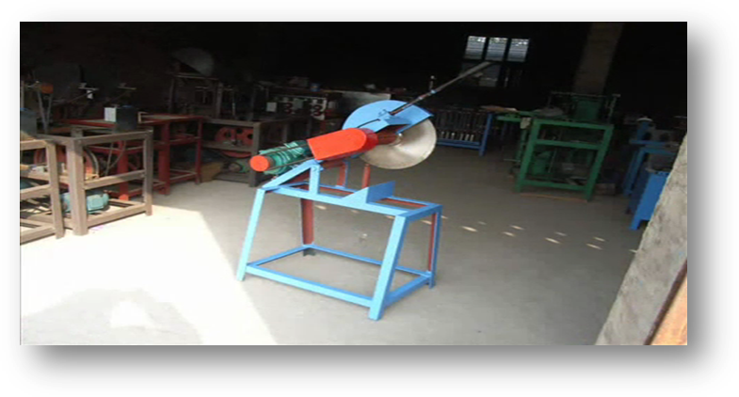
The cross cutting of bamboo includes the cutting of bamboo into required size so that it can fit into splitting machines .This is done due to the varying sizes of bamboo.

Fig. No. 1
SPLITTING MACHINE:
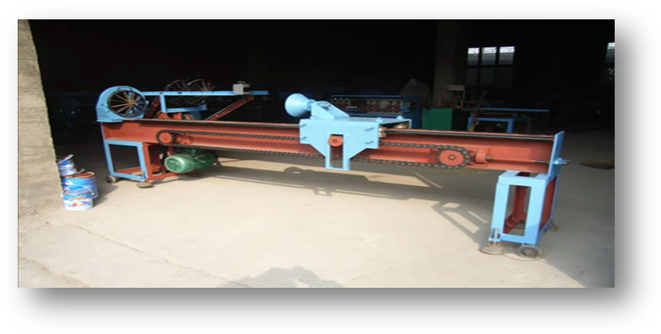
This machines are used for splitting of bamboo into no of equal parts it depends upon the module of die it might of four or six equal parts and so on…

Fig. No. 2

KNOT REMOVING MACHINE:

For removing the internal and external knots present on the joints of bamboo.
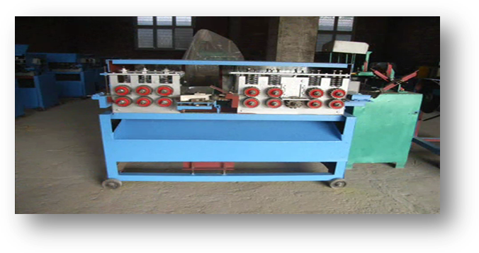

Fig. No. 3
SLICE MAKING MACHINE:

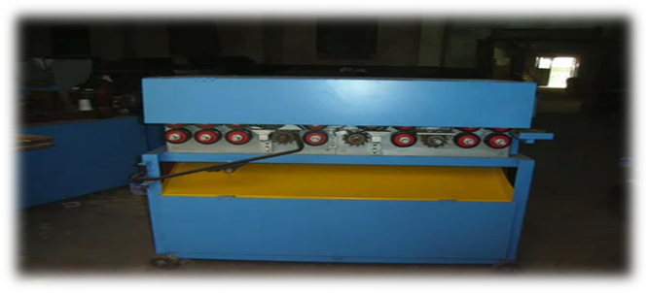
To make the slice of ¼ or 1/6 part of split bamboo to get desired thickness of stick.

Fig. No. 4
STICK LENGTH SETTING:
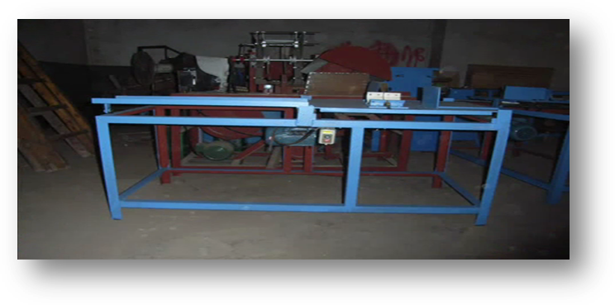
For setting the length of sticks .

Fig. No. 5

- INTEGRATED BAMBOO PROCESSING MACHINES
The bamboo processing consist of the following components.
- A. C. Motor
- V- Belt Drive
- Crank and Sliding Mechanism
- Pulleys
- Ball Bearings
- Spring Loaded Clampper
- Slicing Tool
- Vertical Tool
- Tray
- Machine Supporting Base
CONSTRUCTIONAL LINE DIAGRAM

Fig. No. 6
2.1 WORKING
Initially we switch ON the main power supply, this power supply provided to flow through various switches which used to operate machine.
At first, the AC motor is energised which rotates the smaller pulley attached to motor, with the help of V-belt drive the smaller pulley rotates the bigger pulley. The shaft on which rhe bigger pulley is mounted, another smaller pulley is also mounted on the same shaft, rotates with same RPM.
The smaller pulley no. 2 transmitte the power with reducing RPM to the prime mover of reciprocating mechanism.
Now the reciprocating mechanism reciprocates the work holding spring loaded clamper. At the end of the stroke the slicing tool is mounted which slice the bamboo during the forward motion of the work holding device. The verical tool is mounted next to the slicing tool just below the reciprocating mechanism. The slices are moves through vertical tool and we get square sticks of required diameter.

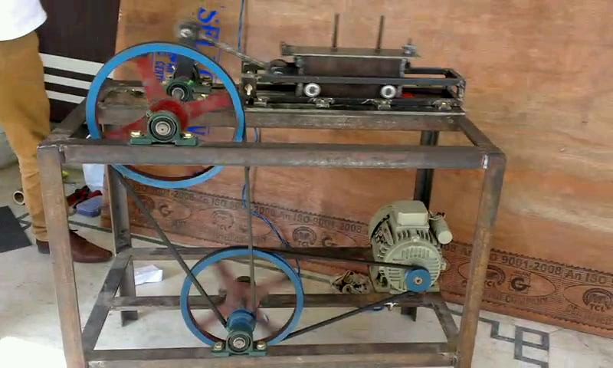
Fig. No. 7 INTEGRATED MACHINE
2.2 FOCUS ON SLICING AND VERTICAL TOOL
Tools are the machining element which are one of the most important and essential element in the field of bamboo processing machine. Tools are used to break down the bamboo (raw material) and convert it into finish product such as tooth pick, ice-cream etc.
Tool system is made of slicing and vertical tool plates which are placed are mounted on the base plate. This plates are kept as adjustcent so that right from slicing to the end of finish product can be achieved.

2.2.1 SLICING TOOL BLADES :-
The slicing tool blades are made up of high speed steel. These slicing blades are fixed on the base plate with the help of screw. The arrangement is so made that when the mechanism start reciprocating motion , the sliing tool so mounted starts making the slices of bamboo.

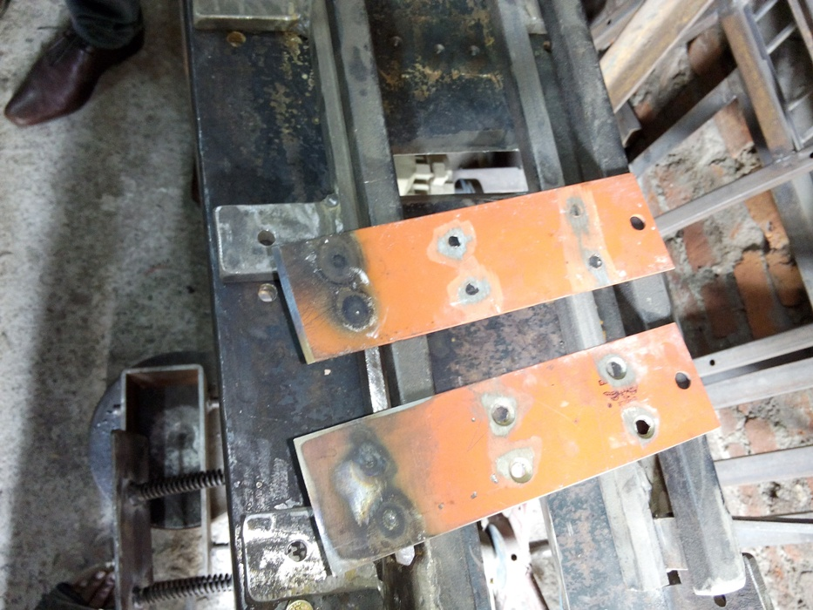

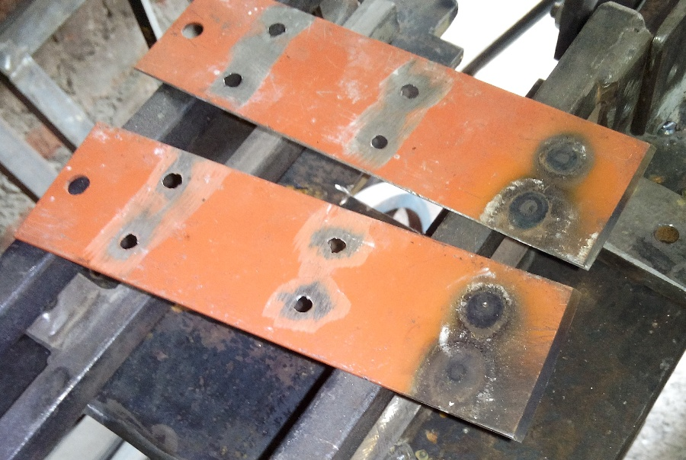
Fig No. 8 BACK

2.2.3 Vertical Tool Blade:-
The vertical tool arrangement is made up of number of blades arranging together in vertical position. The blades are fixed between the vertical plates and are gross together with the help of nut and bolt arrangement.
As the slicing tool slices the bamboo, the slice with the stroke moves forward by providing the guiding arrangement and cutting power cut the slice by the vertical tool and we get the square sticks of required dimensions.

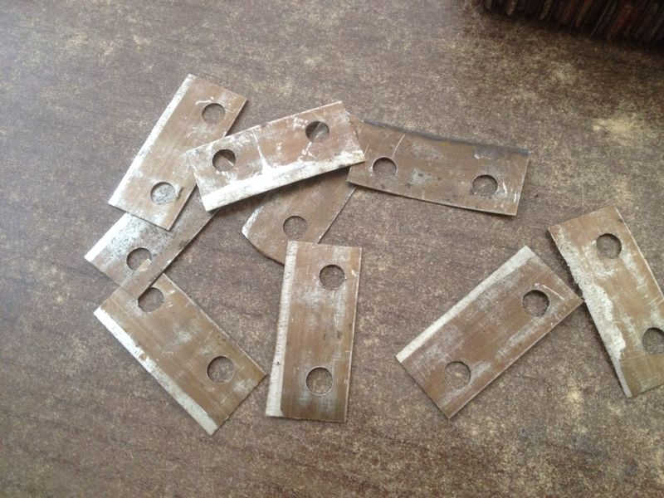

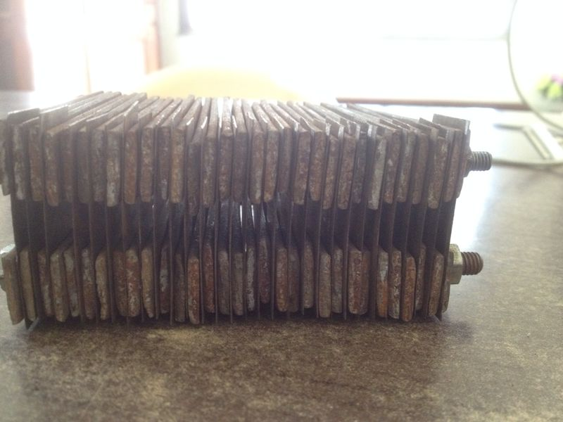

Fig. No. 9 SECOND TOOL PLATES

3.1 OTHER COMPONENTS REQUIRED :-
PULLEYS:
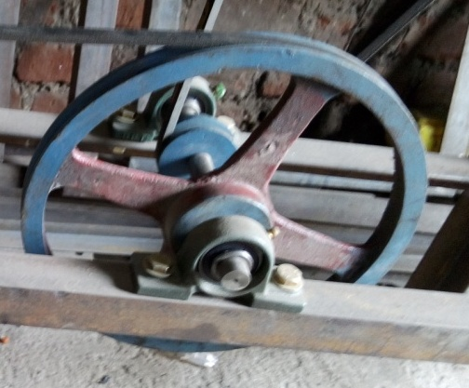

Motor:
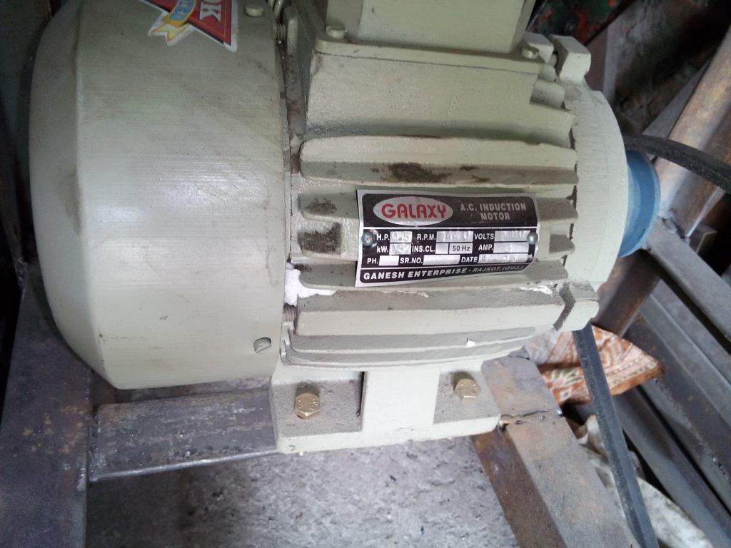

Bearings:

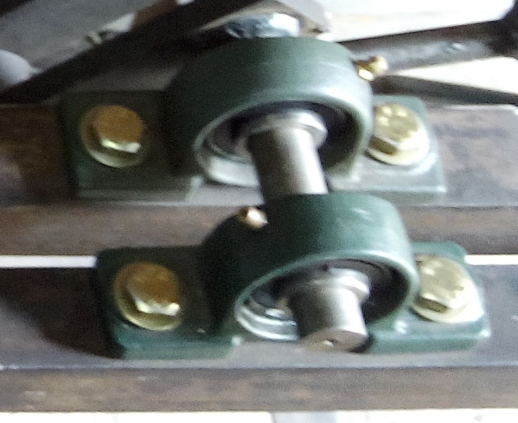

Work Holding Device:
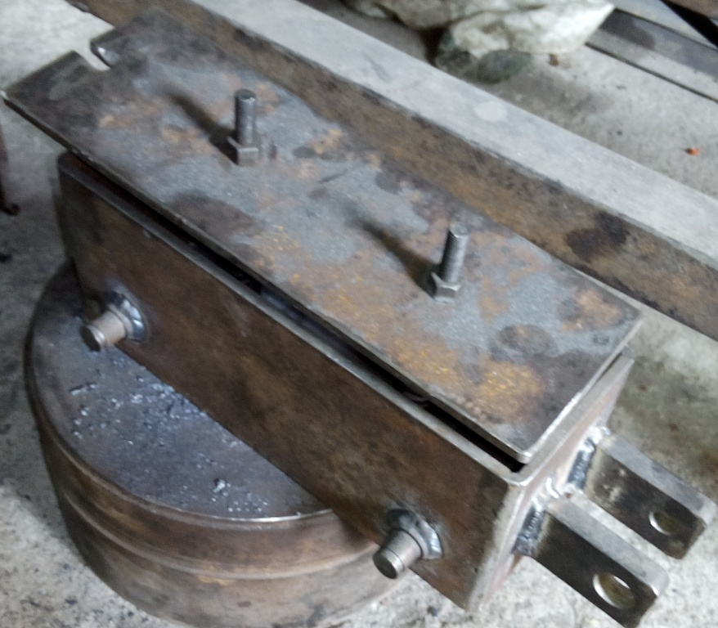

Spring Perssure :
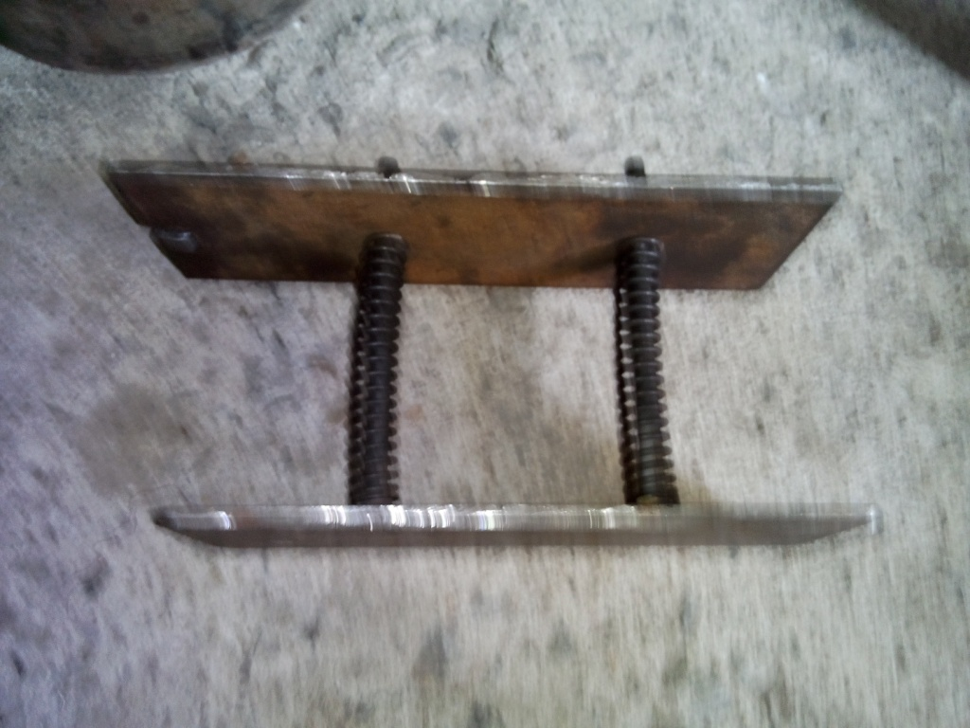

Connecting Rod :

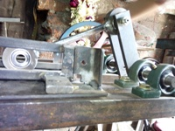

3.2 TESTING
The following processes are taken for making the desired product.
First, we checked all the components and machine before starting the testing that components are working properly or not. Then check the slicing blade and vertical blade properly fixed or not.
We switched ON power supply of the machine. Placed the Required length of bamboo in work holding device that is clamper in proper manner so that it could cut properly without providing exceptionally more force. As the machine starts reciprocating motion, the force applied on the bamboo per unit area due to reciprocating motion and slices of bamboo are made. In second tool that is vertical tool the process of sticks making is carried out. Then product is allowed to flow in tray and we achieved final product. This final product is collected in collector.

SLICES OF BAMBOO MADE BY SLICING TOOL

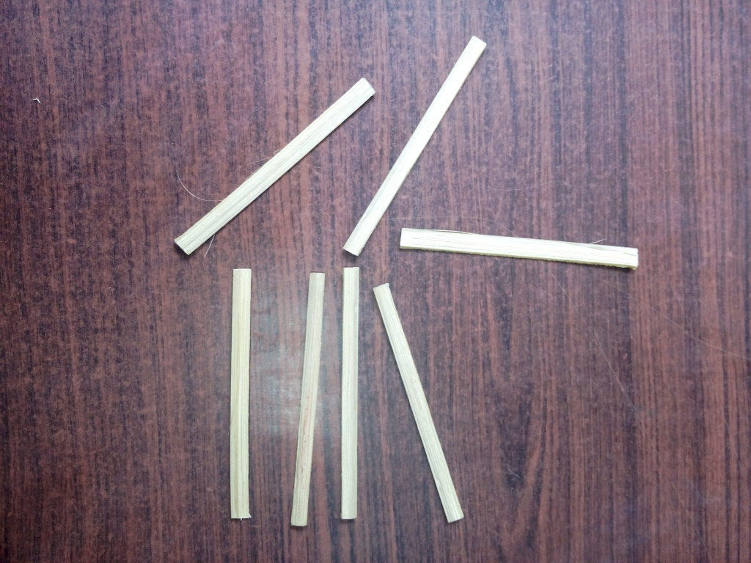

CONCLUSION
1. Vibrations are reduced by heavy and compact construction.
2. Final product is obtained in one stroke.
3. Machine is compact and robust in construction .
4. Time required to process bamboo using modified machine is less as compared to conventional machine.
5. Initial cost of conventional machine is larger as compared to modified bamboo processing machine.
6. Labour cost is high in conventional bamboo processing machine as compared to modified machine.

REFERENCES
1. P. G. Mehar, Dr. A. V. Vanalkar et. al. “ Utility of bamboo in different sectors and development of integrated bamboo processing machine” Golden Research Thoughts, Vol. 2, Issue 3, Sept. 2012.
2. P. G. Mehar, Dr. A. V. Vanalkar et. al.”Experimentation on various dies for slicing on improved hydraulic bamboo processing machine” IJERA, Vol. 2, Issue 6, Nov-Dec 2012, pp 162-166
3. Mr.Ranjeet Kumar et it, book “DESIGN OF A COMPREHENSSIVE BAMBOO PROCESSING” Student of M.Tech (MED),, Priyadarshini College of Engineering, Nagpur, India..PP , PP.51-54
4. Mr. Ramanuja Rao Principal Scientist, INBAR book “Local Tools and Equipment Technologies” PP. 110-150
5. Mr. Cherla B. Sastry,Director, INBAR book “bamboo production technology” PP 130-137
6. Krumi and Gupta. “Theory of Machine”, S.Chand Publication
7. Liu Kekun; “Production Process & Equipment For Bamboo Daily Products”, Proceedings Of International Training Workshop.

