A Survey on Distributed File System
With Refernce to HDFS & GFS

Prateek Kumar
B.E. 3RD year , Computer Technology
K.D.K. College Of Engineering
Nagpur, India -440009
prateekkr1295@gmail.com

Abstract – Demand of digital data of various applications such as wireless sensor, bioinformatics next generation sequencing, and high throughput instruments, is growing rapidly. Dealing with demands of analysis of ever-growing data requires new techniques in software, hardware, and algorithms. MapReduce is a programming model initiated by Google’s Team for processing huge datasets in distributed systems; it helps programmers to write programs that process big data. The aim of this paper is to compare GFS and HDFS.

Introduction
Applications in different domain such as environmental studies, biometrics, sensors, etc. deal with intensive data. There is a great need to handle this kind of data.
MapReduce is a programming model that aims at handling these data with intensive applications. It is this programming paradigm that allows for massive scalability across hundreds or thousands of servers in clusters. MapReduce enables programmers who have no experience with distributed systems to write applications that process huge datasets in large cluster of commodity machines; it manages data partitioning, task scheduling, and nodes failure.
The motivation of this study is:
1) Introduce an overview of MapReduce.
2) Determine strengths, weakness of MapReduce, and
research trends of MapReduce.
3) Provide overview of enhancements efforts for
MapReduce.
4) Learn about MapReduce architecture
5) Comparing Hadoop & Google file systems.
5) Finally, determine the open issues as future research
directions.

Mapreduce Background
Prior to development of MapReduce, the authors and many others at Google implemented hundreds of special-purpose computations that process large amounts of raw data, such as crawled documents, Web request logs, etc., to compute various kinds of derived data, such as inverted indices, various representations of the graph structure of Web documents, summaries of the number of pages crawled per host, and the set of most frequent queries in a given day.
Processing huge volume of data requires distributing data into hundreds or thousands of nodes in order to finalize processing task in short reasonable time. Google team developed MapReduce to automatically parallelize computation; MapReduce manages data partitioning and distribute it among computation nodes. In addition, it handles node failures. MapReduce helps programmers to concentrate in writing programs that process large data; programmers concentrate on the problem details and MapReduce manage distributed computation issues.
Apache Hadoop is an open source implementation of MapReduce. Most of programmers and researcher outside Google use Hadoop in their experiments.

Programming Model
The computation takes a set of input key/value pairs, and produces a set of output key/value pairs. The user of the MapReduce library expresses the computation as two functions: Map and Reduce.
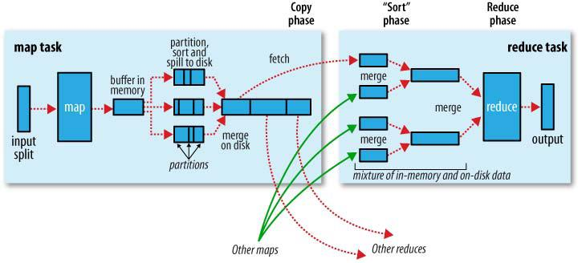
Fig: Process of MapReduce

Map, written by the user, takes an input pair and produces a set of intermediate key/value pairs. The MapReduce library groups together all intermediate values associated with the same intermediate key I and passes them to the Reduce function.
The Reduce function, also written by the user, acceptsan intermediate key I and a set of values for that key. It merges together these values to form a possibly smaller set of values. Typically just zero or one output value is produced per Reduce invocation. The intermediate values are supplied to the user's reduce function via an iterator. This allows us to handle lists of values that are too large to fit in memory.

Classification of MapReduce Algorithms
- The first class represents algorithms that can be
adapted as a single execution of MapReduce models;
factoring integers is an example of this type ofalgorithms.
- The second class represents algorithms that
can beadapted as a sequential execution of a constant number of MapReduce models; Clustering Large Application (CLARA) is an example of this class of algorithms.
- The third class represents iterative algorithms;
Where each iteration is represented as an execution of a single MapReduce model; clustering algorithms such
as Partitioning Around Medoids (PAM) represents an example of this type of algorithms.
- The fourth class of algorithms represents
Complex iterative algorithms where the content of one iteration is represented as an execution of multiple MapReduce models. Conjugate Gradient (CG) is an example of this type of algorithms.

Hadoop Architecture
Hadoop is composed of Hadoop MapReduce, an implementation of MapReduce designed for large clusters, and the Hadoop Distributed File System (HDFS), a file system optimized for batch-oriented workloads such as MapReduce. In most Hadoop jobs, HDFS is used to store both the input to the map step and the output of the reduce step. Note that HDFS is not used to store intermediate results (e.g., the output of the map step): these are kept on each node’s local file system.
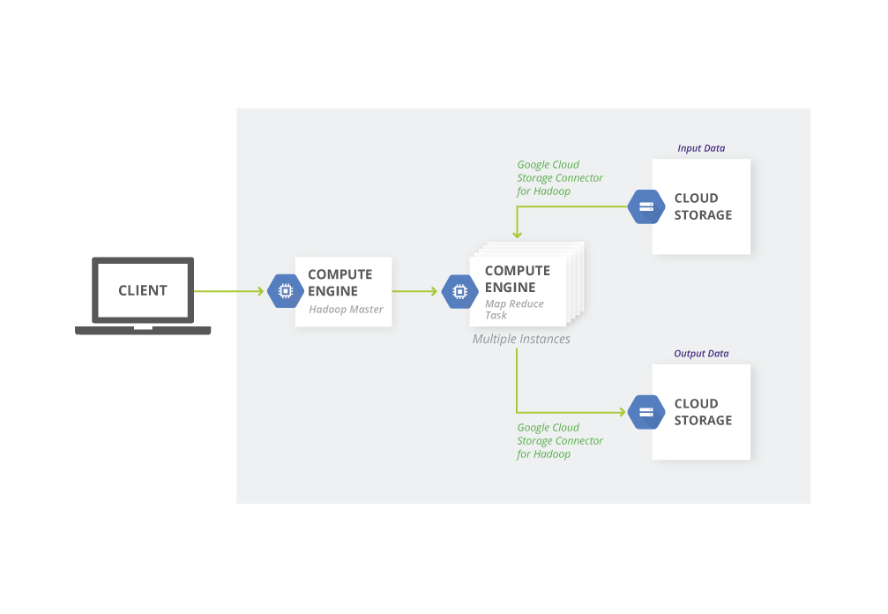

A Hadoop installation consists of a single master node and many worker nodes. The master, called the Job-Tracker, is responsible for accepting jobs from clients, dividing those jobs into tasks, and assigning those tasks to be executed by worker nodes. Each worker runs a Task-Tracker process that manages the execution of the tasks currently assigned to that node. Each Task Tracker has a fixed number of slots for executing tasks (two maps and two reduces by default).

Algorithm
The basic idea is that the data is divided into inter block ordered data, so that it can be sorted in the memory as much as possible.

Map Reduce Capabilities And Limitations
MapReduce has many advantages. First it supports data locality by collocating the data with the compute node; so it reduces network communication cost . Also it support scalability; the runtime scheduling strategy enables MapReduce to offer elastic scalability which means the ability of dynamically adjusting resources during job execution. In addition, it has a fault tolerance strategy that transparently handles failure; it detects map and reduce tasks of failed nodes and reassigns it to other nodes in the cluster. Also it has the ability to handle data for heterogeneous system, since MapReduce is storage independent, and it can analyze data stored in different storage system .
In contrast to these positive features MapReduce has some limitations.
One of the main performance problems with Hadoop MapReduce is its physical data organization including data layouts and indexes.
Data layouts: Hadoop MapReduce jobs often suffer from a row-oriented layout. The disadvantages of row layouts have been thoroughly researched in the context of column stores . However, in a distributed system, a pure column store has severe drawbacks as the data for different columns may reside on different nodes leading to high network costs. Thus, whenever a query references more than one attribute, columns have to be sent through the network in order to merge different attributes values into a row (tuple reconstruction). This can significantly decrease the performance of Hadoop MapReduce jobs.
Indexes: Hadoop MapReduce jobs often also suffer from the lack of appropriate indexes.

Google File System
Google File System (GFS or GoogleFS) is a proprietary distributed file system developed by Google. It is designed to provide efficient, reliable access to data using large clusters of commodity hardware.
A GFS cluster consists of a single master and multiple chunk servers and is accessed by multiple clients, as shown in Figure 1. Each of these is typically a commodity Linux
machine running a user-level server process. It is easy to run both a chunk server and a client on the same machine, as long as machine resources permit and the lower reliability caused by running possibly flaky application code is acceptable.
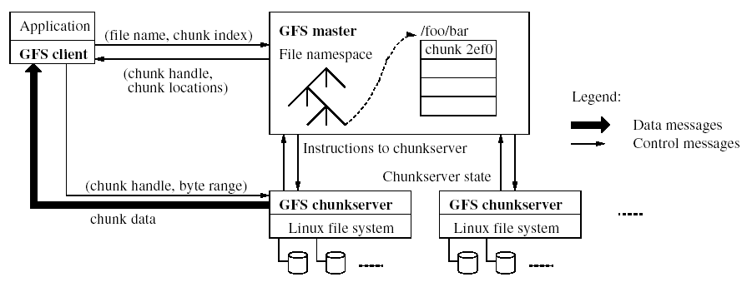

Files are divided into fixed-size chunks. Each chunk isidentified by an immutable and globally unique 64 bit chunk handle assigned by the master at the time of chunk creation. Chunk servers store chunks on local disks as Linux files and read or write chunk data specified by a chunk handle and byte range. For reliability, each chunk is replicated on multiple chunk servers. By default, we store three replicas, though users can designate different replication levels for different regions of the file namespace.
The master maintains all file system metadata. This includes the namespace, access control information, the mapping from files to chunks, and the current locations of chunks. It also controls system-wide activities such as chunk lease management, garbage collection of orphaned chunks, and chunk migration between chunk servers. The master periodically communicates with each chunk server in HeartBeat messages to give it instructions and collect its state.

Comparing Hadoop And Gfs
PROPERTIES | GFS | HDFS
Design Goals | - Main goal of GFS is to support large files  - Used for data intensive computing.  - Store data reliably, even when failures occur within chunk servers, master, or network partitions.  - GFS is designed more for batch processing rather than interactive use by users. | - One of the main goals of HDFS is to support large files.  - Used for data intensive computing.  - Store data reliably, even when failures occur within name nodes, data nodes, or network partitions.  - HDFS is designed more for batch processing rather than interactive use by users.
Processes | - Master and chunk server | - Name node and Data node
File Management | - Files are organized hierarchically in directories and identified by path names.  - GFS is exclusively for Google only. | - HDFS supports a traditional hierarchical file organization.  - HDFS also supports third-party file systems such as CloudStore and Amazon Simple Storage Service
Protection | - Google have their own file system called GFS. With GFS, files are split up and stored in multiple pieces on multiple machines. | - The HDFS implements a permissionmodel for files and directories that shares much of the POSIX model.  - File or directory has separate permissions
Database Files | - Bigtable is the database used by GFS. Bigtable is a proprietary distributed database of Google Inc. | - HBase provides Bigtable (Google) like capabilities on top of Hadoop Core.
File Serving | - A file in GFS is comprised of fixed sized chunks. The size of chunk is 64MB. Parts of a file can be stored on different nodes in a cluster satisfying the concepts load balancing and storage management. | - HDFS is divided into large blocks for storage and access, typically 64MB in size. Portions of the file can be stored on different cluster nodes, balancing storage resources and demand.
Communication | - TCP connections are used for communication. Pipelining is used for data transfer over TCP connection. | - RPC based protocol on top of TCP/IP
Available Implementation | - GFS is a proprietary distributed file system developed by Google for its own use. | - Yahoo, Facebook, IBM etc. are based on HDFS.

Conclusion
Google File System is a proprietary distributed file system and is exclusive for Google Inc. Mapreduce is the programming frame work used by Google. Hadoop Distributed File System and Mapreduce are the components of Hadoop project owned by Apache.

In this paper the comparison between these two file systems is made by selecting few parameters.

References
[1Avro. http://avro.apache.org.
[2] Hadoop. http://hadoop.apache.org.
[3] Hive. http://hive.apache.org/.
[4] Jaql. http://code.google.com/p/jaql/.
[5] LZO. http://www.oberhumer.com/opensource/lzo/.
[6] Nutch. http://nutch.apache.org/.
[7]ProtocolBuffers. http://code.google.com/p/protobuf/.
[8] Thrift. http://incubator.apache.org/thrift/.
[9] J. Dean and S. Ghemawat, "MapReduce: simplified data processing on large clusters," in Proc. the 6th conference on Symposium on Operating Systems Design & Implementation, 2004, pp. 137-150.
[10] T. White, Hadoop: The Definitive guide, 1st ed.: O'Reilly Media, 2010.
[11] S. Ghemawat, H. Gobioff, and S. T. Leung, "The Google file system," in Proc. the nineteenth ACM symposium on Operating systems principles, 2003, pp. 29-43.
[12] A. Rajaraman and J. Ullman, Mining of Massive Datasets, Cambridge University Press, 2011, ch. 2.
[13] A. M. Middleton, Data-Intensive Technologies for Cloud Computing. B. Furht and A. Escalante, Handbook of Cloud Computing, New York: Springer, 2010, ch. 5.
[14] D. K. G. Campbell. A survey of models of parallel
computation. Technical report, University of York, March1997.
[15] GRAEFE, G. Encapsulation of parallelism in the Volcano query processing system. In SIGMOD (1990).
[16]MapReduce tutorial. [Online]. Available:http://hadoop.apache.org/common/docs/r0.20.2 mapred_tutorial.html

