Security Issues in Infrastructure as a Service(IaaS) in Cloud Computing

Aishwarya Handa KDKCOE, Nagpur achanda017@gmail.com
Sukruti Sakarde KDKCOE, Nagpur sukrutisakarde@gmail.com
Prerna Bhattad KDKCOE, Nagpur psbhattad027@gmail.com

Abstract— Cloud computing is current buzzword in the market. It is paradigm in which the resources can be leveraged on per use basis thus reducing the cost and complexity of service providers. Cloud computing promises to cut operational and capital costs and more importantly let IT departments focus on strategic projects instead of keeping datacenters running. It is much more than simple internet. It is a construct that allows user to access applications that actually reside at location other than user’s own computer or other Internet-connected devices. There are numerous benefits of this construct. For instance other company hosts user application. This implies that they handle cost of servers, they manage software updates and depending on the contract user pays less i.e. for the service only. Confidentiality, Integrity, Availability, Authenticity, and Privacy are essential concerns for both Cloud providers and consumers as well. Infrastructure as a Service (IaaS) serves as the foundation layer for the other delivery models, and a lack of security in this layer will certainly affect the other delivery models, i.e., PaaS, and SaaS that are built upon IaaS layer. This paper presents an elaborated study of IaaS components’ security and determines vulnerabilities and countermeasures. Service Level Agreement should be Considered very much importance.

Introduction
Human eye is probably the most important sense organ as it gives the sense of sight, allowing people to observe things around them and thus learn more about the surrounding world. Looking at the figures over the last 20 years we see that there has been significant progress in preventing and curing visual impairments in many countries.
Traffic safety is one of the field where considerations of problems faced by blind people is inevitable. In our project we are detecting an obstacle based on its distance from the person concerned using a GPS, sound alarm from buzzer will alert the user about the object and the person can avoid the object safely without hitting the object.
Thus we design a cost effective and low power dissipation device that helps in proper locomotion of blind people by detecting problematic outputs in critical conditions. Also we make use of a GSM to communicate with the guardian. The most commonly used and famous travel aid for blind is walking stick. It can detect obstacles.

Background
Vision is the most important part of human physiology as 83% of the information human being gets from the environment via sight. The 2011 statistics by the world health organization estimates that there are 285 billion people in the world with visual impairment, 39 billion of which are blind and 246 with low vision.
The traditional and oldest mobility aids for person with visual impairments are the walking cane and guide dogs. The most important drawbacks of these aids are necessary skills and training phase, range of motion and very little information conveyed.
Keywords— Computing, Cloud Computing Security , Service Level Agreement (SLA), Infrastructure as a Service (SaaS) .
With the rapid advances of modern technology, both in hardware and software front have brought potential to provide intelligent navigation capabilities. Recently there has been a lot of electronic travel aids design and devised to have the blind navigate independently and safely. Also high-end technological solutions have been introduces recently to help blind person navigate independently.

Circuit Diagram
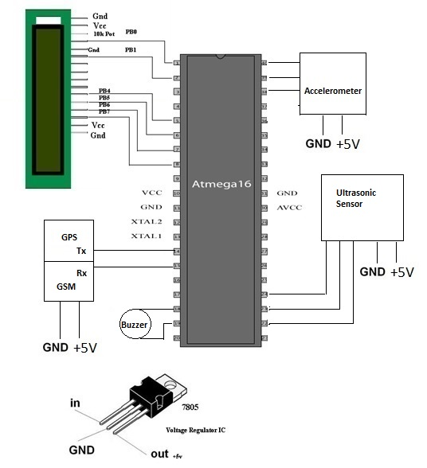
Fig.(1) Circuit Diagram

Working
It is clear from the above circuit diagram that the ultrasonic sensor attached to the system will be connected to the microcontroller for detecting any obstacles in front of the stick and send the digital signals to the microcontroller for converting it into speech using voice kit.
The accelerometer attach with the system will detect falling moment of the blind person. GSM is inbuilt in the stick is used to send message to the guardian of that person. The mobile application in android of the guardian will detect the exact location of that person.

Components
- ATmega32

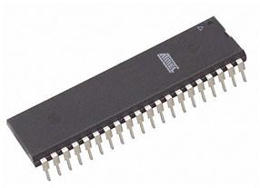
Fig.(2) ATmega32
All output signals generated from flex sensors are in analogue form and these signals need to be digitized before they can be transmitted to encoder. Therefore microcontroller ATMEGA 16 is used as the main controller in this project. It has inbuilt ADC module, which digitizes all analogue signals from the sensors and inbuilt multiplexer for sensor signal selection. It supports both serial and parallel communication facilities.
ATmega32 is an 8-bit high performance microcontroller of Atmel’s Mega AVR family with low power consumption. Atmega32 is based on enhanced RISC (Reduced Instruction Set Computing) architecture with 131 powerful instructions. Most of the instructions execute in one machine cycle. Atmega16 can work on a maximum frequency of 16MHz.

- GPS Module

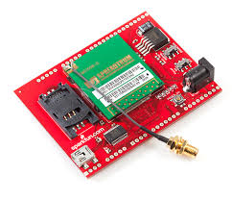

Fig.(3) GPS Module

The Global Positioning System (GPS) is a space-based navigation system that provides location and time information in all weather conditions, anywhere on or near the Earth where there is an unobstructed line of sight to four or more GPS satellites. The system provides critical capabilities to military, civil, and commercial users around the world. The United States government created the system, maintains it, and makes it freely accessible to anyone with a GPS receiver.
The US began the GPS project in 1973 to overcome the limitations of previous navigation systems, integrating ideas from several predecessors, including a number of classified engineering design studies from the 1960s. The U.S Department of Defense (DOD) developed the system, which originally used 24 satellites. It became fully operational in 1995. Bradford Parkinson, Roger L. Easton, and Ivan A. Getting are credited with inventing it.[7]
- Ultrasonic Sensor
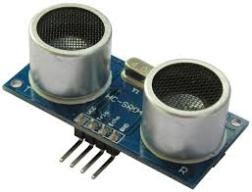
Fig(4). Ultrasonic Sensor
An ultrasonic sensor is a device that works in much same way as RADAR and SONAR. Ultrasonic sensors broadcast a powerful, ultrasonic frequency, then detect the ultrasonic sound waves as they bounce off of objects and return to the sensor.
They are almost always used to measure speed or direction and are efficiently at determining position. Ultrasonic sensors are commonly used for a wide variety of noncontact presence, proximity, or distance measuring applications. These devices typically transmit a short burst of ultrasonic sound toward a target, which reflects the sound back to the sensor. The system then measures the time for the echo to return to the sensor and computes the distance to the target using the speed of sound in the medium.
The first step toward identifying the right proximity sensor for your application is to understand the fundamental ultrasonic properties of the transmission medium and the way they influence the measurement and system operation. [8]

- Accelerometer

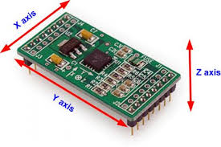
Fig.(5) Accelerometer

An accelerometer is a device that measures proper acceleration ("g-force"). Proper acceleration is not the same as coordinate acceleration (rate of change of velocity). For example, an accelerometer at rest on the surface of the Earth will measure an acceleration g= 9.81 m/s² straight upwards. By contrast, accelerometers in free fall orbiting and accelerating due to the gravity of Earth will measure zero.
Accelerometers have multiple applications in industry and science. Highly sensitive accelerometers are components of inertial navigation systems for aircraft and missiles. Accelerometers are used to detect and monitor vibration in rotating machinery. Accelerometers are used in tablet computers and digital cameras so that images on screens are always displayed upright. Accelerometers are used in drones for flight stabilization. Pairs of accelerometers extended over a region of space can be used to detect differences (gradients) in the proper accelerations of frames of references associated with those points. These devices are called gravity gradiometers, as they measure gradients in the gravitational field. Such pairs of accelerometers in theory may also be able to detect gravitational waves
Single- and multi-axis models of accelerometer are available to detect magnitude and direction of the proper acceleration (or g-force), as a vector quantity, and can be used to sense orientation (because direction of weight changes), coordinate acceleration (so long as it produces g-force or a change in g-force), vibration, shock, and falling in a resistive medium (a case where the proper acceleration changes, since it starts at zero, then increases). Micro-machined accelerometers are increasingly present in portable electronic devices and video game controllers, to detect the position of the device or provide for game input.[9]
- 7805 Voltage Regulator IC
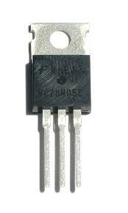
Fig.(6) 7805 Voltage Regulator Ic
The 7805 voltage regulators employ built-in current limiting, thermal shutdown, and safe-operating area protection which makes them virtually immune to damage from output overloads. 7805 is a three-terminal positive voltage regulator.
With adequate heat sinking, it can deliver in excess of 0.5A output current. Typical applications would include local (on-card) regulators which can eliminate the noise and degraded performance associated with single-point regulation.
7805 regulator comes from the 78xx family of self-contained fixed linear voltage regulator integrated circuits. The 78xx family is a very popular choice for many electronic circuits which require a regulated power supply, due to their ease of use and relative cheapness. When specifying individual ICs within this family, the xx is replaced with a two-digit number, which indicates the output voltage the particular device is designed to provide (for example, the 7805 voltage regulator has a 5 volt output, while the 7812 produces 12 volts). The 78xx line are positive voltage regulators, meaning that they are designed to produce a voltage that is positive relative to a common ground. There is a related line of 79xx devices which are complementary negative voltage regulators. 78xx and 79xx ICs can be used in combination to provide both positive and negative supply voltages in the same circuit, if necessary.
7805 ICs have three terminals and are most commonly found in the TO220 form factor, although smaller surface-mount and larger TO3 packages are also available from some manufacturers. These devices typically support an input voltage which can be anywhere from a couple of volts over the intended output voltage, up to a maximum of 35 or 40 volts, and can typically provide up to around 1 or 1.5 amps of current (though smaller or larger packages may have a lower or higher current rating).
- SIM300
SIM300 is a Tri-band GSM/GPRS engine that works on frequencies EGSM 900 MHz, DCS 1800 MHz and PCS1900 MHz. SIM300 provides GPRS multi-slot class 10 capability and support the GPRS coding schemes CS-1, CS-2, CS-3 and CS-4.
With a tiny configuration of 40mm x 33mm x 2.85 mm , SIM300 can fit almost all the space requirement in your application, such as Smart phone, PDA phone and other mobile device.
The physical interface to the mobile application is made through a 60 pins board-to-board connector, which provides all hardware interfaces between the module and customers’ boards except the RF antenna interface. The SIM300 is designed with power saving technique, the current consumption to as low as 2.5mA in SLEEP mode.
The SIM300 is integrated with the TCP/IP protocol Extended TCP/IP AT commands are developed for customers to use the TCP/IP protocol easily, which is very useful for those data transfer applications. Module will automatically go into SLEEP mode if DTR is set to high level and there is no on air or audio activity is required and no hardware interrupt (such as GPIO interrupt or data on serial port).
In this case, the current consumption of module will reduce to the minimal level.
During sleep mode, the module can still receive paging message and SMS from the system normally.

Software
- PCB Artist

PCB’s are backbone of any production level electronic device in today market, and therefore knowledge of PCB layout tools can be a vital skill. Both analog and digital circuits are used in PCBs depending on the application ,and with different types of circuits the designer must take into account certain design considerations. More advance circuits like RF circuits or power circuits take more thought in layout and design because circuit is more sensitive to component placement.

- AVR studio

AVR studio is used by embedded programmers for programming and debugging for many of the Atmel microprocessor such as Atmega8 or even the Atmega128.While it has support for assembly programming for those who prefer to use higher languages, it uses the off format for debugging.
Beginning with version 4 AVR studio has now moved to dwarf2 and can be more readily used in conjunction with the open source gcc based compiler WinAVR. This software would also benefit clear bug reports for some the overrides required.

Acknowledgment
With profound feeling of immense gratitude and affection, we would like to thank our guide Prof. Mrs. J.S.Gawai Dept. of Electronics Engineering for her continuous support, motivation, enthusiasm and guidance. Her encouragement, supervision with constructive criticism and confidence enabled us to complete this seminar.
We also wish to extend our reverences to Dr. P. D. Khandait, Head of Electronics Engineering for providing necessary facilities to complete our seminar.
We are gratifying to Dr. A. V. Vanalkar, Dean (R & D) for motivating us to put our best efforts in this seminar work.
We express our admirations for Dr. A. M. Badar, Vice Principal, for his valuable advice and support throughout this venture.
We also put forth our deepest sense of gratitude towards Dr. D. P. Singh, Principal for constant motivation and providing necessary infrastructure and facilities.
Finally, a special thank to Project In-Charge Prof. V. V. Chakole and all the faculty members of the department for their cooperation throughout the seminar.

References
[1] Iman M. Almomani, Nour Y. Alkhalil, Enas M. Ahmad and Rania M. Jodeh, "Ubiquitous GPS Vehicle Tracking and Management System", IEEE Jordan Conference on Applied Electrical Engineering and Computing Technologies (AEECT), 2011.
[2] ZongweiLuo, Tianle Zhang and ChunluWgan, "RFID Enabled Vehicular Wireless Query for Travel Information in Intelligent Transportation System", IEEE International Conference on RFID-Technologies and Applications, 2011.
[3] SaeFujii, Atsushi Fujita, TakaakiUmeduHirozumi Yamaguchi, TeruoHigashino, Shigeru KanedaandMineoTakai, "Cooperative Vehicle Positioning via V2V Communications and Onboard Sensors", IEEE 2011.
[4] Ghassan Samara, Wafaa A.H. Al-Salihy and R. Sures, "Security Analysis of Vehicular Ad Hoc Networks", Second International Conference on Network Applications, Protocols and Services, 2010.
[5] Atmel 32 bit AVR MICROCONTROLLER AT320C3LO123
[6] SKYLAB DS-SKM58-V1.0-110101.
[7] TEXAS INSTRUMENT ULTRASONIC Ranging module HC-SROH.
[8] ANALOG DEVICES Small, Low Power 3-Axis 3g accelerometer.
[9]TEXAS INSTRUMENTS NATION SEMICONDUCTOR LM386 Voltage Audio Amplifier.

