Analysis and Delay Calculation Of RTP and RTPC Packets Using Wireshark

Mr.Snehal Wairale K.D.K.C.E.Nagpur 9595493911 snehalwairale27@gmail.com
Mr.Oshin Kamble K.D.K.C.E.Nagpur 7276492767 oshin740@gmail.com
Mr.Akash Naidu K.D.K.C.E.Nagpur 8793676124 lazyakash@yahoo.in
Mr.Kalidas Hatwar K.D.K.C.E,Nagpur 8698359264 pinkuhatwar@gmail.com
Ms.SonamKhante K.D.K.C.E.Nagpur 8793319591

Abstract- The evaluation of performance parameters of modern data transfer network is a crucial matter to
arrange flow route selection and flow control. In this paper formulae which allow to calculate the average cost of increment of predicted total packet delay caused by accepting a certain packet coming to the data communication system have been derived.

Introduction
Multimedia services, such as video conferencing, Internet telephony and streaming audio, have recently been introduced for the millions of users of the Internet. The popularity of these services and the feedback received has clearly revealed that some modifications and extensions to the current internet protocols are needed to be able to support real-time applications better. Minimisation of the end-to-end delay, accurate synchronisation of the voice and video streams and a feedback mechanism for the quality of service monitoring are some of the main requirements of these various multimedia applications. The Transmission Control Protocol (TCP) is the most widely used transport-level protocol in the Internet. However, there are several facts that make TCP quite unsuitable for the real-time traffic. Firstly, TCP includes an in-built retransmission mechanism, which may be useless with strict real-time constraints. Secondly, TCP is a point-to-point protocol without direct support for multicast transmission. Thirdly, there is not any timing information carried, which is needed by most real-time applications. The other widely-used transmission protocol, User Datagram Protocol (UDP), does not either include any timing information. So, a new transport level protocol, called Real Time Transport Protocol (RTP),was specified within the Internet Engineering Task Force (IETF) to cope with the before mentioned problems with the real-time traffic.

Related Work
The goal of this project is to capture and analyse RTP and RTCP packets during a real time conference session over a wired and wireless network. For this purpose the first step was to perform some experiments for sample packets capture.

Experiment 1: Writing Wireshark filter expressions for packet capture.

Write the exact packet capture filter expressions to accomplish the following:
1.Capture all TCP traffic to/from Facebook, during the time when you log in to your Facebook account
2.Capture all HTTP traffic to/from Facebook, when you log in to your Facebook account .
3.Find a popular YouTube video and play it while capturing all traffic to/from YouTube.
After running Wireshark with the above capture filters and collect the data, do the following:
Write a DISPLAY filter expression to count all TCP packets (captured under item #1) that have the flags SYN, PSH, and RST set. Show the fraction of packets that had each flag set.

captured data Analysis
Count how many TCP packets you received from / sent to Facebook or YouTube, and how many of each were also HTTP packets. Determine if any TCP packets with SYN or PSH flags set were sent from your host or received from Facebook/Youtube.
Go flag-by-flag and count how many packets have tcp.flags.push set, then how many have tcp.flags.syn set, and finally, how many have tcp.flags.reset set. The display filter to show only SYN packets.

tcp.flags.syn==1&&tcp.flags.ack==0
The display filter to show only PSH packet.
Tcp.flags.push==1
The display filter to show RST packets.
Tcp.flags.reset==1

Experiment 2: Analysis of RTP packets.
The goal of this project is to capture and analyse RTP and RTCP packets during a real-time conference session over a wired and wireless network. The first step is to install a video conferencing software on computers in your project team. The most important requirements are that this software is based on RTP/RTCP and does not encrypt the packet payload. Establish a conferencing session over a wireless/Wi-Fi LAN (activate both the audio and video options).
Each participant should be in a different geographic location, or at least should try to connect to a different wireless LAN while conferencing. Conference for about 5 – 10 min; longer durations will ensure more meaningful statistics. At the same time all participants should use Wireshark to capture all the IP packets sent from their host and received from other host (s). After capturing the packets, use Wireshark filters to partition the traffic to/from your computer so they can be analysed separately.
The data preprocessing consists of the following steps: 1.Separate the RTP data packets from RTCP control packets. 2.Identify the encoding schemes used to create the packet payload for audio/video RTP streams.
Data Flow Diagram.
Data Flow Diagram for RTP packets
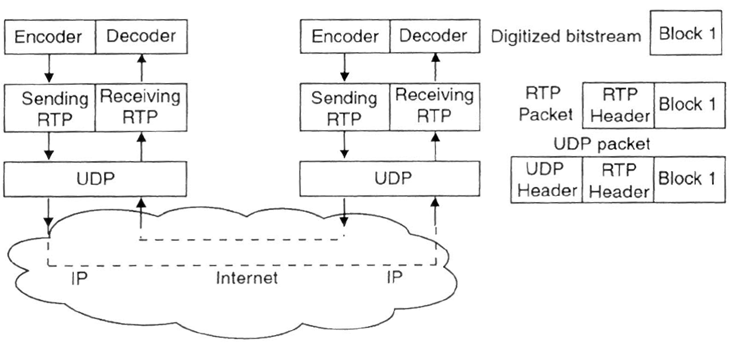
Fig.1. Data Flow Diagram for RTCP packets
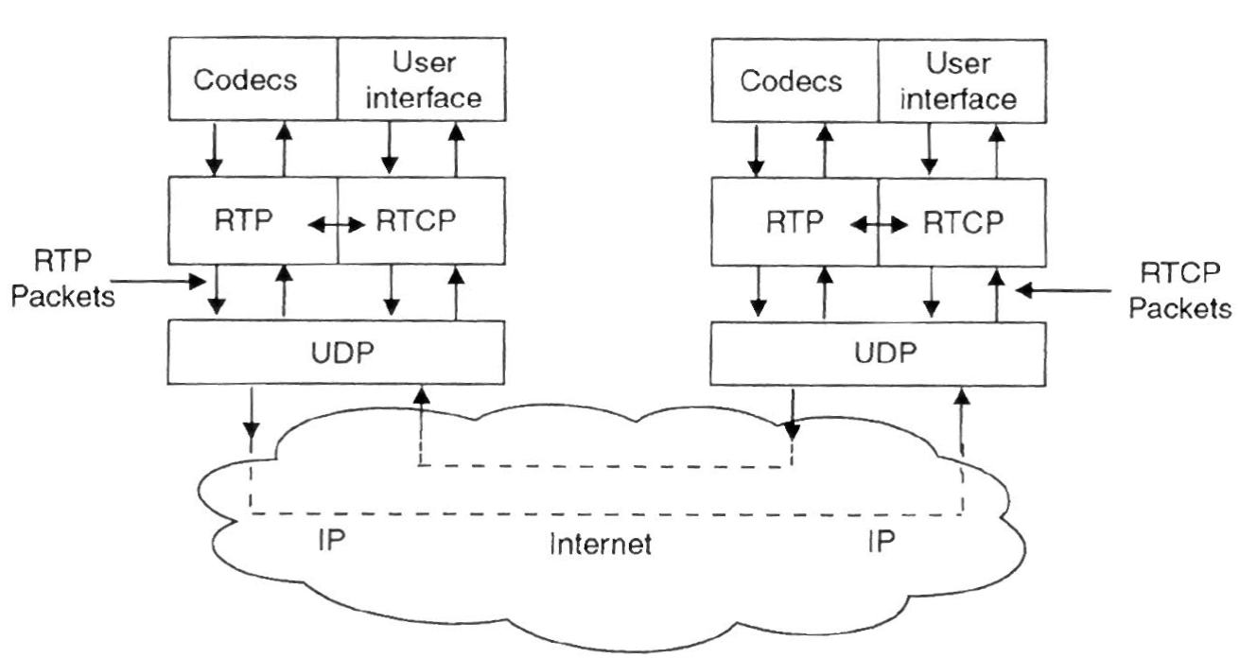

Analysis of RTP Packet Delay And Loss
Wireshark records the arrival time of each packet (find it in the Wireshark packet frame description). However, note that this time may be set relative to the start of the session, rather than the absolute time (known as “wall-clock time”). Alternatively, the arrival time may be represented as the absolute time but in your geographic location, in which case you need to convert it to the UTC time because NTP timestamps are represented in the UTC time zone.
In addition, we cannot directly use the timestamps found in RTP packets. Recall that the timestamp at the start of each session is initialized randomly and incremented by a fixed amount for each “data segment”, which may be different from a transmitted packet. For audio, a “data segment” usually corresponds to 20 milliseconds of audio recording, which is transmitted in a single packet. For video, a single video frame may be broken and transmitted in several packets, all of which will carry the same timestamp. This situation can be detected by checking the marker (M) bit of the RTP .The timestamp clock is incremented by a fixed number for each sampling period. For example, if you transmit audio sampled at the usual τ = 8000 Hertz, the increment unit is 1/8000 of a second. Then, if the sending audio application records, say, 160 sampling periods from a microphone, the timestamp will be increased by 160 units for each such audio segment, regardless of whether the segment is transmitted in a packet or dropped as silent. Therefore, we may observe gaps in timestamps even if none of the packets were lost during transmission. Because RTP/RTCP is an unreliable protocol, some RTP or RTCP packets may be lost in transmission. However, the above procedure will work even in the presence of packet loss.
After we performed the above conversion, we are ready to calculate the transit delays. For each packet p_{i}, calculate the delay as the difference between the packet’s timestamp (in the RTP header) and the time this packet arrived to the receiver:
delay(p_{i}) = arrival-time(p_{i}) – timestamp(p_{i})
To apply this formula, we need to convert the RTP timestamp of each packet from randomly-initiated incremental units to wall-clock time (in time units, such as seconds).
Below are some notations used for delay calculation:
- Š_{i} denotes the RTP timestamp (in increment units) from the most recent RTCP Sender Report, corresponding to the timestamp in RTP packet i.
- Ñ_{i} denotes the NTP timestamp (in UTC time) from the most recent RTCP Sender Report, representing the time when RTP packet i was prepared.
- Š_{i+n} denotes the RTP timestamp (in increment units) from the RTP packet i+n (n = 1, 2, 3, …), where all these packets are assumed to carry the same SSRC identifier (i.e., are generated by the same source).
- Given an RTP packet p_{i}, we assume that the packet p_{i+1} is the first RTP packet from the same SSRC that arrived to the receiver after p_{i}. And so on for the subsequent packets p_{n}, n = 2, 3, … Note that the 16-bit sequence numbers of packets p_{i} and p_{i+1} are not necessarily consecutive and ordered, because packets may become reordered or lost during transport. Similarly, it is not necessarily the case that Š_{i+n} > Š_{i}.
- τ denotes the sampling rate (in Hertz) for the given source SSRC.
- R_{i+n} denotes the time of arrival for packet i+n. Note that the time of arrival on Wireshark may be measured relative to the start of the session, so you may need to convert the arrival times to absolute time. (Or you may need to convert from the absolute time in your time zone to the UTC time zone.
- The timestamp S_{i+n} (in seconds) is computed.
- S_{i+n} = Ñ_{i} + (Š_{i+n} – Š_{i}) / τ
- The transit delay of the packet i+n is computed as: Д_{i+n} = R_{i+n} – S_{i+n}
- Inter-arrival Time between Subsequent Packets.
- Inter-arrival time is the time difference between the arrival times of two consecutive packets (no other packets arrived in between). Given that S_{i} is the timestamp from the packet i and R_{i} is the time of arrival for packet i, the difference is computed as:
- D(i–1, i) = (R_{i} – R_{i–1}) – (S_{i} – S_{i–1}) = (R_{i} – S_{i}) – (R_{i–1} – S_{i–1})
- Given an RTP packet p_{i}, we assume that the packet p_{i–1} is the first previous RTP packet from the same SSRC that arrived to the receiver before p_{i}. Note that the 16-bit sequence numbers of packets p_{i–1} and p_{i} are not necessarily consecutive and ordered, because packets may become reordered or lost during transport. (Observe that this notation is similar to the notation used above for transit delay computation.) Another interesting observation is that inter-arrival time D(i–1, i) as defined above may be negative. It is always true that R_{i} > R_{i–1}. However, because of packet reordering and loss during transmission, it is possible that S_{i} < S_{i–1} and |R_{i} – R_{i–1}| < |S_{i} – S_{i–1}|, in which case D(i–1, i) < 0. For this reason, in delay jitter calculation in the next section we will use the absolute value of D(i–1, i). You may also use the absolute value when plotting the inter-arrival time graphs; however, it may be interesting to consider the negative values as they are.

V. Delay Jitter
Formally, jitter is defined as a statistical variance of the RTP data packet inter-arrival time (also see this). In the RTP, jitter is measured in timestamp units. For example, if you transmit audio sampled at the usual 8000 Hertz, the unit is 1/8000 of a second.
- In RTP, the receiving endpoint computes an estimate using a simplified formula (a first-order estimator).
- J(i) = J(i–1) + ( |D(i–1, i)| – J(i–1) ) / 16
- where the value D(i–1, i) is the difference of relative transit times for the two packets.

Conclusion
1. When sniffing out TCP packets, we often receive TCP packets, SSL packets, and HTTP packets. This is because HTTP/SSL run on top of TCP and you capture their packets by default because they are subclasses of TCP packets.
2. It is not possible to recognise RTCP packets only based on their header. You must infer RTCP based on the UDP port—the UDP port(s) with majority packets are RTP data sessions. To separate the RTP data packets from RTCP control packets, use the fact that they are usually transmitted on different ports. Note that the number and properties of RTP packets sent by one participant may not exactly correspond to those of packets received by the other participant. First, some packets may be lost in transmission (because UDP is an unreliable protocol). Second, the Google server over which the session is run may transcode audio or video from one compression format to another. As a result, more (smaller) packets or fewer (larger) packets may be received by the receiver than what the sender sent. Also, some of the packets’ parameters (such as SSRC identifiers) may be changed.

VII. Suggested Work
The Loss-Delay Based Adjustment Algo- rithm (LDA-)
The LDA algorithm is a sender based adaptation scheme. It relies on the Real Time Transport Protocol (RTP) [20] for feedback information about the losses at the receivers and round trip time. We additionally enhanced RTP to estimate the bottleneck bandwidth of a connection. Based on these information, the sender calculates for each received feed- back message from receiver (i) the appropriate bandwidth to use for the reporting receiver (ri ). During periods with- out losses the sender increases ri by an additive increase rate (AIRi ) which is estimated using the loss, delay and bottleneck bandwidth values included in the feedback reports. The actual sending rate is then determined at equally spaced adaptation points as min ri .
We divide the algorithm description into three parts handling the feedback information, upon which the adaptation decisions are taken, the mechanisms for setting the adaptation parameters and the actual adaptation mechanisms.
- Feedback Information
The loss-delay based adjustment algorithm is based upon the Real Time Transport Protocol (RTP) [20] designed within the Internet Engineering Task Force (IETF). RTP en- hances other transport protocols such as UDP with features needed by continuous media applications, such as the capa- bility of distinguishing between different media streams and keeping track of various statistics describing the quality of the transmission as seen by other members of the session.
RTP sessions consist of two lower-layer data streams, namely a data stream for, say, audio or video and a stream of control packets (using the sub-protocol called RTCP). Each session member periodically sends RTCP control reports to all other session members. Senders transmit reports describing the amount of data they have sent and a timestamp indicating the time the report was generated. For each incoming stream the receivers send a report indicating the fraction of lost data, the timestamp of the last received sender re- port (tLSR ) for that stream and the time elapsed in between receiving the last sender report and sending the receiver report (tDLSR ). Knowing the arrival time t of the RTCP packet the sender can calculate the round trip time (RTT) as follows:

RTT= t- tDLSR- tLSR ………….. (2)
This calculation requires no synchronization between the clocks of the sender and receiver and is therefore rather ac- curate. With the LDA algorithm, we estimate the round trip propagation delay (τ ) as the smallest measured RTT.
2. Dynamical Determination of the Additive In- crease Rate (AIR)
The appropriate value to use for AIR depends largely on the bandwidth share a connection could utilize. That is, AIR is set initially to a small value, and is then increased during periods without losses. If losses are reported by the receivers, the senders set the AIR back to the initial value. We have chosen an initial value of 10 kb/s, which is small enough to be used even in narrowband ISDN connections. If the received RTCP messages from receiver indicate no losses, the sender calculates an AIR(i) for this receiver as follows:
AIRi =AIR +AIR* Bf
With Bf =1- (r/b)
with AIR as the additive increase value calculated for the en- tire session, r the current transmission rate, b the bottleneck bandwidth and Bf as a bandwidth factor that allows connections with a low bandwidth share to use larger AIR values and thereby converge faster to their fair bandwidth share .

3. Congestion Control Mechanism
With each received RTCP packet from a member i the sender calculates a transmission rate ri it would use if member i was the only member of the multicast session. ri is then saved into a data base. So, if no losses were indicated the sender can recalculate AIRi as was described in (2 ) and ri is then set to ri =r +AIRi as the transmission rate the sender is using for the entire session. Otherwise, the sender reduces ri in a rather TCP similar fashion, i.e., proportional to the indicated losses (l)
ri= r*( l-(l* Rf))
with Rf as the reduction factor. This factor determines the degree of the reaction of the sender to losses. Higher values result in a faster reduction of the transmission rate but a more oscillatory behavior. Lower values, on the other hand, lead to more stable rate values but result in longer convergence periods.

Reference
[1].The Loss-Delay Based Adjustment Algorithm: A TCP-Friendly Adaptation Scheme.Dorgham Sisalem,Gmd-Fokus,Berlin sisalem@fokus.gmd.de HenningSchulzrine,Columbia University,New York,Schulzrine@cs.columbia.edu
[2] Computer Networks Fifth edition by Andrew S. Tanenbaum Vrije University,Amesterdam,Netherland David J.Wetherall,University of Washington Seattle,WA.
[3]Computer Networks wireshark Projects, www.ece.rutgears.edu

