A Survey on SAP Security
Ravina Jain
B.E. 3rd year,
Computer Technology,
KDKCE, Nagpur – 440 009

Abstract – When we say SAP security we refer to the protection of an entity .As the technology is changing by the day so are the threats of the technology being misused. With the advent of new measures of protection, each day a new threat is also being created. Hence it has become extremely important to tighten our security measures at each point. In case of information Technoology ,Security has an important place because here we deal with sensitive information and data of the client . In this paper we will deal with SAP Security. SAP is now most widely used ERP today. So to increase the efficiency of software the SAP has seperated security module from basis and enhanced the functions and utilities of SAP Security. SAP Security revolves around protecting the access of the user and restricting it to access the data and applications related to his job profile only. Therefore , protecting the SAP data and applications from the unauthorized use and processing is called SAP Security.

Keywords: SAP, SAP Security

Introduction
The name SAP is acronym for Systems, Applications and Products in Data Processing. SAP is an enterprise resource planning (ERP) software product capable of integrating multiple business applications, with each application representing a specific business area. These applications update and process transactions in real time mode. It has the ability to be configured to meets the needs of the business.
SAP runs on a fourth generation programming language language called Advance Business Application Programming (ABAP). It have many of the features of other modern programming languages such as the familiar C, Visual Basic, and Power Builder. Your programs name conventions begins with a letter yxxx or zxxx.
[NOTE: ABAP- It originally stood for Allgemeiner Berichts – Aufbereitungs- Prozessor(Generic report preparation/generation processor ).
Now it stands for Advanced Business Application Programing.
It was created by SAP initially for report creation.Later it evolved into a full language.It was made public for program customization and enhancement by companies .
It is notable for its data base abstraction and ease of interaction . It is platform independent .]

Functional areas:-
SAP are categorized into 3 core functional areas
1.Logistics
- Sales and Distribution (SD)
- Material Management (MM)
- Warehouse Management (WM)
- Production Planning (PP)
- Plant Maintenance (PM)
- General Logistics (LO)
- Quality Management (QM)
- Project System (PS)

2.Financial
- Financial Accounting (FI)
- Controlling (CO)
- Enterprise Controlling (EC)
- Investment Management (IM)
- Treasury (TR)
3.Human Resources
- Personnel Administration (PA)
- Personnel Development (PD)

B.SAP Arechitecture:-
SAP system has a 3-layers,
1. Presentation Layer (Windows based)
2.Application Layer (Windows Server/UNIX)
3.Database Server Database Layer (Windows
Server/Unix)
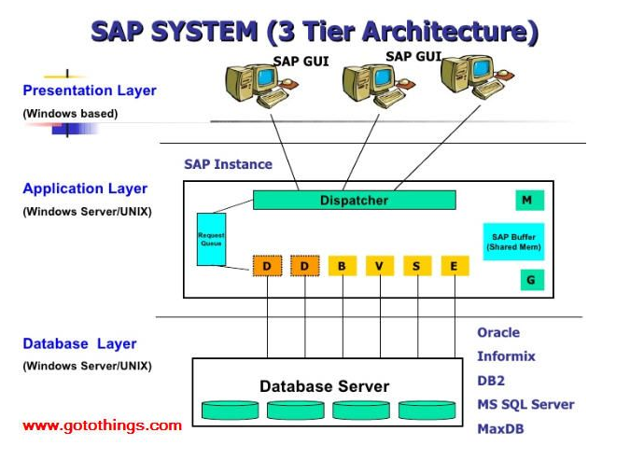
A.SAP R/1
SAP R/1 was the first version and it is one tier architecture in which three layers Presentation,Application and Database are installed in one system / server .
Server 1- Presentation+ Application+ database
B.SAP R/2
SAP R/2 is the mainframe version of software and it is a two tier architecture in which three layers Presentation ,Application and Database are installed in two seperate servers .
Server 1: Presentation
Server 2: Application+ Database
C.SAP R/3:
SAP R/3 is the client / server version of software and it is three tier architecture in which three layers Presentation, Application and Database are installed in three servers / system.
Server 1: Presentation
Server 2: Application
Server 3: Database

The Environments For Sap Erp
SAP runs on multiple Hardware, Operating Systems and Databases.

  - Supported Hardware for SAP ERP
SAP can be installed on many system platforms. The functionality and programming technique is same for all systems.
a) HP
b) IBM
c) Sun
d) AT&T
e) AS400
f) Bull
g) Sequent
h) SNI
i) Compaq Digital

B. Supported Database for SAP ERP
SAP is a back-end-free ERP system which co-operate with many database companies. That means companies have many choices. The database is common for all modules and avoids duplication of maintaining master records. For e.g. the customer records will be maintained in SD module like customer code, customer type, Credit/payment terms, address etc. The same would be used by the FI module while perusing the customer accounts or entering the receipt of payments. Similarly the sales manager can view the customer balances in the FI module for follow up with the customer.The following Database can be used in SAP software. The functionality/programming technique is same for all database system.
a) Oracle
b) MS SQL
c) Informix
d) Sybase
e) Adabas D
f) DB2 for AIX
g) DB2/400

C. Supported Operating System for SAP
The SAP business suites can be installed on the following platforms (Operating systems):
a) MS Windows NT
b) OS/400
c) Unix
d) Solaris
e) AIX
f) HP UX
g) Sinux

Benefits:
Benefits to the suppliers :
1) SAP increases their market share and , increased business by virtue of AMCs.
2) Implementer gets business and people working at client side will build their resume.
3) Hardware manufacturer gets their share of business without any effort.
Benefits to the clients
1) one data flows across all domains
2) Visibility of data
3) Visibility of inventory/accounts/MIS for better control
4) Planning and automated working avoiding procedural hurdles for various domains like purchase/production/sales etc
5) Inter-connectivity with other applications of PDM/SCM/CRM etc.

Modules
A .SAP R/3 modules are divided into the following types viz.
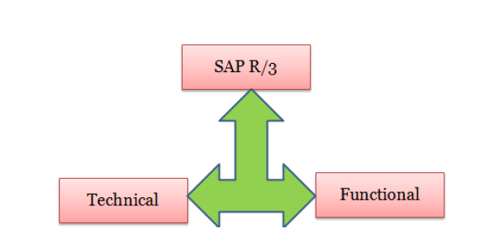

1. Functional
1. FICO (Finance & Controlling)
2. HR (Human Resource)
3. PP (Production Planning)
4. MM (Material Management)
5. SD (Sales & Distribution)
6. PM (Plant Maintenance)
7. PS (Project System)
8. QM (Quality Management)
9. BIW (Business Information Warehousing)

2. Technical
1. Programming (ABAP)
2. BASIS

3. Techno-Functional Modules
1. ABAP + HR
2. ABAP + SD
3. BIW (Business Information Warehouse)
B. Listing of each modules in SAP R/3:-
1. Basis
2. ABAP/4 Programming
3. FI (Financial Accounting)
4. CO (Controlling)
5. EC (Enterprise Controlling)
6. TR (Treasury)
7. IM (Investment Management)
8. HR (Human Resource)
9. SD (Sales and Distribution)
10. Logistics Information System
11. MM (Materials Management)
12. PM (Plant Maintenance)
13. PP (Production Planning)
14. QM (Quality Management)
15. BW (Business Warehousing)
16. IS (Industry Solutions) / SAP for Industries specific solutions
17. CS (Customer Service)
18. SMB
19. CA (Cross Application Components)
20. PS (Project Systems)
21. mySAP SEM
22. mySAP CRM (Customer Relationship Management)
23. mySAP Product Life Cycle Management
24. SCM (SAP Supply Chain Management)
25. Netweaver
26. mySAP SRM (Supplier Relationship Management)
Here in this paper, we deal with ‘Security’ which is a sub-module of the module ‘Basis’.

Security controls in SAP:-
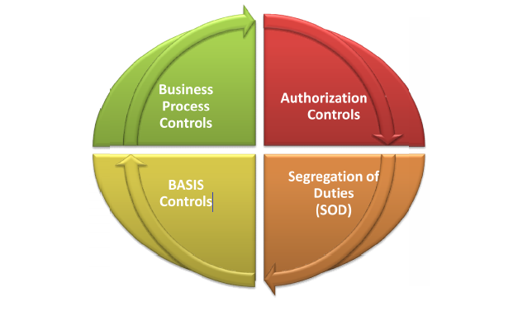
1:Authorization Controls:
- Allows users in SAP to perform their work while securing transactions from unautorized access.
- Its a complex and scalable concept:
-Determines WHAT activity can be performed by a user as well as WHERE it can be performed.
-Enforced through a pseudo-object oriented concept using authorization objects.
-Authorizations are assigned to roles which are then assigned to users.
2:Segregation of duties(SoD)
- Ensures that no one individual has complete control over major phase of a process
- Key component of any effective internal controls environment
- Typically enforced through a combination of access controls and mitigating controls

3: Basis Controls
- Refers to technical controls in SAP
- Password controls
- User administration
- Privileged users
- Auditing
- Change controls
- Batch-job maagement
- Direct access to data through tables
4: Business Process Controls:
- Refers to automated (and IT dependent) controls available in SAP for various business processes such as purchasing , sales , financial reporting , inventory , HR ,etc.
- Broadly classified under the following 3 categories:
-Inherent controls
-Configurable controls
-Procedural controls
- Inherent controls – Enforced by default in SAP.
- Sales order cannot be created with an invalid customer.
- Configurable controls – ‘Switches’ that can be set by turning them on or off based on the business requirements.
- Configured through Implementation Guide(IMG)
- Examples- Tolerance limits for 3 way match , PO approval hierarchy
- Procedural controls – IT dependent controls (example: review of exception reports)
Percentage usage by organisations:
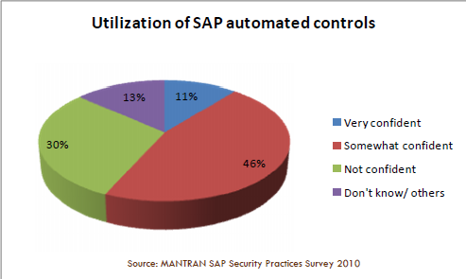

From the following figure we get an overview of Security Controls:

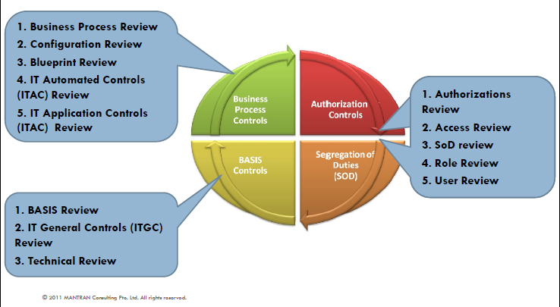
5:Infrastructure controls
- It is equally important to enforce security controls in the underlying infrastructure components
- SAP interacts with its underlying infrastructural components in unique ways
- Therefore, it is important to consider controls related to these interactions on the infrastructure level

SAP Security Overview
The abstraction levels in SAP Security are
• Network Security
• OS Security
• Database Security
• Application Security
• ERP Security
• Client-side Security

A.Network Security:
Encryption
• Password sniffing (passwords xored with known value in RFC)
• No traffic encryption by default (DIAG,Netweaver, visual admin, J2ee telnet, etc).

Potocol vulnerabilities
• RFC protocol vulnerabilities
• Getting information (RFC Ping)
• Executing remote commands (RFCEXEC, SAPXPG, RFC_START_PROGRAM)
• Registering External server

Inprooper components implementation
• Improper SAP firewall rules implementation (allow all)
• Network segmentation between users, administrators, servers, dmz

Operating System Security:
OS and application vulnerabilities
Any critical vulnerability in OS or applications installed on SAP server can be used to get access to OS and business DATA. Examples of OS vulnerabilities are everywhere (securityfocus, milw0rm,exploit-db).

OS specific security options
• NFS access. SAP data and binaries can be accessed by an anonymous user
with NFS
• OS access rights. Critical SAP files and Oracle data files may have insecure
rights such as 755 or even 777
• Insecure rhosts. Remote access can be managed by rlogin from trusted
servers thus getting access to one of SAP servers an attacker can access to
other
• Physical access.
Etc.

Database Security:
Many SAP instances installed with Oracle database. As it’s known Oracle
database has many security problems in all the areas with default installation.
Briefly:
• Database vulnerabilities
• Many default passwords + Default SAP passwords (SAPR3/SAP )
• Password policies such as password length and locking are not installed
by default
• Security properties such as

Remote_Os_Authent
• Listener security (for example latest buffer overflows that give remote
access to OS)

Application Security:
• There are many different Web servers installed in SAP landscape
such as: WEB AS, ITS, IGS
• SAP usually installs with many different web applications that use
different technologies:
JSP servlets, Web services, Webdynpro, EJB, Portal iviews, BSP
• All SAP implementations have internally developed stuff so every
company may have their own vulnerabilities
• All possible Web application vulnerabilitieses
• Buffer overflow and format string vulnerabilities in SAP IGS, SAP ITS,
Netweaver, etc.
• Other specific vulnerabilities.

ERP Security:
• The most known area of SAP security
• It is about roles, privileges and segregation of duties
• Every SAP security consultant or administrator knows this area.

Client Site Security:
SAP users may connect using the following to be secure :
• SAP Graphical User Interface.
• Browser
• Remote Function Calls
• Other Applications such as VA,Mobile client other things.

SAP Security Framework

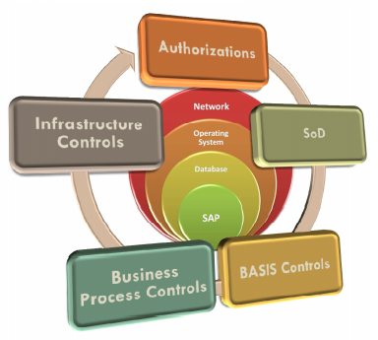

Conclusion
This paper is a survey or a research paper on Sap Security. It gives the overview of basic terminologies related with it.
It provides the basic information on :-
Sap Architecture, Modues of Sap R/3,its benefits,types of Security controls in SAP.
It also gives the SAP Security overview and its abstraction levels in SAP Security.

References
[1] www.sap.com
[2] www.saponlinetutorials.com
[3] www.sapsecuritypages.com
[4] www.computerweekly.com
[5]www.sapsecuritytrainer.blogspot.com
[6] https://en.m.wikipedia.org
[7] www.simplilearn.com /sapmodules
[8] www.sapoverview.blogspot.com

