Data and Domain Integrity Protection in Cloud Storage - Using Data Partitioning Technique

Amit Kumar Gupta
Guru Nanak Institute of Engineering
+91-9881670888 amit.iaf73@gmail.com

Abstract – Cloud computing is the aggregation of multiple computing services, storage, network resources into a single entity called ”cloud” over the Internet. In cloud computing data security, integrity of data and access control are challenging issues, these issues remain the primary source for adoption of cloud computing services Protection of outsourced data in cloud storage becomes critical because of corruptions of data, enabling integrity protection, fault tolerance, and efficient recovery for cloud storage becomes necessary. Codes which are regenerating of data provide fault tolerance by splitting data across respective multiple servers, while concentrating on less repair traffic than traditional codes during failure recovery. Therefore, remotely checking the integrity of data against corruptions and other issues under a real time cloud storage setting is our problem of study. We practically design and implement data integrity protection (DIP) environment for a specific recovering code, while at the same time we preserving the essential properties of fault tolerance and repair traffic saving. Adversarial model is designed under a DIP scheme, and enables a user to conveniently verify the unity of random subsets of outsourced data against general or destructive corruptions. We demonstrate that remote integrity checking can be conveniently integrated into regenerated codes in practical implementation.

Keywords- fault tolerance, DIP, Adversarial, integrity.

Introduction
Cloud storage offers an on-demand data deployment service model and agile deployment, and is gaining acceptance due to its scalability and low maintenance cost. However, security concerns arise when data storage is deploying to false-party cloud storage providers. It is necessary to enable clients of cloud to verify the integrity of their deploy data in the cloud suppose their data has been accidently lost or maliciously destroyed by insider/outsider attacks.
One major use of cloud storage is long term synchronisation while the stored data is rarely read, it is very necessary to ensure its integrity for loss recovery with legal requirements. Since it is typical to have a huge amount of stored data, whole-file checking becomes prohibitive. Suppose that we deploy the data to a server, which could be a storage site or a cloud storage provider. If we detect corruptions or loss in our deployed data (e.g., when a server crashes), then we should repair or recover the corrupted or loss data and restore the original data. However, storing all data in a single server is not a very good idea to the single-point-of-failure problem [5] and vector lock-ins. Thus, to repair a failed server or corrupt data, we can (i) read data from backend servers, (ii) regenerate the corrupted data of the failed server, and (iii) write the regenerate data to a respective server. In particular, chunking coding (e.g., Reed-Solomon codes) has less storage overhead than replication under the same fault-tolerance level.
In this paper practical data integrity protection for regenerating-coding-based cloud storage has been design and implemented. FMSR-DIP [8] technique aims to achieve several design features and performance. First, it sustain fault tolerance and repair traffic. Second, it assumes only the thin-cloud interface, Third, it exports several parameters that allow clients to trade performance for security.

Detail Experiment
  - Fundamental
This section provide the background detail , based on existing studies, for data integrity protection .We first describe the function minimum storage regeneration (FMSR) [8] code considered in this paper. Then we state the cryptographic primitives being used in our DIP scheme.

  - FMSR
We consider a distributed storage setting in which a file is split over four servers using an code. Each server can be a storage environment provider and is completely independent of respective other server. Lets say one server fails our goal is to reconstruct the lost data of the corrupt server in a new server, so as to maintain the fault tolerance. We define the repair traffic as the live data being read from other surviving servers.
And write the reconstruct data to the new server. We assume that there is a proxy that handles the read, reconstruct, and write operation during repair.

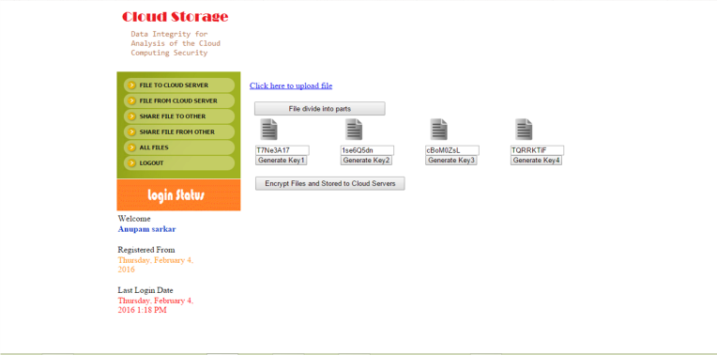
Fig 1. Working of Encrypted Split file in cloud

  - Cryptographic Primitives
Our DIP scheme is build on several cryptographic primitives.
The primitives include: (i) symmetric encryption, and (ii) Cipher block chaining (CBC MACs) [3]. Each of the primitives takes a secrete keys. Intuitively, it means that without knowing its corresponding secret key it is computationally infeasible for adversary to break the security of a primitive.
We also need a systematic Blowfish Encryption
Algorithm to protect against the corruption of a chunk. In conventionally error-correcting codes (ECC) [3], when a large amount of file is encoded, it is first broken down into respective smaller parts to which error-correcting codes is applied independently. Blowfish uses a 32-448 key length building block to randomize the block structure so that it is computationally impractical for an challenger to target and corrupt any particular stripe. Note that both FMSR and Blowfish provide fault tolerance. The difference is that FMSR applies to a file that is striped across servers, while Blowfish applies to a file that is striped across server, while Blowfish applies to a single chunk stored within server.
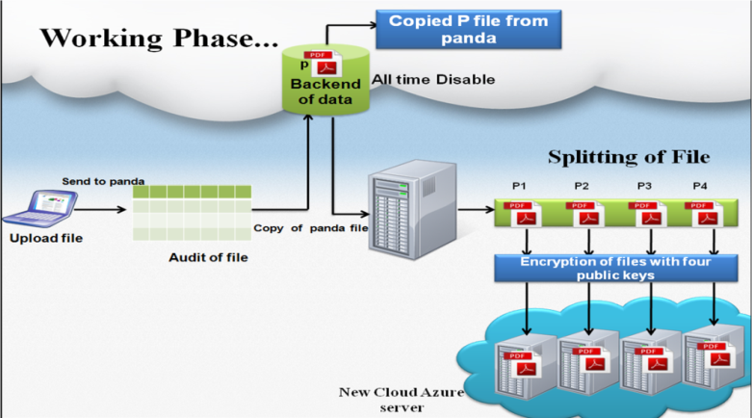
Fig 2.Working of DIP of how file is splitting and stored in cloud server

D. Algorithm: Partitioning and merging files
- Load the Input file.
- Calculate size of file.
- Partitioning file: If size<=minimum size or size>=maximum size Show error message. Else Split file respect to number of servers with extension and index value.
- Extract Digital Signature of each partition.
- Generate secret key for each partition.
- Encrypt respective partition using respective secret keys.
- Store partition sequence, digital signature, keys and file attribute at TPA.
- Send each partition at respective server.
- Decrypt the merged file with key.
- Merging file: TPA request for file partitions from servers.
- Extract new digital signature of each partition and compare it with stored digital signature at TPA. If new digital signature equals to stored digital signature at TPA Merge file otherwise data is corrupted.

Implementation
In this section, we describe our DIP implementation and how we instantiate cryptographic primitives. Also, we address how we fine-tune various design parameters to trade security for performance.

  - Integration of DIP into Cloud
We implement a standalone DIP module and a storage GUI module, and integrate them with multi-Cloud [5] .In the Upload operation, system generates code chunks for a file based on local host. The code chunks will be temporarily stored in the local file.The DIP module then reads the code chunks from the local file system then splits them into four parts according to size let say if file size is 8mb then it will divide into 2mb per each then encodes them with Blowfish encryption , and passes the resulting respective data to server, which will upload the chunks to multiple respective four servers (or a cloud-of-clouds [1], [9]). In the Download operation, the module checks the integrity of the chunks retrieved from the servers before relaying the chunks to Cloud for decoding. Note that we can issue a range GET request to download a selected range of bytes. Here if we lost the one of split data then we are going to regenerate the data from backend server then lost data is regenerated and after that we are going to decode the data automatically then merge the data and after that data we will going to download the file. We are also providing the sharing of file with encrypted one means we can share the any data to anyone from anywhere.
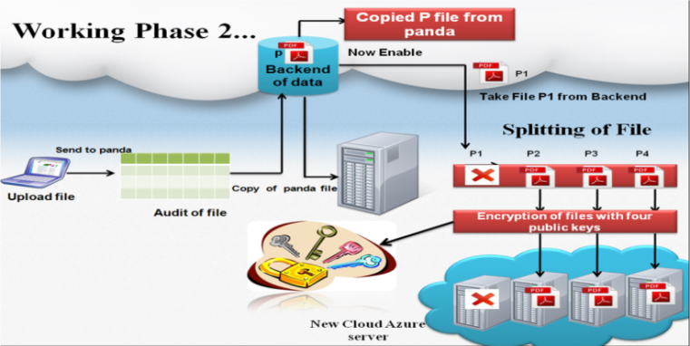
Fig 3. Process of Lost File Recovery
  - Cryptographic Primitives
We implement all cryptographic operation using 64-bit secret keys. We require that all secret client side without being revealed to any server. Since the files in the cloud are typically of large size, we expect that the secret keys only incur a small overhead. The primitives are instantiated as described below.
Symmetric encryption. We use BLOWFISH-64 bit on cipher-block chaining (CBC) mode.
Cipher Block Chaining Message authentication codes (CBC MACs) [5]. Work on previous blocks as chaining to other blocks if one block is change then it also change the other blocks make it as XOR which avoid the further attacks to the blocks.

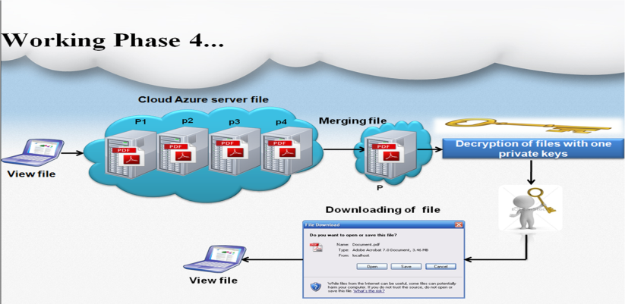
Fig 4. Process of Merging and Decryption of file

Security Analysis

In this section, we elaborate the design choices of DIP and investigate its security guarantees.

  - Uses of Security Primitives
We briefly summarize the effects of various security primitives used in DIP
Symmetric Encryption. We encrypt the metadata to hide the FMSR encoding coefficients. This protects against the scenario where the values can be recovered with known encoding coefficients and original file content.
Blowfish Encryption: symmetric block encryption algorithm [7] designed in consideration with :
Fast : Encrypts data on large 64-bit microprocessors at a rate of 26 clock cycles per byte.
Compact: it can run in less than 5K of memory.
Simple: Uses addition, XOR, lookup table with 32-bit operands.
Secure: the key length is variable ,it can be in the range of 32~448 bits: default 128bits key.
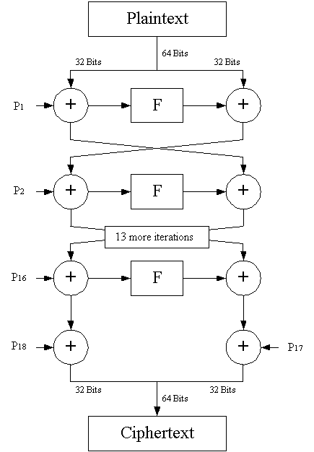
Fig 5. Blowfish Encryption
  - Security Guarantees
We provide a analysis of the robustness of DIP against adversarial attacks. In the interest of time, we refer readers to a more detailed mathematical analysis. We have analyse various symmetric algorithm like Blowfish, DES, 3DES, AES and compare them on the basis of execution times(in seconds) of encryption algorithm in CBC Mode on a P-4 2.4 GHz machine and also using .NET implementation.

Table1-Execution of various block cipher algorithms in seconds
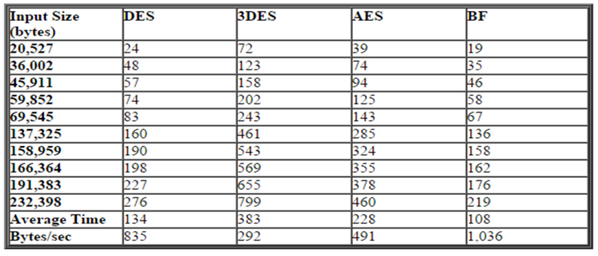
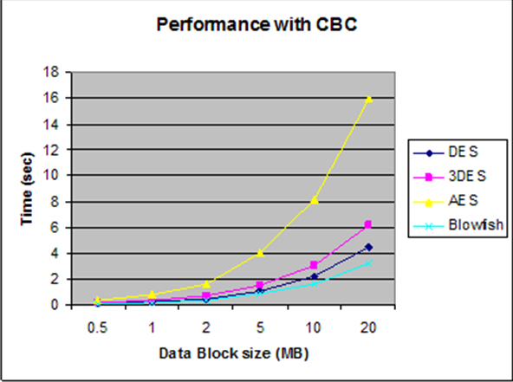
Fig 6.Performance Results with CBC Mode

The presented results showed that Blowfish has a better performance than others block cipher algorithm. Since Blowfish [7] has not any known security weak points so far therefore blowfish [7] considered to be best performance based algorithm. AES showed indigent performance results compared to other algorithms because it requires more processing power as well less load. Using mode of operation has added extra processing time, but overall it was nearly negligible for certain application that requires large amount of secure encryption to a relatively large data blocks.

Evaluation
We evaluate the practicality of DIP in a real storage setting by measuring the overhead of DIP in the upload, check, download, and repair operations .We empirically evaluate the running time overhead a local cloud storage testbed, and we further analyse the cost overhead with the pricing method of different commercial cloud providers.

  - Running Time Analysis
We first conduct experiments on a local cloud platform that is built on Cloud Azure. We deploy our DIP implementation in single-threaded mod on a machine equipped with 16GBs Ram ,64 bit and 64 Bit Window 8 the machine is connected via a storage emulator and cloud Azure platform that is attached with 5 servers We create multiple container on servers, such that each container mimics a storage server. We focus on measuring the running time of each operation. We assume that a file objects being processed remain intact throughout an operation, so that we can measure the overhead of DIP in normal usage. Our results are averaged over 40 runs.
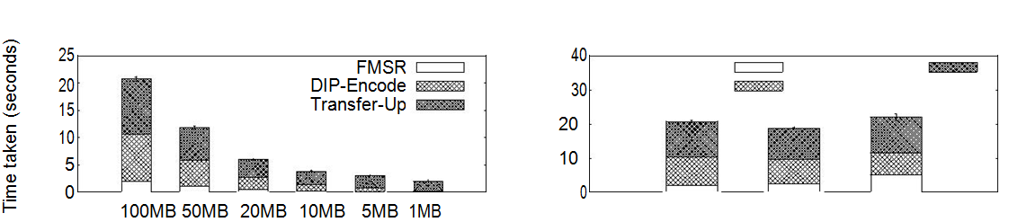
Fig 7.Different File sizes
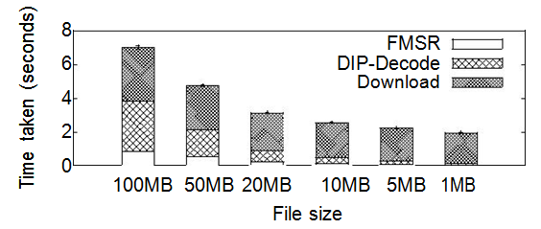
Fig 8. Running time of the entire Download operation on a local cloud
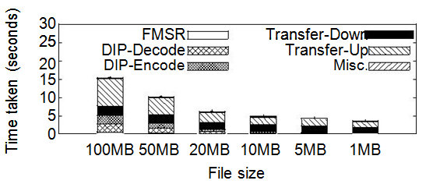
Fig 9.Running time of the entire Repair operation on a local cloud

  - Monetary Cost Analysis
We now describe the monetary overhead of DIP in each of the operations compared to the original implementation in cloud.
Upload: The major source of the monetary overhead of our DIP scheme which expands the stored data and increases the storage cost by roughly (note that the inbound transfer cost is free for all commercial cloud providers that we consider ). The cost due to expanded file metadata in a negligible constant if the file size is large enough. For example, when using our encrypted metadata size is 320Byte, which is 160Byte more than the current implementation . Furthermore, some cloud providers such as Rackspace and Azure allow a small metadata to be associated with an uploaded object for free.
Download: When no corrupted data is detected, we do not have to use regenerated mechanism. Thus, the monetary cost incurred by DIP is similar to other cloud . Our DIP scheme adds a small constant overhead in downloading the metadata, which now has a larger as size then the original other cloud Implementation.
Repair:The major monetary overhead again comes from in regenerated code blocks As discussed above., if there is no corrupted data in backend servers, we resurvey the network transfer cost of cloud when downloading data from the backend servers. Also, the inbound transfer cost of writing reconstructed DIP chunks [10] to a server is free for many commercial cloud storage providers.
Therefore, we steal preserve the cost saving property of the repair operation cloud when compare to the convention repair method.

Acknowledgment
This work was supported by grant ECMP from the IIT Bombay and Nagpur University of INDIA.

References
- Amazon Elastic Cloud. http://aws.amazon.com/ec2/.
- Amazon Simple Database Service. http://aws.amazon.com/s3/.
- H. C. H. Chen and P. P. C. Lee. Enabling Data Integrity Protection in Regenerating-Coding-Based Cloud Storage. Technical report, CUHK, 2012.
- G. Ateniese, R. Burns, R. Curtmola, J. Herring, O. Khan, L. Kissner, Z. Peterson, and D. Song. Remote Data Checking Using Integrity Data Possession. ACM Trans. on Information and System Security, 14:12:1– 12:34, May 2011.
- G. Ateniese, R. Di Pietro, L. V. Mancini, and G. Tsudik. Scalable and Efficient Provable Data Possession. In Proc of SecureComm, 2008. .
- .A. Bessani, M. Correia, B. Quaresma, F. Andre,´ and P. Sousa. DEPSKY: Dependable and Secure Storage in a Cloud-of-Multi-Clouds.In Proc. of ACM EuroSys, 2011.
- J. Black and P. Rogaway. Ciphers with arbitrary finite domains of computing. In Topics in Cryptology – CT-RSA 2002, volume 2271 of LNCS, pages 114–130. Springer, 2002.
- K. Bowers, A. Juels, and A. Oprea. HAIL: A High-Availability and Integrity Layer for Cloud Storage. In Proc. of ACM CCS, 2009.
- 9. B. Chen, R. Curtmola, G. Ateniese, and R. Burns. Remote Data Checking for Network Coding-Based Distributed Storage Systems. In Proc. of ACM CCSW, 2010. .
- Y. Hu, H. Chen, P. Lee, and Y. Tang. NCCloud: Applying Network Coding for the Cloud Storage Repair in a Cloud-of-Multi -Clouds. In Proc. of USENIX FAST, 2012.
- Open SSL. http://www.openssl.org/.
- Open Stack.http://www.openstack.org/projects/storage/.
- C. Wang, Q. Wang, K. Ren, and W. Lou. Privacy-Preserving Public Auditing tool for cloud Data Storage. In Proc. of IEEE INFOCOM, 2010.
[14] zfec http://pypi.python.org/pypi/

