Alumni Retrieval Management System

Tina Jangde , Shweta Mahadule, Aishwarya Mondhe
Department Of Information Technology
KDK College Of Engineering , Nagpur
Email:tina5jangde@gmail.com

Abstract– This project is aimed at developing a Repository and each Engine for alumni of the college, which is of importance to a college. The Alumni Information Database is a web based application that can be accessed throughout the World. Anyone can access the search Engine to know about any Alumni of that college but can’t able to add This system can be used as an application for the Alumni Information Database to manage the college information and student’s information. Student logging should be able to upload the information of the student.

Introduction

An Alumni Association acts as a bridge between the alumni and the current student of any institute. It helps to make a stronger relationship between the institute and the students who have benefited from the institute. It does the institute a lot of good to stay connected with its student base who have grown and developed over the years and can give back to their Alma mater. Opportunities for job placements, donations, sponsorships, faculty positions are also possible through such platform that helps alumni to connect with the institute and present students. So, ever thought of having an alumni association for your institute, but don’t know how to start the one? So, here’s your answer. There are essentially two requirements to start an Alumni association for institute, via, (i) An enthusiastic and willing team to take up this initiative with all its challenges and see the entire process through.(ii) A body of alumni and present students willing to participate on the venture and make it a success. An important role in an Alumni Association is that of a leader. He/she would be the one who would spearhead all activities and ensure they are going in the correct path. For this he/she has to be level-headed, appealing and passionate person who is eager to go that extra mile tore build lost ties. Based on your needs, you could have an unofficial or a official Alumni Association. If

you have a relatively small group of people in a region or area who want to come together, you could have an informal/unofficial Alumni Association led by one or two persons. The ability of these individuals to lead and encourage the other members would determine the course of action rather than a code of conduct of an alumni association and strict guidelines. They would be the ones who would coordinate with the institute and other members, circulate any notifications or announcements and be a contact point between others and the Alumni Association. On the other hand, if the group is bigger and system-oriented, a formal Alumni organization would work better. You could have a code of conduct, standard policies and procedures, goals and objectives and if required, a foundation. Registration of an Alumni Association is a legal mandate in some countries and hence their rules would be per-determined. A formal association may have a formal hierarchy and line of authority as well with a President / Vice-President to preside over all meetings and take major decisions. There could be other roles such as Secretary, Treasurer, Events Organizer, Communication Officer, etc. Once you have finalized on what group you wish to form, here are the actual steps to create an Alumni Association: 1. Form an informal group – Contact the alumni in your network and others in your geographical region to get a members’ listing. Use your institute’s alumni database to get in touch with all the members and seek their willingness to be a part of such an Association.
2. Spread the word – An initial message needs to be sent to all the participating members informing them about the group constitution, leader’s profile, group members’ information, and other important details. 3. Get started – Once you have all members updated about the Association, have a meeting where the group can decide through mutual consensus on the goals and objectives of the group, the activities to be undertaken, code of conduct, standard operating procedures and further course of action. There could also be plans made on further induction of other alumni members into the group. If the group so decides, there could be a committee formed to handle the administration and other functions of the Association. 4. Follow-up meeting – After the inaugural session, a follow-up meeting should be arranged on an immediate basis to reinforce the establishment of the Association and check for more participation. 5. Plan for funding – Your Alumni Association could get funds in three ways: by an annual membership taken from all alumni members or by contributions / donations received by alumni on specific occasion or specific purposes or a combination of both these methods. There could also be sponsorship opportunities provided through advertisements in newsletters/directories as well. 6. be sponsorship opportunities provided through advertisements in newsletters/directories as well. 6. combination of both these methods. There could also be sponsorship opportunities provided through advertisements in newsletters/directories as well. 6. Make your presence known – Using modern day tools such as social networking sites, Alumni network, professional networking sites, online web etc., make your presence known to all your alumni members of your institute and build your membership base. So, here’s to a smooth start to creating your own Alumni Association. You may find on your way, some members who do not actively participate in all activities or who find such things a waste of time. Yet, most members would do it voluntarily and rap immense benefits from such Alumni Associations.

Existing System
The Existing system is a computerized system but which is maintained at individual databases i.e. in excels sheets, it’s a time delay process. And maintaining all the records in Excel sheets is difficult. If they want any record they have to search all the records. It doesn’t provide multiple user accessibility and also doesn’t have different user privileges. So the system is not accessible for all the employees of the organization.

Proposed System
The Proposed system is a computerized system but which is maintained at Centralized databases i.e. in automated forms it’s a very fast process. And maintaining all the records in online systems database which makes it very easy to access and retrieve data from the database. If they want any record they can easily search all the records. It provides multiple user accessibility and also has different user privileges. So the system is accessible for all the employees of the organization.

Implementation
Administrator Module: The administrator is responsible for maintaining information of students. When a student submits the registration form, administrator will complete the verification process and, if successful, the student details are added into the database. The administrator maintains the passwords of Event Manager and that of himself.

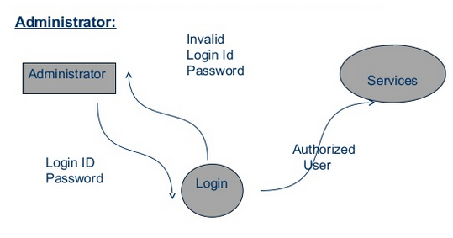• Event Manager Module: This module maintains the information about various events that are conducted by various colleges and universities. Details of notifications are also maintained. The manager can add, delete, edit and view event details.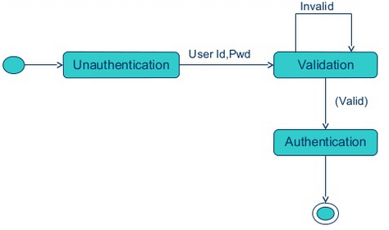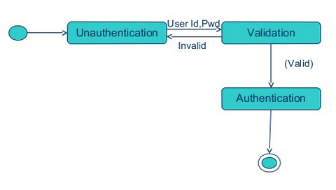 • Alumni & Student Module: The Alumni/Students can register themselves and after the approval from the administrator, they can logon into their account and can send mails, post queries, update their profiles and even search for other student details. one can view the event details and search for specific information.
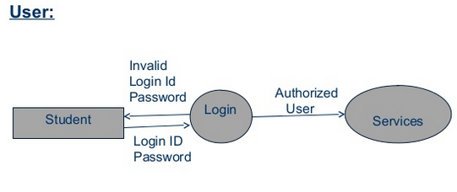 The module provides mail and query functionalities.

- Future Scope
Contact alumni officer it would be very useful if the members of the alumni web site which are former students of College could directly contact the alumni officer through the web site. The system that was implemented does not offer this functionality. However it is easy to find the e-mail address of the alumni officer because it will be placed on the home page of the online community. The contact alumni officer functionality could be easily implemented using asp, which is also used in order to implement the broadcast e-mail functionality that the alumni web site offers. Submit CV It would be very useful if the former students would be able to directly submit their CV using the alumni web site. This could be found very useful because of the fact that College cooperates with many different companies. The CV’s would be stored on the server where some companies would be able to access them if they are looking for a new employ. This means that another type of user should be added to the system. As mentioned above, the alumni of College offers many benefits and services to the former graduated students. One of those services is to help the graduated students to get employed. If the alumni students were able to submit a CV and the companies would have been able to access those CV’s, the alumni office would be able to help the graduates get employed without direct interference. Discussion forum A very useful functionality from which the alumni members could benefit would be if the web site had a forum where any discussion could be opened that is related to a person’s field of study. Many universities around the world have a forum on their alumni web site. The forum could also be used to ask some question. Setting personal information private or public Some people would not like the idea that their information could be seen by everybody that is a member of the alumni web site. That is why it would be useful to be able to set some information, such as the contact details as private or public. This could be done very easy with the use of radio buttons.
• Search button The user should be able to us search option to find particular information on the alum website. Profile updating: Right now, alum website offer only inserting details, later it can be modified to update information.

- Result
The project has been developed as per the requirement specification. It has been developed using php, html, apache and SQL server compact, the complete system is thoroughly tested with the availability of data and throughput reports which are prepared manually. Design procedure and output reports are presented in this project report. This design is easy to understand that any new modules can be incorporated easily.

References

- The complete reference php by steven holzner, HTML5 kozent, http://evonet.com.au/webmatrix-authentication and-authorization/ http://www.microsoft.com/web/post/your-first-website-using-webmatrix http://www.microsoft.com/visualstudio/eng/products/visual-studio-express-for- windows-phone#product-express-phone

Circuit Diagram
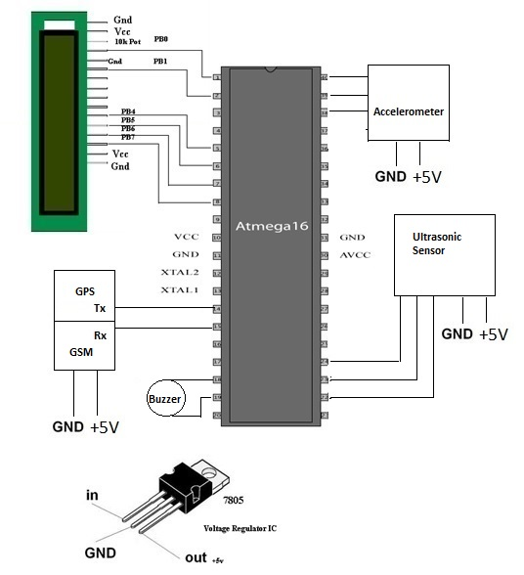
Fig.(1) Circuit Diagram

Working
It is clear from the above circuit diagram that the ultrasonic sensor attached to the system will be connected to the microcontroller for detecting any obstacles in front of the stick and send the digital signals to the microcontroller for converting it into speech using voice kit.
The accelerometer attach with the system will detect falling moment of the blind person. GSM is inbuilt in the stick is used to send message to the guardian of that person. The mobile application in android of the guardian will detect the exact location of that person.

Components
- ATmega32

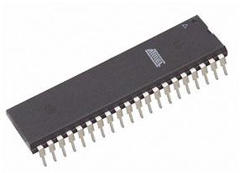
Fig.(2) ATmega32
All output signals generated from flex sensors are in analogue form and these signals need to be digitized before they can be transmitted to encoder. Therefore microcontroller ATMEGA 16 is used as the main controller in this project. It has inbuilt ADC module, which digitizes all analogue signals from the sensors and inbuilt multiplexer for sensor signal selection. It supports both serial and parallel communication facilities.
ATmega32 is an 8-bit high performance microcontroller of Atmel’s Mega AVR family with low power consumption. Atmega32 is based on enhanced RISC (Reduced Instruction Set Computing) architecture with 131 powerful instructions. Most of the instructions execute in one machine cycle. Atmega16 can work on a maximum frequency of 16MHz.

- GPS Module

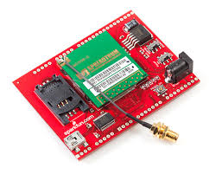

Fig.(3) GPS Module

The Global Positioning System (GPS) is a space-based navigation system that provides location and time information in all weather conditions, anywhere on or near the Earth where there is an unobstructed line of sight to four or more GPS satellites. The system provides critical capabilities to military, civil, and commercial users around the world. The United States government created the system, maintains it, and makes it freely accessible to anyone with a GPS receiver.
The US began the GPS project in 1973 to overcome the limitations of previous navigation systems, integrating ideas from several predecessors, including a number of classified engineering design studies from the 1960s. The U.S Department of Defense (DOD) developed the system, which originally used 24 satellites. It became fully operational in 1995. Bradford Parkinson, Roger L. Easton, and Ivan A. Getting are credited with inventing it.[7]
- Ultrasonic Sensor
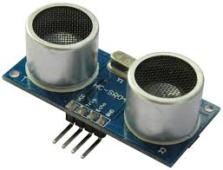
Fig(4). Ultrasonic Sensor
An ultrasonic sensor is a device that works in much same way as RADAR and SONAR. Ultrasonic sensors broadcast a powerful, ultrasonic frequency, then detect the ultrasonic sound waves as they bounce off of objects and return to the sensor.
They are almost always used to measure speed or direction and are efficiently at determining position. Ultrasonic sensors are commonly used for a wide variety of noncontact presence, proximity, or distance measuring applications. These devices typically transmit a short burst of ultrasonic sound toward a target, which reflects the sound back to the sensor. The system then measures the time for the echo to return to the sensor and computes the distance to the target using the speed of sound in the medium.
The first step toward identifying the right proximity sensor for your application is to understand the fundamental ultrasonic properties of the transmission medium and the way they influence the measurement and system operation. [8]

- Accelerometer

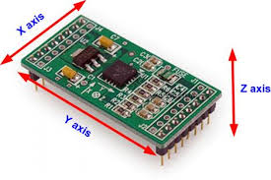
Fig.(5) Accelerometer

An accelerometer is a device that measures proper acceleration ("g-force"). Proper acceleration is not the same as coordinate acceleration (rate of change of velocity). For example, an accelerometer at rest on the surface of the Earth will measure an acceleration g= 9.81 m/s² straight upwards. By contrast, accelerometers in free fall orbiting and accelerating due to the gravity of Earth will measure zero.
Accelerometers have multiple applications in industry and science. Highly sensitive accelerometers are components of inertial navigation systems for aircraft and missiles. Accelerometers are used to detect and monitor vibration in rotating machinery. Accelerometers are used in tablet computers and digital cameras so that images on screens are always displayed upright. Accelerometers are used in drones for flight stabilization. Pairs of accelerometers extended over a region of space can be used to detect differences (gradients) in the proper accelerations of frames of references associated with those points. These devices are called gravity gradiometers, as they measure gradients in the gravitational field. Such pairs of accelerometers in theory may also be able to detect gravitational waves
Single- and multi-axis models of accelerometer are available to detect magnitude and direction of the proper acceleration (or g-force), as a vector quantity, and can be used to sense orientation (because direction of weight changes), coordinate acceleration (so long as it produces g-force or a change in g-force), vibration, shock, and falling in a resistive medium (a case where the proper acceleration changes, since it starts at zero, then increases). Micro-machined accelerometers are increasingly present in portable electronic devices and video game controllers, to detect the position of the device or provide for game input.[9]
- 7805 Voltage Regulator IC
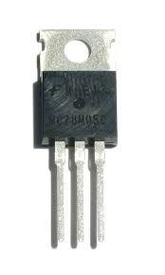
Fig.(6) 7805 Voltage Regulator Ic
The 7805 voltage regulators employ built-in current limiting, thermal shutdown, and safe-operating area protection which makes them virtually immune to damage from output overloads. 7805 is a three-terminal positive voltage regulator.
With adequate heat sinking, it can deliver in excess of 0.5A output current. Typical applications would include local (on-card) regulators which can eliminate the noise and degraded performance associated with single-point regulation.
7805 regulator comes from the 78xx family of self-contained fixed linear voltage regulator integrated circuits. The 78xx family is a very popular choice for many electronic circuits which require a regulated power supply, due to their ease of use and relative cheapness. When specifying individual ICs within this family, the xx is replaced with a two-digit number, which indicates the output voltage the particular device is designed to provide (for example, the 7805 voltage regulator has a 5 volt output, while the 7812 produces 12 volts). The 78xx line are positive voltage regulators, meaning that they are designed to produce a voltage that is positive relative to a common ground. There is a related line of 79xx devices which are complementary negative voltage regulators. 78xx and 79xx ICs can be used in combination to provide both positive and negative supply voltages in the same circuit, if necessary.
7805 ICs have three terminals and are most commonly found in the TO220 form factor, although smaller surface-mount and larger TO3 packages are also available from some manufacturers. These devices typically support an input voltage which can be anywhere from a couple of volts over the intended output voltage, up to a maximum of 35 or 40 volts, and can typically provide up to around 1 or 1.5 amps of current (though smaller or larger packages may have a lower or higher current rating).
- SIM300
SIM300 is a Tri-band GSM/GPRS engine that works on frequencies EGSM 900 MHz, DCS 1800 MHz and PCS1900 MHz. SIM300 provides GPRS multi-slot class 10 capability and support the GPRS coding schemes CS-1, CS-2, CS-3 and CS-4.
With a tiny configuration of 40mm x 33mm x 2.85 mm , SIM300 can fit almost all the space requirement in your application, such as Smart phone, PDA phone and other mobile device.
The physical interface to the mobile application is made through a 60 pins board-to-board connector, which provides all hardware interfaces between the module and customers’ boards except the RF antenna interface. The SIM300 is designed with power saving technique, the current consumption to as low as 2.5mA in SLEEP mode.
The SIM300 is integrated with the TCP/IP protocol Extended TCP/IP AT commands are developed for customers to use the TCP/IP protocol easily, which is very useful for those data transfer applications. Module will automatically go into SLEEP mode if DTR is set to high level and there is no on air or audio activity is required and no hardware interrupt (such as GPIO interrupt or data on serial port).
In this case, the current consumption of module will reduce to the minimal level.
During sleep mode, the module can still receive paging message and SMS from the system normally.

Software
- PCB Artist

PCB’s are backbone of any production level electronic device in today market, and therefore knowledge of PCB layout tools can be a vital skill. Both analog and digital circuits are used in PCBs depending on the application ,and with different types of circuits the designer must take into account certain design considerations. More advance circuits like RF circuits or power circuits take more thought in layout and design because circuit is more sensitive to component placement.

- AVR studio

AVR studio is used by embedded programmers for programming and debugging for many of the Atmel microprocessor such as Atmega8 or even the Atmega128.While it has support for assembly programming for those who prefer to use higher languages, it uses the off format for debugging.
Beginning with version 4 AVR studio has now moved to dwarf2 and can be more readily used in conjunction with the open source gcc based compiler WinAVR. This software would also benefit clear bug reports for some the overrides required.

Acknowledgment
With profound feeling of immense gratitude and affection, we would like to thank our guide Prof. Mrs. J.S.Gawai Dept. of Electronics Engineering for her continuous support, motivation, enthusiasm and guidance. Her encouragement, supervision with constructive criticism and confidence enabled us to complete this seminar.
We also wish to extend our reverences to Dr. P. D. Khandait, Head of Electronics Engineering for providing necessary facilities to complete our seminar.
We are gratifying to Dr. A. V. Vanalkar, Dean (R & D) for motivating us to put our best efforts in this seminar work.
We express our admirations for Dr. A. M. Badar, Vice Principal, for his valuable advice and support throughout this venture.
We also put forth our deepest sense of gratitude towards Dr. D. P. Singh, Principal for constant motivation and providing necessary infrastructure and facilities.
Finally, a special thank to Project In-Charge Prof. V. V. Chakole and all the faculty members of the department for their cooperation throughout the seminar.

References
[1] Iman M. Almomani, Nour Y. Alkhalil, Enas M. Ahmad and Rania M. Jodeh, "Ubiquitous GPS Vehicle Tracking and Management System", IEEE Jordan Conference on Applied Electrical Engineering and Computing Technologies (AEECT), 2011.
[2] ZongweiLuo, Tianle Zhang and ChunluWgan, "RFID Enabled Vehicular Wireless Query for Travel Information in Intelligent Transportation System", IEEE International Conference on RFID-Technologies and Applications, 2011.
[3] SaeFujii, Atsushi Fujita, TakaakiUmeduHirozumi Yamaguchi, TeruoHigashino, Shigeru KanedaandMineoTakai, "Cooperative Vehicle Positioning via V2V Communications and Onboard Sensors", IEEE 2011.
[4] Ghassan Samara, Wafaa A.H. Al-Salihy and R. Sures, "Security Analysis of Vehicular Ad Hoc Networks", Second International Conference on Network Applications, Protocols and Services, 2010.
[5] Atmel 32 bit AVR MICROCONTROLLER AT320C3LO123
[6] SKYLAB DS-SKM58-V1.0-110101.
[7] TEXAS INSTRUMENT ULTRASONIC Ranging module HC-SROH.
[8] ANALOG DEVICES Small, Low Power 3-Axis 3g accelerometer.
[9]TEXAS INSTRUMENTS NATION SEMICONDUCTOR LM386 Voltage Audio Amplifier.

