Secure Multimedia Retrieval System Using Selective Ordered Bucketization

Introduction
Ordered Bucketization is dealt as a cryptographic object. In OB, plaintext-space is split into a pre-defined range of buckets. With bucketization, along with OB, varied styles of SQL queries over encrypted data can be performed, if the bucket number corresponding to the initial plaintext is given with encrypted information [10]. For instance, if a client needs to get the data within a certain specified range, it first calculates the numbers of buckets whose union is that the smallest set covering the queried range. The client then sends the bucket numbers to the main server that acts as the database. The database server searches all the encrypted information whose bucket range matches one of the received numbers. The server then, sends the information back to the client. After decryption, correct results can be acquired by filtering out the data that are outside the specified range. During this case, a huge quantity of information is sent and received across the client and server than in the case where the database stores unencrypted information as a result of the false positives that occur in cases in which a bucket has the data required by the client and the data that it doesn't need.
This approach is very efficient compared to the case where the client receives all the encrypted information from the server and decrypts all information to get the proper query result. Therefore, this technique is very helpful when users cannot store unencrypted information like in cloud computing. Bucketization is very much useful for vary queries if the bucket range is assigned in an ordered manner. For instance, in the same case reported above, the client has to send only two bucket numbers: one that has start of the range value and the one that has the end of the range value. In this way, order preserving encryption (OPE) can be replaced by OB [6], [8].
OPE supports more efficient range queries compared to the case of OB. Besides, the results of range queries on ciphertexts encrypted by OPE doesn't produce false positives as a result of its comparison ability on ciphertexts which differentiates whether a ciphertext has the specified plaintext within the given range when the server has encryption of two borders of queried range in plaintext-space. But OPE doesn't support a weak version of IND-OCPA (INDistinguishability under Ordered Chosen Plaintext Attack) security [3]. This lack of security led to the consideration of using OB rather than OPE.

Related Work
Paper [1] introduces encryption with ordered bucketization (EOB), a combination of OB and a symmetric encryption scheme, that provides reasonable range querying efficiency by showing that the bucket size distribution is not skewed and suggests a new security model for EOB called IND-OCPA-P which ensures high level security.
Paper [2] presents the first order-preserving scheme that achieves ideal security using the idea of mutable ciphertexts called mOPE, proposes a stronger notion of same-time OPE security, stOPE, that reveals only the order of the elements in encrypted database at the same time and presents versions of mOPE and stOPE that protect against a malicious server by using Merkle hashing.
Paper [3] deals with construction of real OPE scheme for specific plaintext domain and proves that it is secure under IND-OCPA and that ideal OPE is not secure under the same conditions and extends the concept of OPE to generalized OPE (GOPE) which is secure under IND-OCPA in polynomial-sized domains and then the security notion is weakened to IND-OLCPA to prevent the big jump attack in superpolynomial-sized domains.
Paper [4] deals with securely executing multidimensional range queries over outsourced data and provides a tunable data bucketization algorithm that allows the data owner to control the trade-off between disclosure risk and cost, identifies two distributional properties- variance and entropy, which when higher reduces the worst-case risk, proposes a trade-off algorithm called controlled diffusion (CDf) that increases variance and entropy values and carries out extensive experimentation to test the quality and performance of optimal partitioning and diffusion algorithms.

Paper [5] proposes a secure data storage scheme that can effectively defend against frequency-based attacks in wireless networks, designed a novel 1-to-n encryption scheme that utilizes the proposed dividing and emulating techniques that provides robust security guarantee against frequency-based attacks with low overhead and supports efficient query evaluation over encrypted data.

III . MULTIMEDIA RETRIEVAL SYSTEM
Multimedia bucketization is made possible, that is, text as well as video files are encrypted and split and can be stored in the same bucket. An asymmetric encryption is used so as to avoid key leakage between client and server. The plaintexts in text files are converted into ciphertexts on encryption whereas the video files are split into chunks based on their time-frames and stored as non-playable files in the cloud server. The data are thus evenly split into the predefined number of buckets and coefficient values for each bucket are stored separately as index file which helps in bucket identification for data retrieval.

- MODULES
- Architecture Diagram
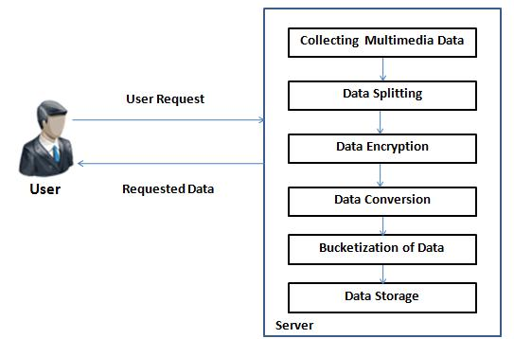

- User Registration and Server Deployment
A user application is created to allow the user to access the data from the cloud server. The user needs to create an account to access the network. All the user details will be stored in the database of the server. A user interface frame is designed to communicate with the server through network coding using the programming language java. The server then establishes the connection to communicate with the users. Each user’s activities will be updated in the database by the server. Server also checks for user authentication to prevent unauthorized users from accessing the application.

- Data Splitting & Storage in Separate Buckets
By splitting the jobs the user requests are easily executed and work load of server is reduced. The server will split the data into multiple segments based on their sizes and store them in multiple buckets. These data are also stored in the replica servers as a back-up.

D. Index File Maintenance
The co-efficient values of each batch of data are taken. The batch files and the co-efficient values are stored in a single child. The index information of all the data are maintained in the child, which handles the query from the user. The server uses the index information to easily identify which bucket a file is stored in and retrieve the required data quickly.

- Data Retrieval
The server retrieves the data the user needs. The retrieval of data is quick because the server knows the data location through the child. This largely reduces the time consumption in the transmission of data. The user first selects the file type, after which the server displays a list of files of that type for the user to select the required file. The decrypted data is received only if the user is authorized, i.e. if the user provides the correct key for decryption. In case of data loss, the server gets the back-up data from the replica servers.

- EXPERIMENTAL SETUP AND RESULT

A Hard Disk Drive of 80 GB and a RAM memory of 512 MB are used for the implementation. Java JDK 1.7 is used as the front-end and MySQL 5.0 is used as the back-end with Windows 7 operating system.

- Screenshots
The following screenshots show the sample output for encrypting and bucketizing multiple files and gives an idea on splitting of the multimedia files.
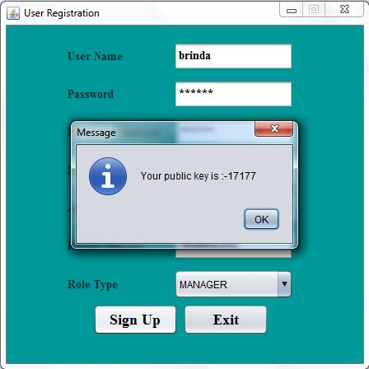

Fig. 1 Public Key on User Registratio
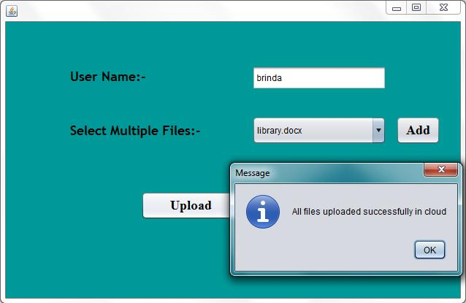

Fig2. File Upload by Admin
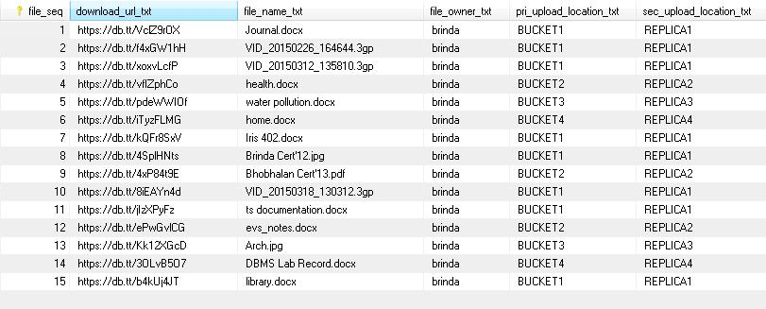

Fig3.Index File Maintenance

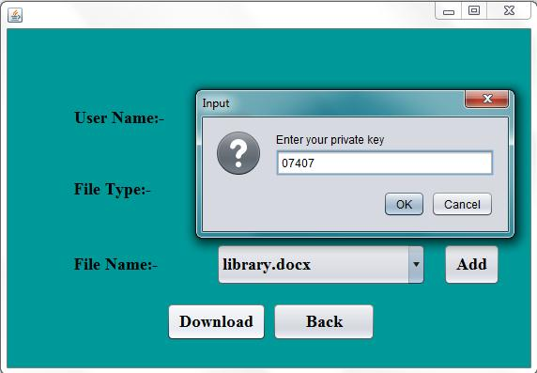

Fig4.file download using private key

- Comparison with Existing System
The bucketization concept that has been used only for plain-text files is modified so that video files are bucketized as well enabling video and text files to be stored in same bucket to prevent adversaries from knowing the file location. The existing system used symmetric cryptography for encryption and decryption, but proposed system uses asymmetric cryptography which does not involve exchange of key for decryption, thus preventing leakage of key.

VI.CONCLUSION
This project introduced the bucketization of multimedia files, especially video and text. The data were evenly split and securely stored in separate buckets with back-ups in the server after encrypting using an asymmetric key algorithm where key exchange is not essential and the keys generated were provided to the user. The data were easily identified and located by the server using their index details stored in the database and the user is authorized before encryption and decryption. Thus an effective and secure way for storage and retrieval of multimedia data is provided.

REFERENCES
- Younho Lee , “Secure Ordered Bucketization”, Dependable Secure Computing, IEEE Transactions on, 2014, pp.292-303

- R. A. Popa, F. Li, and N. Zeldovich, “An ideal-security protocol for order-preserving encoding,” in Proc. IEEE Symp. Security Privacy, 2013, pp. 463–477.

- L. Xiao and I. Yen, “A note for the ideal order-preserving encryption object and generalized order-preserving encryption,” IACR ePrint Archive, pp. 535–552, 2012.

- B. Hore, S. Mehrotra, M. Canim, and M. Kantarcioglu, “Secure multidimensional range queries over outsourced data,” The Very Large Data Bases J., vol. 21, pp. 333–358, 2012.

- H. Liu, H. Wang, and Y. Chen, “Ensuring data storage security against frequency-based attacks in wireless networks,” in Proc. 6th IEEE Int. Conf. Distrib. Comput. Sensor Syst., 2010, pp. 201–215.

- A. Boldyreva, N. Chenette, Y. Lee, and A. O’Neill, “Order-preserving symmetric encryption,” in Proc. 31st Annu. Int. Conf. Adv. Cryptology, 2009, vol. 5479, pp. 224–241.

- D. Boneh and B. Waters, “Conjunctive, subset, and range queries on encrypted data,” in Proc. 4th Conf. Theory Cryptography, 2007, pp. 535–554.

- R. Agrawal, J. Kiernan, R. Srikant, and Y. Xiu, “Order preserving encryption for numeric data,” in Proc. ACM SIGMOD Int. Conf. Manage. Data, 2004, pp. 563–574

- B. Hore, S. Mehrotra, and G. Tsudik, “A privacy-preserving index for range queries,” in Proc. 30th Int. Conf. Very Large Data Bases, 2004, pp. 720–731.

