E-Emergency Services

Auther 1 : Himashri Rewatkar Name of College KDKCE Mobile No.8956985340 Email-ID himashripr@gmail.com
Auther 2 : Rajendra Bankar Name of College KDKCE Mobile No. 9765829472 Email-ID rajendrapsbankar@gmail.com
Auther 3 : Prasad Joshi Name of College KDKCE Mobile No. 9823414564 Email-ID prasadbuldana@gmail.com
Auther 4 : Kishor Ambhore Name of College KDKCE Mobile No. 9404072015 Email-ID kishor28ambhore@gmail.com

Abstract- Emergency never comes with prior intimation. The System is intended to function in case of emergencies in society. The emergencies includes Fire, Medical Emergencies, accident and External Emergencies (Earthquake, Floods, Strom). In this paper we present Emergency Management System (EES), which enables smart phone based ad-hoc communication sat disaster times over Wi-Fi. The person in an emergency or any body at the emergency site will call the EES at avail service. Location Coordinates are sending on each request. The system works on the principles of client-Server system, where in the server responds to the requests of the Clients. We have Implemented the EES Client Application, Rescue Application and Server. The Client and Rescue Application was Implemented as an Android Application. The Sever is implemented as a Web Based Java Application. We tested the System using several real Android Phones with GPS on phone, clients communicating over Wi-Fi.

Introduction
We are proposing the new idea to automate this process of emergency detection and reporting, this system will record and report emergency in real time.
It works in three steps as Detection of emergency, data collection & processing and reporting it to outside world.
Various emergency handling services are present world- wide to cater to the emergencies faced by the common man. The USA has its own such system by the name 911. At present, India does not have a such similar well-defined emergency-handling approach. EES is developed keeping in mind the lack of any such system in India. It is loosely based on 911 system, but suited more to india. EES is responsible for leading the department in providing a properly planned and organized emergency management force, capable of responding to public emergencies. The person in an emergency or anybody at the emergency site will call EES at avail the service. The common man can make use of this system in case of any emergencies. The system works is such a way, that victims will receive help in the form of police, fire, ambulances or fire-brigades depending on the situation. This system drives to and responds to emergencies promptly.

- RELATED WORK
System 108 is a free telephone number for emergency services providing integrated medical, police and fire emergency services in Indian states. System 100 is emergency service number in India for calling police. When an emergency is reported through 1-0-8, the call taker gathers the needed basic information and dispatches appropriateservices.US-Alert Disaster Alert: US Alert-Disaster Alert android app for emergency provide Street map, Report an event and submit a photo or video, share events by email or post links to face book and twitter, provide feed back regarding credibility of post to prevent fraudulent posts.

- FLAWS IN CURRENT SYSTEM
Limitations of system 108/100 are, All the basic information required such as caller name, location, type of emergency is collected orally. Typical response time in metros when the police station in nearly is 30 min. India has different emergency numbers like system 100 for police, system 102 for medical and system 101 for fire so, lack of unified approach. All these system have very low response time and low efficiency. Also if emergency is occur red in other state so India then problems like language barrier and unknown area to victim can occur. There is no use of GPS in these system EES.
Limitations of Us Alert-Disaster Alert are, there is no need to use social networking site at time of emergency because due to posting of video and pictures lot of time will consume and prompt rescue operation will be delayed. Due to social networking site rum or swill be spread. So ,main aim of emergency system will not meet to its goal of saving life of people.

IV. FEATURES OF EES
[1] EES system uses GPS for location tracking.
[2] Authorized person will be responsible for rescuing the
victim.
[3] Report can be generated Area wise, Issues wise, Location
Wise, and Priority wise.
[4] Location tracking will be done in Network mode also if
the GPS is disable.
[5] EES system is useful in any type of emergency that would
Occurred in society.
[6] EES system is very cost effective as compared to other
Emergency services.
[7] Admin will be able to send the emergency number.

V. FLOW MODEL
The flow model is designed and implemented with the objective that it has to be user friendly and triggering of the application should take least time during emergency. The application for full functioning demand GPS service to be available in the handset. If the handset don’t have GPS service, attempt to trigger this application will so an error message, but still sending an SMS to the registered phone number.
VI. ARCHITECTURE
EES drives to and responds to emergencies. It serves as the head for emergency preparedness. It also plans, organizes and mobilizes the emergency rescue efforts of the agencies (i.e. Public Health, Mental Health, Public Works, Police department, Fire department, Volunteer agencies etc.) during emergencies. In the end , it compiles data and prepares a variety of records and reports. Along with this it prepares public information materials i.e. analyses the services and materials required for emergency preparedness, response and recovery operations, and suggests for the development of the same.
TheEESoverviewisbeenillustratedinFigure2.TheEESsystemconsistsofaWebserverandsmartphone based application, these currently implement as an android app. The app operate in two modes. Network mode and GPS mode.

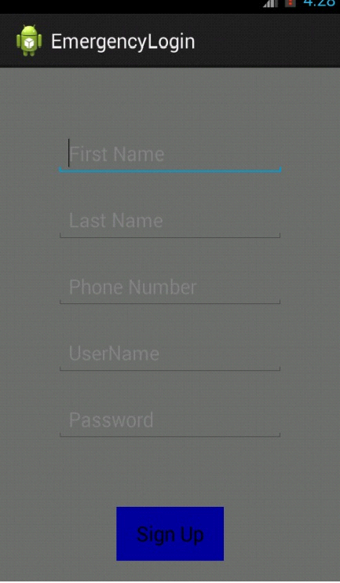
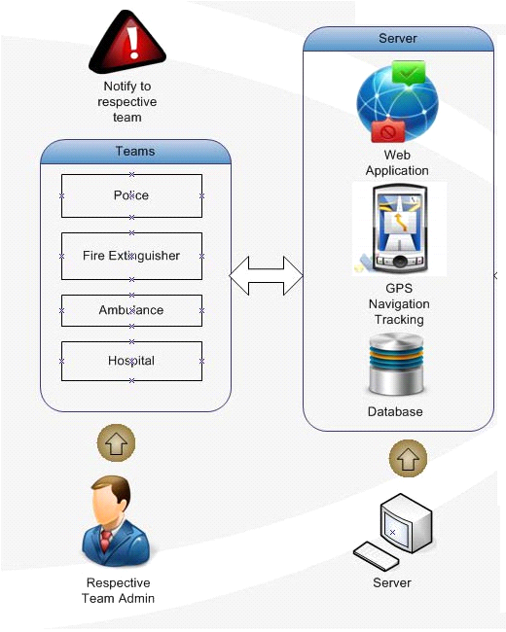

Design And Implementation

  - User Module:
User Raise the issue in case of any emergency from his Android Application with description and nature of issue severity. User’s location tracking is done with the help of GPS is OFF then location tracking is done in Network mode. All the details of user like Title, Description, Priority and Current location report is send to the server for further assistance. Server respond location based Emergency Contact No s to the user application.

  - Admin Module:
Admin gets notifications on his Android application with Emergency Issues. Admin can also view the person details and his/her location that has raised the issue. Admin can view the optimal path on Google map with marker to reach the victim who raised the issue in case of emergency. After resolving the issue, admin can marked the issue as resolved with certain comments.

  - Service Module:
Web Application is useful for generating the reports such as, Area wise issues report, Priority wise issues report, Location wise issues report. In service module we are provided three services Hospital, Police Station , Fire Fighter.

VII. FUTUREWORK
We are implementing this application using Ad-hoc network currently. If resources permit, we can implement this using cloud computing techniques as a future work. This would give a leverage to global access by expanding the scope of the application from an ad-hoc network to, say WAN.

VIII. CONCLUSION
In this paper we were describe the first module of our project. The first module contain login page for register user, the sign up page for new user.
REFERENCES

[1] Osnat (Ossi) Mokryn Dr or Karmi Akiva ElkayamTomer Teller\Help Me: Opportunistic Smart Rescue Application and System"," 2012 The 11th Annual Mediterranean Ad Hoc Networking Workshop (Med-Hoc-Net).

[2] D. Horowitz and S. Kamvar, “The anatomy of a large-scale social search engine,” in Proceedings of the 19th international conference on World wide web. ACM, 2010, pp. 431–440.

[3] J. Fajardo and C. Oppus, “A mobile disaster management system using the android technology,” WSEAS TRANSACTIONS on COMMUNICATIONS, vol. 9, no. 6, pp. 343–353, 2010.

[4] A. Pietilainen, E. Oliver, J. LeBrun, G. Varghese, and C. Diot, “MobiClique:middleware for mobile social networking,” in Proceedings ofthe 2nd ACM workshop on Online social networks. ACM, 2009, pp.49–54.

[5] B. Van de Walle, G. Van Den Eede, and W. Muhren, “Humanitarian information management and systems,” Mobile Response, pp. 12–21,200

