Product Brand Analysis through Social Media Using Hadoop

Aparna Dhote, Bhagyashri Tighare, Diksha Raut, Prajakta Watkar
Department Of Information Technology
KDK College Of Engineering, Nagpur

Introduction
As social media is expanding day by day the data is also expanding enormously.This large amount of unstructured data needs to be store somewhere so that it can be processed easily. Social media analytics is the practice of gathering data from blogs and social media websites and analyzing that data to make business decisions. The most common use of social media analytics is to mine customer Sentiment in order to support marketing and customer service activities..
As we know Big data is emerging as one of the most important technologies in modern world. Using the information kept in the social network like Facebook, the marketing agencies are learning about the response for their campaigns, promotions, and other advertising mediums. Using the information kept in the social network like preferences & product perception of their consumers, product companies & retail organization are planning their production. Using the data regarding previous history, companies can provide better & quick service.
Sentiment analysis is widely applied to reviews and social media for a variety of applications, ranging from marketing to customer service. Sentiment analysis aims to determine the attitude of a writer with respect to some topic. A basic task in sentiment analysis is classifying the polarity of a given text at the document or a sentence. Polarity refers to the positive, negative & neutral attitude.
Hadoop is an open-source software framework written in a Java for storing & processing big data in distributed environment across clusters of computers. The core of Hadoop consists of HDFS & MapReduce. HDFS is a Hadoop Distributed File System that stores data on commodity machines, providing high aggregate bandwidth across a cluster.
MapReduce is a programming model for large scale data processing.
Namenode is the node which stores the filesystem metadata i.e. which file maps to what block locations and which blocks are stored on which datanode. The secondary namenode regularly connects to the primary namenode and keeps snapshotting the filesystem metadata into local/remote storage. It is basicalluy used when namenode cause failure or it gets crashed.
Datanode stores data. All datanodes send a heartbeat message to the namenode every 3 seconds to say that they are alive. If the namenode does not receive a heartbeat from a particular data node for 10 minutes, then it considers that data node to be dead/out of service and initiates replication of blocks which were hosted on that data node to be hosted on some other data node.The data nodes can talk to each other to rebalance data, move and copy data around and keep the replication high.
The primary function of the job tracker is resource management (managing the task trackers), tracking resource availability and task life cycle management (tracking its progress, fault tolerance etc.)The task tracker has a simple function of following the orders of the job tracker and updating the job tracker with its progress status periodically.
The task tracker is pre-configured with a number of slots indicating the number of tasks it can accept. When the job tracker tries to schedule a task, it looks for an empty slot in the tasktracker running on the same server which hosts the datanode where the data for that task resides.

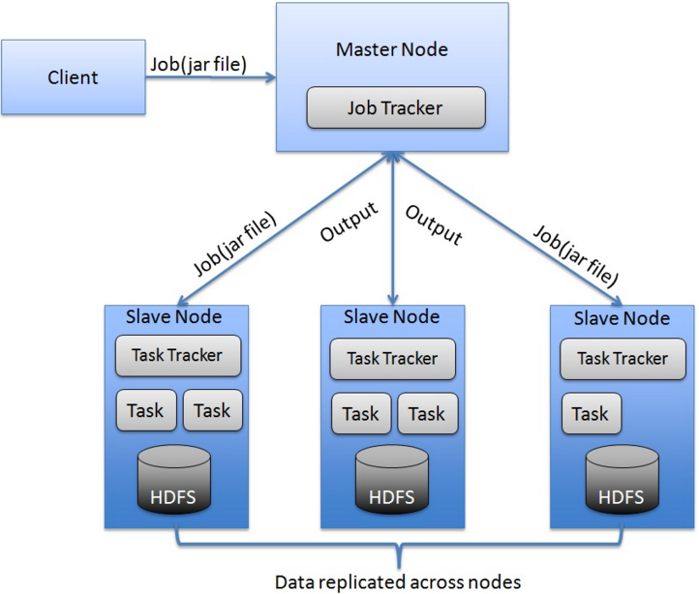

Related work
The Boxwood project [24] has components that overlapping some ways with Chubby, GFS, and Big table, since it provides for distributed agreement, locking, distributed chunk storage, and distributed B-tree storage. In each case where there is overlap, it appears that the Boxwood's component is targeted at a somewhat lower level than the corresponding Google service. The Boxwood project's goal is to provide infrastructure for building higher-level services such as _le systems or databases,while the goal of Bigtable is to directly support client applications that wish to store data.
Many recent projects have tackled the problem of providing distributed storage or higher-level services over wide area networks, often at .Internet scale.. This includes work on distributed hash tables that began with projects such as CAN [29], Chord [32], Tapestry [37], and Pastry [30]. These systems address concerns that do not arise for Bigtable, such as highly variable bandwidth, untrusted participants, or frequent recon_guration; decentralized control and Byzantine fault tolerance are not Bigtable goals.

Data Flow Diagram
The working of project is as per the following data flow diagram.the data from social media like Fecebook and Twitter is fetched and store in the Hadoop.
Then this data is stored in a Hadoop cluster using Map-Reduce.On this data an NLP algorithm is applied and according to that an analysis is generated in the form of graphs,piecharts and shown on theDashboard.

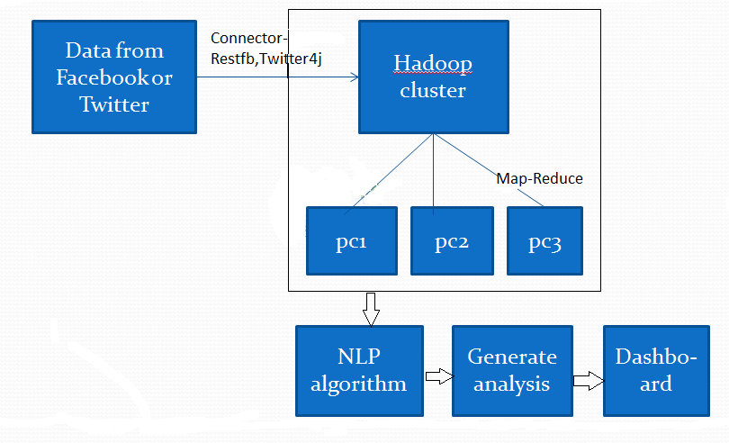

Module With Screenshots
- Requirement Gathering
We use agile approach to develop the project.First we analyse social media sites.We use the data from social media sites like facebook and twitter. After fetching ,we store data using the tools like Restfb and Twitter4j.

- Hadoop Insatallation

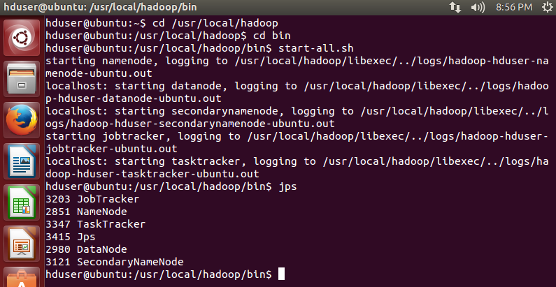

- Graphical Representation
The graphical view of analysis of product maggi is shown as follows :-

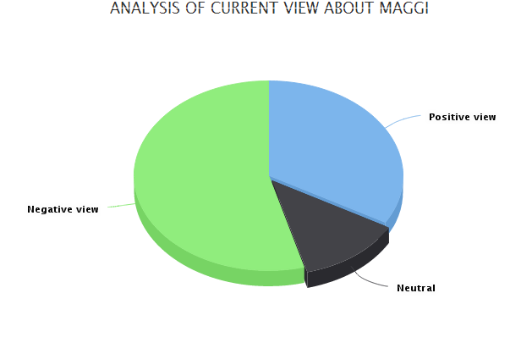

Conclusion And Future Scope
Data Analysis helps to take business decisions as the customer demands and expectations can be easily identified with the help of social media analytics.Hadoop is used to store and processs the whole data collected from Social Media. Some of the common characteristics of all Big Data methods are as follows:
Data is distributed across several nodes (Network I/O speed less than Local Disk I/O Speed).
Applications are distributed to data (nodes in the cluster) instead of the other way around. As much as possible, data is processed local to the node (Network I/O speed less than Local Disk I/O Speed).
Random disk I/O is replaced by sequential disk I/O (Transfer Rate less than Disk Seek Time). The purpose of all Big Data paradigms is to parallelize input/output (I/O) to achieve performance improvements.

References
- Jump up to: a b Pang, Bo; Lee, Lillian (2005). "Seeing stars: Exploiting class relationships for sentiment categorization with respect to rating scales". Proceedings of the Association for Computational Linguistics (ACL). pp. Pang, Bo; Lee, Lillian; Vaithyanathan, Shivakumar (2002). "Thumbs up? Sentiment Classification using Machine Learning Techniques". Proceedings of the Conference on Empirical Methods in Natural Language 115–124. Jump up ^ Liu, Bing (2010). "Sentiment Analysis and Subjectivity" (PDF). In Indurkhya, N.; Damerau, F. J. Handbook of Natural Language Processing (Second ed.).
- "Case Study: Advanced Sentiment Analysis". Retrieved 18 October 2013. Jump up ^ Ogneva, M. "How Companies Can Use Sentiment Analysis to Improve Their Business". Mashable. Retrieved 2012-12-13. "Inversion of Forum Content Based on Authors' Sentiments on Product Usability". AAAI Spring Symposium
- a b Wright, Alex. "Mining the Web for Feelings, Not Facts", New York Times, 2009-08-23. Retrieved on 20 09-10-01.
- Galitsky, Boris; Dobrocsi, Gabor; de la Rosa, Josep Lluís (2010). "Inverting Semantic Structure Under Open Domain Opinion Mining". FLAIRS Conference.
- Pang, Bo; Lee, Lillian (2008). "4.1.2 Subjectivity Detection and Opinion Identification". Opinion Mining and Sentiment Analysis. Now Publishers Inc.
- Mihalcea, Rada; Banea, Carmen; Wiebe, Janyce (2007). "Learning Multilingual Subjective Language via Cross-Lingual Projections" (PDF). Proceedings of the Association for Computational Linguistics (ACL). pp. 976–983.
- Su, Fangzhong; Markert, Katja (2008). "From Words to Senses: a Case study in Subjectivity Recognition" (PDF). Proceedings of Coling 2008, Manchester, UK.
- Pang, Bo; Lee, Lillian (2008). "4.1.2 Subjectivity Detection and Opinion Identification". Opinion Mining and Sentiment Analysis. Now Publishers Inc.
- Cambria, Erik; Hussain, Amir (2012). Sentic Computing: Techniques, Tools, and Applications (PDF). Springer.

