Privacy Preserving Location Monitoring With Collision Detection
Ravina Jain
B.E. 3rd year,
Computer Technology,
KDKCE, Nagpur – 440 009

Abstract – Monitoring personal locations with a potentially untrusted server poses privacy threats to the monitored individuals. To this end, we propose a privacy-preserving location monitoring system for wireless sensor networks. In our system, we design two in network location anonymization algorithms, namely, resource- and quality-aware algorithms, that aim to enable the system to provide high quality location monitoring services for system users, while preserving personal location privacy. Both algorithms rely on the well established k-anonymity privacy concept, that is, a person is indistinguishable among k persons, to enable trusted sensor nodes to provide the aggregate location information of monitored persons for our system. Each aggregate location is in a form of a monitored area A along with the number of monitored persons residing in A, where A contains at least k persons. The resource-aware algorithm aims to minimize communication and computational cost, while the quality-aware algorithm aims to maximize the accuracy of the aggregate locations by minimizing their monitored areas. To utilize the aggregate location information to provide location monitoring services, we use a spatial histogram approach that estimates the distribution of the monitored persons based on the gathered aggregate location information. Then the estimated distribution is used to provide location monitoring services through answering range queries. We evaluate our system through simulated experiments. The results show that our system provides high quality location monitoring services for system users and guarantees the location privacy of the monitored persons.

Introduction
The advance in wireless sensor technologies has resulted in many new applications for military and/or civilian purposes. Many cases of these applications rely on the information of personal locations, for example, surveillance and location systems. These location-dependent systems are realized by using either identity sensors or counting sensors. For identity sensors, for example, Bat and Cricket, each individual has to carry a signal sender/receiver unit with a globally unique identifier. With identity sensors, the system can pinpoint the exact location of each monitored person. On the other hand, counting sensors, for example, photoelectric sensors, and thermal sensors, are deployed to report the number of persons located in their sensing areas to a server. Unfortunately, monitoring personal locations with a potentially untrusted system poses privacy threats to the monitored individuals, because an adversary could abuse the location information gathered by the system to infer personal sensitive information. For the location monitoring system using identity sensors, the sensor nodes report the exact location information of the monitored persons to the server; thus using identity sensors immediately poses a major privacy breach. To tackle such a privacy breach, the concept of aggregate location information, that is, a collection of location data relating to a group or category of persons from which individual identities have been removed, has been suggested as an effective approach to preserve location privacy. Although the counting sensors by nature provide aggregate location information, they would also pose privacy breaches. This paper proposes a privacy-preserving location monitoring system for wireless sensor networks to provide monitoring services. Our system relies on the well established k-anonymity privacy concept, which requires each person is indistinguishable among k persons. In our system, each sensor node blurs its sensing area into a cloaked area, in which at least k persons are residing. Each sensor node reports only aggregate location information, which is in a form of a cloaked area, to preserve personal location privacy; we propose two in-network aggregate location anonymization algorithms, namely, resource- and quality-aware algorithms. Both algorithms require the sensor nodes to collaborate with each other to blur their sensing areas into cloaked areas, such that each cloaked area contains at least k persons to constitute a k-anonymous cloaked area. The resource-aware algorithm aims to minimize communication and computational cost, while the quality-aware algorithm aims to minimize the size of the cloaked areas, in order to maximize the accuracy of the aggregate locations reported to the server. In the resource-aware algorithm, each sensor node finds an adequate number of persons, and then it uses a greedy approach to find a cloaked area. On the other hand, the quality-aware algorithm starts from a cloaked area A, which is computed by the resource-aware algorithm. Then A will be iteratively refined based on extra communication among the sensor nodes until its area reaches the minimal possible size. For both algorithms, the sensor node reports its cloaked area with the number of monitored persons in the area as an aggregate location to the server.We evaluate our system through simulated experiments. The results show that the communication and computational cost of the resource-aware algorithm is lower than the quality-aware algorithm, while the quality-aware algorithm provides more accurate monitoring services (the average accuracy is about 90%) than the resource-aware algorithm (the average accuracy is about 75%). Both algorithms only reveal k-anonymous aggregate location information to the server, but they are suitable for different system settings. The resource-aware algorithm is suitable for the system, where the sensor nodes have scarce communication and computational resources, while the quality-aware algorithm is favorable for the system, where accuracy is the most important factor in monitoring services.

Problem Definition
This work is not applicable to some landscape environments, for example, shopping mall and stadium, and outdoor environments. Our work distinguishes itself from this work, as we do not assume any hierarchical structures, so it can be applied to all kinds of environments. We consider the problem of how to utilize the anonymized location data to provide privacy-preserving location monitoring services services while the usability of anonymized location data was not discussed in other privacy related works include: anonymous communication that provides anonymous routing between the sender and the receiver.
.

Existing System
Existing location monitoring systems in an identity-sensor location monitoring System, since each sensor node reports the exact location information of each monitored object to the server, the adversary can pinpoint each object's exact location. On the other hand, in a counting-sensor location monitoring system, each sensor node reports the number of objects in its sensing area to the server. The adversary can map the monitored areas of the sensor nodes to the system layout. If the object count of a monitored area is very small or equal to one the adversary can infer the identity of the monitored objects based on the mapped monitored.

Limitations Of Existing System
We consider the problem of how to utilize the anonymized location data to provide privacy-preserving location monitoring services services while the usability of anonymized location data was not discussed in other privacy related works include: anonymous communication that provides anonymous routing between the sender and the receiver.

Proposed System
This paper proposes a privacy-preserving location monitoring system for wireless sensor networks to provide monitoring services. Our system relies on the well established k-anonymity privacy concept, which requires each person is indistinguishable among k persons. In our system, each sensor node blurs its sensing area into a cloaked area, in which at least k persons are residing. Each sensor node reports only aggregate location information,
We propose two in-network aggregate location anonymization algorithms, namely, resource- and quality-aware algorithms. Both algorithms require the sensor nodes to collaborate with each other to blur their sensing areas into cloaked areas, such that each cloaked area contains at least k persons to constitute a k-anonymous cloaked area. The resource-aware algorithm aims to minimize communication and computational cost, while the quality-aware algorithm aims to minimize the size of the cloaked areas, in order to maximize the accuracy of the aggregate locations reported to the server.

Advantages Of Proposed System
Advantages of a spatial histogram approach that analyzes the aggregate locations reported from the sensor nodes to estimate the distribution of the monitored objects. The estimated distribution is used to provide location monitoring services through answering range queries. We evaluate our system through simulated experiments. The results show that our system provides high quality location monitoring services (the accuracy of the resource-aware algorithm is about 75% and the accuracy of the quality aware algorithm is about 90%), while preserving the monitored object's location privacy.

Related Work
In[10]In [3] system relies on the well established k-anonymity privacy concept, which requires each person is indistinguishable among k persons. each sensor node blurs its sensing area into a cloaked area, in which at least k persons are residing. Each sensor node reports only aggregate location information.In [2]This paper provides dataprivacy from unauthorized users. The data protection provides security to documents, files, etc. The results showthat system provides high quality location monitoring anddata protection privacy services. In this system servers canblacklist the misbehaving users (unauthorized) from network.In[1] proposed system thus achieves a balance between high-quality location monitoring services and thus as well yet preserving the privacy of those monitored objects through a k-anonymity concept. Resource-aware algorithm accepts the no. Of monitored objects and forms a so to say roughly estimated-sized cloaked area. This cloaked area is refined iteratively again and again to form a minimal formed cloaked area. This cloaked area is reported to the server which plots a spatial (two-dimensional) histogram based on the information it receives from the sensor nodes. 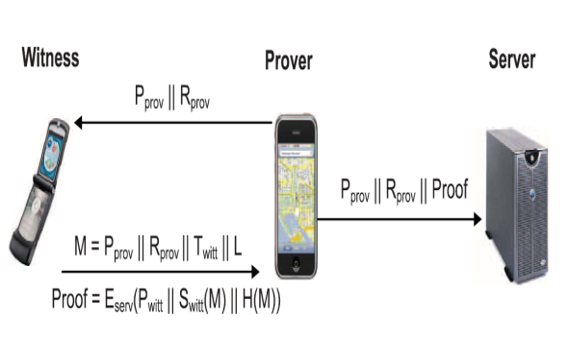

Module Description

1. WSN Location Monitoring Module
The location monitoring system using identity sensors, the sensor nodes report the exact location information of the monitored persons to the server; thus using identity sensors immediately poses a major privacy breach. To tackle such a privacy breach, the concept of aggregate location information, that is, a collection of location data relating to a group or category of persons from which individual identities have been removed , has been suggested as an effective approach to preserve location privacy . Although the counting sensors by nature provide aggregate location information, they would also pose privacy breaches.
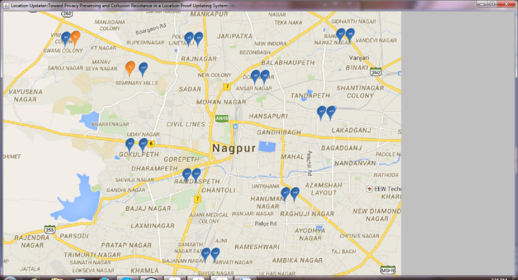
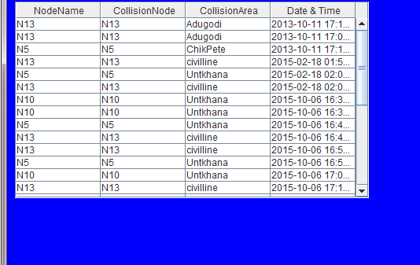
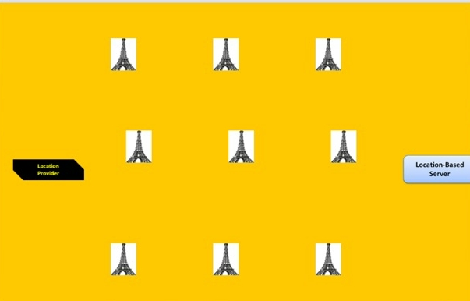

2. Aggregate Locations Module
We design two in-network location anonymization algorithms, namely, resource- and quality-aware algorithms that preserve personal location privacy, while enabling the system to provide location monitoring services. Both algorithms rely on the well established k-anonymity privacy concept that requires a person is indistinguishable among k persons. In our system, sensor nodes execute our location anonymization algorithms to provide k- anonymous aggregate locations, in which each aggregate location is a cloaked area A.


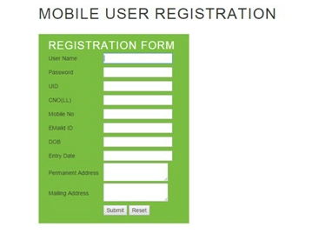

3. Mapped Location Monitoring Module
Sensor Nodes:
Each sensor node is responsible for determining the number of objects in its sensing area, blurring its sensing area into a cloaked area A, which includes at least k objects, and reporting A with the number of objects located in A as aggregate location information to the server. We do not have any assumption about the network topology, as our system only requires a communication path from each sensor node to the server through a distributed tree . Each sensor node is also aware of its location and sensing area.

Server
The server is responsible for collecting the aggregate locations reported from the sensor nodes, using a spatial histogram to estimate the distribution of the monitored objects, and answering range queries based on the estimated object distribution. Furthermore, the administrator can change the anonymized level k of the system at anytime by disseminating a message with a new value of k to all the sensor nodes.

System Users
Authenticated administrators and users can issue range queries to our system through either the server or the sensor nodes, as depicted in Above System Architecture figure. The server uses the spatial histogram to answer their queries.
4. Minimum bounding rectangle (MBR)
We find the minimum bounding rectangle (MBR) of the sensing area of A. It is important to note that the sensing area can be in any polygon or irregular shape.

Conclusion
In this paper, we proposed a privacy-preserving location proof updating system called APPLAUS, where colocated Bluetooth enabled mobile devices mutually generate location proofs and upload to the location proof server. We use statistically changed pseudonyms for each device to protect source location privacy from each other, and from the untrusted location proof server. We also develop a usercentric location privacy model in which individual users evaluate their location privacy levels in real time and decide whether and when to accept a location proof exchange request based on their location privacy levels. To the best of our knowledge, this is the first work to address the joint problem of location proof and location privacy. To deal with colluding attacks, we proposed betweenness ranking based and correlation clustering-based approaches for outlier detection. Extensive experimental and simulation results show that APPLAUS can provide real-time location proofs effectively. Moreover, it preserves source location privacy and it is collusion resistant.

Future Scope
In our system admin is registering the location of witnesses,but in future witnessses can regester their location by themself with the help of their mobile.

References

[1] Asst. Prof. Ashwini L. Balkawade, Asst. Prof. U. A. Mande “Location Monitoring System in WSN” (ISSN 2250-2459, ISO 9001:2008 Certified Journal, Volume 5, Issue 2, February 2015).

[2] Kirankumar B. Balavalad, Ajayakumar C. K. Atageri, Prithviraj. S. Patil, and Basavaraj M. Angadi “A Privacy-Preserving Location Monitoring System for WSNs with Blocking Misbehaving Users in Anonymity Networks”(Journal of Advances in Computer Networks, Vol. 2, No. 4, December 2014).

[3] Dattatray P. Gade, Dhiraj S. Rathod, Vilas R. Khomne, Yogita R. Avhad Pune University Implementing “ Privacy Preserving Location Monitoring System in WSN” (ISSN 2250-2459, ISO
9001:2008 Certified Journal, Volume 3, Issue 3, March 2013).

[4]Z. Zhu and G. Cao, “APPLAUS: A Privacy-Preserving Location Proof Updating System for Location-Based Services,” Proc. IEEE INFOCOM, 2011.

[5] N. Smart et al., “Ecrypt II Yearly Report on Algorithms and Key Lengths (2009-2010),” ICT-2007-216676, Revision 1.0, 2010.

[6] Z. Zhu, G. Cao, S. Zhu, S. Ranjan, and A. Nucci, “A Social Network Based Patching Scheme for Worm Containment in Cellular Networks,” Proc. IEEE INFOCOM, 2009.

[7] B. Hoh, M. Gruteser, R. Herring, J. Ban, D. Work, J.C. Herrera,
A.M. Bayen, M. Annavaram, and Q. Jacobson, “Virtual Trip Lines
for Distributed Privacy-Preserving Traffic Monitoring,” Proc. ACM MobiSys, 2008

