Comparative Study between Two and Three Level Converter for Electric Application

Sneha Timande Smt. Rajshree Mulak College Of Engineering For Woman
Sneha Rodge Smt. Rajshree Mulak College Of Engineering For Woman
Sonali Udapure Smt. Rajshree Mulak College Of Engineering For Woman
Tejaswini Honade Smt. Rajshree Mulak College Of Engineering For Woman
Vaishnavee Burde Smt. Rajshree Mulak College Of Engineering For Woman

Abstract – The main objective of static power converters is to produce an ac output waveform from a dc power supply. These are the types of waveforms required in adjustable speed drives (ASDs), uninterruptible power supplies (UPSs), static VAR compensators, active ﬁlters, ﬂexible ac transmission systems (FACTSs), and voltage compensators, which are only a few applications. For sinusoidal ac outputs, the magnitude, frequency, and phase should be controllable. Frequency converters are used in electric turbines because they make it possible to apply the variable speed concept. The traditional frequency converter is back-to-back connected two-level converter, in which the output voltage has two possible values. However, the output voltage is smoother with a three-level converter, where output voltage has three possible values. This result in smaller harmonics, but on the other hand it has more components and is more complex to control. In this paper we study the comparison between the two-level and three-level converter and also a controlling device microcontroller.

Keyword- Two-level, three-level, converter, output, voltage, frequency, switching, triggering

Introduction
The converters which produce an output voltage or a current with levels either 0 or +- V are known as two level converter. In high power and high voltage application these two level inverters have some limitations in operating at high frequency mainly due to switching losses and constraints of device rating. The three level converter produce output voltage or a current with three levels. The unique structure of three level voltage source converter allows them to reach high voltages with low harmonics without the use of transformer. This results in smaller harmonics. As compare to two level converters, three level converters have smaller output voltage. In addition, the output waveform provides an effective switching frequency twice that of actual switching frequency. In two level converter total harmonic distortion is poor while in three level it is better. Power losses in two level converter is more than that of three level converter. Efficiency of three level converters at full load is better than two level converter which is dominate by rectifier losses. Cost of three level converter. The cost of the converter is 40% higher than two level converter. The cost of the converter is mainly dependent on the IGBT and other component used in circuit. Pulse Width Modulation (PWM) technique here used to obtain variable output voltage by varying the gain of the inverter if the dc input voltage is fixed and it is not controllable. The inverter gain may be the ratio of ac output voltage to dc input voltage. The output voltage waveforms of the ideal inverters should be sinusoidal but waveforms of practical inverters are non –sinusoidal and contain certain harmonics. For low and medium power applications, square wave or quasi –square-wave voltages may be acceptable; and for high power applications, low distorted sinusoidal waveform are required.
System overview
To achieve the goal, the following additional technical arrangements are implemented in the system. Multiple devices are controlled and processed by micro-controller. Gate drive is used to access the selected mode of the IGBTs. Micro-controller is used to control the IGBTs switching operation. IGBTs uses gate drive to perform the switching process through which it gives desired output.
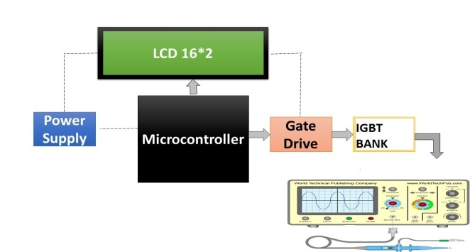
Figure 1. System Functional Diagram

Two-Level Converter
The converters which produce an output voltage or current with level either zero or +ve /-ve are known as two level converteres.In high power and high voltage applications this two level inverter however have some limitations in operating at high frequency mainly due to switching losses and constraints of device rating.
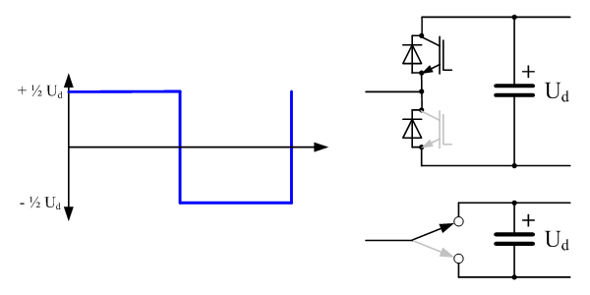

Figure 2 . Two-level converter

Figure 2.Two-level converter

Table 1: Two-level converter switching table

IGBT | Vout= Vp | Vout=Vn
Q1 | ON | OFF
Q2 | OFF | ON

Three-Level Converter
The unique structure of three level voltage source converters allows them to reach high voltages with low harmonics without the use of transformers or series-co . The harmonic content of the output voltage waveform decreases significantly. As compared to two level inverters, three level inverters have smaller output voltage. In addition, the output waveform provides an effective switching frequency twice that of the actual switching frequency.
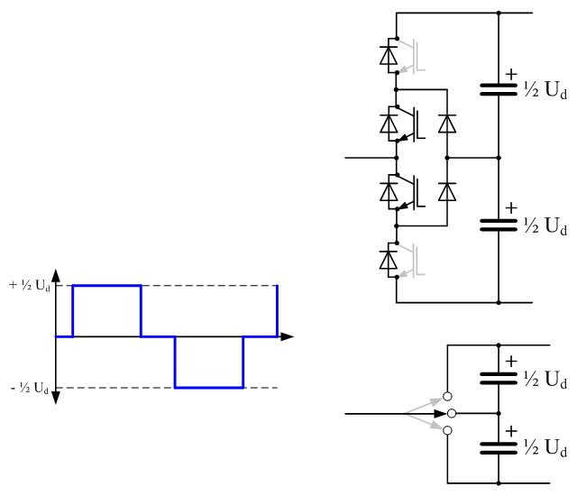
Figure 3.Three-level converter
Table 2: switching table

IGBT | Vout= Vp | Vout = V0 | Vout=Vn
Q1 | On | Off | Off
Q2 | On | On | Off
Q3 | Off | On | On
Q4 | Off | Off | On

Microcontroller
Some features of micro-controller are :8051 have 128 bytes of RAM
8051 have 128 user defined flags
it consist of 16 bit address bus
it also consist of 3 internal and two external interrupts less power usage in 8051 with respect to other micro-controller it consist of 16-bit program counter and data pointer 8051 can process 1 million one-cycle instructions per second
it also consist of 32 general purpose registers each of 8 bits
ROM on 8051 is 4 Kbytes in size
it also consist of Two 16 bit Timer/ Counter.

References
[1] M.RASHID , Power Electronics Circuits, devices and Applications, 3rd edition(Page no. 226 to 301) Nagrath G. Hingorani ,Laszlo Gyugyi, Understanding FACTS concept and technology of flexible AC transmission system (Page no. 69 to 71 , 87 to 91)
[2] M D Singh , K B Khanchandani, Power Electronics Electrical and Electronics Engineering series , second addition (Page no. 535 to 657) Semikron application manual.
[3]Web-document. Available at http://www.semikron.com/internet/index.jsp?sekId=13 (reference SKM 145GB123D datasheet.
[4] SKM 145GB123D datasheet Available at http://www.semikron.com/internet/ds.jsp?file=33.html (references ).
[5] 10.9.2005)d 14SKM 145GB123D datasheet
Multilevel Inverter 3 level available at www.academia.edu/7896
[6]l evel and 3 level HVDC converter circuit at Wikipedia.org/wiki/HVDC converter .

