TCSC as an optimal power flow controller
Santosh D. Jadhao, Ankit Wadekar, Munishwar Dhoble, Prof. C.S. Hiwarkar
Department of Electrical Engineering, K. D. K College Of Engineering, Nagpur, India
Email: ankitwadekar@gmail.com

Abstract – In any power system, unexpected outages of lines or transformers occur due to faults or other disturbances. These events, referred to as contingencies, may cause significant overloading of transmission lines or transformers, which in turn may lead. Flexible AC Transmission System (FACTS) controllers provide a new facilities, both in steady state power flow control and dynamic stability control. Thyrister Controlled Series Capacitor (TSCS) based FACTS device for minimize the losses and power flow in long distance transmission line. The problem of determining the optimal TCSC parameters is formulated as an optimization problem and a N-R method based approach is applied to solve the Optimal Power Flow (OPF) problem. Programme is done on 3 bus system by N-R method.

Index Terms – FACTS, Optimal Power flow , TCSC.

Introduction
In the recent year with the deregulation of the electricity market the traditional concepts and practice of the power system are changed. In this process the existing transmission lines are over loaded and lead to unstable system. Overloading may also due to transfer of chap power from generator bus to load bus ,this lead to the introduction of FACTS devices.This devices control the power flow in the network and reduce the flow heavily loaded line there by resulting in an increase load ability low system losses improved stability of the network and reduced cost production. The OPF solution gives the optimal settings of all controllable variables for a static power system loading condition. A number of mathematical programming based techniques have been proposed to solve the OPF problems .Thyristor Controlled Series Capacitor (TCSC) is a variable impedance type FACTS device and is connected in series with the transmission line to increase the power transfer capability, improve transient stability, and reduce transmission losses. Optimal power flow (OPF) is an operating condition in which the power flow in an electrical system occurs optimally. The type of control that an optimal power flow must be able to statisfied are active and reactive power injections, generator voltages, transformer tap ratios and phase shift angles. The optimal power flow is problem seeks to find an optimal profile of active and reactive power generations along with voltage magnitudes in such a manner as to minimize the total operating cost of a power system, while satisfying network security constraints.The main purpose of OPF to schedule power system controls to optimize an objective function. Mathematically, the OPF problem can be formulated as a constrained non-linear optimization problem. Different solution approaches have been proposed to solve OPF problems. N-R method have solved optimal power flow problem incorporating FACTS devices leading to highly robust iterative solutions.
Voltage control: Applications to optimize bus voltage values. These studies take into account the stability of power system voltages from the maximum and minimum admissible values.

Basic Concept And Problem Formulation
The most widely used method for solving simultaneous nonlinear algebraic equations is the Newton Raphson method (NR). Newton’s method is found to be more efficient and practical. The number of iterations required to obtain a solution is independent of the system size, but more functional evaluations are required at every iteration. Since in the power flow problem real power and voltage magnitude are specified for the voltage-controlled buses, the power flow equation is formulated in polar form. This equation can be rewritten in admittance matrix as
$I_{i}=\sum_{j=1}^{n}{Y_{\text{ij}}V_{j}}$
In the above equation, j includes bus i. expressing this equation in polar form, we have
$I_{i}=\sum_{j=1}^{n}{|V_{\text{ij}}||Y_{\text{ij}}|}θ_{\text{ij}}+δ_{j}$
The complex power at bus i is
$P_{i}+{\text{jQ}}_{i}=V_{i}^{}I_{i}$
Separating the real and imaginary parts
$P_{i}=\sum_{j=1}^{n}{|V_{i}|}|V_{j}||Y_{\text{ij}}|\text{cos}(θ_{\text{ij}}−δ_{i}+δ_{j})$
$\begin{aligned} \\ Q_{i}=−\sum_{j=1}^{n}{|V_{i}|}|V_{j}||Y_{\text{ij}}|\text{sin}(θ_{\text{ij}}−δ_{i}+δ_{i}) \\ \begin{aligned}\left[ΔP | \right] \\ \end{aligned} \\ \end{aligned}$
By running the load flow analysis using NR-method we can fine the Power flows in individual lines and loss.

Bus System
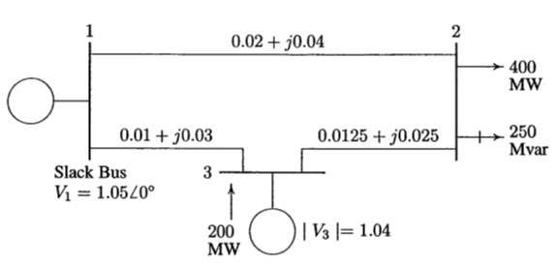

Thyristor Controlled Series Capacitor
Thyristor Controlled Series Capacitor compensator consisting of the series compensating capacitor, whereto is parallel connected thyristors controlled reactor (TCR), and it is one of FACTS devices which are mainly used to control active power flow in power system and increase the transmission power lines capacity. TCSC is involved in a series to line (in terminal) and allows changing impedance of the transmission path and thus affecting the power flows. Control is fast, efficient and increased between the transmitted powers. Basic scheme of TCSC device is shown in the follows figure.
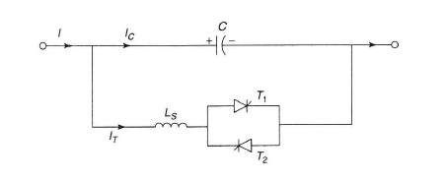
Fig.1 Basic diagram of TCSC

Change of impedance of TCSC is achieved by changing the thyristor controlled inductive reactance of inductors connected in parallel to the capacitor. The magnitude of inductive reactance is determined by angle switching thyristors α , which can also be controlled continuously flowing amplitude of current reactor from the maximum value to zero. Angle switching thyristors can change inductive reactance controlled choke from a minimum value (α = 0, X_{TCR} = X_{L}) theoretically to infinity (α = Π/2 , X_{TCR} = infinity).

$X_{\text{TCSC}}(α)=\frac{X_{C}\text{.}X_{\text{TCR}}(α)}{X_{\text{TCR}}(α)−X_{C}}$

where XC = 1/ωC is capacitive reactance of capacitor and C its capacity.

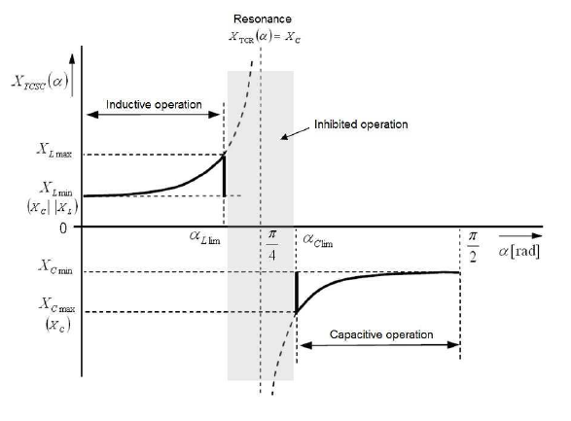 Fig 2. Operating diagram of TCSC

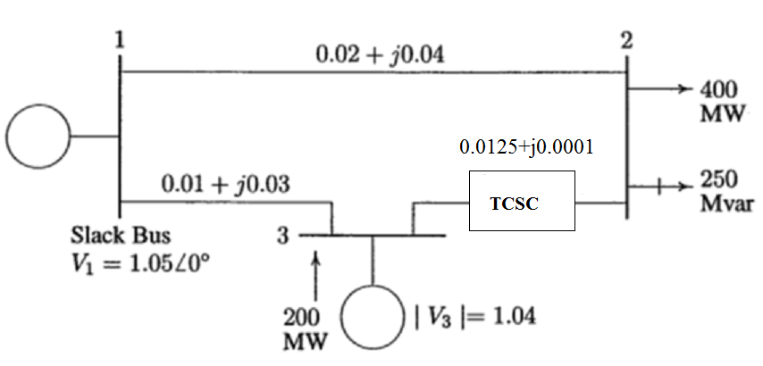

Fig. 3 Bus system with TCSC

Components
- Bus data without TCSC -
BUS | P | Q | V | Angle
1 | 2.1842 | 1.4085 | 1.0500 | 0
2 | -4 | -2.5 | 0.9717 | -0.0471
3 | 2 | 1.4618 | 1.0400 | -0.0087
- Busdata with TCSC -
BUS | P | Q | V | Angle
1 | 2.2030 | 0.8025 | 1.0500 | 0
2 | -4 | -2.5 | 1.0003 | -0.0170
3 | 2 | 1.8020 | 1.0400 | -0.0370

conclusion
The capability of TCSC in optimal power flow applications was demonstrated and compared with losses of TCSC. It was shown that a FACTS Devices can be controlled in a power system .
The voltage of weak bus is compensated by using TCSC and thus active power of bus1 is improved. Reactive power of bus3 is increased and that of bus1 is decreased.The torque angle of bus2 is decreased and that of bus3 is increased. Thus the power flow is optimised.

References
[1] M. Karthik, P. Arul, “Optimal power flow control using FACTS device”,IJESE(International journal of emerging Science and engineering) ISSN :2319-6378,volume-1, Issue-12, October 2013.

[2] Abhishek Bhardwaj, Manbir Kaur, “ power flow control in corporating TCSC using differential evolution”, IJERT ISSN :2278-0181,Vol. 2 Issue 10, October – 2013.

[3] Martin German-Sobek, Ľubomír Beňa, Roman Cimbala, “Using of the Thyristor Controlled Series Capacitor in Electric Power System ”, ELEKTROENERGETIKA, Vol.4, No.4, 2011.

[4] Priyanka Kathal, Arti Bhandakkar, “Power Flow Control in Power System using FACTS Device Thyristor Controlled Series Capacitor (TCSC): A Review ”, IJSR ,India Online ISSN:2319-064,Volume 2 Issue 3, March 2013.

[5] D P Kothari, I J Nagrath , “ Modern Power System Analysis”, fourth edition, Mcgraw Hill Education(India) Pvt Ltd.

[6] Hadi Saadat , “Power System Analysis” , Mcgraw Hill Publications Pvt Ltd.

[7] N.G. Hingorani, and L. Gyugyi, "Understanding FACTS; Concepts and Technology of Flexible AC Transmission Systems”.

[8] K. R. Padiyar, “FACTS : Controllers in power transmission and distribution”, 1st , New age international.

