SPEED COPNTROL OF INDUCTION MOTOR BY V/F CONTROL METHOD USING SPWM TECHNIQUE

Nilesh Banode
Final Year, Electrical Engineering , Nagpur polytechnic Nagpur(NPN), Nagpur, Maharashtra, India.
Mo. No.9766948289
Nil.banode@gmail.com

Abstract – In this project, v/f control of Induction motor is simulated for both closed loop systems. The induction motor (IM) is fed from single phase bridge inverter which is operated with sinusoidal pulse width modulation (SPWM) technique. Among the various modulation strategies sinusoidal pulse width modulation technique is the efficient one because it has better spectral performance and output voltage is more closed to sinusoidal.
The performance of sinusoidal pulse width modulation technique is compared with other PWM techniques for harmonics, THD, dc bus utilization and Output voltage and observed that SPWM has better performance. These techniques when applied for speed control of Induction motor by v/f method for closed loop systems it is observed that the induction motor performance is improved with SPWM.

Keywords- Speed control of induction motor , V/F control method , Sinusoidal pulse width modulation technique .

Introduction
Before last few decades all process industries were making use of DC motors because speed control of DC motor is very easy when compared to AC motors. But as we know that the main drawback of DC motor is maintenance problem. But after the invention of Power electronic devices, all DC motors are being replaced with AC motors, because speed control of AC motors is very easy with Power electronic device.
The torque developed by the induction motor is directly proportional to the ratio of the applied voltage and the frequency of supply. By varying the voltage and the frequency, but keeping their ratio constant, the torque developed can be kept constant throughout the speed range. This is exactly what VF control tries to achieve.

Objective
The main objective of the project is to implement a simple and cost effective process to control the speed of AC induction motors using the most popular technique of voltage to frequency ratio (V/F) method.

Hardware
In this project, We have used 9 different hardwares and they are as follows:

  - Microcontroller: The AT89S52 is a low-power, high-performance CMOS 8-bit-microcontroller with 8K bytes of in-system programmable Flash memory .The device is manufactured using Atmel’s high-density nonvolatile memory technology and is compatible with the industry- standard 80C51 instruction set and pin out. The on-chip Flash allows the program memory to be reprogrammed in-system or by a conventional nonvolatile memory programmer. By combining a versatile 8-bit CPU with in-system programmable Flash on a monolithic chip, the Atmel AT89S52 is a powerful microcontroller which provides a highly-flexible and cost-effective solution to many embedded control applications. The AT89S52 provides the following standard features:
- 8K bytes of Flash,
- 256 bytes of RAM,
- 32 I/O lines,
- Watchdog timer,
- two data pointers,
- three 16-bit timer/counters,
- a six-vector two-level interrupt architecture
- a full duplex serial port,
- on-chip oscillator,
- and clock circuitry.

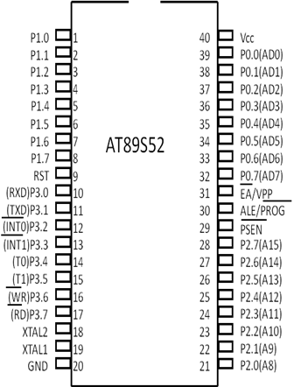
  - Power supply: In this project, power supply consist of step down transformer, Rectifier, filter, regulator. In this project , we are giving two power supply. One regulated power supply of +5V is supplied to the microcontroller IC. While the other of +12V is supplied to the inverter. This +12V regulated power supply is again converted into 240V variable voltage variable frequency AC supply. This 240V AC supply is then supplied to the induction motor.

  - Rectifier: Rectifier is a device which convert AC supply into DC supply. In this project, we have used full wave bridge rectifier because of its merits like good stability and full wave rectification in both the power supply in order to convert the AC supply into the DC supply. This DC supply is then supplied to the filter circuit.

  - Filter: In this project , In both the power supply we have usedthe capacitor filter in order to reduce the ripple content present in the output of the rectifier.



  - Regulator: A voltage regulator is an electrical regulator designed to automatically maintain a constant voltage level. In this project, power supply of 5V and 12V are required. In order to obtain these voltage levels, 7805 and 7812 voltage regulators are to be used.

  - Inverter: The inverter circuit is used to convert the DC supply into the AC supply. In this project, the regulated power supply which is given to the induction motor is first converted into the 240V variable voltage variable frequency AC supply By inverter circuit .

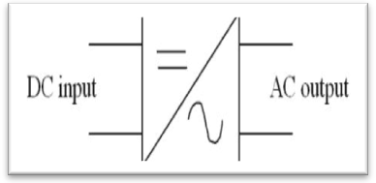

  - Liquid crystal display (LCD): In this project , we have used the LCD screen instead of using the CRT screen due to advantages like lightweight construction, portability, and its ability to be produced in much larger screen sizes.
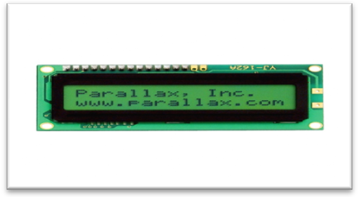

  - Induction motor: Induction motor characteristics are well suited for Adjustable or Variable Speed Drive, which is, nowadays, preferred over Constant Speed Drive In this paper, Variable Voltage-Variable Frequency (V/f) base torque-speed control of three phase induction motor fed by a PWM Voltage Source Inverter. The PWM method, which involves the modulation of conventional sinusoidal reference signal and a triangular carrier to produce pulse width modulated output signals, which are applied to Power Electronic Switches of a 2-Level Voltage Source Inverter, driving Induction Motor, shall be used. The performance analysis of single phase induction motor fed by PWM voltage source inverter in terms of phase current of inverter, rotor and stator current, speed, and electromagnetic torque developed of inverter is simulated.
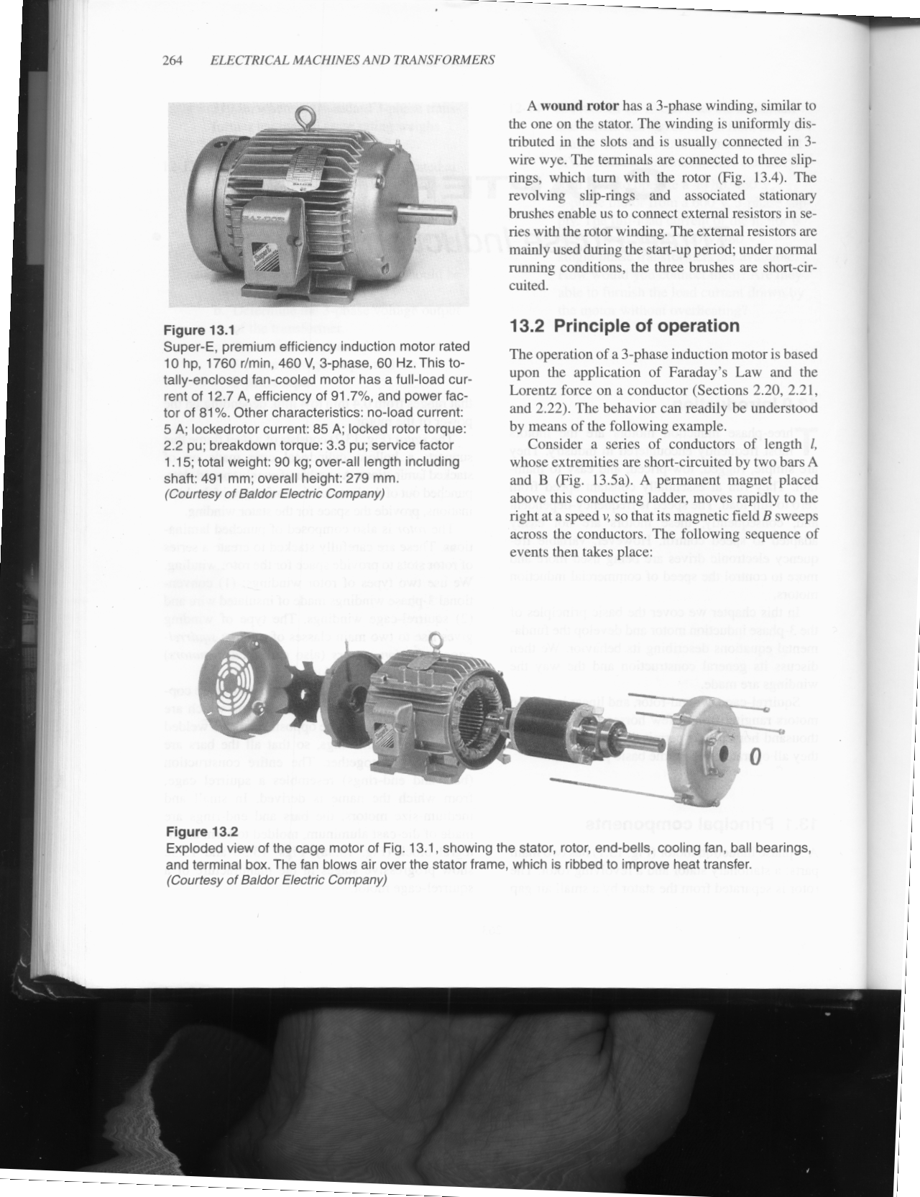

  - Keypad: The speed that we required for a particular application we will give input to the microcontroller with the help of keypad.

Sotware
In this project, we are using two kind of software and they are as follows:
  - Embedded C: Embedded C is a set of language extensions for the C Programming language by the C Standards committee to address commonly issues that exist between C extensions for different embedded systems. Historically, embedded C programming requires non standard extensions to the C language in order to support exotic features such as fixed point arithmetic, multiple distinct memory banks, and basic operation.
  - Keil Software:When starting a new project, simply select the microcontroller you use from the device database and the micro vision IDE sets all complier, assembler, linker and memory options for you.

Working

In this project, we are giving two power supply. One power supply of +5V DC is supplied to microcontroller IC while the other regulated power supply of +12 volt DC is supplied to inverter circuit in which it is again converted into 240 volt variable voltage variable frequency AC supply and then it is given to induction motor. This is exactly what V/F control method tries to achieve.
The speed that we required for a particular application, we will give input to the microcontroller with the help of pot. After getting the input the microcontroller will vary the speed of I.M. by adjusting the firing angle using SPWM technique. Thus we get the speed that we required for the particular application.
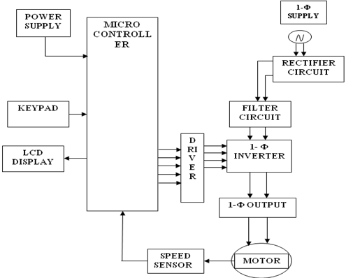

Advantages
Smooth speed control ,Air gap flux remains constant so no possibility of core saturation.
It is possible to get a constant maximum torque at all the speeds right from 0 to the rated speed.

Future Expansion
Instead of using single phase induction motor, three phase induction motor can be used in high performance of variable speed applications.

Conclusion
Instead of using single phase induction motor, three phase induction motor can be used in high performance of variable speed applications.

References
- B. L. Theraja , Volume 2 , S. Chand and Co.
- Kenneth Ayala , microcontroller 8051 , Penram International Publication (India) 1996
- S. K. Bhattacharya , Electrical Machine , Tata McGraw Hill Publication Co. Ltd. , New Delhi
- www.8051projectsnet
- http://www.engineersedge.com/motor/alternator_types.htm

