Load Flow Analysis Using N-R method
Swapnil Ambade, Prasiddhi Kohade, Prof. C.S. Hiwarkar
Department of Electrical Engineering, K. D. K College Of Engineering, Nagpur, India
Email: swapambade@gmail.com

Abstract – Power flow analysis is the backbone of power system analysis and design. They are necessary for planning, operation, economic scheduling and exchange of power between utilities. The principal information of power flow analysis is to find the magnitude and phase angle of voltage at each bus and the real and reactive power flowing in each transmission lines. Power flow analysis is an importance tool involving numerical analysis applied to a power system. In this analysis, iterative techniques are used due to there no known analytical method to solve the problem. This paper presents a simplified version of the well - known Newton - Raphson power - flow solution method, which is based on the current balance principle to formulate a set of nonlinear equations. Although there exist several powerful power flow solvers based on the standard Newton - Raphson (NR) method.

Keyword - Load flow analysis, N-R method.

I. Introduction
The power flow study (also known as load-flow study) has been widely applied to power systems for system planning, operating and control. Over the past decades, researchers have made an enormous amount of efforts to develop numerical power flow calculation approaches. Load flow studies (LFS) in power system parlance, is the steady state solution of the power system network in which the power system is designed as an interconnected network and then solved for the steady state power and voltages at each bus .
Through the load flow studies we can obtain the voltage magnitudes and angles at each bus in the steady state. This is rather important as the magnitudes of the bus voltages are required to be held within a specified limit. Once the bus voltage magnitudes and their angles are computed using the load flow, the real and reactive power flow through each line can be computed. Also based on the difference between

power flow in the sending and receiving ends, the losses in a particular line can also be computed. Furthermore, from the line flow we can also determine the over and under load conditions. The steady state power and reactive power supplied by a bus in a power network are expressed in terms of nonlinear algebraic equations. We therefore would require iterative methods for solving these equation. Conventional methods for load flow analysis problem are based on iterative method such as the Newton-Raphson (NR) or the Gauss-Seidel (GS) methods. To date, the standard NR power flow method is one of the most powerful algorithms, and is widely used to develop commercial power-flow solution software. Although the standard NR power flows method is very efficient and commonly used for the power flow calculation in several power system textbooks.

II. LOAD FLOW ANALYSIS

Load flow analysis (LFA), is a vital tool for the system planning purpose like system installation, system expansion and system modification. LFA is the determination of current, voltage, active power, and reactive power volt-amperes at various points in a power system by using Newton-Raphson method operating under normal steady-state or static conditions. Thus All these system parameters values are used for decisive the best possible location as well as best possible capacity of system installation, system expansion and system modification. These values also indicate that which of the system parameter is operating with in the stability limit range and which is not. For system to operate within the stability limit, the system parameter should be maintained within its acceptance limit with lessen transmission losses.

III.BUS CLASSIFICATION

A bus is a node at which one or many lines, one or many loads and generators are connected. In a power system each node or bus is associated with 4 quantities, such as magnitude of voltage, phage angle of voltage, active or true power and reactive power in load flow problem two out of these 4 quantities are specified and remaining 2 are required to be determined through the solution of equation. Depending on the quantities that have been specified, the buses are classified into 3 categories
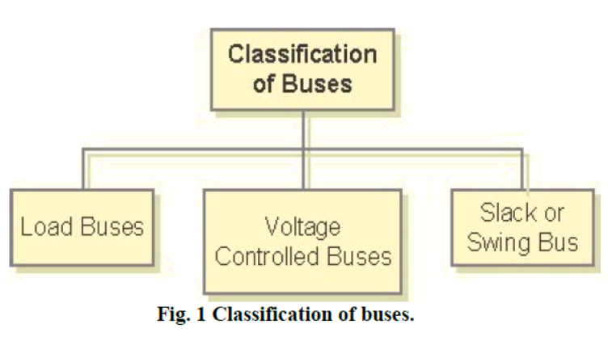

- Load Buses:
In these buses no generators are connected and hence the generated real power PGi and reactive power QGi are taken as zero. The load drawn by these buses are defined by real power -PLi and reactive power -QLi in which the negative sign accommodates for the power flowing out of the bus. This is why these buses are sometimes referred to as P-Q bus. The objective of the load flow is to find the bus voltage magnitude |Vi| and its angle δi.

- Voltage Controlled Buses:
These are the buses where generators are connected. Therefore the power generation in such buses is controlled through a prime mover while the terminal voltage is controlled through the generator excitation. Keeping the input power constant through turbine-governor control and keeping the bus voltage constant using automatic voltage regulator, we can specify constant PGi and | Vi | for these buses.
- Slack or Swing Bus:
Usually this bus is numbered 1 for the load flow studies. This bus sets the angular reference for all the other buses. Since it is the angle difference between two voltage sources that dictates the real and reactive power flow between them, the particular angle of the slack bus is not important. However it sets the reference against which angles of all the other bus voltages are measured. For this reason the angle of this bus is usually chosen as 0°. Furthermore it is assumed that the magnitude of the voltage of this bus is known.

IV.BASIC CONCEPTS AND PROBLEM FORMULATION
The most widely used method for solving simultaneous nonlinear algebraic equations is the Newton Raphson method (NR). Newton’s method is found to be more efficient and practical. The number of iterations required to obtain a solution is independent of the system size, but more functional evaluations are required at every iteration. Since in the power flow problem real power and voltage magnitude are specified for the voltage-controlled buses, the power flow equation is formulated in polar form. This equation can be rewritten in admittance matrix as
$$I_{i}=\sum_{j=1}^{n}{Y_{\text{ij}}V_{j}}$$
In the above equation, j includes bus i. expressing this equation in polar form, we have
$$I_{i}=\sum_{j=1}^{n}{|V_{\text{ij}}||Y_{\text{ij}}|}θ_{\text{ij}}+δ_{j}$$
The complex power at bus i is
$P_{i}+{\text{jQ}}_{i}=V_{i}^{}I_{i}$
Separating the real and imaginary parts
$$P_{i}=\sum_{j=1}^{n}{|V_{i}|}|V_{j}||Y_{\text{ij}}|\text{cos}(θ_{\text{ij}}−δ_{i}+δ_{j})$$
$$\begin{aligned} \\ Q_{i}=−\sum_{j=1}^{n}{|V_{i}|}|V_{j}||Y_{\text{ij}}|\text{sin}(θ_{\text{ij}}−δ_{i}+δ_{i}) \\ \begin{aligned}\left[ΔP | \right] \\ \end{aligned} \\ \end{aligned}$$
By running the load flow analysis using NR-method we can fine the Power flows in individual lines and loss’
V. BUS SYSTEM
Example-Figure shows the one line diagram of a simple 3-bus system with generators at buses 1 and 3.The magnitude of voltage at bus 1 is adjusted to 1.05pu.Voltage magnitude at bus 3is fixed at 1.04pu with real power generation of 200MW.A load of 400MW and 250Mvar is taken from bus 2.Line impedence are marked in per unit on a100MVA base, and the line charging susceptance are neglected. Obtain the power flow solution by the N-R method.
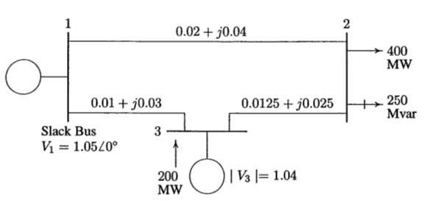
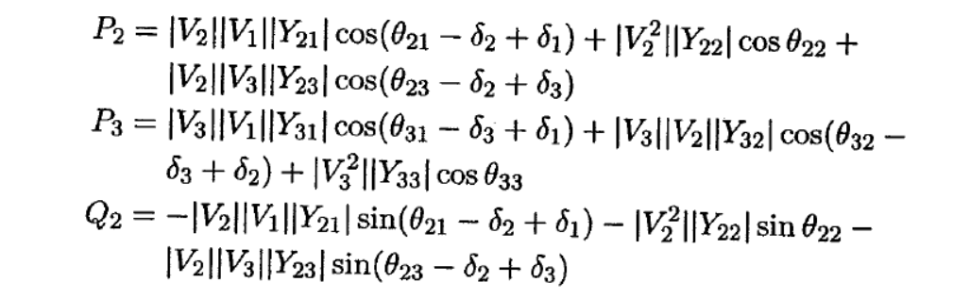
Calculated parameters | Iteration 1 | Iteration 2 | Iteration 3
$$δ_{2}$$ | -0.0452 | -0.0470 | -0.0470
$$δ_{3}$$ | -0.0077 | -0.0087 | 0.0087
V₂ | 0.9734 | 0.9716 | 0.9716

VI.LINE LOSSES AND LINE FLOWS
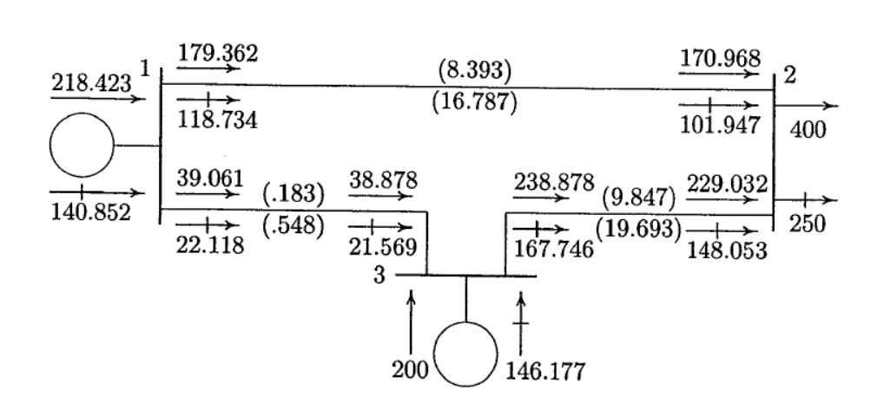

VII. RESULTS
1) Bus data
BUS | P | Q | V | Angle
1 | 2.1842 | 1.4085 | 1.0500 | 0
2 | -4 | -2.5 | 0.9717 | -0.0471
3 | 2 | 1.4618 | 1.0400 | -0.0087

VIII. CONCLUSION

Power flow or load-flow studies are important for planning future expansion of power systems as well as in determining the best operation of existing systems. The principal information obtained from the power flow study is the magnitude and phase angle of the voltage at each bus, and the real and reactive power flowing in each line On the other hand, in Newton-Rahpson method, the calculations are complex, but the number of iterations is low even when the number of buses is high.
The line flows can be known through load flow analysis. Although the standard NR power flow method is very efficient and commonly used for the power flow calculation in power system .

REFERENCE

[1] Dharamjit, D.K. Tanti, “Load Flow analysis on IEEE 30 bus System”, IJSRP(International journal of scientific and research publication) ISSN :2250-3153,volume-2, Issue-11, November 2012.

[2] Puneet Sharma, Pratima Walde, “Optimized Line Flow Analysis of IEEE Bus System with the Load Dependency Factor”, International Journal of Applied Engineering Research. ISSN 0973-4562, Volume 9

[3] Thanatchai Kulworawanichpong, “Simplified Newton-Raphson power-flow solution method”, 32 (2010) 551-558

[4] Jiaxiong Chen, Yuan Liao, “State Estimation and Power Flow Analysis of Power Systems”, JOURNAL OF COMPUTERS, VOL. 7, NO. 3, MARCH 2012.

[5] D P Kothari, I J Nagrath , “ Modern Power System Analysis”, fourth edition, Mcgraw Hill Education(India) Pvt Ltd.

[6 Hadi Saadat , “Power System Analysis” , Mcgraw Hill Publications Pvt Ltd.

