Design and Implementation of Step Up DC - DC Converter for Microsource Application

Prajakta Bhutange S.R.M.C.E.W. 7387721102 prajaktabhutange010@gmail.com
Pranita Patmase S.R.M.C.E.W. 8975895334 pranitapatmase@gmail.com
Priyanka Wasnik S.R.M.C.E.W. 7083376614 priynkawasnik1295@gmail.com
Rambha Thakur S.R.M.C.E.W. 8446058211 rambhathakur93@gmail.com
Ravina Kumbhalkar S.R.M.C.E.W. 8793469464 ravinakumbhalkar59@gmail.com
Reshmi Bhagwat S.R.M.C.E.W. 8600570662 reshmibhagwat@gmail.com

Abstract – This paper presents the modelling, simulation and implementation of solar photovoltaic cell using MATLAB Simulink. A high step up DC – DC converter is proposed. The conventional sources of energy are going to be exhausted in few years. The output voltage from most renewable sources like photovoltaic, fuel cell or energy storage device such as super capacitor and batteries are not useful for commercial usage. In order to make them to use we have to step up this voltage to grid voltage level so boost converter are introduced to meet the above mentioned requirement. The 15 V DC is step up to 230 V DC using high step up DC – DC converter. This DC is converted into AC by using inverter.

Index terms- Coupled inductor, DC–DC converter, high voltage gain, microsources.

I. INTRODUCTION
The technology development of renewable energy sources such as photovoltaic (PV), fuel cell, wind, etc., are gaining more and more attention nowadays. The integration of renewable energy sources such as solar photovoltaic cells, wind turbines, fuel cells, and microturbines are well-developed in recent years due to the problems of running out the fossil fuels and environmental pollution produced by the traditional power systems.
Among all of the renewable energy sources, PV source plays a key role in energy portfolio of the world because it is clean and reliable. The cost of PV modules is very high.. Therefore, the focus should be placed on new, innovative and cost effective solutions, which results in a high diversity within the power converters and system configurations.
One of the main drawbacks of PV generation is that the output voltage of the PV panels is low (typically 25-40 V per panel). Thus, connecting the PV panels in series is the conventional solution. Unfortunately, the output power of the PV panels would drop greatly due to partial shading and module mismatches, especially in urban areas. In such case, the parallel-connected configuration is more efficient than series-connected configuration due to PV performance. It is also easier to full fill the safety requirements using parallel-connected configuration in residential applications. However, the PV output voltage is relatively low in parallel-connected configuration.
Therefore, converters with high step-up ratio and high efficiency are required to boost the PV voltage to a high level, such as 380 V. In a PV power system, battery is usually used as either the energy storage element or backup source depending on the solar irradiation and load demand. The bidirectional DC-DC converter should also provide a high step-up gain since it is also connected to the high voltage DC-link.
In renewable energy systems, converters with high boosting capability, high efficiency and high power density are necessary to improve system performance and reduce system cost. High step-up DC-DC converters are widely used to boost the low input voltage level at the front end of distributed power systems. These systems are powered by renewable energy sources such as solar panels, batteries, and fuel cells. A new trend in residential photovoltaic generation systems is to adopt parallel configuration rather than series connection to full fill the safety requirement while drawing maximum available power from the PV panels.
High step up gain can be achieved by using switched capacitor technique but there be high transient current on main switch and the conduct loss is high. The converters using coupled inductors could achieve high voltage conversion ratio through adjusting the turns ratio. However, high voltage spike would be observed on the main switch due to the leakage inductor. Active clamp circuit is required to address such issue but the converter cost will be increased. Voltage-lift technique provides another option to reach high voltage gain but it has the same drawback as switched capacitor technique.
This paper is about the converter which may be used to regulate the voltage and current at the load to control the power flow in grid connected system and mainly to track the maximum power point of the device.

II. BLOCK DIAGRAM

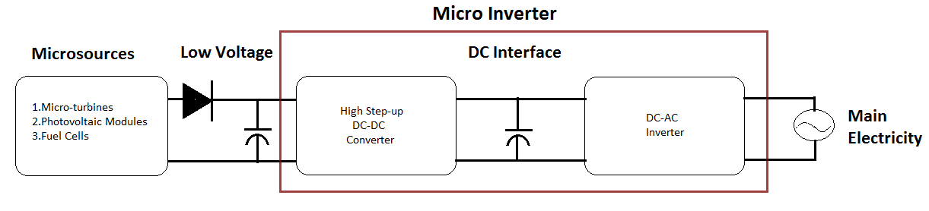
Fig. 1. Basic schematic of the microgrid consisted of diversely microsources and power converters.

A boost converter (step-up converter) is a DC-to-DC power converter with an output voltage greater than its input voltage. It is a class of switched-mode power supply (SMPS) containing at least two semiconductors and at least one energy storage element, a capacitor, inductor, or the two in combination. Filters made of capacitors (sometimes in combination with inductors) are normally added to the output of the converter to reduce output voltage ripple.
- Microsources
A. Photovoltaic:
Photovoltaic, or solar, cells have advantages including sustainable nature, no polluting by-product, long lifetime, and quiet operation. PV technology is developed in recent years
and employed to convert DC voltage into AC voltage for the utility through PV inverters. However, the power that PV cells
could provide is highly depend on the irradiation intensity of the sun and the surface area of the cells. Therefore, the maximum power point tracking (MPPT) algorithms are adopted to track the best operation point so that the maximum output power can be obtained. One could connect a number of PV cells in series and/or parallel connection to increase the power rating since the output power of a single PV cell is really small.

B. Wind turbine:
Wind generation technology is mature for being commercial usage. Wind turbines are recognized as the most cost-effective renewable energy source due to the construction and operation costs are still dropping. These turbines typically employ induction generators driven by a rotor with two blades or more. The kinetic energy of the wind can be transferred to electric power. The output power of the wind turbines depends on the velocity of the wind and the design of the turbine. Wind turbines can be roughly classified into fixed speed type and variable speed type. Since the intermittent and unpredictable nature of the wind, wind turbines should be integrated with storage systems or other backup generation systems to provide a constant output power.

C. Fuel cells:
Fuel cells directly convert chemical energy into electrical energy without combustion, pollutant and noise. They are attractive because of their potential of high efficiency in power conversion process. Fuel cell is usually composed of a cathode, an anode and an electrolyte. The electrolyte serves as a separator to prevent the mixing of hydrogen fuel and the oxygen. Water and heat are the two main by-products of the overall chemical reaction. This ecofriendly feature makes the fuel cells more suitable for the residential area than other energy sources. It is noted that the output power produced by a single fuel cell is very small. For this reason, numbers of cells are connected in series to form a fuel cell stack. There are many different types of fuel cells including proton exchange membrane (PEMFC), phosphoric acid (PAFC), molten carbonate (MCFC), and solid oxide (SOFC).

D. Microturbines:
Microturbines consist of turbines in smaller size on a single shaft or split shaft. Serve as generation units, they are quite common in the CHP systems and distributed generation system. These units could supply output power rating from tens of watts to hundreds of kilowatts. Generally, microturbines can reach the conversion efficiency around 30 %. However, the overall system efficiency may be increased to about 80 % under CHP operation. Other advantages of microturbines include competitive cost, fuel flexibility, long operational life and simpler installation.

III. OPERATING PRINCIPLES OF THE PROPOSED CONVERTER
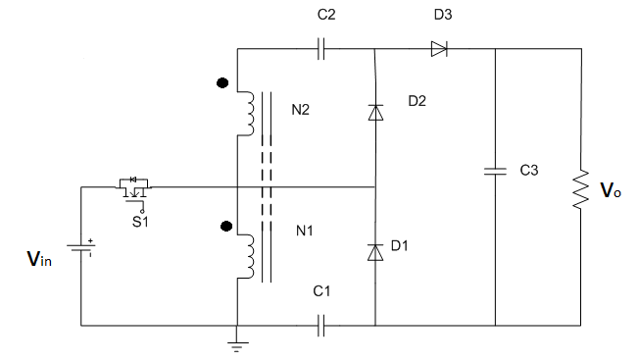
Fig. 2. Circuit configuration of proposed converter.
The proposed converter, shown in figure, is comprised of a coupled inductor T1 with the floating active switch S1. The primary winding N1 of a coupled inductor T1 is similar to the input inductor of the conventional boost converter, and capacitor C1 and diode D1 receive leakage inductor energy from N1. The secondary winding N2 of coupled inductor T1 is connected with another pair of capacitors C2 and diode D2 , which are in series with N1 in order to further enlarge the boost voltage. The rectifier diode D3 connects to its output capacitor C3.

The proposed converter has several features:
i) The connection of the two pairs of inductors, capacitor, and diode gives a large step-up voltage-conversion ratio;
ii) The leakage-inductor energy of the coupled inductor can be recycled, thus increasing the efficiency and restraining the voltage stress across the active switch; and
iii) The floating active switch efficiently isolates the PV panel energy during non-operating conditions, which enhances safety.In order to simplify the circuit analysis of the proposed converter, the following assumptions are made.
i) All components are ideal, except for the leakage inductance of coupled inductor T1, which is being taken under consideration. The on-state resistance RDS (ON) and all parasitic capacitances of the main switch S1 are neglected, as are the forward voltage drops of diodes D1 and D3.
ii) The capacitors C1 and C3 are sufficiently large that the voltages across them are considered to be constant.
iii) The ESR of capacitorsC1 and C3 and the parasitic resistance of coupled inductor T1 are neglected.
iv) The turn’s ratio n of the coupled inductor T1 windings is equal to N2 /N1.

IV. MAXIMUM POWER POINT TRACKING (MPPT)
Solar cells are devices that absorb sunlight and convert that solar energy into electrical energy. By wiring solar cells in series, the voltage can be increased; or in parallel, the current. Solar cells are wired together to form a solar panel. Solar panels can be joined to create a solar array. The solar array we will be working with is the BP MSX 120, which provides 120 watts of nominal maximum power. The Maximum Power Point Tracker (MPPT) is needed to optimize the amount of power obtained from the solar array to the power supply. The output of a solar array is characterized by a performance curve of voltage versus current, called the I-V curve. The maximum power point of a solar array is the point along the I-V curve that corresponds to the maximum output power possible for the array.
MPPT’s are used to correct for the variations in the I-V characteristics of the solar cells. The I-V curve will move and deform depending upon such things as temperature and illumination. For the array to be able to put out the maximum possible amount of power, either the operating voltage or current needs to be controlled. Since the maximum power point quickly moves as lighting conditions and temperature change, a device is needed that finds the maximum power point and converts that voltage to a voltage equal to the system voltage. Cost is a major factor when deciding to utilize solar energy as a source. As one might expect, a purchaser would want to extract the maximum power per dollar spent on an array. Solar arrays do present an interesting problem in the transfer of energy to a load. Since the solar array has a unique I-V relationship similar to a silicon diode, the maximum power point must be tracked to extract the most energy possible.Connection of an arbitrary load to a solar array does not guarantee operation at the maximum power point. As an example, if an array has a maximum power point at a source voltage of 100V (with current being constant) a 24V load will absorb energy, but it will not be at the optimal rate (maximum power). A means of controlling the source voltage or current is needed to guarantee operation at the maximum power point. Essentially, the load impedance must be matched to the source impedance.
V. OPERATION AND CIRCUIT
i) Mode I [t₀ – t₁]: When the mode operation is started in between the time interval (t0-t1) the transition interval, the magnetizing inductor Lm continuously charges capacitor C₂ through T₁ when S₁ is turned ON. Current i_{Lm} is decreasing because source voltage V_{in} crosses magnetizing inductor Lm and primary leakage inductor L_{k1} magnetizing inductor L_{m} is still transferring its energy through coupled inductor T₁ to charge switched capacitor C₂, but the energy is decreasing the charging current i_{D2} and i_{C2} are decreasing. The secondary leakage inductor current iL_{K2} is declining as equal to i_{Lm} / n. Once the increasing i_{Lk1} equals decreasing i_{Lm} at t = t1, this mode ends.

ii) Mode II [t₁ – t₂]: During this interval, the condition of the magnetizing inductor Lm is changed from releasing energy to storing energy from V_{in}. As a result, the switched capacitors

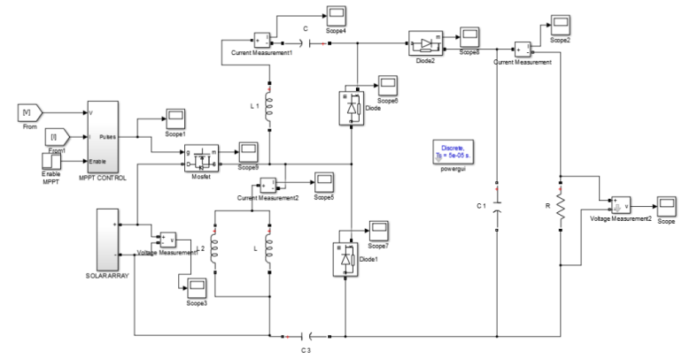
Fig. Simulation circuit

also changed their condition from charging, to discharging energy to output. During this interval the source energy V_{in} is series connected with N₂, C₁, and C₂ to charge output capacitor C₃ and load R; meanwhile magnetizing inductor L_{m} is also receiving energy from V_{in}. The current flow path where switch S1 remains ON, and only diode D₃ is conducting. The i_{Lm}, i_{Lk1} , and i_{D3} are increasing because the Vin is crossing L_{k1} , L_{m}, and primary winding N₁ ; L_{m} and L_{k1} are storing energy from V_{in} ; meanwhile Vin is also serially connected with secondary winding N₂ of coupled inductor T₁ , capacitors C₁ , and C₂ , and then discharges their energy to capacitor C₃ and load R. The i_{in}, i_{D3} and discharging current |i_{C1} | and |i_{C2} | are increasing. This mode ends when switch S₁ is turned OFF at t = t.
iii) Mode III [t₂ – t₃]: When the time period (TS) is operating at the time of t₂ – t₃interval, during this transition interval the secondary leakage inductor L_{k2} keeps charging C₃ when switch S₁ is OFF. The energy stored in leakage inductor L_{k1} flows through diode D₁ to charge capacitor C₁ instantly when S₁ is OFF. Meanwhile, the energy of secondary leakage inductor L_{k2} is series connected with C₂ to charge output capacitor C₃ and the load. Because leakage inductance L_{k1} and L_{K2} are far smaller than L_{m}, i_{Lk2} rapidly decreases, but i_{Lm} is increasing because magnetizing inductor Lm is receiving energy from L_{k1}. Current i_{Lk2} decreases until it reaches zero; this mode ends at t = t₃.

iv) Mode IV [t₃ – t₄]: When the time period is operating at the time of t₃ – t₄ interval, during this transition interval the energy stored in magnetizing inductor L_{m} is released to C₁ and C₂ simultaneously. Only diodes D₁ and D₂ are conducting. Currents i_{Lk1} and i_{D1} are continually decreased because the leakage energy still flowing through diode D₁ keeps charging capacitor C₁. The L_{m} is delivering its energy through T₁ and D₂ to charge capacitor C₂. The energy stored in capacitor C₃ is constantly discharged to the load R. These energy transfers result in decreases in i_{Lk1} and iLm but increases in _{iLk2}. This mode ends when current i_{Lk1} is zero, at t = t_{4.}
v) Mode V [t₄ – t₅]: During this interval the only magnetizing inductor L_{m} is constantly releasing its energy to C₂. The current flow path which only diode D₂ is conducting. The i_{Lm} is decreasing due to the magnetizing inductor energy flowing through the coupled inductor T₁ to secondary winding N₂, and D₂ continues to charge capacitor C₂. The energy stored in capacitor C₃ is constantly discharged to the load R. This mode ends when switch S₁ is turned ON at the beginning of the next switching period.

VI. .CONCLUSION
Since the energy of the coupled inductor’s leakage inductor has been recycled, the voltage stress across the active switch S1 is constrained, which means low ON-state resistance RDS (ON) can be selected. Thus, improvements to the efficiency of the proposed converter have been achieved. The switching signal action is performed well by the floating switch during system operation. From the simulation modelled converter, the turns ratio n = 5 and the duty ratio D is 55%; thus, without extreme duty ratios and turns ratios, the proposed converter achieves high step-up voltage gain, of up to 10 times the level of input voltage. The simulation results show that the maximum efficiency of 93%.

VII. FUTURE WORK
This paper proposes a converter that employs a floating active switch to isolate energy from the PV panel when the ac module is OFF; this particular design protects installers and users from electrical hazards. By using close loop PI controller we can maintain the DC-link voltage across the DC-DC converter.

REFERENCES
[1International Journal of Advanced and Innovative Research (2278-7844) / #287, Volume 2 Issue 9- 2013.
[2] Pooja Devi & T.B.Dayananda “ Boost Converter for PV Module Application”, International Journal of Recent Advances in Engineering & Technology (IJRAET), 2347 - 2812, Volume] Dinesh Kumar Munigala & J.Srinivas Rao “A Step Up Dc – Dc Converter With High Voltage Gain for Microsource Applications”, -2, Issue - 4, 2014.
[3] Ponugoti Sri Lakshmi, Kande Dayakar,& Dola Sanjay S “High Step-Up DC–DC Converter for AC Photovoltaic Module Application”, International Journal of Innovative Technology and Exploring Engineering (IJITEE), ISSN: 2278-3075, Volume-4 Issue-7, December 2014.
[4] S.Daison Stallon, K.Vinoth Kumar & S.Suresh Kumar “High Efficient Module of Boost Converter in PV Module”, International Journal of Electrical and Computer Engineering (IJECE), Vol.2, No.6, December 2012.

