Enhancement of Power Quality In an Isolated Power System
Bhairavee Bhagadkar KDKCOE, Nagpur bhagadkarbhairavee@gmail.com
Rakesh G Thakur KDKCOE, Nagpur rakeshthakurrex@gmail.com
Prof. D. M. Holey KDKCOE, Nagpur

Abstract – The power quality requirement is one of the most important issues especially with the introduction of sophisticated device whose performance is very sensitive to the quality of power supply. Power quality problem is an occurrence manifested as a nonstandard voltage, current or frequency that results in failure of end user equipment In general, maintaining and the operation of sensitive loads is difficult but power electronics and advanced control systems made it possible for solving the power quality problems. The most severe power quality problems which affect the sensitive loads are sag, swells and harmonics. For the mitigation of these disturbances the best suitable method is Series compensation. Due to presence of non-liner loads which causes harmonics in the network Series compensator not only mitigates sag but also harmonics in the system. The main components of series compensator are Energy Storage System (ESS), Voltage Source Inverter (VSI), and Injection Transformer. ESS acts as energy system which injects voltage into system through injection transformer during sag which regulates voltage to appropriate level. By implanting this way, terminal voltage maintained at constant level and sensitive loads are protected. This method gives the effective solution than conventional methods.

Keywords—sensitive load, power quality, harmonics, voltage sag, ESS(Energy Storage System), VSI(Voltage Source Inverter),injection transformer.

Introduction
In recent years power engineers are increasingly concerned over quality of the electrical power. In modern industries, load equipment uses electronic controllers which are sensitive to poor voltage quality and will shut down if supply voltage is depressed and may mal-operate in other ways if harmonic distortion of supply voltage is excessive. Much of this modern load equipment itself uses electronic switching devices which then can contribute to poor voltage network quality. The introduction of competition into electrical energy supply has created greater commercial awareness of the issues of power quality while equipment is now readily available to measure quality of voltage waveform and so qualify the problem. Along with advance technology, the organization of worldwide economy has evolved towards
globalization and the profit margins of many activities tend to decrease. The increased sensitivity of the vast majority of processes like (industrial, services and even residential) to PQ problem turns the availability of electrical power with quality a crucial factor for competitiveness in every activity sector. The continuous process industry and the information technology services are most critical area. Due to disturbance huge amount of financial losses may happen, with the consequent loss of productivity and competitiveness.
Many efforts have been taken by utilities to fulfill consumer requirement, some consumers require a level of PQ higher than the level provided by modern electric networks. This implies that some measures must be taken in order to achieve higher levels of Power Quality.
The FACTS devices and Custom power devices are introduced to electrical system to improve the power quality of electrical power. DVR, SERIES COMPENSATOR, ACTIVE FILTER, UPFC, UPQC etc. are some of the devices used to improve power quality of voltage and current. With the help of these devices we are capable to reduce the problems related to power quality.
Here SERIES COMPENSATOR has been used to improve the quality of power under different conditions. Its main objective is to mitigate voltage sag/ swell, harmonics and other disturbances occurring in the system.

Power Quality

Definition
Power Quality is a term that mean different to different people. Institute of Electrical and Electrical Engineering (IEEE) standard IEEE 1100 defines power quality as “the concept of powering and grounding sensitive electronic equipment in a manner suitable for the equipment.”
A simpler words power quality is a set of electrical boundaries that allow a piece of equipment to function in its intended manner without significant loss of performance or life expectancy. This definition embraces two things that we demand from an electrical device which are performance and life expectancy.
- Power Quality Problems
- Volage Sag
It is the decrease of normal voltage level between 10 and 90% of the nominal voltage at the power frequency, for durations of 0.5 cycles to 1 minute.
Its main cause is the faults in consumer’s installation on the transmission or distribution network. Most of the times faults occur on parallel feeders. Connections of heavy loads and start-up of large motor also results in voltage sag.
Consequences:
- Tripping of contactors and electromechanical relays.
- Malfunction of information technology equipment, namely microprocessor-based control systems (PCs, PLCs, ASDs, etc) that may lead to a process stoppage.
- Disconnection and loss of efficiency in electric rotating machines.
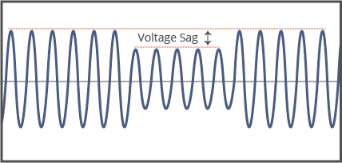
Fig (1): Voltage Sag

- Volage Swell
It is the momentary increase of voltage, at the power frequency, outside the normal tolerances, with duration of more than one cycle and typically less than a few seconds.
Voltage swell may occur due to start/ stop of heavy loads, badly dimensioned power sources or badly regulated transformers (mainly during off-peak periods)
Consequences:
- Flickering of lighting and screens and data loss.
- Stoppage or damage of sensitive equipment, if the voltage values are too high.
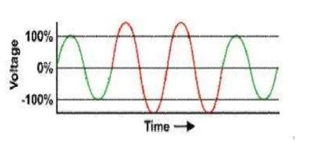
Fig(2): Voltage Swell
- Harmonic Distortion
It is the signal or wave whose frequency is an integral multiple of some reference signal or wave. Presence of harmonics in the signal makes it distorted and non-sinusoidal. Its classic causes are electric machines working above the knee of the magnetization curve (magnetic saturation), arc furnaces, welding machines, rectifiers, and DC brush motors and the modern sources are all non-linear loads, such as power electronics equipment including ASDs, switched mode power supplies, data processing equipment, high efficiency lighting.
Consequences:
- Increased probability in occurrence of resonance
- Overheating of all cables and equipment.
- Neutral overload in 3-phase systems.
- Interference with communication systems.
- Loss of efficiency in electric machines.

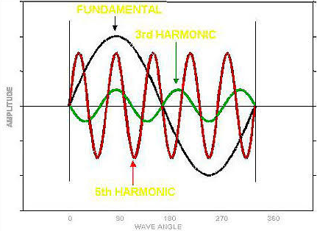
Fig (3): Harmonic Distortion

Series Expansion

Basic Principle
Figure 3(a) shows the simplified model of a power transmission system. Two power grids are connected by a transmission line which is assumed lossless and represented by the reactance X_{L}. 11δ∠V and 22δ∠V represent the voltage phasors of the two power grid buses with angle δ= δ₁- δ₂ between the two. The corresponding phasor diagram is shown in Figure 3(b).

Fig 3(a): Power Transmission System Simplified Model

Fig 3(b): Phasor Diagram
The magnitude of the current in the transmission line is given by:
- - -(1)
The active and reactive components of the current flow at bus 1 are given by:
- - - (2)
The active power and reactive power at bus 1 are given by: - - - (3)
Similarly, the active and reactive components of the current flow at bus 2 can be given by:
- - - (4)
The active power and reactive power at bus 2 are given by: - - - (5)
Equations (1) through (5) indicate that the active and reactive power/current flow can be regulated by controlling the voltages, phase angles and line impedance of the transmission system. From the power angle curve shown in Figure 3(b), the active power flow will reach the maximum when the phase angle δ is 90º. In practice, a small angle is used to keep the system stable from the transient and dynamic oscillations.

Series Compensation
Series compensation aims to directly control the overall series line impedance of the transmission line. Tracking back to Equations (1) to (5), the AC power transmission is primarily limited by the series reactive impedance of the transmission line. A series-connected can add a voltage in opposition to the transmission line voltage drop, therefore reducing the series line impedance.
A simplified model of a transmission system with series compensation is shown in Figure (a). The voltage magnitudes of the two buses are assumed equal as V, and the phase angle between them is δ. The transmission line is assumed lossless and represented by the reactance X_{L}. A controlled capacitor is series-connected in the transmission line with voltage addition V_{inj}. The phase diagram is shown in Figure (b).
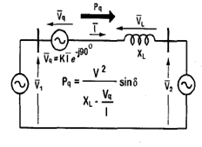
Fig (a): The elementary two-machine system
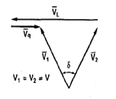
(b) Phasor diagram

Where
V1 is the voltage magnitude of machine-1.
V2 is the voltage magnitude of machine-2.
δ is the phase difference between these voltages.
I is the current flowing from machine-1 to machine-2.
VL is the voltage drop across the line impedance.
Pq is the active power flowing through the line.
Vq is the injected voltage

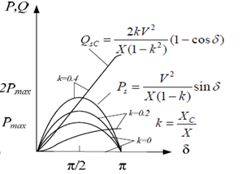
Fig (c) Power angle curve

Defining the capacitance of C as a portion of the line reactance,
X_{C =} k X_{L} - - - (1)

The overall series inductance of the transmission line is,

X = X_{L} − X_{C =} (1 − k) X_{C} - - - (2)
The active power transmitted is,
- - -(3)
The reactive power supplied by the capacitor is calculated as:
- - - (4)

System Model
The simple isolated power system model shown in Fig 3(C) is used to explain the principle of the proposed harmonics compensation method of the SC. The upstream generators are represented as an ideal voltage source and ZS represents the equivalent source impedance. The main drives or machinery loads are modeled as a lumped resistance-inductance load connected to the source through a power converter which is assumed to be an uncontrolled six-pulse rectifier in this study.
The following are the important parts of Series Compensator as explained in below.
Storage Devices/ESS: This is required to provide active power to the load during deep voltage sags. A storage capacitor is used for energy storage. It is also possible to provide the required power on the DC side of the VSI by an auxiliary bridge converter that is fed from an auxiliary AC supply.

Fig 3(C): System Model

The compensator need real power for compensation purpose during voltage disturbance in the distribution system. In this case the real power of the compensator must be supplied by energy storage when the voltage disturbance occurs. The energy storage such as battery is responsible to supply an energy source in D.C form.

Voltage Source Inverter/VSI: A VSI is a power electronic system consists of a storage device and switching devices, which can generate a sinusoidal voltage at any required frequency, magnitude, and phase angle. Here we have used a storage capacitor and Insulated Gate Bipolar Transistors (IGBT)as a switch.

Harmonic filter/Passive filter: The passive filters can be placed either on the high voltage side or the converter side of the injection transformers. Basically filter unit consists of inductor (L) and capacitor(C). In compensator, filters are used to convert the inverted PWM waveform into a sinusoidal waveform. This can be achieved by eliminating the unwanted harmonic components generated by the VSI action. Higher order harmonic components distort the compensated output volt-age. The unnecessary switching harmonics generated by the VSI must be removed from the injected voltage waveform in order to maintain an acceptable Total Harmonics Distortion (THD).

Control System
The control circuit consists of discrete Proportional Integral (PI) controller, and a Pulse Width Modulator (PWM). The output of the control circuit is pulses, which is given to the Voltage Source Inverter (VSI) and thus the inverter will operate and injects the required value of voltage for the operation of sensitive load and thus reduced the problem of voltage sag, in the mean while the harmonics which are produced due to the operation of six pulse converter are also mitigated to the acceptable level.

Fig: Control circuit of the series compensator

Simulink Diagram

- An Isolated Power System Without Series Compansator

Fig :-voltage and current waveforms without series compensator

- Voltage And Current Waveforms Without Series Compensator

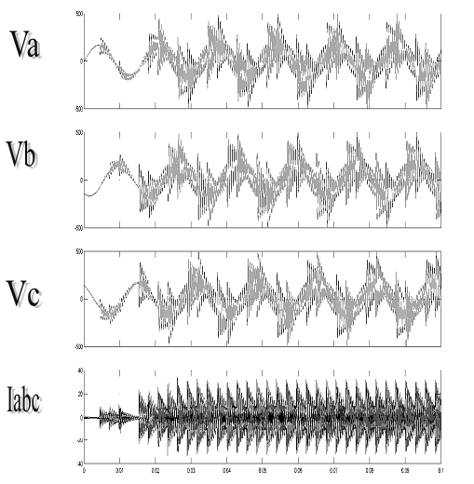

Fig 5.2:-voltage and current waveforms without series compensator

- An Isolated Power System With Series Compansator

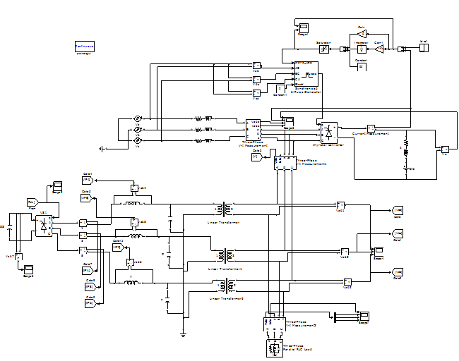
Fig 5.3: Isolated Power system with Series Compensator

- Voltage And Current Waveforms With Series Compensator

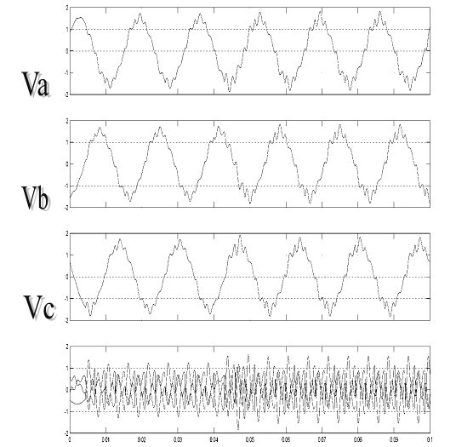

Fig: voltage and current waveforms with series compensator

Conclusion
Voltage quality improvement in an isolated power system through series compensation has been investigated. It is observed that the power system contains significant proportion of fluctuating nonlinear load and high level of harmonic distortions. A method to control the injection voltage of the series compensators (SC) so that it can mitigate the effects of the harmonics has been proposed. The SC is also designed to maintain the fundamental frequency component of the terminal voltage of protected sensitive load. In the process of harmonic voltage compensation, it is shown that power exchange exists between the SC and the external network. Based on the analysis of the harmonic real power flow in the power system, it is seen that the SC would import harmonic real power from the external system. A new SC control strategy is then proposed which involves the phase adjustment of the fundamental frequency component of the sensitive load terminal voltage. Through the analysis of the power exchange, it is shown that the load ride through capability during voltage sag can be improved with the support of the harmonic real power absorbed by the SC. The capacity of the SC required is modest and, therefore, makes it a viable device for such an application. Simulations have confirmed the effectiveness of the proposed method, as it is applied on the SC to achieve improved quality of supply in the power system.

References
[1] Matt Matele – “Enhancing of transmission capability of power corridors by means of series compensation”, Power Tech Conference, Mumbai, India, October 1999, ABB Power Systems AB, Vasteras, Sweden

[2] K. Ramar and M.S.Raviprakash – “Design of series compensation of line AC transmission lines for maximum power transfer limited by voltage stability”, International Journal of Electrical Power and Energy Systems, vol. 17, no.2, April 1995

[3] A. Leonidaki, G.A. Manos ,N.D. Haziargyrio – “An effective method to locate series compensation voltage stability enhancement”, International Journal of Energy Applications and Technology, vol. 2, no. 1, 2015

[4]S. Chawala, S. Garg, B. Ahuja – “Optimal location of series FACTS devices for transmission line compensation”, Conference, Power Engineering Society, Winter Meeting 2002, IEEE, vol. 1

[5] S.S. Choi, T.X. Wang and E.K. Sng –“Power quality enhancement in an isolated power system through series compensation”. Center for Advanced Power Electronics,

School of Electrical and Electronic Engineering Nanyang Technological University Singapore esschoi@ntu.edu.sg

[6] L. Gyugyi, “Application characteristics of converter-based FACTS controllers”, IEEE
Conference on Power System Technology, Vol. 1, pp. 391 - 396, Dec. 2000.
13

[7] N.G. Hingorani, L. Gyugyi – “Understanding FACTS, Concepts and Technology of Flexible AC Transmission systems”, IEEE Press 2000

[8] B. T. Ramakrishna Rao, P. Raghunath, S. Ravikishore, Y. Janardhana and G. Nagabhushanam – “Modeling of Series Compensator for Enhancement of Power Quality in an Isolated Power System ” International Journal of Electrical and Electronics Research ISSN 2348-6988 (online) Vol. 3, Issue 1, pp: (273-280), Month: January - March 2015

[9] K.Satish Babu –“A series compensation techniques for enhancement of power quality Isolated Power System”, AE International Journal, vol 2 Issue 1, jan-2013

[10]JBV Subrahmanyam –“Enhancement of voltage Quality in Isolated Power System”, International Journal of Engineering and Technology, vol 1 No. 2,november 2011

