SOLAR TRACKER USING RTC
Darshana Zanzad PJLCOE, Nagpur darshana199418@gmail.com
Chaitali Dhabekar PJLCOE, Nagpur chaitali249@gmail.com
Isha Ramteke PJLCOE, Nagpur isharamteke13@gmail.com
Prof. Joydeep Sutradhar PJLCOE, Nagpur joydeepsutradhar1@gmail.com

Abstract – The growth or energy demand in response to industrialization, urbanization, and societal affluence has led to an extremely uneven global distribution of primary energy consumption. The sun, wind, waves and geothermal heat are renewable energy sources that will never run out. They are perpetual, or self-renewing. The rate of consumption does not exceed the rate of renewability. The cost of generating electricity from wind and solar power has decreased by 90% over the past 20 years. Maximizing power output from a solar system is desirable to increase the efficiency of a solar tracing system. To maximize the power output from solar panels, we need to keep the panels aligned with the sun. In this paper, the design of an efficient solar tracking system based on Real Time Clock (RTC) using AVR processor is described. The proposed tracking system is a low cost, high accurate, more efficient with low power consumption.

Keywords – AVR processor, Real Time Clock, Renewable energy, Solar tracking system.

Introduction

The regeneration of energy, also called as the green energy, has gained much importance nowadays. Green energy can be recycled, much like solar energy, water power, wind power, biomass energy, terrestrial heat, temperature difference of sea, sea waves, morning and evening tides, etc.
Among the non-conventional, renewable energy sources, solar energy affords great potential for conversion into electric power, able to ensure an important part of the electrical energy needs of the planet. The conversion principle of solar light into electricity, called Photo-Voltaic (PV) conversion, is not very new, but the efficiency improvement of the PV conversion equipment is still one of top priorities for many academic and industrial research groups all over the world. Among the proposed solutions for improving the efficiency of PV conversion, we can mention solar tracking, the optimization of solar cell configuration and geometry, new materials and technologies, etc.
The topic proposed in this paper refers to the design of a single axis solar tracker system that automatically adjusts the optimum PV panel position with respect to the sun by means of a DC motor controlled by an intelligent controller unit that equipped with a positioning algorithm to mathematically solve the optimum tracker position for any time of the day using RTC. A practical measurement of the sun position with respect to the natural time relational table is implemented as an algorithm to track the sun position to achieve maximum energy.
Finally, a comparison between the tracking system and the fixed system is made. From the experimental results, the proposed tracking system is verified more efficiently in generating energy than the fixed system.

Sensing and Tracking Principals
Various methods have been implemented and used to track the position of the sun. The direction of the sun changes with respect to time during the daytime. So it is necessary to trap sunlight from all possible directions during the daytime.
The tracking is used to increase the efficiency of the solar panel. The concept is the solar panel has more efficiency if the panel is perpendicular to the sun. For everyone hour the sun goes upwards by 15 degrees. The sun rays are received from morning 6 a m to evening 6 p m so it will be enough if it tracks for 12 hours. For another 12 hours no tracking will take place. After 12 hours the panel will move to initial position of morning 6 am position.
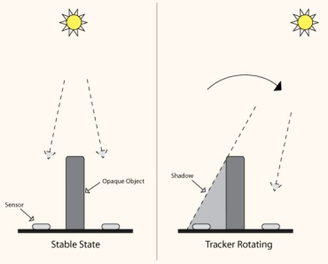

Fig: Movement of sun and effect on solar panel
The simplest of all uses an LDR – a Light Dependent Resistor to detect light intensity changes on the surface of the resistor.The problem with a design using LDR is that phototransistors have a narrow range of sensitivity, once they have been set up in a circuit under set bias conditions. As a result, a simple RTC based control system is proposed, with the natural positioning of the sun with respect to time has been implemented as an algorithm to control the solar PV by controlling the DC motor.

Architecture For System Hardware

The system architecture of the proposed solar tracking control system using ATmega16 is shown in block diagram of the RTC based solar tracking system. The positional direction of the sun with respect to time has been measured and implemented as an algorithm in the controller. Then, the controller in the chip delivers an output, the corresponding PWM signals, to drive the DC motor. Then, the corresponding power that is delivered is shown on the LCD display screen. Thus, the directions of the single dimensional solar platform can be tuned to achieve optimal energy, respectively. There are two modes in the controller as follows:
  - Balancing mode: It is used to set the initial position of the solar platform, we use switches for balancing position. The goal is to set boundary problems around for preventing too large elevating angles, which may make the solar panels crash the mechanism platform, and thus damage the motors and the platform
  - Automatic mode: In this mode the controller continuously reads the Real Time Clock (RTC) and compares with the tabular values stored, if it matches with those values the corresponding positional values will be send to the PWM generator which will make the motor to operate to rotate solar panel to words sun shine. By tuning the two-dimensional solar platform, the optimal efficiency of generating power will be achieved.

Principles of Proposed Solar Tracker

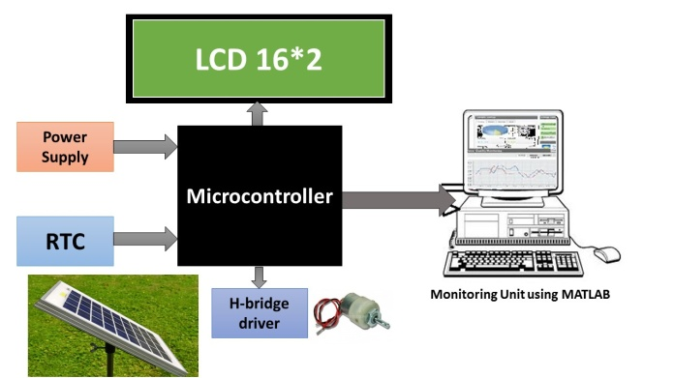

Fig: Block Diagram of the proposed solar tracker system
The final stage involves coupling the circuitry to the motor and mounting it as single unit. A 6V, 100mA solar panel is fixed to the rotor of the DC motor. Communication between controller and Personal Computer (PC) is established through serial communication using MAX232 to record the output voltage. LCD display screen is used to monitor the output voltage .The DC motor control input signals are connected to the controller and the output of the panel is connected to the load through a H-Bridge motor driver IC. The voltage across and current through the load is monitored using ADC channels of the controller.

Flowchart
The flowchart is so drawn that it is self-explanatory and gives the complete idea of how computer sequentially does the different operations to measurement and control. The flowchart of motor position control system for solar tracking application is shown in figure.

Fig: Flow chart of the RTC based solar tracking system

Experimental Results
The hardware implementation of AVR based solar tracking system kit board is shown in below:
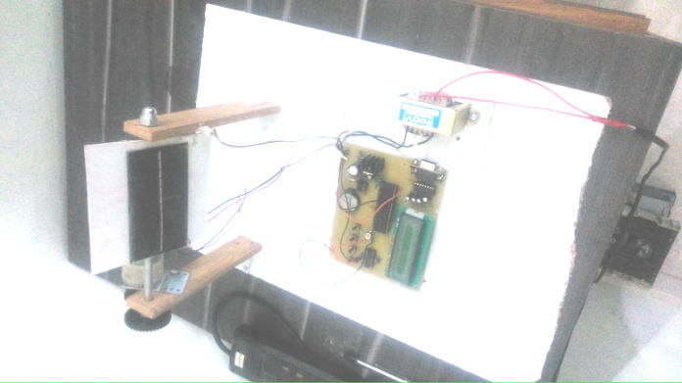
Fig: Prototype of the proposed solar tracking system
The panel is connected to the DC motor and is controlled through the microcontroller. The output voltage of the panel will be read through the ADC channel of the controller and the converted digital voltage values are sent to the remote device through the RS232 communication channel, at the receiver side the personal computer will receives the signals sent by the controller and stores the readings in the Data Base.
Initially the panel output voltage readings are to be measured for a day by fixing the panel in a fixed direction, the tracking results are then compared with fixed solar system results. From the results, it could be observed that the performance of the tracking system is 40% more efficient than a fixed solar system. The solar energy captured from the sun with fixed system i.e. without tracking can be taken for six days as shown in Table 1 and the energy captured with the tracking system can be taken for six days is shown in Table 2. The performance analyses of the proposed solar tracking system over fixed solar panel for six days are shown.

Table 1: Captured energy without proposed solar tracking system

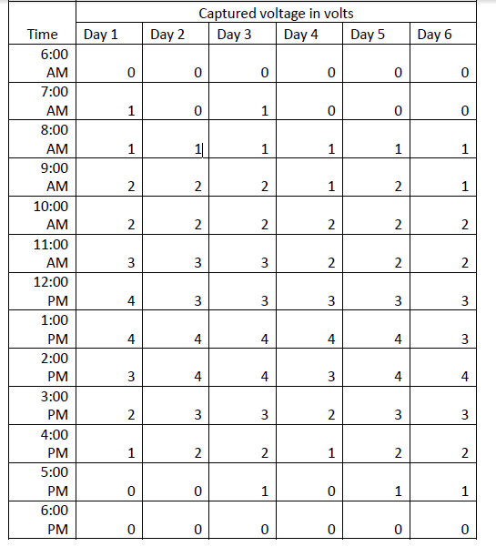
Table 2: Captured energy with proposed solar tracking system
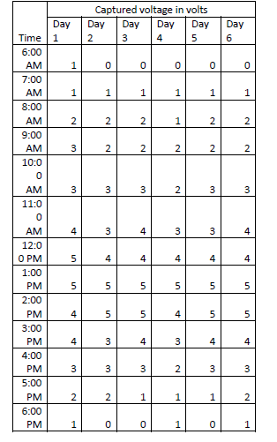
Fig: Assessment on Day 1
Fig: Assessment on Day 2

Fig: Assessment on Day 3

Fig: Assessment on Day 4

Fig: Assessment on Day 5
Fig: Assessment on Day 6

From the above graphs, it is concluded that the energy received from the Sun can be increased using the proposed solar tracking system during the time interval from 9.00AM to 4.00PM when compared with fixed solar cell system.

Conclusion
The design of AVR processor based an efficient solar tracking system with real time clock is developed and described. The proposed system provides a variable indication of their relative angle to the sun by comparing with pre defined measured readings. By using this method, the solar tracker was successfully maintained a solar array at a sufficiently perpendicular angle to the Sun. The power increase gained over a fixed horizontal array was in excess of 40%. The proposed design is achieved with low power consumption, high accuracy and low cost.

References
- “Design and Development of Real Time Clock based efficient Solar Tracking System” by K. Anusha, S. Chandra Mohan Reddy , International Journal of Engineering Research and Applications (IJERA) Vol. 3, Issue 1, January -February 2013.
- “Light Intensity RTC Based Solar Tracking for Power Conservation in Irrigation” System by Prakash. N and Dhakshinamoorthy. T,International Journal of Engineering Research & Technology (IJERT) Vol. 3 Issue 1, January – 2014.
- S. R. Bull, “Renewable energy today and tomorrow,” IEEE Proc., vol.89, no. 8, pp. 1216-1226, 2001.
- S. Rahman, “Green power: what is it and where can we find it?” IEEE Power and Energy Magazine, vol. 1, no. 1, pp. 30-37 , 2003.
- Asst.Prof.K.Sambasiva rao, P.Harish, V.N.V.Ramana, M.V.S.Krishna teja, “Time operated solar tracking for optimum power generation”, International Journal of Scientific & Engineering Research, Volume 4, Issue 5, May-2013 1909 ISSN 2229-5518.
- Soumen Ghosh , Nilotpal Haldar, “Solar Tracking System using AT89C51 Microcontroller and LDR” , (ISSN 2250-2459, ISO 9001:2008 Certified Journal, Volume 4, Issue 12, December 2014).
- Assistant Professor, Dadi Institute of Engineering & Technology, “Design and Implementation of Microcontroller Based Time Operated Solar Tracking System”, ISSN No: 2348-4845, IJMETMR.

