SIMULATION OF IMPEDANCE SOURCE INVERTER FED SINGLE PHASE INDUCTION MOTOR

Aachal V. Jaiswal, Aarti N. Jaiswal, Ashwini R. Rokde, Bhesheshwari N. Nimje, Chanchal S. Wagh, Charulata P. Wahane
Students, Department of Electrical Engineering,SRMCEW,RTMNU,Nagpur
aachalj15@gmail.com, sonunimje005@gmail.com

Abstract– This paper presents an alternative power conversion topology that can buck or boost the input voltage or current with linear and non-linear load depending upon duty ratio and modulation index in single stage conversion with the help of Impedance source passive Network (L&C), which is usually known as Z-Source. The objective of this paper is to demonstrate a low-cost, efficient, and reliable inverter for various load. The simulation and the performance of single-phase induction motor is studied with the control of single phase Z-source inverter. The unique features of Z-source network is it acts as filter which reduces the line harmonics and shoot-through duty cycle, extends the output ac voltage range of inverter, improves power factor and increases reliability.

Keywords— Z-source inverter (ZSI), pulse width modulation (PWM), Single phase induction motor.

I. INTRODUCTION
This report focuses on DC to AC power inverters, which aim to efficiently transform a DC power source to a high voltage AC source, similar to power that would be available at an electrical wall outlet. Inverters are used for many applications, as in situations where low voltage DC sources such as batteries, solar panels or fuel cells must be converted so that devices can run off of AC power.
Z-source inverter can boost dc input voltage with no requirement of dc-dc boost converter or step up transformer, hence overcoming output voltage limitation of traditional voltage source inverter as well as lower its cost. A comparison among conventional PWM inverter, dc-dc boosted PWM inverter, and Z-source inverter shows that Z-source inverter needs lowest semiconductors and control circuit cost, which are the main costs of a power electronics system. This results in increasing attention on Z-source inverter. The main advantage of this approach is that it adopts a consistent strategy for the entire range of modulation index i.e. it does not require any mode change and also causes exactly same number of switching per cycle.
The well known Traditional inverter VSI and CSI have also some limitation as below: -
(i) The two switches can’t be gated on simultaneously which can damage the inverter.
(ii) Buck and Boost both phenomenon can’t be take from single topology.
(iii) The cost of circuit increases as high generating semiconductor devices are required.
(iv) The newly proposed inverter had overcome
the problems which were occurred in traditional inverter.

II. Z-SOURCE INVERTER
The main objective of static power converters is to produce an AC output waveform from a DC power supply. Switches used in the converter can be a combination of switching devices and diodes such as the anti parallel combination or the series combination etc. It consists of 2 identical inductors and 2 identical capacitors which are composed to form a unique impedance network to avoid short circuit when the devices are in shoot through mode, a diode to block reverse current, and a three phase bridge as in traditional inverter. The inductor and capacitor pair as shown in fig. forms a second order filter and the values of both the inductor and capacitor are equal.

III. PROBLEM FORMULATION
The equivalent circuit of the impedance network is shown in fig.1.
Fig.1 Equivalent Circuit of Impedance Network

For simplicity, assuming that the inductors L1 and L2 and capacitorsC1 and C2 have the same inductance and capacitance respectively, the Z-source network become symmetrical.
From the symmetry and the equivalent circuits, we have
V_{C1}=V_{C2} (1)
V_{L1}=V_{L2} =V_{L} (2)
Now consider that the inverter bridge is in one of the non shoot-through states for an interval of T1, during the switching cycle. From the equivalent circuit, Fig. 1, one has

V_{L}=V₀-V_{C} (3)
V_{d}=V₀
V_{i}=V_{C}-V_{L}=V_{C}-(V₀-V_{C} )
V_{i}=2V_{C}-V₀ (4)
Where Vo is the DC source voltage and
T=T₀+T₁ (5)
The average voltage of the inductor over one switching period should be zero in steady state,
thus,
We have
V_{L}=(T₀-T₁)V_{C} / T + (T₁V₀)/T
V_{C}/V₀=T₁/T₁-T₀ (6)
Similarly the average DC link voltage across the inverter bridge can be found as follows.
From equation 4:
V_{i}= ( T₀*0+T₁(2V_{C-}V₀) )/T
V_{i}=(2V_{C}.T₁/T)-(T₁V₀/T)
2V_{C}=V₀ (7)
From equation 6:
V_{C}=V₀.T₁/(T₁-T₀)
The peak DC-link voltage across the inverter bridge is
V_{i}=V_{C}-V_{L}=2V_{C}-V₀=0
=T/(T₁-T₀).V₀=B.V₀ (8)
B=T/(T₁-T₀)>=1
B is a boost factor
The output peak phase voltage from the inverter
V_{out}=M.V_{i}/2 (9)
Where M is the modulation index
In this source
V_{out} =M.B.V₀/2 (10)
The output voltage can be stepped up and down by choosing an appropriate buck - boost factor ‘B*’
B*= B.M (it varies from 0 to α) (11)
The capacitor voltage can be expressed as
V_{C}=V_{C2}=V_{C1}=(1-T₀/T).V₀/(1-2T₀/T)
The boost factor B is determined by the modulation index M. The boost factor B can be controlled by duty cycle of the shoot-through zero state over the non-shoot through states of the PWM inverter. The shoot-through zero state does not affect PWM control of the inverter. Because, it equivalently produces the same zero voltage to the load terminal, the available shoot- through period is limited by the modulation index.

IV. SIMULATION OF IMPEDANCE SOURCE INVERTER DRIVEN SINGLE PHASE INDUCTION MOTOR
The simulink model of Z-Source Inverter is shown in Fig.6 the switching signals which are applied to all the four switches so that the output of the Z-Source Inverter is according to the requirement. For the simulation purpose we have kept the modulation index 0.6.
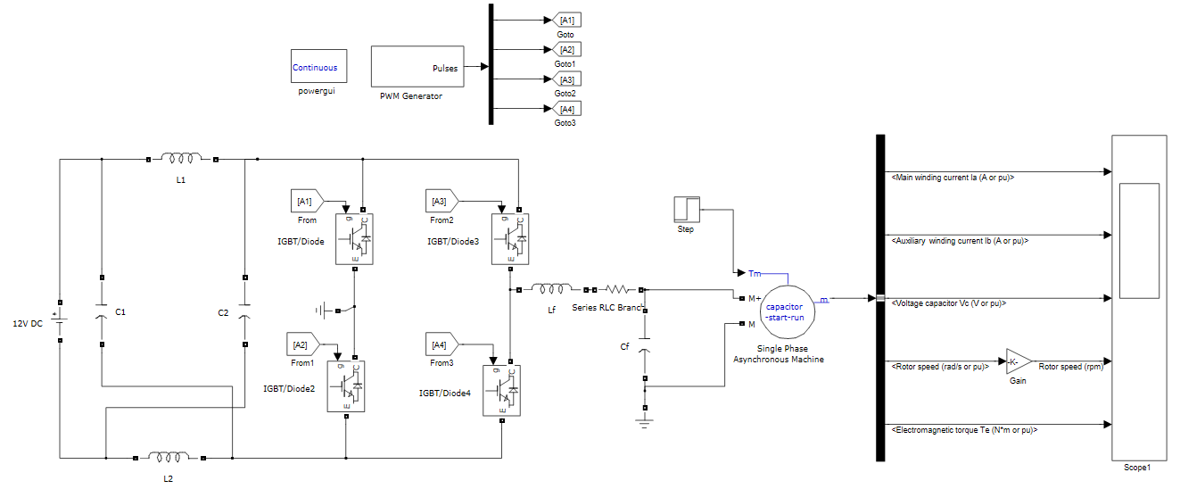
Fig.2 Simulation of impedance source inverter driven single phase induction motor.

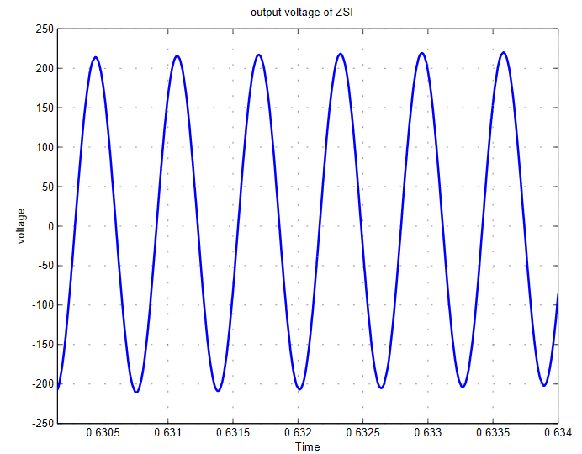

Fig.3 Output voltage of ZSI

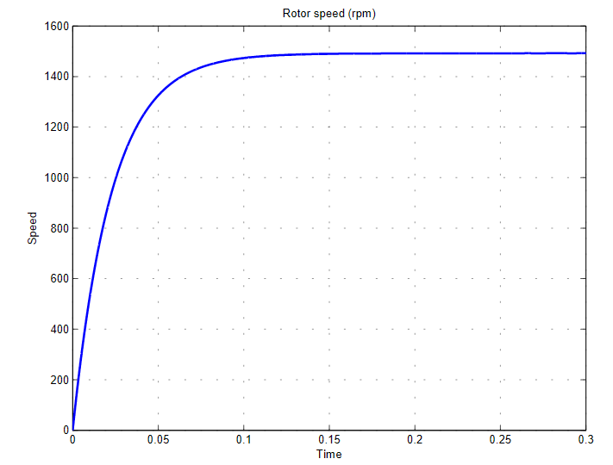 Fig.4 Rotor speed.
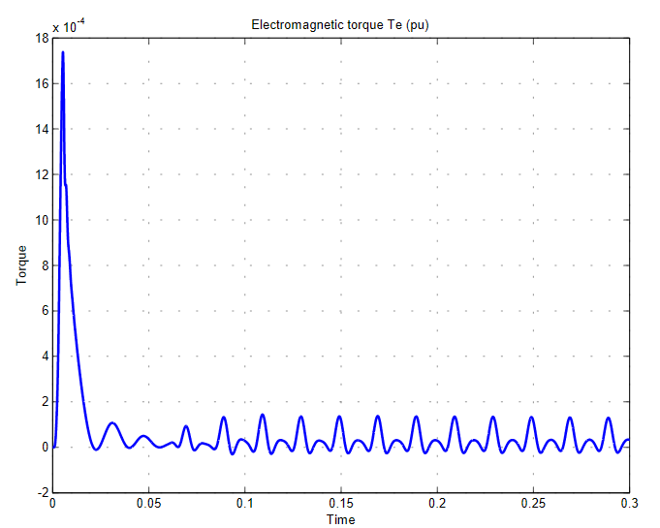
Fig.5 Electromagnetic torque.

V. CONCLUSION
The Z-source converter uses an impedance source network to replace the limitations of traditional voltage source and current source inverters while working with the light load. Z source inverter is used for buck and boost operation so that it increases the efficiency with low cost and less power loss. Recently Z Source inverter is in demand because of its attractive power conversion.

VI. REFERENCES
[1] Sattyendrasing A. Seragi,” Review on Z-Source Inverter”, International Journal of Computer Applications (0975 – 8887)
[2] Suresh L., G.R.S. Naga Kumar, M.V. Sudarsan & K.Rajesh,”Simulation of Z-Source Inverter Using Maximum Boost Control PWM Technique”,IJSS,Vol.7 No.2 July-December 2013, pp.49-59
[3] Penchalababu.V,Chandrakala. B,Gopal Krishna, ”A Survey on Modified PWM Techniques for Z-Source Inverter”, International Journal of Engineering and Advanced Technology,5 June 2012 Volume No.1
[4] J.B.Gupta, “Theory and performance of electrical machines”, S.K. Kataria and Sons, publisher of engineering and computer book.

