Design of Five Level Inverter
Using PWM Technique
Divya Bawankule,Akanksha Kumbhare,Ashwini Chavhan.
Department Of Electrical Engineering
Priyadarshini J.L.College Of Engineering
Nagpur, Maharashtra, India.
\

Abstract – This paper proposes a cascaded H-Bridge Multilevel inverter. Multi-level Inverter has several advantages over conventional inverter such as lower total harmonic distortion (THD), low switching loss, good power quality, high output voltage. The main feature of multilevel inverter is that it uses many small dc sources to supply various output levels. The H-bridge cascaded multilevel inverter is chosen in this paper is that it uses many small dc sources to supply various output level. The H-bridge cascaded multilevel inverter with five levels is designed. The simple phase shifted carrier PWM technique is used to generate pulses for multilevel inverter. The performance of designed multilevel inverter is investigated extensively through MATLAB simulation. The promising and interesting results obtained are comprehensively presented.

Keywords: Cascaded H-bridge Inverter, Multilevel Inverters, Pulse Width Modulation (PWM).

Introduction
In recent times, multilevel inverters are gaining popularity and widely used for many drive applications. It is especially used for medium to high voltage and high current drive applications. There are many advantages of multilevel inverters as compared to conventional inverters. Main advantages are low total harmonics distortion (THD), low switching losses, good power quality and reduced electromagnetic interference. Main feature of multilevel inverter is that it reduces voltage stress on each component.
Demand for high-voltage, high power converters capable of producing high-quality waveforms while utilizing low voltage devices and reduced switching frequencies has led to the multilevel inverter development with regard to semiconductor power switch voltage limits.
Multilevel inverters include an array of power semiconductors and capacitor voltage sources, the output of which generate voltages with stepped waveforms. The commutation of the switches permits the addition of the capacitor voltages, which reach high voltage at the output, while the power semiconductors must withstand only reduced voltages.
The most attractive features of multilevel inverters are as follows:-
1) They can generate output voltages with extremely low distortion and lower dv/dt.
2) They draw input current with very low distortion.
3) They generate smaller common mode (CM) voltage, thus reducing the stress in the motor bearings. In addition, using sophisticated modulation methods, CM voltages can be eliminated.
4) They can operate with a lower switching frequency.
The multilevel inverter has been implemented in various applications ranging from medium to high-power levels, such as motor drives, power conditioning devices, also conventional or renewable energy generation and distribution. The different multilevel inverter structures are
cascaded H-bridge, diode clamped and flying capacitor multilevel inverter. Among the three topologies, the cascaded multilevel inverter has the potential to be the most reliable and achieve the best fault tolerance owing to its modularity, a feature that enables the inverter to continue operating at lower power levels after cell failure. Modularity also permits the cascaded multilevel inverter to be stacked easily for high power and high-voltage applications. The cascaded multilevel inverter typically comprises several identical single phase H-bridge cells cascaded in series at its output side. Multilevel inverters include an array of power electronic devices and voltage sources with shunt capacitances, the output of which are voltages generated in the form stepped waveforms.

Basic Structure
Its structure configured in six sections such as DC supply, five level, gate driver, opto coupler, gate signal and induction motor.

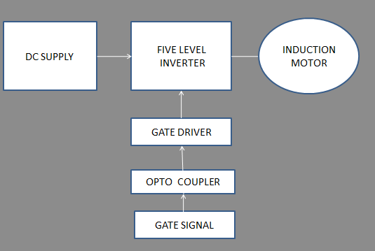

Fig.1.Basic block diagram
AC input is rectified using a diode rectifier. It is filtered using a capacitor filter. DC is applied to the multilevel inverter. The output of the inverter is fed to the Induction motor. This system will be simulated using Matlab Simulink. Input pulses to the IGBT are generated by the sources Voltages (V1 to V6). A Microcontroller based gating circuit generates the gating pulses required by the inverter. The pulses are generated using phase shifted carrier PWM technique.

Block Diagram And Its Working
Five level Inverter has been a very popular technique used in AC motor control. This is a method that employs a triangular carrier wave modulated by a sine wave and the points of intersection determine the switching points of the power devices in the inverter. Though this method is unable to make full use of the inverter’s supply voltage and the asymmetrical nature of the PWM switching characteristics produces relatively high harmonic distortion in the supply it is still popular for its simplicity. The circuit shall be made using a programmed microcontroller of 8051 family duly interfaced to 3 phase inverter with 6 no’s IGBT from DC derived from a single phase or 3 phase ,50 Hz supply. The load shall be a three phase 50Hz motor, 440volt, 0.5 to 1 HP motor. Alternatively a star lamp load can be used to view the waveform only. This project uses an 8051 family microcontroller duly interfaced to the opto-
isolators for feeding to the bridge drivers. 3 no’s of dual bridge drivers are used to feed 3 phase bridge inverter with the DC supply developed from single phase AC after rectification. Powering the circuit is achieved by a pair of control transformers with bridge rectifier and filter capacitors. One set of this power is used for the microcontroller and the other one is used for driving circuits of the three phase bridge.
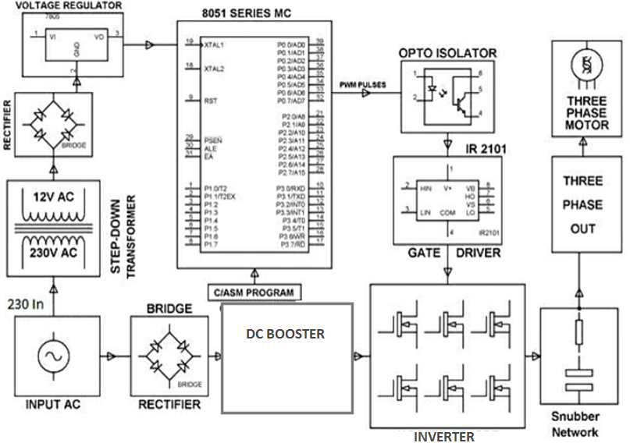
Fig.2 Block diagram of five level inverter fed induction motor

Proposed Technology
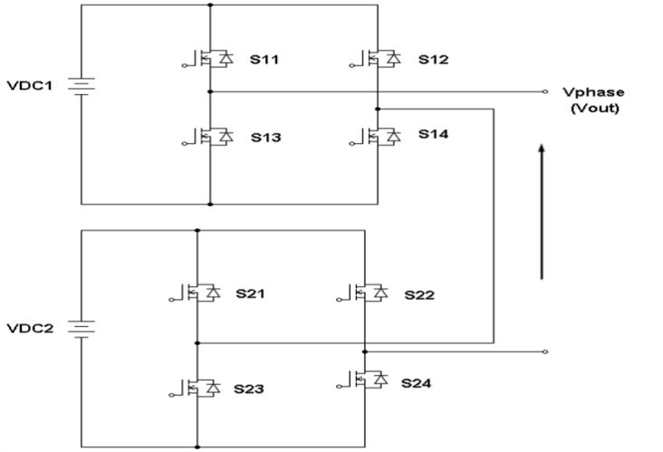

Fig.3. Single Phase Structure Of Cascaded Five-level inverter
The main circuit of a single-phase 5-level inverter is shown in the Fig. 3, includes a standard one leg inverter with a separate dc power source connected in series with a single H-bridge inverter. In this topology, one is main inverter and the another one is auxiliary inverter. Low switching losses occur during PWM mode, the main inverter will operate on square wave mode band the auxiliary inverter will operate on PWM mode. In modified PWM technique the reference wave is a combination of both sine and triangular wave and it is compared with a carrier triangular wave then the gate pulses are generated.

Simulation Circuit Of Cascaded H-Bridge 5-Level Inverter
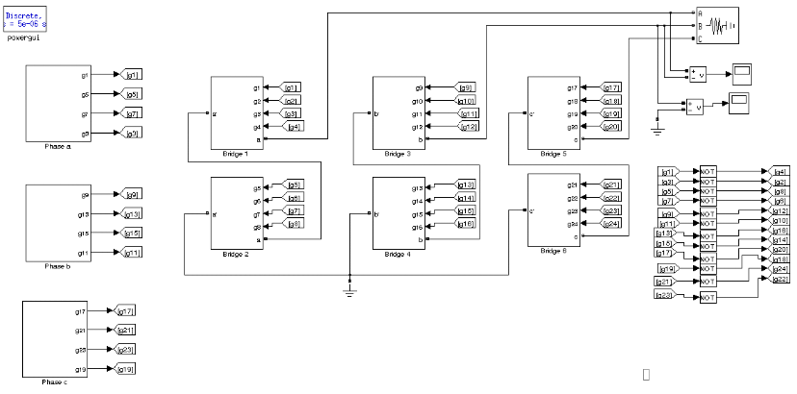
Fig.4. Three-phase cascaded H-bridge 5-level inverter
Fig. 4. illustrates the circuit configuration of a cascaded H-bridge 5-level inverter. The each phase has its own dc sources. A separate dc source is connected to each leg of an H-bridge inverter. The number of output-phase voltage levels is defined by m = 2N +1, where N is the number of DC sources. The number of switches used in this topology are Nswitch = 4s, where N is the number of dc sources.
The 5-level cascaded H-bridge MLI consists of two H-bridges in each phase. Therefore the output voltage of the inverter is a combination two. The five possible values are +Vdc, +Vdc/2, 0, −Vdc/2, −Vdc.

Output Voltage Level of Simulation
  - Phase Voltage
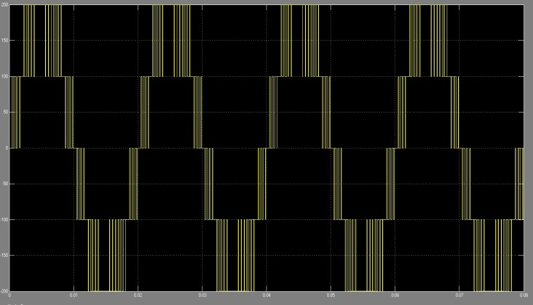
  - Line Voltage
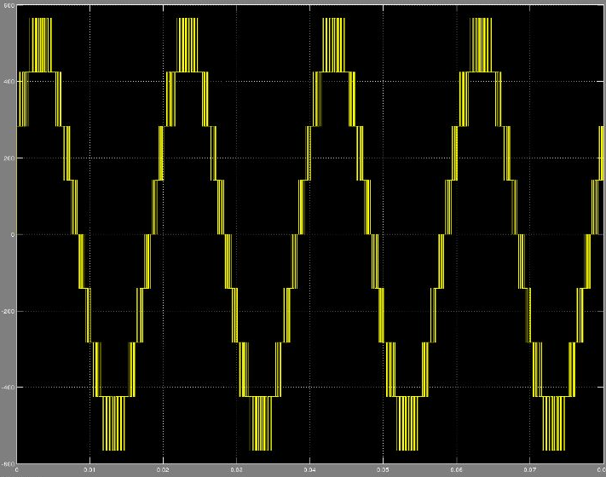

  - Three Phase Voltage
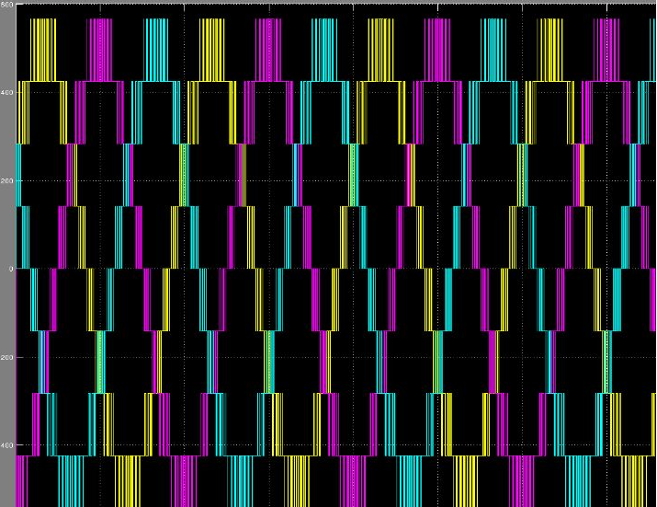

Modulation Topology
It is universally accepted that with improved switching strategies, harmonic contents of output voltages can be considerably reduced. Power electronics researchers have studied many novel control techniques to reduce harmonics in output waveform. Space vector and multicarrier PWM techniques are considered as high switching frequency modulation methods and active harmonic elimination, selective harmonic elimination and fundamental frequency methods are considered as low switching frequency methods. In the present work, multicarrier PWM scheme is used.
In a multicarrier PWM scheme, carrier signals depending upon number of levels are compared with the reference signal and pulses obtained are given to switches corresponding to different levels. The reference signal or the modulating signal is a sinusoidal waveform and all the carrier signals are triangular. At every instant, each carrier is compared with the modulating signal. For all the carrier signals above the zero reference, each comparison gives „1‟ if the modulating signal is greater than the carrier and „0‟ otherwise. For all the carrier signals below the zero reference, each comparison gives „0‟ if the modulating signal is greater than the carrier and „-1‟ otherwise. Above results obtained are added and it is observed that it acquires same wave shape as that of expected output voltage. Figure 6a Shows Simulink model of multicarrier PWM generation for a five level inverter. In this four triangular carriers are compared with a reference sinusoidal waveform. Figure 6b shows switching pattern produced using carrier based PWM scheme for a Five Level Inverter
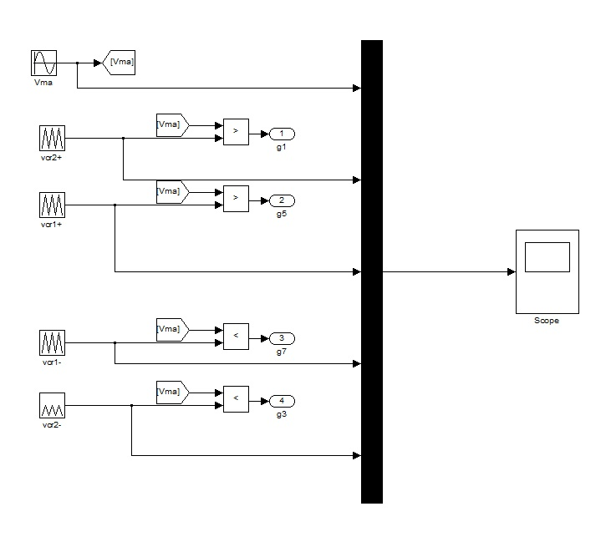
Fig.6a. Simulink model of multicarrier PWM generation for a five level inverter.

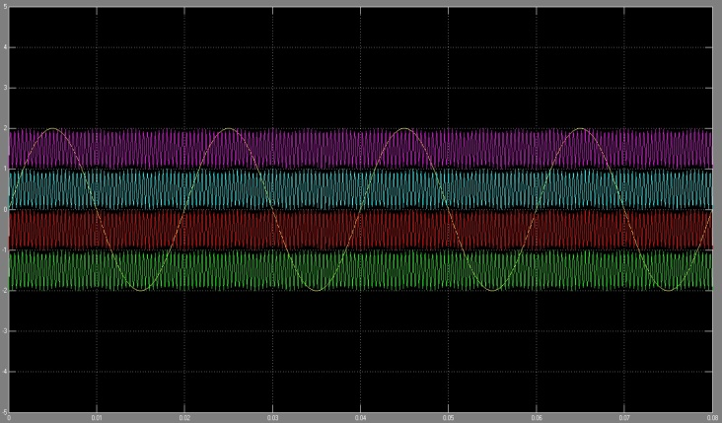
Fig.6b. Switching pattern produced using carrier based PWM scheme for a five level inverter

Conclusion
The Three Phase Five level Cascaded inverter is simulated using multicarrier PWM technique. The results are observed that the total harmonic distortion in the output voltage of multilevel inverter using multicarrier PWM is less .This can be extended to higher levels so that harmonics are reduced further.

References
- Hybrid 5-level inverter fed induction motor drive Dr. P.V.V. Rama Rao_, P. Devi Kiran, A. Phani Kumar Department of Electrical and Electronics Engineering, Shri Vishnu Engineering College for Women Bhimavaram Andhra Pradesh, India (Received August 21 2012, Accepted June 13 2014)
- THD Reduction in Performance of Cascaded Multi-Level Inverter Fed Induction Motor Drive Naveen Kumar Verma, Preeti Gupta, Amit ShrivastavaInternational Journal of Research in Engineering and Technology.
- Speed Control of 3 phase of Induction Motor by Using Multilevel Inverter A.R.Shelar, S.M.Chaudhari International Journal of Innovative Research in Advanced Engineering (IJIRAE) ISSN: 2349-2163 Volume 1 Issue 12 (December 2014).

4.Multilevel Inverter fed Induction Motor drives
S Krishnapriya, Unnikrishnan L
International Journal of Research in Engineering and Technology

