Speed control of DC motor using PWM technique
Ayushi Dubey PJLCOE, Nagpur Ayushey.dubey3601@gmail.com
Pooja Patil PJLCOE Nagpur Patilpooja1000@gmail.com
Shrutika kurve PJLCOE Nagpur Shruti_kurve02@rediffmail.com
Prof.Jaya Agrawal PJLCOE Nagpur jayaagrawalyahoo.co.in

Abstract – The speed control of DC motor is very crucial in applications where precision and protection are of essence.This paper proposes the speed control of a separately excited dc motor varying armature voltage. The entire system has been modelled using MATLAB. The switching of the dc-dc converter Is controlled by PWM technique. The PWM technique is realized using the comparator technique. The speed of motor is directly proportional to the DC voltage applied across its terminals. PWM can be used to control the speed of the motor. As the input voltage to dc motor can controlled, ultimately the speed of the motor controlled.

Introduction
Variable voltage AC-DC and DC-DC converters are widely used in industrial applications. The variable voltage AC to DC converters requires conversion of AC supply into DC supply. Phase angle controlled converters using thyristors are widely used for this purpose with both single phase and three phase AC supply system. These converters however suffer from the drawback of poor input power factor and discontinuous conduction mode operation, resulting into torque oscillations of DC motors especially at lower voltage range and discontinuous load current leading to voltage rise in case of power supplies.
However, the high-frequency switching convertors offer number of advantages over phase angle controlled voltage converters for DC-DC and AC-DC converters. Because of higher frequency output voltage and current ripple, output current is less. A reduction in output current ripple reduces the machine losses. A simple, medium switching frequency, pulse width modulated (PWM) Converter has been studied in this project. The high frequency active switches like power MOSFETS and Insulated Gate Bipolar Transistors (IGBTs) are nowadays used as they are available with sufficiently higher voltage and current ratings.

PROPOSED SYSTEM
The block diagram of the proposed system is shown in fig.1 below
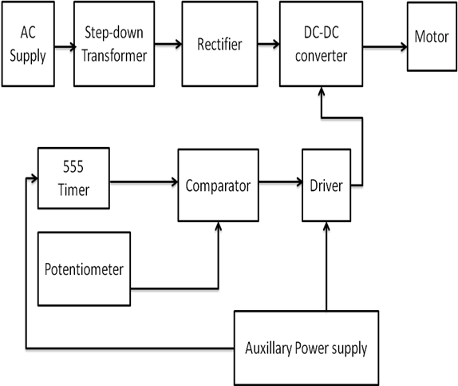
Fig1: Block diagram of proposed system

Rectifier
A rectifier is an electronic circuit that converts AC voltage to DC voltage. It can be implemented using a capacitor diode combination. The unique property of diodes, permitting the current to flow in a single direction is utilized in here. full wave rectifier circuit using the combination of four diodes to form a bridge. It has the advantage that it converts both the half cycles of AC input into DC output.
Full wave rectifier rectifies the full cycle in the waveform i.e. it rectifies both the positive and negative cycles in the waveform. This Full wave rectifier has an advantage over the half wave i.e. it has average output higher than that of half wave rectifier. The number of AC components in the output is less than that of the input.

Where: V_{MAX} is the maximum peak value in one half of the secondary winding and V_{RMS} is the rms value.

Fig2: Circuit diagram of rectifier

During the positive half cycle of secondary voltage, diodes D2 and D3 are forward biased and diodes D1 and D4 are reverse biased. Now the current flows through D2–>Load–>D3.
During the negative half cycle of the secondary voltage, diodes D1 and D4 are forward biased and rectifier diodes D2 and D3 are reverse biased. Now the current flows through D4–>Load–>D1
In both the cycles, load current flows in the same direction. Hence we get a pulsating DC voltage.
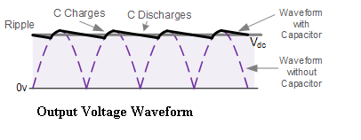Fig3:Output voltage waveform of Rectifier

IV.DC-DC CONVERSION USING PWM CONVERTER
Nowadays, high power solid-state devices are available to make the solid state DC power converters practically viable and cost-effective for DC drives powered from DC/AC source. These converters offer simplicity, reliability, greater efficiency, faster response, smooth operation, smaller size, and lower weight and cost.

Boost Converter
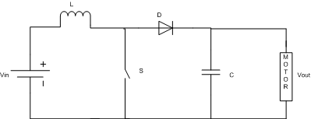

Fig4: Circuit diagram of boost converter

The boost converter produces an output which is greater than the source. In this, when switch is closed, energy is transferred to the inductor. And when switch is opened, it forward biases the diode and both source voltage and inductor voltage are added up and applied across the load. Thus voltage boost occurs across the load.
The capacitor used in the circuit must be kept large enough so as to keep the output voltage approximately constant.

Modes of operation of boost Converter:
This involves following modes of operation :
When Switch is closed, energy is transferred to the inductor.

Fig5: Circuit diagram when S=ON
When switch opens, it forward biases diode and hence both source and inductor transfers energy to the load.

Fig.6: Circuit diagram when S=OFF

In this way, Voltage boost occurs across the load.
The following waveform as shown in the fig7:
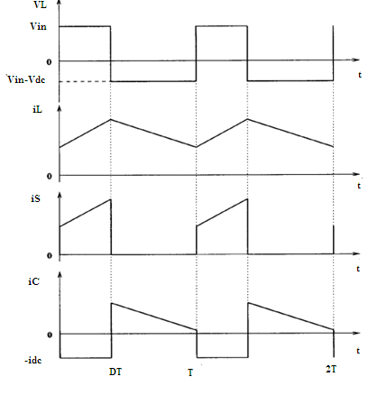
Fig7: Operating waveforms of DC-DC Convertor

V. Separately excited dc motor
Fig8: Circuit diagram of separately excited DC motor

Separately excited dc motor has field and armature winding with separate supply voltage. Field winding supplies field flux to armature. When DC voltage is applied to motor, current is fed to the armature winding through brushes and commutator. Since rotor is placed in magnetic field and it is carrying current also. So motor will develops a back emf and a
torque to balance load torque at particular speed.

The armature equation is shown below:
Va =Eg+ IaRa+ La (dIa/dt)
The description for the notations used is given below: 1. Va is the armature voltage in volts. 2. Eg is the motor back emf in volts. 3. Ia is the armature current in amperes. 4. Ra is the armature resistance in ohms. 5. La is the armature inductance in Henry.
Now the torque equation will be given by:
Td = Jdω/dt +Bω+TL
Where: 1. TL is load torque in Nm. 2. Td is the torque developed in Nm.
J is moment of inertia in kg/m². 4. B is friction coefficient of the motor. 5. ω is angular velocity in rad/sec.
Assuming absence (negligible) of friction in rotor of motor, it will yield: B=0 Therefore, new torque equation will be given by:
Td = Jdω/dt + TL --------- (i)
Taking field flux as Φ and (Back EMF Constant) Kv as K.
Equation for back emf of motor will be:
Eg = K Φ ω --------- (ii) Also, Td = K Φ Ia --------- (iii)
From motor’s basic armature equation, after taking Laplace Transform on both sides, we will get:
Ia(S) = (Va – Eg)/(Ra + LaS)

VI.CONTROL SCHEME OF DC-DC CONVERTER
The average value of the output voltage can be controlled through the semiconductor switch periodically. The various control strategies for varying the duty cycle are as follows:

- Time Ratio Control (TRC)
As the name suggests, in this control scheme, time ratio control Ton/Toff (as duty ratio or duty cycle) is varied. This is realized in two different strategies called as constant frequency system and variable frequency system as detailed below:
a) Variable frequency fixed ON time and OFF time control:
In this scheme, the chopping frequency is varied and either ON time or OFF time is kept constant. This method of controlling the duty ratio cycle is called as frequency modulation scheme. This scheme has some disadvantages as compared to the PWM scheme. These are as under:
The chopping frequency has to be varied over a wide range for the control output voltage in the frequency modulation. Filter design for such a wide frequency variation is therefore quite difficult. For the control of duty ratio, frequency variation would be wide. As such there is a possibility of interference with signaling and telephone lines in frequency modulation scheme. The large OFF time in frequency is undesirable because it may take the load current fed to the motor discontinuous. It is seen from the above that the constant frequency or the PWM scheme is better than the variable frequency scheme. PWM technique has, however a limitation. In this technique, Ton cannot be reduced to zero for most of the commutation circuits used in chopper control of dc motor. This can however be increased by increasing the chopping period of the chopper used.
b) Constant frequency system
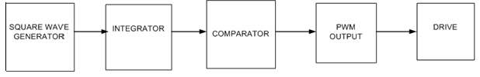
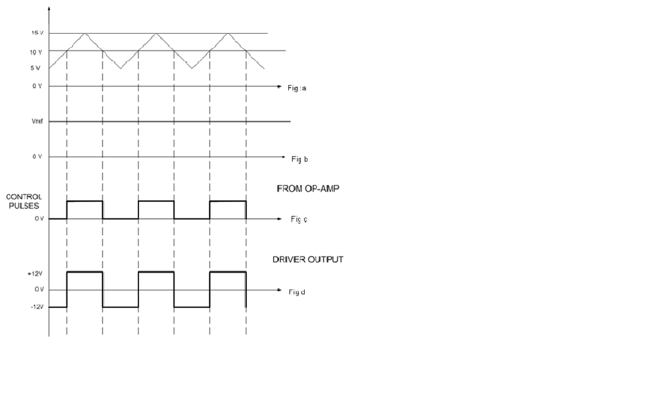
Fig 9.1 : Control Circuit Waveforms of PWM Converter
Fig 9.1a :Triangular carrier waveforms
Fig 9.1b:Reference Voltage
Fig 9.1c :PWM pulses generated from comparator
Fig 9.1d : Driver circuit output pulses

In this scheme, the on time is varied but the chopping frequency is kept constant. Variation of Ton means adjustment of pulse width; as such this scheme is also called as pulse width modulation scheme. By varying the ON time, the output
voltage supplied to the motor can be controlled through a power MOSFET switch. The same voltage control can be obtained by varying the OFF time instead of the ON time but still keeping the frequency constant. Variation in ON time keeping the frequency constant is automatically changes the OFF time and vice versa.

- Current Limit Control

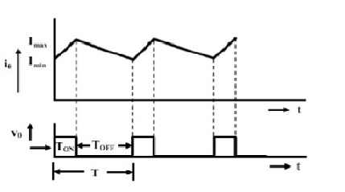
Fig10: Waveform of chopper
In this scheme, the load current is allowed to vary only between a predetermined maximum and minimum limit. If the load current tends to increase beyond maximum limit, thyristor is turned off and if the load current tends to fall below the minimum (lower) limit, the thyristor is turned on .
Since the chopper operates between I_{max} and I_{min} is not equals to zero, the current is continuous . The switching frequency is determined by the difference between I_{min} and I_{max .} If the difference is large, the switching frequency will be less, however the ripples in the output current will be more. If the difference is small, the switching frequency will be more resulting higher switching losses, however ,ripples in the output current will be less.

VII. Simulation in Matlab
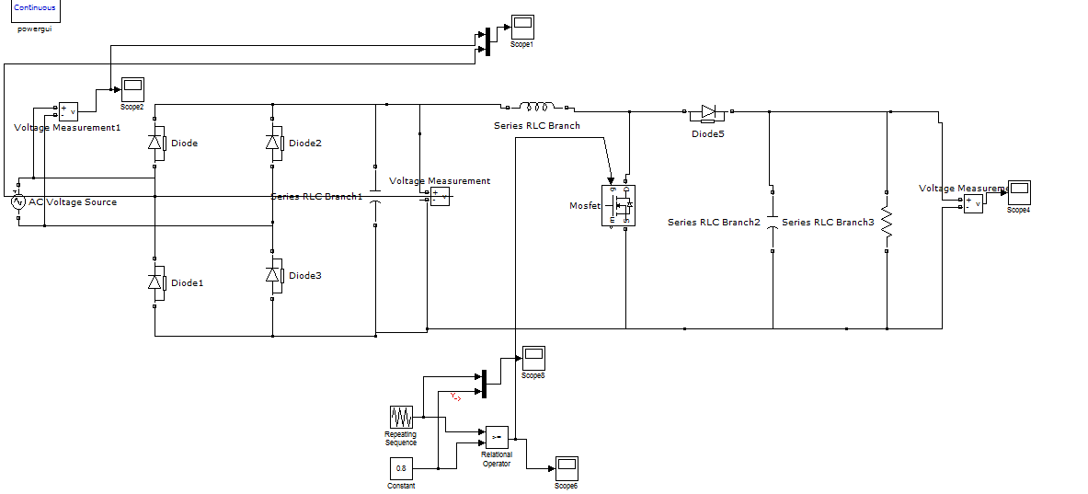
Fig11: simulation of complete system

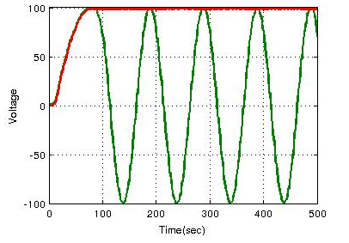
Fig12: Input and output waveform of rectifier

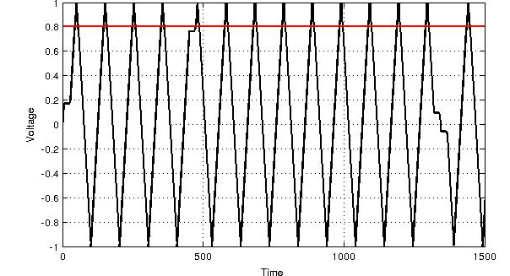
Fig13: Tiangular waveform for duty cycle=0.8
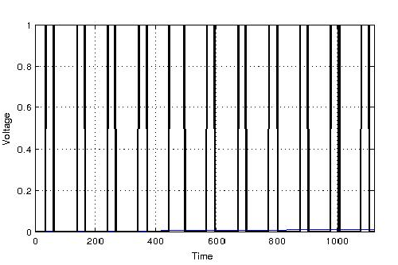
Fig14: pulse wave for duty cycle=0.8
VIII. CONCLUSION:
The method adopted in this paper is low cost technique of controlling the speed of the DC motor. Speed controller system based on PWM technique has been successfully developed using MATLAB to control the speed of a separately excited dc motor. The method implemented can be used for various industrial applications.

REFERENCES

[1] Moleykutty George,” Speed Control of Separately Excited DC Motor,” American Journal of Applied Sciences 5 (3): 227-233, 2008.
[2] Saffet Ayasun, Gu¨ Ltekin Karbeyaz Department of Electrical and Electronics Engineering, Nigde University, Nigde 51100, Turkey 12 March 2007 Wiley Periodicals Inc.
[3] Electrical machine by Dr.P S Bimbhra by Khanna publishers New Edition
[4] Automatic control system by S Hasan saeed, published by S K Kataria vol vi
[5] Control system engineering, by Nagrath & Gopal, published by New Age International publishers Fifth Edition
[6] Gopal K. Dubey, “Fundamentals of Electric Drives”,.Narosa Publishing House New Delhi,1989.
[7] S. M. Bashi, I. Aris and S.H. Hamad “Development of Single Phase Induction Motor Adjustable Speed Control Using M68HC11E-9 Microcontroller,” Journal of Applied Sciences 5 (2), pp. 249-252 .
[8] Kumara MKSC, Dayananda PRD, Gunatillaka MDPR,Jayawickrama SS, “PC based speed controlling of a dc motor”, A fmal year report University of Moratuwa Illiniaus USA, 2001102
[9] J Nicolai and T Castagnet , “A Flexible Microcontroller Based Chopper Driving a Permanent Magnet DC Motor”, The European Power Electronics Application. 1993.
[10] J. Chiasson, Nonlinear Differential-Geometric Techniquesfor Control of a Series DC Motor, IEEE Transactionson Control Systems Technology.vol 2, pp.35-42,1994.
[11] Yodyium Tipsuwan and Mo-Yuen Chow “FuzzyLogic microcontroller implementation for DC motor speed control”, IEEE Transactions on Power Electronics, V0l.11, No.3, June 1999, pp 1271-1276.

