Speed control of DC motor using PWM technique
Ayushi Dubey PJLCOE, Nagpur Ayushey.dubey3601@gmail.com
Pooja Patil PJLCOE Nagpur Patilpooja1000@gmail.com
Shrutika kurve PJLCOE Nagpur Shruti_kurve02@rediffmail.com
Prof.Jaya Agrawal PJLCOE Nagpur jayaagrawalyahoo.co.in

Abstract – This paper deal with various method of speed control of DC Motor and literature review on speed control of DC motor is presented. DC motors are widely used in industry applications,robotics and domestic appliances because of its low cost and lesscomplex control structure and wide range of speed and torque. So wide range of position control is required. The performance of the proposed system has been compared with the traditional one using conventional controllers. The entire system has been modeled using MATLAB 7.0 toolbox. It has been found that both PI and hysteresis current controllers could be eliminated by the use of controller.

I. Introduction
An electrical drive consists of electric motors, its power controller and energy transmitting shaft. In modern electric drive system power electronic converters are used as power controller. Electric drives are mainly of two types: DC drives and AC drives. The two types differ from each other in that the power supply in DC drives is provided by DC motor and power supply in AC drives is provided by AC motor. DC drives are widely used in applications requiring adjustable speed control, frequent starting, good speed regulation, braking and reversing. Some important applications are paper mills, rolling mills, mine winders, hoists , printing presses, machine tools, traction, textile mills, excavators and cranes. Fractional horsepower DC motors are widely used as servomotors for tracking and positioning. For industrial applications development of high performance motor drives are very essential. DC drives are less costly and less complex than AC and DC motors are used extensively in adjustable speed drives and position control system. The speed of DC motors can be adjusted above or below rated speed. Their speed above rated speed are controlled by field flux control and speed below rated speed is controlled by armature voltage. DC motors are widely used in industry because of its low cost, less complex control structure and wide range of speed and torque. There are various methods of speed control of DC drives – armature voltage control, field flux control and armature resistance control.

II. PRAPOSED SYSTEM

The block diagram of proposed system as shown fig below:
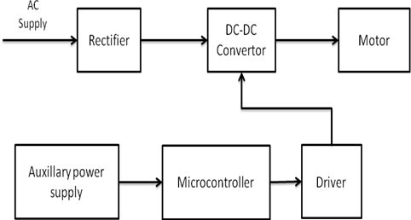

Fig1: Block Diagram

III. Rectifier
A rectifier is an electronic circuit that converts AC voltage to DC voltage. It can be implemented using a capacitor diode combination. The unique property of diodes, permitting the current to flow in a single direction is utilized in here. full wave rectifier circuit using the combination of four diodes to form a bridge. It has the advantage that it converts both the half cycles of AC input into DC output. Full wave rectifier rectifies the full cycle in the waveform i.e. it rectifies both the positive and negative cycles in the waveform. This Full wave rectifier has an advantage over the half wave i.e. it has average output higher than that of half wave rectifier. The number of AC components in the output is less than that of the input.
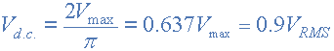
Where: V_{MAX} is the maximum peak value in one half of the secondary winding and V_{RMS} is the rms value.

Fig2: Circuit diagram of rectifier

During the positive half cycle of secondary voltage, diodes D2 and D3 are forward biased and diodes D1 and D4 are reverse biased. Now the current flows through D2–>Load–>D3 During the negative half cycle of the secondary voltage, diodes D1 and D4 are forward biased and rectifier diodes D2 and D3 are reverse biased. Now the current flows through D4–>Load–>D1 In both the cycles, load current flows in the same direction. Hence we get a pulsating DC voltage.
Nowadays, high power solid-state devices are available to make the solid state DC power converters practically viable and cost-effective for DC drives powered from DC/AC source. These converters offer simplicity, reliability, greater efficiency, faster response, smooth operation, smaller size, and lower weight and cost.
Identify applicable sponsor/s here. If no sponsors, delete this text box (sponsors).

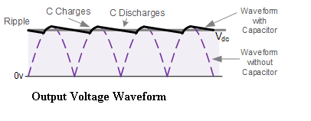
Fig3:Output voltage waveform

IV. BOOST CONVERTER
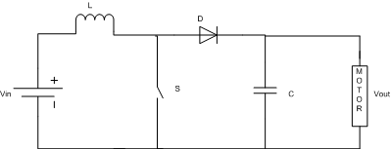

Fig4: Boost Converter

The boost converter produces an output which is greater than the source. In this, when switch is closed, energy is transferred to the inductor. And when switch is opened, it forward biases the diode and both source voltage and inductor voltage are added up and applied across the load. Thus voltage boost occurs across the load.
The capacitor used in the circuit must be kept large enough so as to keep the output voltage approximately constant.
Modes of operation of boost Converter:
This involves following modes of operation :
When Switch is closed, energy is transferred to the inductor.

Fig5: Switch is Close

When switch opens, it forward biases diode and hence both source and inductor transfers energy to the load.

Fig6: Switch is Open

In this way, Voltage boost occurs across the load.
The following waveform as shown in the fig:
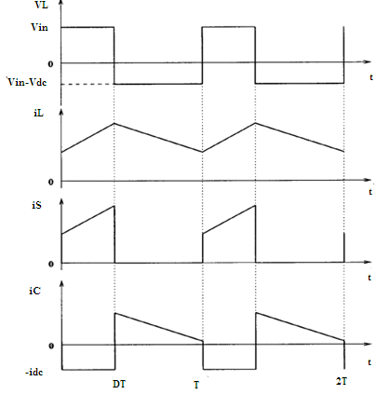
Fig7: Operating waveforms of DC-DC Convertor

V. Separately excited dc motor
Fig8: Separately excited DC motor

Separately excited dc motor has field and armature winding with separate supply voltage. Field winding supplies field flux to armature. When DC voltage is applied to motor, current is fed to the armature winding through brushes and commutator. Since rotor is placed in magnetic field and it is carrying current also. So motor will develops a back emf and a
torque to balance load torque at particular speed.
The armature equation is shown below:
Va =Eg+ IaRa+ La (dIa/dt)
The description for the notations used is given below: 1. Va is the armature voltage in volts. 2. Eg is the motor back emf in volts. 3. Ia is the armature current in amperes. 4. Ra is the armature resistance in ohms. 5. La is the armature inductance in Henry.
Now the torque equation will be given by:
Td = Jdω/dt +Bω+TL
Where: 1. TL is load torque in Nm. 2. Td is the torque developed in Nm.
J is moment of inertia in kg/m². 4. B is friction coefficient of the motor. 5. ω is angular velocity in rad/sec.
Assuming absence (negligible) of friction in rotor of motor, it will yield: B=0 Therefore, new torque equation will be given by:
Td = Jdω/dt + TL --------- (i)
Taking field flux as Φ and (Back EMF Constant) Kv as K.
Equation for back emf of motor will be:
Eg = K Φ ω --------- (ii) Also, Td = K Φ Ia ----(iii)
From motor’s basic armature equation, after taking Laplace Transform on both sides, we will get:
Ia(S) = (Va – Eg)/(Ra + LaS)

VI. MICROCONTROLLER
Microcontroller is an integrated chip that Is often part of an emmbeded system.The microcontroller includes a CPU,RAM,ROM,I/O PORTS,and timer like standard computer.
They are designed to execute only asingle specific task to control the single system,they are much smaller& simplified so they can include all the functions required in single chip.
A microcontroller can be considered a self-contained system with a processor, memory and peripherals and can be used as an embedded system.^{[13]} The majority of microcontrollers in use today are embedded in other machinery, such as automobiles, telephones, appliances, and peripherals for computer systems.
. 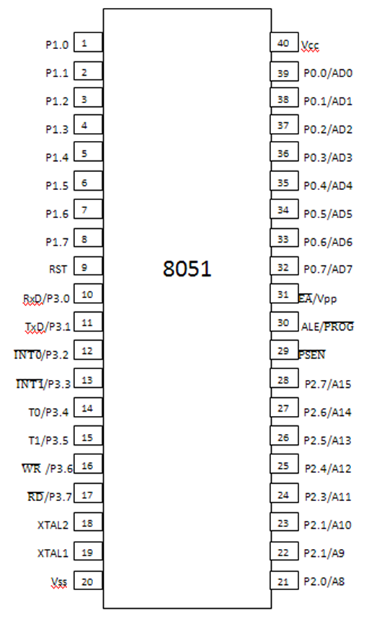
Fig9: pin Diagram of Microcontroller

VII. ADVANTAGES OF MICROCONTROLLER

Microcontrollers are widely used in today’s control systems for the following reasons:
Design and Simulation – Because you are programming with software, detailed simulations may be performed in advance to assure correctness of code and system performance. Flexibility – Ability to reprogram using Flash, EEPROM or EPROM allows straightforward changes in the control law used
High Integration – Most microcontrollers are essentially single chip computers with on-chip procession, memory, and I/O. Some contain peripherals for serial communication and reading analog signals (with an analog-to-digital converter ADC). This differentiates a microcontroller from a microprocer. require that this functionality be provided by added components.
Cost – Cost savings come from several locations. Development costs are greatly decreased because of the design/flexibility advantages mentioned previously. Because so many components are included on one IC, board area and component savings are often evident as well.
Easy to Use – Just program and go! While in the past, programming has often involved tedious assembly code, today C compilers are available for most microcontrollers. Microcontrollers often only require a single 5V supply as well which makes them easier to power and use.

VIII. RESULT
Rectifier:
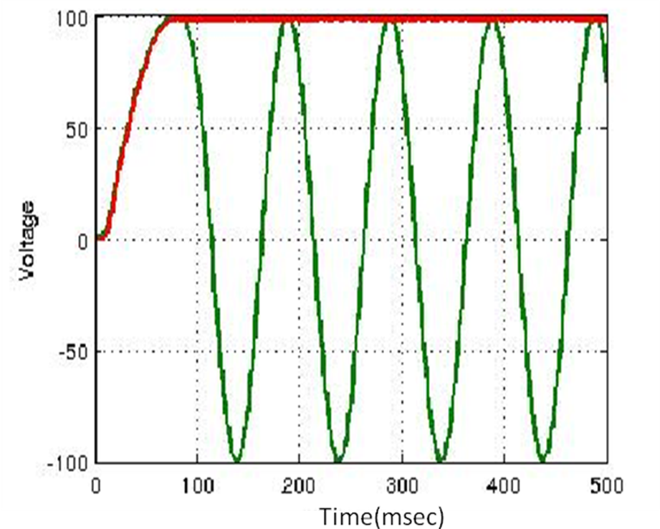
Fig10: Input and output waveform of rectifie
Pulse Wave:
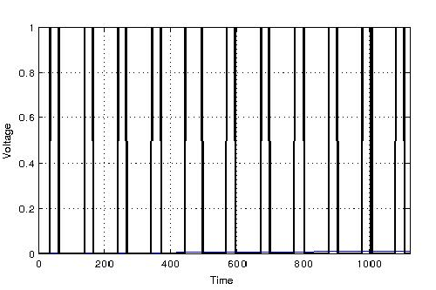
Fig11: pulse wave for duty cycle=0.8
IX. CONCLUSION
Speed controller system based on controller has been successfully developed using MATLAB to control the speed of a separately excited dc motor. The novelty of this paper lies in the application of controller to control of a separately excited dc motor. This paper also discusses modeling and control of SEDM using SimPowerSystems and simulink models. The performance of the system has been compared using different types of controllers. It has been found that controller is able to regulate the speed well above the rated value.

References
- Moleykutty George,” Speed Control of Separately Excited DC Motor,” American Journal of Applied Sciences 5 (3): 227-233, 2008.
- Saffet Ayasun, Gu¨ Ltekin Karbeyaz Department of Electrical and Electronics Engineering, Nigde University, Nigde 51100, Turkey 12 March 2007 Wiley Periodicals Inc.
- Electrical machine by Dr.P S Bimbhra by Khanna publishers New Edition .
- Automatic control system by S Hasan saeed, published by S K Kataria vol vi.
- Control system engineering, by Nagrath & Gopal, published by New Age International publishers Fifth Edition.
- Gopal K. Dubey, “Fundamentals of Electric Drives”,.Narosa Publishing House New Delhi,1989.
- S. M. Bashi, I. Aris and S.H. Hamad “Development of Single Phase Induction Motor Adjustable Speed Control Using M68HC11E-9 Microcontroller,” Journal of Applied Sciences 5 (2), pp. 249-252 .
- Kumara MKSC, Dayananda PRD, Gunatillaka MDPR,Jayawickrama SS, “PC based speed controlling of a dc motor”, A fmal year report University of Moratuwa Illiniaus USA, 2001102.
- J Nicolai and T Castagnet , “A Flexible Microcontroller Based Chopper Driving a Permanent Magnet DC Motor”, The European Power Electronics Application. 1993.
- J. Chiasson, Nonlinear Differential-Geometric Techniquesfor Control of a Series DC Motor, IEEE Transactionson Control Systems Technology.vol 2, pp.35-42,1994.
- Yodyium Tipsuwan and Mo-Yuen Chow “FuzzyLogic microcontroller implementation for DC motor speed control”, IEEE Transactions on Power Electronics, V0l.11, No.3, June 1999, pp 1271-1276.
- J Nicolai and T Castagnet , “A Flexible Microcontroller Based Chopper Driving a Permanent Magnet DC Motor”, The European Power Electronics Application. 1993.
- J. Chiasson, Nonlinear Differential-Geometric Techniquesfor Control of a Series DC Motor, IEEE Transactionson Control Systems Technology.vol 2, pp.35-42,1994.
- Yodyium Tipsuwan and Mo-Yuen Chow “FuzzyLogic microcontroller implementation for DC motor speed control”, IEEE Transactions on Power Electronics, V0l.11, No.3, June 1999, pp 1271-1276.

