Study of Micro-Hydro Power Project

Namrita Singh KDKCOE, Nagpur namrita25singh@gmail.com
Ranjan Kumar KDKCOE, Nagpur ranjangajmer10@gmail.com
Prof. C. J. Sharma KDKCOE, Nagpur Chandar.sharma75@gmail.com

Abstract – The main aim is to study micro-hydro project to serve the electricity to the village and community. This plant is the improvement of big hydro power plant. It has less operation and maintenance so such power plant is need to supply the power to the remote village for the development of nation power.
Keywords— Spillways, forebay tank, penstock

Introduction
Hydropower is a renewable, non-polluting and environmentally benign source of energy. Hydropower is based on simple concepts. Moving water turns a turbine, the turbine spins a generator, and electricity is produced. Many other components may be in a system, but it all begins with the energy in the moving water. The use of water falling through a height has been utilized as a source of energy since a long time. It is perhaps the oldest renewable energy technique known to the mankind for mechanical energy conversion as well as electricity generation.
Small hydro is the largest contributor of electricity from renewable energy sources, both at European and world level. With the advancement of technology, and increasing requirement of electricity, the thrust of electricity generation was shifted to large size hydro and thermal power stations. Small hydro projects are economically viable and have relatively short gestation period. The major constraints associated with large hydro projects are usually not encountered in small hydro projects. Renewed interest in the technology of small scale hydropower actually started in China which has more than 85,000 small-scale, electricity producing, hydropower plants.
Hydropower will continue to play important role throughout the 21st Century, in world electricity supply. Hydropower development does have some challenges besides the technical, economic and environmental advantages it shares above other power generation (fossil fuel based) technologies. At the beginning of the new Millennium hydropower provided almost 20% (2600 TWh/year) of the electricity world consumption (12900 TWh/year). It plays a major role in several countries. According to a study of hydropower resources in 175 countries, more than 150 have hydropower resources. For 65 of them, hydro produces more than 50% of electricity; for 24, more than 90% and 10 countries have almost all their electricity requirements met through hydropower.

CLASSIFICATION
- Large- hydro More than 100 MW and usually feeding into a large electricity grid
- Medium-hydro 15 – 100 MW - usually feeding a grid
- Small-hydro 1 - 15 MW - usually feeding into a grid
- Mini-hydro Above 100 kW, but below 1 MW; either standalone schemes
- Micro-hydro From 5kW up to 100 kW; usually provided power for a small community or rural industry in remote areas away from the grid
- Pico-hydro From a few hundred watts up to 5kW

PRINCIPLES OF MHP
Power generation from water depends upon a combination of head and flow. Both must be available to produce electricity. Water is diverted from a stream into a pipeline, where it is directed downhill and through the turbine (flow). The vertical drop (head) creates pressure at the bottom end of the pipeline. The pressurized water emerging from the end of the pipe creates the force that drives the turbine. The turbine in turn drives the generator where electrical power is produced. More flow or more head produces more electricity. 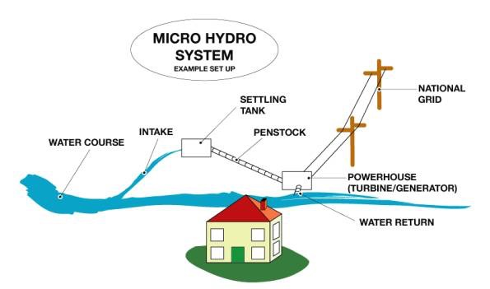 Fig. a
Water pressure or Head is created by the difference in elevation between the water intake and the turbine. Head can be expressed as vertical distance (feet or meters), or as pressure, such as pounds per square inch (psi). Net head is the pressure available at the turbine when water is flowing, which will always be less than the pressure when the water flow is turned off (static head), due to the friction between the water and the pipe. Pipeline diameter also has an effect on net head. Flow is quantity of water available, and is expressed as ‘volume per unit of time’, such as gallons per minute (gpm), cubic meters per second (m3/s), or liters per minute (lpm). Design flow is the maximum flow for which the hydro system is designed. It will likely be less than the maximum flow of the stream (especially during the rainy season), more than the minimum flow, and a compromise between potential electrical output and system cost.

CONSTRUCTION DETAILS:
A. Weir And Intake: A micro hydropower system necessitates that water from the river to be diverted and extracted in a reliable and controllable manner. The water flowing in the channel must be regulated during high river flow and low flow conditions. A weir can be used to raise the water level and ensure a constant supply to the intake. Sometimes it is possible to avoid building a weir by using natural features of the river. A permanent pool in river could also act as a weir.

B. Power Channels:
The power channel or simply a channel conducts the water from the intake to the forebay tank. The length of a channel depends upon the topography of the region and the distance of powerhouse from the intake. Also the designing of the MHP systems states the length of the channel – sometimes a long channel combined with a short penstock can be cheaper or required, while in other cases a combination of short channel with long penstock would be more suitable. In the Himalayan region, the MHP channels are sometimes as long as a few kilometres to create a head of 10 to 60 metres or more.

C. Settling Basin:
The water diverted from the stream and carried by the channel usually carries a suspension of small particles such as sand that are hard and abrasive and can cause expensive damage and rapid wear to turbine runners. To get rid of such particles and sediments, the water flow is allowed to slow down in ‘settling basins’ so that the sand and silt particles settle on the basin floor. The deposits are then periodically flushed.

D. Spillways:
Spillways along the power channel are designed to permit overflow at certain points along the channel. The spillway acts as a flow regulator for the channel. During floods the water flow through the intake can be twice the normal channel flow, so the spillway must be large enough to divert this excess flow. The spillway can also be designed with control gates to empty the channel. The spillway should be designed in such a manner that the excess flow is fed back to the without damaging the foundations of the channel.

E. Forebay Tank:
The forebay tank serves the purpose of providing steady and continuous flow into the turbine through the penstocks. Forebay also acts as the last settling basin and allows the last particles to settle down before the water enters the penstock. Forebay can also be a reservoir to store water – depending on its size (large dams or reservoirs in large hydropower schemes are technically forebay).
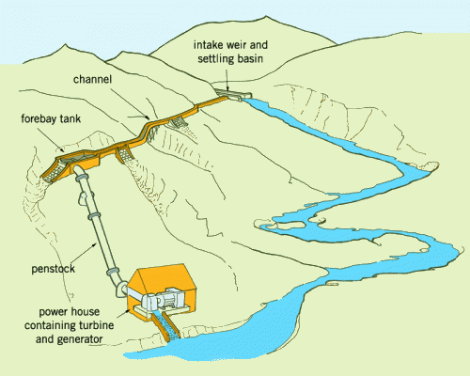
Fig. b

E. Penstock:
The penstock is the pipe which conveys water under pressure from the forebay tank to the turbine. Penstock is a significant component of the MHP scheme and needs to be designed and selected carefully as it represents a major expense in the total budget (for some high head installations this alone could cost as much as 30% of the total costs).
Here the main aspects to consider are head loss and capital cost. Head loss due to friction in the pipe decreases dramatically with increasing pipe diameter. Conversely, pipe costs increase steeply with diameter. Therefore a compromise between cost and performance is considered for design and selection of pipe diameter and material.

F. Power From Mhp
The power potential of water in a stream it is necessary to know the flow quantity of water available from the stream (for power generation) and the available head. The quantity of water available for power generation is the amount of water (in m3 or litres) which can be diverted through an intake into the pipeline (penstock) in a certain amount of time. This is normally expressed in cubic meters per second (m3/s) or in litres per second (l/s). Head is the vertical difference in level (in meters) through which the water falls down.
The theoretical power (P) available from a given head of water is in exact proportion to the head and the quantity of water available.

P= Q × H × e × 9.81 Kilowatts (kW)

Where,
P = Power at the generator terminal, in kilowatts (kW)
H = The gross head from the pipeline intake to the tailwater in metres (m)
Q = Flow in pipeline, in cubic metres per second (m3/s)
e = The efficiency of the plant, considering head loss in the pipeline and the efficiency of the turbine and genera

Advantages
- Clean Energy Source:
Hydropower does not produce greenhouse gas emissions. Hydroelectricity does not involve a process of combustion, therefore it avoids polluting emissions like carbon dioxide.

- Efficient Energy Source:
It only takes a small amount of flow (as little as two gallons per minute) or a drop as low as two feet to generate electricity with micro hydro.

- Reliable Electricity Source:
Hydro produces a continuous supply of electrical energy in comparison to other small-scale renewable technologies.

- No Reservoir Required:
Microhydro is considered to function as a ‘run-of-river’ system, meaning that the water passing through the generator is directed back into the stream with relatively minimal or no impact on the surrounding ecology.

- Power For Developing Countries:
Because of the low-cost versatility and longevity of micro hydro, developing countries can manufacture and implement the technology to help supply much needed electricity to small communities and remote villages.

Disadvantages
- Site Specific Technology:
Factors to consider are distance from the power source to the location where energy is required stream size and a balance of system components — inverter, batteries, controller, transmission line and pipelines

- Energy Expansion Not Possible:
There is always a maximum useful power available from a given hydropower site, which limits the increase in power generation and the level of expansion of activities which can make use of the power.
- Seasonal Variations:
In many locations the flow in a stream fluctuates seasonally and this can limit the firm power output to quite a small fraction of the possible peak output.

- Environmental And Ecological Concerns:
MHP, like any energy-production activity, has impacts on the local ecosystem.

VII.EXAMPLE FROM A TYPICAL VILLAGE IN INDIA:
In a typical village of about 200 households in North India, the following loads and consumption patter is expected/assumed.

Lighting Load:
48 kW for 365 days @ 6 hours per day (assumption: 4 light points of 60 W each per household) Timing flexibility – none (i.e. all lights are needed at the same time in the evening) Splitting load – none (all households will need the light at the same time)Hence connected load 48 kW
Load to be considered for system sizing 48 kW

Fan Load
90 kW for 120 days @3 hours per day
Not to be considered for system sizing in first cut

Tv Load
37.5 kW for 365 days @ 3 hours per day
Timing flexibility – none (i.e. televisions will be on at specific time each day) Splitting load – none (i.e. everyone wants them on at the same time)
Hence connected load 37.5 kW
Load to be considered for system sizing 37.5 kW

Domestic Flour Mill Load
12 kW for 365 days @ 1 hour per day
Timing flexibility – yes (i.e. load can be on at selected time during day)
Splitting load – none (i.e. load cannot be broken into smaller loads at different times)
Not to be considered for system sizing in first cut
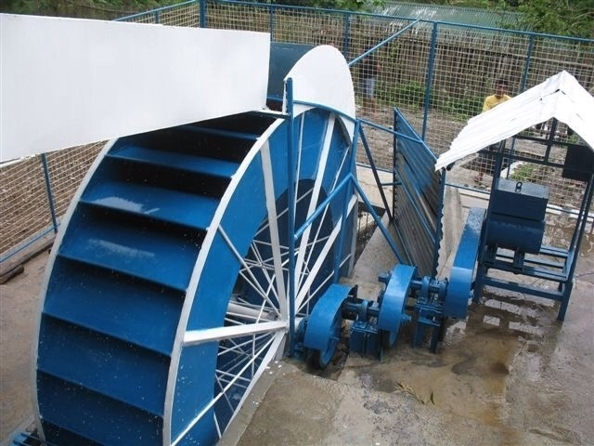
Fig. cIrrigation Pump-Sets

Electrical
84 kW for 150 days @ 6 hours/day
Timing flexibility - none (i.e. load must be on at certain times each day)
Splitting load – yes (i.e. since each pump has to run for only 6 hours, the pumps can be run in maximum four batches, thus reducing the connected load)
Currently Diesel, But Will Shift To Electric Once Available
164 kW for 150 days @ 6 hours/day
Timing flexibility – yes (i.e. pumps can be run at different time of day)
Splitting load – yes (i.e. since each pump has to run for only 6 hours, the pumps may be run in four batches, thus reducing the connected load)
Hence the total irrigation load is 164 + 84 = 260 kW
Since this can be split in four batches, Load to be considered for system sizing 260/4 =65 kW
Therefore total load to be considered
Lighting 48 kW
TV 37 kW
Irrigation pump-sets 65 kW

VIII. CONCLUSION
Environmental Impact:
The ecological impact of small-scale hydro is minimal; however the low-level environmental effects must be taken into consideration before construction begins. Stream water will be diverted away from a portion of the stream, and proper caution must be exercised to ensure there will be no damaging impact on the local ecology or civil infrastructure

Misconceptions About Hydro Power:
Small streams do not provide enough force to generate power: Energy output is dependent on two major factors: the stream flow (how much water runs through the system) and drop (or head), which is the vertical distance the water will fall through the water turbine. A large water reservoir is required: Most small-scale hydro systems require very little or no reservoir in order to power the turbines. These systems are commonly known as ‘run-of-river’, meaning the water will run straight through the generator and back into the stream. This has aminimal environmental impact on the local ecosystem.

REFERENCES

- G.D Rai,” Non-conventional Energy Source”, Kanna Publication
- B. R Gupta, ”Generation of Electrical Engineering”, S.Chand Publication
- B.H. Khan,”Non Conventional Energy”, 2nd , The McGraw Hill Companies
- http://www.smallhydro.com/view/library/documents/financing_report1.pdf?CFID=242301&CFTOKEN=45993942
- http://www.smallhydro.com/view/library/documents/economic_risk_report2.pdf?CFID=242301&CFTOKEN=45993942
- http://www.homepower.com/view/?file=HP125_pg56_Ostermeier
- http://smallhydro.com/
- http://www.intute.ac.uk/sciences/cgi-bin/search.pl?term1=small+hydro+power&limit=0
- http://www.microhydropower.com/Manuals.htm
http://www.small- hydro.com/index.cfm?fuseaction=welcome.home

