Comparative Study of Direct-On-Line, Star-Delta and Soft Starter by Using MATLAB SIMULINK

Swapnil Kourati, Nilesh Mude , Prof. A.M.Halmare
Department of Electrical Engineering, 8th sem, K. D. K College Of Engineering, Nagpur, India
Email:kouratiswapnil01@gmail.com

Abstract – This paper presents a comparison between the Direct-On-Line (D.O.L.), Star-Delta, and Soft Starter by using MATLAB Simulink . The purpose of this project is to find out the theoretical and actual characteristics of Induction motor. These three basic starting methods which differ in their respective wiring connection are the most applicable and widely-used starting method in the industrial area due to its economic reasons. This project is done by analyzing the characteristics during the motor starting by using the MATLAB Simulation to capture the waveforms of the events. After the Simulation, the three different starting method are being compared to conclude the most suitable and applicable starting method .

IndexTerms— D.O.L.,Star-Delta,Softstarter,MATLAB Software

- INTRODUCTION
Soft starter is a electric circuit which reduces the initial starting current of induction motor in ramp form. It consists of three pairs of back to back connected n- channel enhancement type mosfet in each phase. It is used to reduce the initial starting current of induction motor which is gradual in case of direct on line starting. Efficiency, power surges and pulsations during soft starting is reduced. Maintenance cost is also reduced as wear and tear of mechanical stress is less in soft starting. Soft-starters are generally employed in large capacity induction motors to limit the starting current and also to achieve smooth starting. Therefore, the starting process of the motor needs to be controlled thereby limiting its starting current.
The traditional reduced voltage starting methods, such as star-delta starting and impedance starting, result in stepped variation of voltage whereas a soft-start increases the voltage applied to the induction motor in a smooth manner. A 3-phase AC voltage controller is normally employed as a soft-start. However, the output of an AC voltage controller is rich in voltage and current harmonics which results in derating of the induction motor.

- DIRECT-ON-LINE STARTER (D.O.L) STARTING METHOD
This is by far the most common starting method available on the market. The starting equipment consists of only a main contactor and thermal or electronic overload relay. The disadvantage with this method is that it gives the highest possible starting current. A normal value is between 6 to 7 times the rated motor current but values of up to 9 or 10 times the rated current exist. Besides the starting current there also exists a current peak that can rise up to 14 times the rated current since the motor is not energised from the first moment when starting.
The values are dependent on the design and size of the motor, but in general, a smaller motor gives higher values than a larger one. During a direct-on-line start, the starting torque is also very high, and is higher than necessary for most applications. The torque is the same as the force, and an unnecessary high force gives unnecessary high stresses on couplings and the driven application. Naturally, there are cases where this starting method works perfectly and in some cases also the only starting method that works.

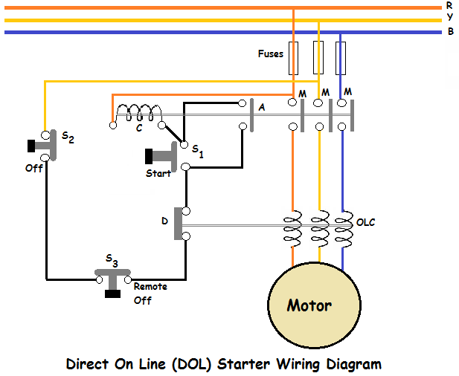
Fig 3.1 Single line diagram for a DOL starter

This is a starting method that reduces the starting current and starting torque. The device normally consists of three contactors, an overload relay and a timer for setting the time in the star-position (starting position). The motor must be delta connected during a normal run, in order to be able to use this starting method. The received starting current is about 30 % of the starting current during direct on line start and the starting torque is reduced to about 25 % of the torque available at a D.O.L start. This starting method only works when the application is light loaded during the start. If the motor is too heavily loaded, there will not be enough torque to accelerate the motor up to speed before switching over to the delta position. When starting up pumps and fans for example, the load torque is low at the beginning of the start and increases with the square of the speed. When reaching approx. 80-85 % of the motor rated speed the load torque is equal to the motor torque and the acceleration ceases. To reach the rated speed, a switch over to delta position is necessary, and this will very often result in high transmission and current peaks. In some cases the current peak can reach a value that is even bigger than for a D.O.L start. Applications with a load torque higher than 50 % of the motor rated torque will not be able to start using the start-delta starter

- STAR-DELTA STARTER STARTING METHOD
This is a starting method that reduces the starting current and starting torque. The components normally consist of three contactors, an overload relay and a timer for setting the time in the star-position (starting position). The motor must be delta connected during a normal run, in order to be able to use this starting method. The received starting current is about 30 % of the starting current during direct on line start and the starting torque is reduced to about 25 % of the torque available at a
D.O.L start. This starting method only works when the application is light loaded during the start. If the motor is too heavily loaded, there will not be enough torque to accelerate the motor up to speed before switching over to the delta position. When starting up, the load torque is low at the beginning of the start and increases with the square of the speed. When reaching approximately 80-85% of the motor rated speed the load torque is equal to the motor torque and the acceleration ceases. To reach the rated speed, a switch over to delta position is necessary, and this will very often result in high transmission and current peaks. In some cases the current peak can reach a value that is even bigger than for a D.O.L start. Applications with a load torque higher than 50% of the motor rated torque will not be able to start using the star-delta starter.
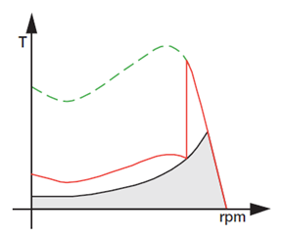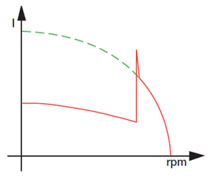
Fig. Characteristics During Starting

Soft Starter
The performance of a soft starter is crucially dependent on the performance of the motor it controls. Therefore, it is essential to understand motor characteristics in order to understand soft starter applications. Soft Starters have been providing precise controlled AC motor starting and stopping for decades.
A motor soft starter is a device used with AC electric motors to temporarily reduce the load and torque in the power train of the motor during startup. This reduces the mechanical stress on the motor and shaft, as well as the electrodynamic stresses on the attached power cables and electrical distribution network, extending the lifespan of the system. Motor soft starters can consist of mechanical or electrical devices, or a combination of both. Mechanical soft starters include clutches and several types of couplings using a fluid, magnetic forces, or steel shot to transmit torque, similar to other forms of torque limiter. Electrical soft starters can be any control system that reduces the torque by temporarily reducing the voltage or current input, or a device that temporarily alters how the motor is connected in the electric circuit.
Electrical soft starters can use solid state devices to control the current flow and therefore the voltage applied to the motor. They can be connected in series with the line voltage applied to the motor, or can be connected inside the delta (Δ) loop of a delta-connected motor, controlling the voltage applied to each winding. Solid state soft starters can control one ormore phases of the voltage applied to the induction motor with the best results achieved by three-phase control. Typically, the voltage is controlled by reverse-parallel connected silicon-controlled rectifiers (thyristors), but in some circumstances with three-phase control, the control elements can be a reverse-parallel-connected SCR and diode.
Modern semiconductor switches such as MOSFETs or Insulated-gate bipolar transistors (IGBTs) are well suited components for high efficiency controllers.Efficiency of 70 – 80 % can be achieved for AC motors.By using additional passive electronic filters, the pulse train can be smoothed and average analog waveform is obtained
. Simulink, an add-on product to MATLAB, provides an interactive, graphical environment for modeling, simulating, and analyzing of dynamic systems. It enables rapid construction of virtual prototypes to explore design concepts at any level of detail with minimal effort. For modeling, Simulink provides a graphical user interface (GUI) for building models as block diagrams. It includes a comprehensive library of pre-defined blocks to be used to construct graphical models of systems using drag-and-drop mouse operations. The user is able to produce an “up-and-running” model that would otherwise require hours to build in the laboratory environment. It supports linear and nonlinear systems, modeled in continuous-time, sampled time, or hybrid of the two. Since students learn efficiently with frequent feedback, the interactive nature of Simulink encourages you to try things out, you can change parameters “on the fly” and immediately see what happens, for “what if” exploration. Lastly, and not the least, Simulink is integrated with MATLAB and data can be easily shared between the programs.

- MATLAB SIMULINK RESULT
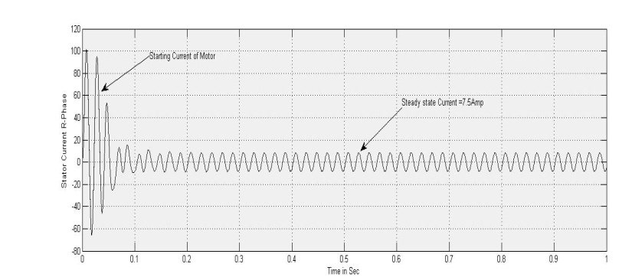
Fig. Stator Current
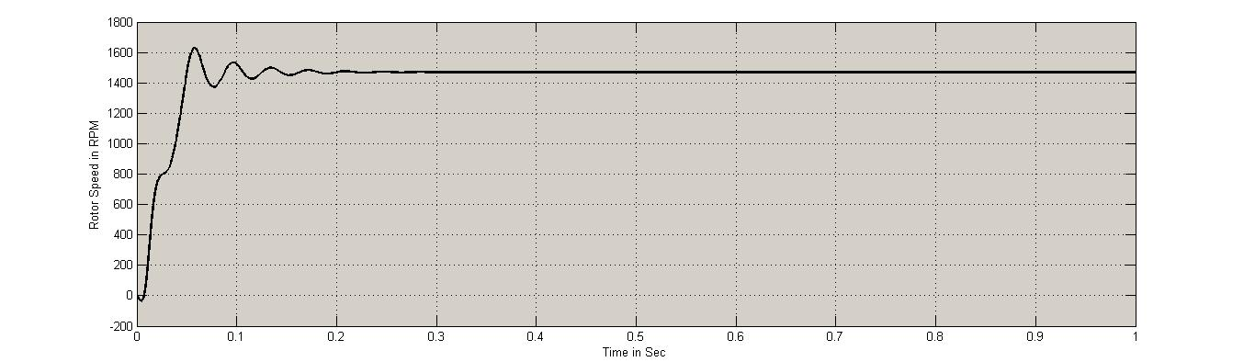 Fig. Rotor Speed

Characteristics: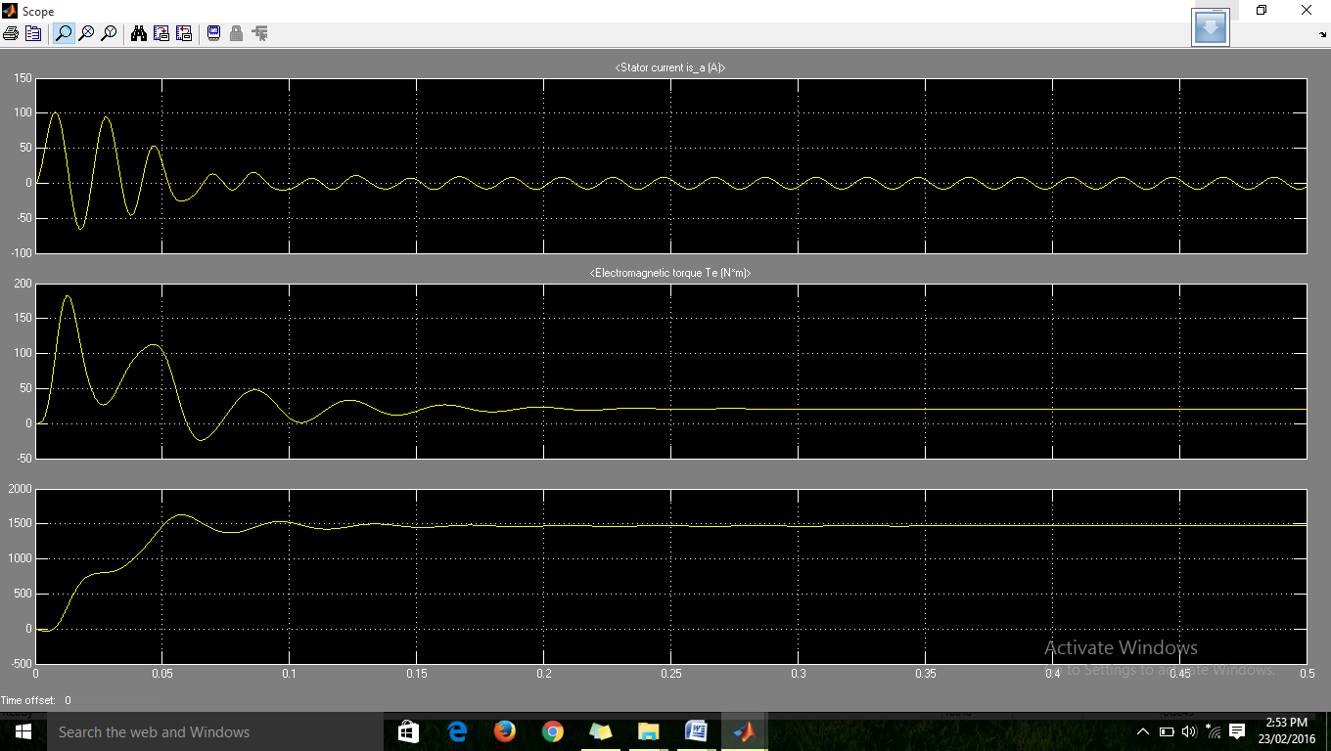

Fig. Star Connected Motor

REFERENCE

- Gürkan Zenginobuz, IsikCadirci, MuammerErmis, and CüneytBarlak, “Performance Optimization of Induction Motors during Voltage-Controlled Soft Starting”, IEEE Transaction On Energy Conversion, Vol. 19, NO. 2, JUNE 2004.
- Charles S, Dr. G.Bhuvameswari, “Power Quality Studies on a Soft-Start for an Induction Motor”, International Journal of Recent Trends in Engineering, Vol 1, No. 3, May 2009.
- Magnus Kjellberg and Sören Kling, “ABB Automation Technology Products”, ABB Control,February 2003.
- L. Rajaji, C. Kumarand M. Vasudevan, “Fuzzy and anfis based soft starter fed Induction Motor drive for high performance applications”, ARPN Journal of Engineering and Applied Sciences, Vol. 3, no. 4, August 2008.
- T. M. Rowan, T. A. Lipo, “A Quantative analysis of Induction Motor performance improvement by SCR voltage control”, IEEE Transaction on Industry Applications, vol IA-19, No 4, July/August 1983.
- AshfaqHussain, “Electric Machines”, DhanpatRai and Co. Publications, 2nd Edition, 2010.
- M. D. Singh, K. B. Khanchandani, “Power Electronics”, Tata McGraw Hill Publications, 2nd Edition, 2009.
- MuniraBatool, “Mathematical Modelling and Speed -Torque Analysis of Three phase induction motor using MATLAB”.
- Amitap Bhatia and Vinit Gupta, “Simulation and Speed control of induction motor drives”, Department of Electrical Engineering National Institute of Technology, May 2003.

