Testing Analysis on Current Transformer at 33KV/11KVsubstation Mowad

Shubham Kadu, Kunika Titarmare, Abhishek Petewar
Guided by- Prof. Dr. S. S. Ambekar
, KDK College Of Engineering, Nagpur

Abstract - This paper presents some general procedures for the proper inspection, testing, and start-up of electrical items in the Mowad (33/11kV) substations. The paper emphasizes Practical methods for testing of Transformer . This paper also discusses the various aspects, considerations, and technical requirements involved in commissioning of the substation.

Keywords: Testing of transformer.

- INTRODUCTION
Over the course of an average day, somewhere in the world a major electrical failure occurs due to corrosion, heat build-up, insulation failures improperly prepared terminations, or mis-operation, the cause is quickly identified and corrected, and the equipment is placed back in service. With properly designed, installed, and maintained protection systems, damage is usually limited in scope. Therefore, for proper working of switchgear equipments testing of that equipments is necessary. Improper testing and start-up may jeopardize the reliability of the equipment, the process, and the safety of personnel. The following section discusses the testing on transformer.

Fig.1. Single line diagram of Mowad (33/11KV) Substation
The above figure is the single line diagram of the MOWAD (33/11KV) distribution substation. All the electrical equipment connections are shown in figure above. The 33 kV supply from transmission line is connected to the 33 kV bus in substation through isolator and circuit breaker. The potential transformer is connected parallel with the 33 kV bus. Before the incoming circuit breaker, current transformer is connected to sense the fault/ healthy condition in the incomer feeder. Also, before feeding supply to the transformer, isolator, current transformer and circuit breaker are connected. Before the transformer, protecting it from high voltage surges, surge absorbers are installed (separate for each phase). The stepped down supply from transformer is supplied to the 11kV bus. To separate two lines of transformers, bus coupler is introduced in 11kV bus.11 kV distribution feeders are taken out from 11 kV bus line

- NEED OF TESTING OF SUBSTATION EQUIPMENTS
The electrical equipments are tested before energizing so that the faulty equipments may be replaced before commissioning of sub-station. The equipment test on each individual equipment are performed in accordance with the site testing plan site tests are with all the associated equipment, auxiliaries, sub-system, etc. The site test is carried out to confirm proper site assembly, no transit damage and proper functioning, and make system to operate reliably. After completing all the equipment test the sub-system tests are carried out. Theses involve a group of equipment e.g. a switchgear bay with circuit breakers, isolators, earthing switches, C.T., protection systems etc. the final system tests are performed as per agreed scheduled and sequence.
Commissioning is carried out from control room in with all the sub-system engineers. The sequence of operation of earthing switches, isolators, circuit breaker is listed, before commencing the charging operation.

- OBJECTIVE

Objective of testing is to check accuracy, completeness and safety of the executed works, and accordingly to produce Test Records and Manuals.

- TESTING OF TRANSFORMER

As per the IS-2026 following tests are carried out on the Substation equipments

- Measurement of Insulation Resistance
- Vector Group Test (Voltage Ratio Test)
- .Magnetic balance Test
- Transformer Ratio Test
- Temperature Rise test

- Insulation Resistance Test:

- Insulation Resistance of transformer winding can be measure by using Megger (5000V)
- Procedure :
- Disconnect the mains of transformer and then connect the one terminal megger to the winding and other to the frame.
- Move the handle of megger at normal speed, which will cause the pointer to move to position on the scale to the value of insulation resistance.

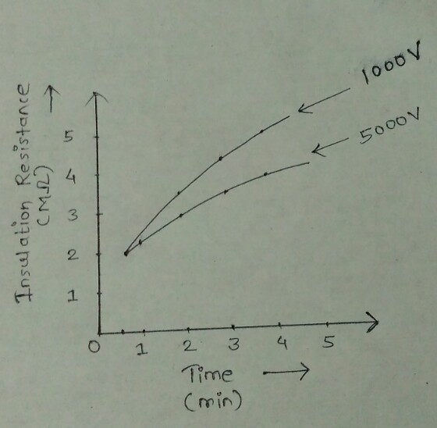

- Above figure shows the graph in between insulation resistance (M-ohm) and time (min).

- Magnetic Balance Test:

Magnetic balance test is carried out only on three phase transformer to check the imbalance in the magnetic circuit of the transformer

Procedure

- First keep the tap changer of transformer in normal position.
- Now disconnect the transformer neutral from ground.
- Apply single phase 230V AC supply across one of the HV winding terminals and the neutral terminal
- Repeat the test for each of the three phases.

Methods For Carry out MBT

- Phase Out Method

- Phase In Method

- Phase Out Method :

- Voltage applied between Primary R-phase and Y-Phase (B-Phase out)

Voltage measured between :
Table 1
RY – 439V | RN – 82V | RY – 151V
YB – 356V | YN – 67V | YB – 52V
BR – 80V | BN – 14V | BR – 97V

- Voltage applied between Primary Y-Phase and B-Phase (R-Phase out)

Voltage measured between :
Table 2
RY – 220V | RN – 40V | RY – 124V
YB – 440V | YN – 82V | YB – 124V
BR – 217V | BN – 40V | BR – 02V

- Voltage applied between Primary Y-Phase and B-Phase (R-Phase out)

Voltage measured between :
Table 3
RY – 73V | RN – 12 | RY – 53V
YB – 367V | YN – 68V | YB – 153V
BR – 442V | BN – 82V | BR – 98V

- Phase In Method :

- Voltage applied between secondary R-Phase and Neutral (R-Phase In)

Voltage measured between :
Table 4
RN – 244V
YN -193V
BN – 48V

- Voltage applied between R-Phase and Neutral (R-Phase In)

Voltage measured between :
Table 5
RN – 128V
YN – 257V
BN – 127V

- Voltage applied between R-Phase and Neural (R-Phase In)

Voltage measured between :
Table 6
RN -51V
YN -198V
BN – 252V

- Vector Group Test :

In three phase transformer, it is essential to carry out a vector group test of transformer. Proper vector grouping in a transformer is an essential criteria for parallel operation of transformers.

There are several internal connection of three phase transformer are available in market.
These several connections gives various magnitudes and phase of the secondary voltage; the magnitude can be adjusted for parallel operation by suitable choice of turn ratio, but the phase divergence cannot be compensated.
So we have to choose those transformer whose phase sequence and phase divergence are same.
All the transformers with same vector ground have same phase sequence and phase divergence between primary and secondary.
So before procuring one electrical power transformer, one should ensure the vector group of transformer, whether it will be matched with his existing system or not.
Proper vector grouping in transformer is an essential criteria for parallel operation of transformers.
Vector group test is carried out by using Voltmeter.

Procedure :
After shorting R-phase primary and secondary for Dy11 connection yY should be equal to bY.Also RY=m+Ny. Also By>Bb
Appling 440 V 3phase supply to 33 KV side and measuring following voltage.
- yY=319 V
- bY=317 V
- RY=436 V
- m=81 V
- By=462 V
- Bb= 319 V
- nY=352 V

- Transformer Ratio test :
The performance of a transformer largely depend upon perfection of specific turns or voltage ratio of transformer. So for ensuring proper performance of electrical power transformer, voltage and turn ratio is one of the important tests.

Procedure
- Apply 3 phase 415 volt supply to HV winding, with keeping LV winding open.
- Measure the induced voltage at HV and LV terminals of transformer to find actual voltage ratio of transformer.
- Repeat the test for all tap position separately.

Range of OLTC - +5% to -15%
Input voltage applied on 33KV

The transformer ratio test is carried out by using Transformer Testing Kit.

- Temperature rise test :
This test can be performed at any temperature not exceeding 40 degree C.
If winding resistance is greater than 0.05–ohm temperature rise can be easily found out by using the formula.

Rt2/Rt1 = 234.5+t2/234.5+t1

Where, t1 = ambient temperature
t2 = final temperature of winding
Rt1 = resistance at temperature t1
Rt2 = resistance at temperature t2

But if winding resistance is less than 0.05-ohm method explained above does not give accurate results so oil temperature is measured by thermometer is measured by thermometer to work out the temperature rise.
The winding resistance is connected between supply and average temperature is found by finding increase in resistance. It should not be more than 55 degree C. [if ambient temperature is 30 degree C, maximum winding temperature should not exceed 30 degree C + 55 degree C = 85 degree C]
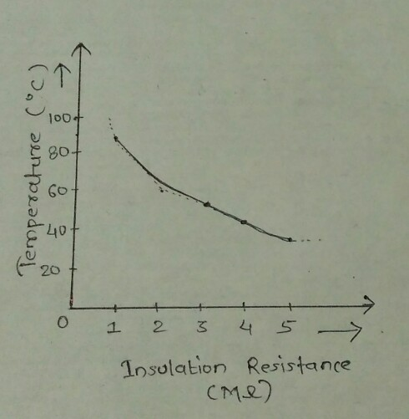
Above figure shows the graph in between insulation resistance (M ohm) and temperature(degree C).

- CONCLUSION

Results have been recorded during the tests which verified that the transformer is operate properly. Also we verified that actual test results according to the standard test results.

REFERENCE

- Test Reports of 33kv/11kv, 5MVA transformer by at MSEDCL substation, Mowad Katol by “Bajaj Electrotech”.

- “Some lessons learned from commissioning substation and medium voltage switchgear equipment” Andrew R. Leoni, John P. Nelson.

- “ Testing of transformer “ Prof. Krishna Vasudevan, Prof. G.Sridhararao, Prof. P.Sasidharara ,.IIT MADRAS.

- Sunil s. Rao, “Switchgear and protection”, Khanna publishers, Eighth Edition.

- Construction manual for substations.

- Ashfaq Hussain, “Electrical Power system”, CBS publishers, 5th Revised Editon.

- C.L. Wadhwa, “ High Voltage Engineering “, New Age International publication, Second Edition

- Designs of transformer by “Dasgupta”.

