Power Quality Improvement & Management of Distribution Panel

Himanshu Balapure K.D.K.C.E. Nagpur himanshuab99@gmail.com
JagrutiRaut K.D.K.C.E. Nagpur jagrutiraut721@gmail.com
VikasPipradeMs. K.D.K.C.E. Nagpur vikaspiprade79@gmail.com Prof. AnkitaShamkuwar K.D.K.C.E. Nagpur ankitas.etr.15@gmail.com

Abstract – This paper explains the problems that are due to poor Power Quality in electrical systems and shows their possible financial consequences. Solutions present in the field are explained and field results are presented. It is shown that by using the right technology a variety of Power Quality problems can be solved rendering installations trouble free and more efficient, and can render them compliant with even the strictest requirements.

I. INTRODUCTION
Ideally, the best electrical supply would be a constant magnitude and frequency sinusoidal voltage waveform. However, because of the non-zero impedance of the supply system, of the large variety of loads that may be encountered and of other phenomena such as transients and outages, the reality is often different. The Power Quality of a system expresses to which degree a practical supply system resembles the ideal supply system. If the Power Quality of the network is good, then any loads connected to it will run satisfactory and efficiently. Installation running costs and carbon footprint will be minimal. If the Power Quality of the network is bad, then loads connected to it will fail or will have a reduced lifetime, and the efficiency of the electrical installation will reduce. Installation running costs and carbon footprint will be high and/or operation may not be possible at all.

II. DISRTIBUTION PANEL
A distribution board (also known as Panel board or Breaker Panel) is a component of an electricity supply system which divides an electricity power feed into subsidiary circuits, while providing protective arrangements for each circuit in a common enclosure. The KDK Boys Hostel building was built way back in the year 1988 thereby the electrical distribution panel therein was installed about twenty six years ago, during this long phase of time the existing old distribution panel has undergone lot of wear and tear.
Distribution panel are majorly used in order to distribute the incoming power supply to various sub distribution boards and corresponding loads connected to it. In case fault occurs in a distribution panel, trained personnel and special measuring instruments are used for quick and accurate fault location. In order to restore supply at earliest possible time, thus design of the distribution panel should be systematic with respect to certain standards.
Since the designing of distribution panel is based upon certain constraints as distribution panel rules and standards, improved protection equipments, future expansions etc a comprehensive data analysis is required.There is a three and half core 415V incomer cable from SNDL Nagpur coming inside the hostel premises of about 50sq mm which energizes the entire distribution panel. Both three phase as well as single phase loads are present in the hostel premises.

III. POWER QUALITY
The term power quality has many different meaning perhaps as many as attempt to describe its impact on the system operation. The electric utility may describe power quality as reliability and quote statistics stating that the system is 99.95% reliable The equipment manufacturer often decfines power quality as the charachteristic of power supply which may vary drastically for different vendors. However customer is the party ultimately affected by the power quality related problemsand the best definition should include his perspective. Considering each of these issues the following definition is often mostly used
Power quality problem.“ Any problem manifested in voltage, current, or frequency deviation that results in the failure or misoperation of customer equipment”
There are many events that can cause power quality problem. Analysis of these events is often difficult due to the fact that the cause of the event may be operated to a switching operation within the facility to a power system fault hundreds of miles away. The paper describes several more power quality problems associated with distribution panel and its corresponding loading

IV. POWER QUALITY PARAMETRES
In an AC supply, the current is often phase-shifted from the supply voltage. This leads to different power definitions
- The active power P [kW], which is responsible of the useful work, is associated with the portion of the current which is in phase with the voltage.
- The reactive power Q [kVAR], which sustains the electromagnetic field used to make e.g. a motor operate is an energy exchange (per unit of time) between reactive components of the electrical system (capacitors and reactors). It is associated with the portion of the current which is phase shifted by 90° with the voltage.
- The apparent power S [kVA], which gives a geometrical combination of the active and of the reactive powers, can be seen as the total power drawn from the network.

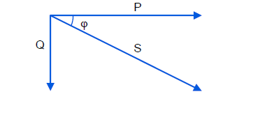
Fig: Basic powers in AC systems
The ratio between the active power and the apparent power if often referred to as the displacement power factor or cos φ, and gives a measure of how efficient the utilization of the electrical energy is. A cosφ that equals to 1 refers to the most efficient transfer of useful energy. A cosφ that equals to 0 refers to the most inefficient way of transferring useful energy.
V. CAUSES OF POOR POWER QUALITY
Poor Power Quality can be described as any event related to the electrical network that ultimately results in a financial loss.
- Unexpected power supply failures (breakers tripping, fuses blowing).
- Equipment failure or malfunctioning
- Equipment overheating (transformers, motors) leading to their lifetime reduction.
- Damage to sensitive equipment (PC‟s, production line control systems).
- Electronic communication interferences.
- Increase of system losses.
- Need to oversize installations to cope with additional electrical stress with consequential increase of installation and running costs and associated higher carbon footprint.
- Penalties imposed by utilities because the site pollutes the supply network too much.
- Connection refusal of new sites because the site would pollute the supply network too much.
- Impression of unsteadiness of visual sensation induced by a light stimulus whose luminance or spectral distribution fluctuates with time (flicker)

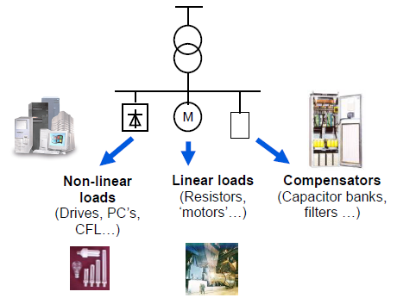
Fig: Generic single line diagram of an installation
Voltage imbalance on respective phases is another issue which is needed to be resolved in order to ensure efficient working In the symmetrical components theory Fortescue has shown that any three phase system can be expressed as the sum of three symmetrical sets of balanced phasors: the first set having the same phase sequence as the initial system (positive phase sequence), the second set having the inverse phase sequence (negative phase sequence) and the third one consisting of three phasors in phase (zero phase sequence or homopolar components). A normal three phase supply has the three phases of same magnitude but with a phase shifted by 120°. Any deviation (magnitude or phase) of one of the three signals will result in a negative phase sequence component and/or a zero phase sequence component.
The definition of voltage unbalance is usually expressed as the ratio between the negative phase sequence component and the positive phase sequence component. This parameter is expressed in %. (Strictly speaking, the homopolar part should also be considered in the definition. However, as it is the negative phase sequence that is the most relevant for causing damage to direct online motors by creating a reverse torque, historically the unbalance definition is often limited to the one expressed in this paragraph).
VI. POWER QUALITY IMPROVEMENT AND MAINTAINCE MEASURES
The effect of the power quality appreciably shows up on the tarrif .This is another key area which needs to be emphasized upon heavily since poor power quality can also result into a rise in the tarrif incurred. The tarrif structure of a three phase supply differs from the single phase one. The small slabs of power factors enlisted by the board authorities are thus a key factor to look into. The power factor of the KDK Boys Hostel is 0.923 thus there is surely room for improvement.
Thus a provision of installing a capacitor bank comes into picture. Compensation is basic principle of the working of capacitor banks. Power quality can also be improved as well as maintained by balancing the reactive power. The required KVAR rating of the capacitor bank to be installed can be approximately calculated by using an equation
KVAR = KW(tanθ_{e}– tanθ_{d})
Where, KVAR = Required KVAR rating of the capacitor bank to be installed.
KW = the present kilo watt rating of the installation.
tanθ_{e} = tan of existing power factor.
tanθ_{d} = tan of desired power factor.
The present installation of the KDK Boys Hostel premises is about 18-19 KW along with a present power factor of 0.923, with the help of these respective values the suitable KVAR rating can be determined which can be made use of.
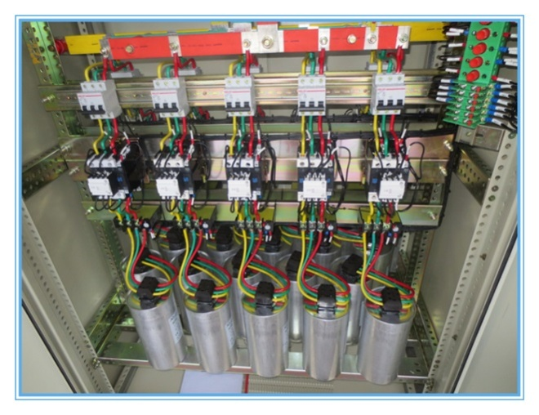
Fig: Installed capacitor bank
VII. CONCLUSION
This paper reviews the importance of good Power Quality. It presents Power Quality costs and solutions to poor Power Quality. A basic description of Power Quality is given together with its quantification through different parameters. Energy is a key to drive various life cycles in our day to day living, generation of energy is also not a simple and cheap process. By power quality improvement and management we can thus ensure that the electrical power produced is harnessed efficiently.
REFERENCES
- IEEE Standard 519-1992, "IEEE Recommended Practices and Requirements for Harmonic Control in Electric Power Systems", IEEE, New York, NY, USA, 1993.

- Hen B, Bae B, Ki H. Combination of unified power-quality conditioner with distributed generation. IEEE Transactions on Power Delivery. 2006 Jan; 21(1):330–8.

- European Standard EN 50160, "Voltage characteristics of electricity supplied by public distribution systems", European Committee for Electrotechnical Standardization, November 1994.

- “THE IMPORTANCE OF GOOD POWER QUALITY”, Dr. Kurt Schipman, Dr. François Delincé,ABB Power Quality Products, Belgium

- T.E. Grabe, “ Power quality and the customer/utility interference” , presented at Southcon 1994.

- Kesler M, Ozdemir E. Synchronous reference frame based control method for UPQC under unbalanced and distorted load conditions. IEEE Transactions on Industrial Electronics. 2010 Sep; 58(9):3967–75.

