Analysis of Distribution Panel
At Bhausaheb Mulak Ayurvedic college, Nagpur- 440009

Vaibhav Waghe K.D.K.C.O.E. Nagpur waghe.vaibhav@gmail.com
Shrutika Lodhe K.D.K.C.O.E. Nagpur Shutikalodhe123@gmail.com
Prof. D.T.korsane K.D.K.C.O.E. Nagpur

Abstract – A distribution board (also known as Panel board or Breaker Panel) is a component of an electricity supply system which divides an electricity power feed into subsidiary circuits, while providing protective arrangements for each circuit in a common enclosure. Bhausaheb Mulak Ayurvedic College building was built way back in the year 1989 thereby the electrical distribution panel therein was installed about twenty five years ago, during this long phase of time the existing old distribution panel has undergone lot of wear and tear. Also due to ageing phenomenon the panel is not suitable for further advancements. In addition to existing load of two floor building, a new load of floor 3 is being introduced. This paper discusses about designing the new distribution panel for Bhausaheb Mulak Ayurvedic College involving analysis of the existing (old) distribution panel and the components present. On account of a comprehensive study of the existing distribution panel considering various aspects such as distribution panel rules and standards, improved protection equipments, future load expansions etc. the design of new distribution panel would be done. This report also covers the study of circuit breakers and various components used in distribution panel.
Keywords—contactor, auxillary contactor, D-G Set.

Introduction
Distribution panel are majorly used in order to distribute the incoming power supply to various sub distribution boards and corresponding loads connected to it. In case fault occurs in a distribution panel, trained personnel and special measuring instruments are used for quick and accurate fault location. In order to restore supply at earliest possible time, thus design of the distribution panel should be systematic with respect to certain standards. Certain standards have already been laid down by various respective authorities in accordance to which distributions panels are designed and installed. The distribution panels which are designed under these standards have better overall life and are easily supervised under undesired fault conditions. Since the designing of distribution panel is based upon certain constraints as distribution panel rules and standards, improved protection equipments, future expansions etc. a comprehensive data analysis is required
To design the electric panel board, there are many things that you have to take into consideration. The function of the main electrical panel is to distribute electric power to the various connected load components. This distribution is done with the aid of electrical circuits that emerge from the panel. Electric panels can be customized and configured to meet the power requirement as desired. This is why there are different dimensions of panel according to their preliminary requirements. Before designing an electrical panel board, it is good to know its components. The main panel distributes electricity through branch circuits.
A distribution panel may provide 100 or 150 or 200 amps. The individual circuits are then distributed from the main breaker by individual breakers which branches the power throughout the hostel premises. These individual breakers are designed depending upon the requirement of power. A light outlet circuit would need 15 amps and other appliances that need more power would usually be 60 to 100 amps serves as the main power supply switch that supplies electricity to the power circuit.

distribution panel
Power Distribution is a system, consisting of a Main Distribution Board (MDB), Sub Main Distribution Boards (SMDBs) and Final Distribution Boards, by which the electrical energy is transmitted via branches to reach the exact end user.
An MDB is a panel or enclosure that houses the fuses, circuit breakers and ground leakage protection units where the electrical energy, which is used to distribute electrical power to numerous individual circuits or consumer points, is taken in from the transformer or an upstream panel. An MDB typically has a single or multiple incoming power sources and includes main circuit breakers and residual current or earth leakage protection devices. A MDB is comprised of a free standing enclosure, a bus bar system, MCCB & MCB, metering and support equipments. There is a three and half core 415V incomer cable from SNDL Nagpur coming inside the college premises of about 50sq mm which energizes the entire distribution panel. Only single phase loads are present in the college premises.
Appropriate tapping’s are taken from the 3-phase bus bar in order to feed these single phase loads and also to make sure that adequate optimum load balancing is done amongst all the respective three phases in order to ensure reliability of supply without any unbalance fault phenomenon taking place causing interruption of supply with respect to the place of fault point. It is made sure in the present distribution panel that each and every circuit is provided with neutral path for ensuring that safety parameter are maintained without any issue. The single -phase loads present in the hostel premises also includes 1.5HP motors which are used for pumping water to the overhead water tank from the well. Both these motor is operated by using direct on line starters (DOL starters).
Incoming line from MSEB 11KV/415V

Energy meter

MCCB 100 Amp

3.5sq mm cable

3.5sq mm cable
100 Amp MCCB

MCCB
100AMP

63 AMP Ground Floor
32 AMP
2ndFloor Floor

63AMP
63 AMP
1st Floor
32 AMP 2nd Floor
1st Floor

Fig: Existing Distribution Panel
The protection equipments used in the existing distribution are iron cladded triple pole and iron cladded double pole switches (ICTP & ICDP) and simple rewirable fuses. As the existing distribution panel is not an enclosed one, rusting has also taken place to certain extent thus there is always a risk that the metal framework entirely or a part of it may collapse causing interruption of supply or even short circuit in adverse condition. Also the design of the old distribution panel is not advanced thus it cannot house modern electrical components and related extension accessories for enhancement.

components used in distribution panel
- Encloser- An enclosure is necessary so as to keep the distribution panel isolated and intact from the external atmospheric conditions such as heat, rain, dust, moisture and other foreign interferences. The enclosure should be strong enough to withstand and protect the distribution panel installed inside it, the enclosure should also be painted so as to corrosion.
- Busbar- In electrical power distribution, a busbar is a metallic strip or bar (typically copper, brass or aluminium) that conducts electricity within a switchboard, distribution board or other electrical apparatus. Its main purpose is to conduct a substantial current of electricity. Busbar are produced in a variety of shapes such as flat strips, solid bars and rods, solid or hollow tubes, and braided wire. Some of these shapes allow heat to dissipate more efficiently due to their high surface area to cross-sectional area ratio: [IS: 375]
- Energy meter- An electricity meter or energy meter is a device that measures the amount of electric energy consumed by a residence, business, or an electrically powered device. They are typically calibrated in billing units, the most common one being the kilowatt hour [kWh]. The energy meter is the first component to which the incomer cables are connected. The energy meter further also has many types, the trivector energy meters are capable of representing the reactive power consumption which is thus of an advanced type as compared to general service energy meters.
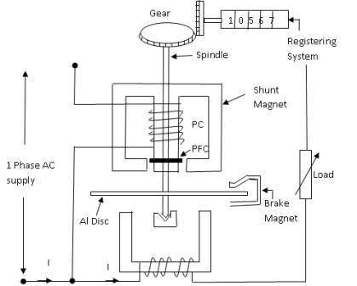
Fig.1. Construction of Energy meter

- ICDP and ICTP switches- The ICTP & ICDP stand for iron cladded triple/double pole switches. These are the manually operated protection components. These switches are placed before the fuses in the distribution panel circuitry. Before installing these switches the current rating is determined previously based upon which there installation is done. In case of abnormal condition these switches melt down on account of excess current flow.
- Starter- An electrical starter is basically a protection device that limits the heavy starting current drawn by the motor ensuring that currents stays below a safe value and gradually cuts off after the motor attains a speed greater than 85% of its rated speed. The starters used in the hostel premises are DOL starters since the motors present are of 5HP each and also these starters are less costly, easy to maintain and controlling mechanism is also simple.
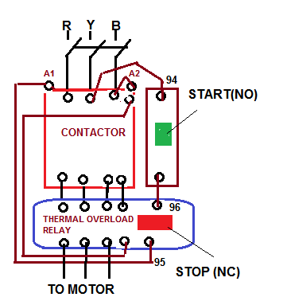

Fig.2. DOL Starter

- Fuses- A fuse is a type of low resistance resistor that acts as a sacrificial device to provide overcurrent protection, of either the load or source circuit. Its essential component is a metal wire or strip that melts when too much current flows through it, interrupting the circuit that it connects. Short circuits, overloading, mismatched loads, or device failure are the prime reasons for excessive current. Fuses are an alternative to circuit breakers. A fuse interrupts excessive current so that further damage by overheating or fire is prevented. Rewirable cartridge type fuses are used in the existing old distribution panel.

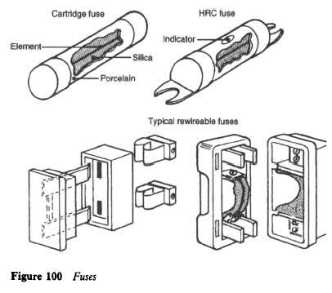
Fig.3. Fuses

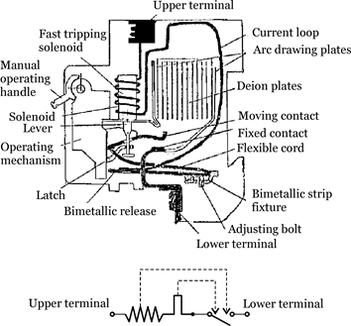
Fig.4. MCB

- MCB and MCCB- The old existing distribution panel
does not consist of MCB and MCCB installed readily but the design layout of the new panel would be having them these thus we need to know about them. MCBs or Miniature Circuit Breakers are electromechanical devices which protect an electrical circuit from an overcurrent. The overcurrent, in an electrical circuit, may result from short circuit, overload or faulty design. An MCB is a better alternative to a Fuse since it does not require replacement once an overload is detected. Unlike fuse, an MCB can be easily reset and thus offers improved operational safety and greater convenience without incurring large operating cost.
The principal of operation is simple. An MCB functions by interrupting the continuity of electrical flow through the circuit once a fault is detected. In simple terms MCB is a switch which automatically turns off when the current flowing through it passes the maximum allowable limit. Generally MCB are designed to protect against over current and over temperature faults (over heating). There are two contacts one is fixed and the other moveable. When the current exceeds the predefined limit a solenoid forces the moveable contact to open (i.e., disconnect from the fixed contact) and the MCB turns off thereby stopping the current to flow in the circuit. In order to restart the flow of current the MCB is manually turned on. This mechanism is used to protect from the faults arising due to over current or over load. To protect against fault arising due to over heating or increase in temperature a bi-metallic strip is used. MCBs are generally designed to trip within 2.5 millisecond when an over current fault arises. In case of temperature rise or over heating it may take 2 seconds to 2 minutes for the MCB to trip. This article covers the insight of a single pole MCB commonly used in the house hold. The following image shows the different internal parts of an
MCB with top casing removed. The subsequent sections will examine each part and its function.
Moulded Case Circuit Breakers are electromechanical devices which protect a circuit from Overcurrent and Short Circuit. They provide Overcurrent and Short Circuit Protection for circuits ranging from 63 Amps up to 3000 Amps. Their primary functions are to provide a means to manually open a circuit and automatically open a circuit under overload or short circuit conditions. The overcurrent, in an electrical circuit, may result from short circuit, overload or faulty design.
MCCB is an alternative to a fuse since it does not require replacement once an overload is detected. Unlike fuse, an MCCB can be easily reset after a fault and offers improved operational safety and convenience without incurring operating cost.
Moulded case circuit breakers generally have a thermal element for overcurrent and Magnetic element for short circuit release which has to operate faster. MCCBs are manufactured such that end user will not have access to internal workings of the over-current protection device. Generally constructed of two pieces of heavy-duty electrically insulated plastic, these two halves are riveted together to form the whole. Inside the plastic shell is a series of thermal elements and a Spring-loaded trigger. When the thermal element gets too warm, from an overcurrent situation, the spring trips, which in turn will shut off the electrical circuit.[ IS:13947 ]

- Cables- An electrical cable comprises two or more wires
running side by side and bonded, twisted, or braided together to form a single assembly, the ends of which can be connected to devices, enabling the transfer of electrical power from one point to the other. The types of cable used precisely depends upon the type of electrical load connected and the power which is to be transferred taking into account the current ratings. [IS: 3961 (PART II) – 1967]

load calculations
Even though the installation of a distribution panel is based upon many essential parameters, the calculation relating to the load have a significant importance since we need to know that what amount of load is to be fed by the distribution panel which is going to be designed.
The old distribution panel currently feeds about 14-15KW of connected load of the college premises. As the old distribution panel was built about twenty five years ago, its design is thereby not much advanced for installing new protection equipments which are these days almost essential in order to ensure smooth and uninterrupted supply of electrical power. Thus there comes a need to design a new panel which would host of modern protection equipments and would be capable of incorporating any kind of future expansions as and when required
Calculation of the connected load of the Bhausaheb Mulak Ayurvedic College can be tabulated as:

Sr no. | EQUIPMENT | RATING | NO. OF EQUIPMENT | TOTAL LOAD
1 | Fans | 60W | 45 | 2700W
2 | Tube Light | 40W | 32 | 1280W
3 | Bulbs | 40W | 14 | 560W
4 | Power Socket with switch | 100W | 36 | 3600W
5 | Water Pumps | 1119W | 1 | 1119W
6 | A.C. | 4000W | 2 | 8000W
 |  |  | TOTAL | 17,259W
Table 1. Load at Ground Floor

Sr no. | EQUIPMENT | RATING | NO. OF EQUUIPMENT | TOTAL LOAD
1 | Fans | 80W | 45 | 3600W
2 | Tubelights | 40W | 32 | 1280W
3 | CCTV | 20W | 02 | 40W
4 | Refrigerator | 400W | 01 | 400W
5 | Bulbs | 40W | 03 | 120W
 |  |  | TOTAL | 5440W

Sr no. | EQUIPMENT | RATING | NO. OF EQUIPMENT | TOTAL LOAD
1 | Fans | 80W | 45 | 3600W
2 | Tubelights | 40W | 32 | 1280W
3 | Geysers | 1500W | 01 | 1500W
4 | CFLS | 12W | 06 | 72W
5 | A.C. | 7000W | 02 | 14000W
 |  |  | TOTAL | 20452W
Table 2. Load at First and Second Floor

On calculation these floors on cumulative basis add up to a total load of about 19 KW for ground floor , about 6KW for 1st floor and about 14KW for 2nd floor which is also required to be considered while designing the new layout of distribution panel which includes the load of 3rd floor too. After considering the entire load requirement summing up of the Ayurvedic College and all the floors in that particular complex, the total maximum load demand ranges to somewhere around 40KW on cumulative basis of calculation .

References

- V.K Jain & Amitabh Bajaj ,“A Textbook of Design of Electrical Installations”; Laxmi Publications Pvt. Limited,1993,1st Edition.

- A.S.Pabla, “Electrical Power Distribution System” ;Tata McGraw-Hill, 5th Edition.

- J.B. Gupta, “A Course in Electrical Installation, Estimating & Costing”; Published by S.K Kataria & Sons, 9th Edition.,

- Indian Electricity Regulation, 1956

