Designing and Installation of 11kV/440V Distribution Substation
Ajinkya Lonare, Pravin Bodhadkar, Suchiket Darunde, Mansi Pathode, Apeksha Manekar
Guided by- Dr. G.H. Agrawal. Prof. Dept. of Electrical Engg., K.D.K.C.E., Napur-09 ghagrawal66@yahoo.com

Abstract – A substation is a part of an electrical generation, transmission, and distribution system. Substations generally have switching, protection and control equipment, and transformers. The low voltage distribution networks are supplied from substation transformers that represent the last step of bringing transformation to the low voltage and ensuring the protection and monitoring of the network. This paper presents a general description for different MV/LV substation and a methodology to design the various elements making up the public distribution substation (choice of the emplacement, engineering, power transformer, pin insulators, lightening arrestors, DO fuse, circuit breakers, fuses, conductors,...etc.).In addition to changing the voltages the substation has a variety of protective devices like circuit breakers and fuses to protect the distribution network. These are designed in such a way that various distribution circuits can be isolated for repairs and load shadings. A Distribution substation is a combination of switching, controlling and voltage step down equipment arranged to reduce sub-transmission voltage to primary distribution voltage for residential, farm, commercial and industrials loads. In addition to transforming voltage, distribution substation also isolate faults in either the transmission or distribution system. Distribution substation are typically the points of voltage regulation. This paper discusses about installation of 11kV/440V substation. It also includes the designing of the dipole structure. It includes the study of various Equipments which are installed on dipole structure. This paper presents the different MV/LV substation transformer and a methodology to design the various elements making up the public distribution substation. This paper also covers the study of earthing system for the substation.
Keywords- Distribution substation, MV/LV, Earthing

Introduction
A substation is a part of an electrical generation, trans-mission, and distribution system. Substations transform voltage from high to low, or the reverse, or perform any of several other important functions. Electric power may flow through several substations between generating plant and consumer, and its voltage may change in several steps. Substations generally have switching, protection and control equipment, and transformers. Distribution circuits are fed from a transformer located in an electrical substation, where the voltage is reduced from the high values used for power transmission.
The MV/LV substations are a node of a network, which includes a set of equipment designed to protect and facilitate the operation of the electrical energy. The
MV/LV substations provide the interface between the distribution MV and LV. The MV / LV adapts to all modes of operation and why should fulfil the following functions:
- Distribute the power and protect the LV departures;
- Isolate the MV/LV substation in case of default;
- Manage the MV network in case of default and the position by remote control;
- Protection of distribution system;
- Voltage control;
- Reducing the reactive power flow by compensation of reactive power, tap changing;
- Fault analysis and pin pointing the cause and subsequent improvement in that area of field;

MV/LV substation transformer has two purposes: -
The interconnection between the lines of the same voltage level, it helps to distribute the power of the different lines from substations.
The transformation of electrical power, processors can switch between voltage levels to another.
So, we can classify the MV/LV substations over the networks on which they are used as well as the functions they perform.
The realization of MV/LV substations needs prior knowledge:
1. Standards of reference and statutory instruments (voltage, quality of supply, short-circuit power etc.);
2. Specific needs-related uses (voltage variations tolerated, compensation of reactive power, regulations related to facility security);
3. Constraints, installation and environment;
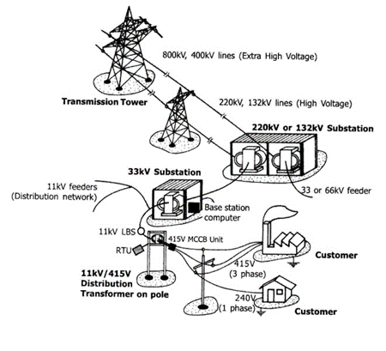
Transmission and Distribution system

The Birth of MV/LV Substation Transformer
The decision of a MV or LV supply will depend on local circumstances and considerations such as those mentioned above, and will generally be imposed by the utility. When a decision to supply power at MV has been made, there are two widely-followed methods of proceeding:
a. The power-supplier constructs a standard substation close to the consumer’s premises, but the MV/LV transformer is located in transformer chamber inside the premises, close to the load center.
b. The consumer constructs and equips his own substation on his own premises, to which the power supplier makes the MV connection.

  - Project Studies:- The consumer must provide certain data to
the utility at the earliest stage of the project. (maximum anticipated power demand (KVA), layout plans and elevations showing location of proposed substation, degree of supply continuity required from the information provided by the consumer),
the power-supplier must indicate:

- The type of power supply proposed, and define the
kind of power-supply system: over headline or under-ground-cable network, the service connection details: single-line service, ring-main installation, or parallel feeders, and the power (kVA) limit and fault current.

- The nominal voltage and rated voltage (Highest
voltage for equipment)

- Metering details which define: The cost of connection
to the power network and tariff details (consumption and standing charges).

  - Implementation- Before any installation work is started, the official agreement of the power-supplier must be obtained. The request for approval must include the following information, largely based on the preliminary exchanges noted above:

a. Location of the proposed substation;
b. Single-line diagram of power circuits and connections, together with earthing circuit proposals;
c. Full details of electrical equipment to be installed, including performance characteristics;
d. Layout of equipment and provision for metering components;
e. Arrangements for power-factor improvement if required; Arrangements provided for emergency standby power plant (MV or LV) if eventually required.

  - Commissioning- After testing and checking of the installation by an independent test authority, a certificate isgranted which permits the substation to be put into service. When required by the authority, commissioning tests must be successfully completed before authority is given to energize the installation from the power supply system. Even if no test is required by the authority it is better to do the following verification tests:
a. Measurement of earth-electrode resistances;
b. Continuity of all equipotential earth-and safety bonding conductors;
c. Inspection and functional testing of all MV components;
d. Insulation checks of MV equipment;
e. Dielectric strength test of transformer oil;
f. Inspection and testing of the LV installation;
g. Checks on all interlocks (mechanical key and electrical) and on all automatic sequences;
h. Checks on correct protective relay operation and settings;
i. Personnel of the power supply authority will energize the MV equipment and check for correct operation of the metering;
j. The installation contractor is responsible for testing and connection of the LV installation. When finally the substation is operational, the power-supply authority has operational control over all MV switchgear in the substation;
k. The power supply personnel have unrestricted access to the MV equipment.
l. The consumer has independent control of the MV switch of the transformers only, the consumer is responsible for the maintenance of all substation equipment, and must request the power-supply authority to isolate and earth the switchgear to allow maintenance work to proceed. The power supplier must issue a signed permit to work to the consumers maintenance personnel, together with keys of locked-off isolators, etc. at which the isolation has been carried out.
A study guide of MV/LV distribution substation includes:
a. Technical supply;
b. Layout plans and elevations showing location of proposed substation;
c. A single-line diagram;
d. Diagrams and plans of electrical equipment;
e. Pole and foundation plans, different cuts of the substation, the views of faces;
f. Plan of earthing system and lighting of the substation.

Classification of Mv/Lv Substation Transformer
Substations transformer may be classified according to metering arrangements (MV or LV) and type of supply (overhead line or underground cable), Substations transformer are classified into two types:
1. Indoor substation
2. Outdoor substation

Outdoor substation is further classified into two types
• Pole mounted substation
• Plinth or Foundation mounted substation
Comparison between outdoor and indoor substation-

Outdoor substation | Indoor substation
More space required | Less space required
Less time required for erection | More time required for erection
Easy future extension | Difficult future extension
Easier fault location because of equipment being in full view | Difficult fault location because of equipment not being in full view
Low capital cost | High capital cost
Difficult operation | Easier operation

Classification of Mv/Lv Substation Transformer Design of Distribution Substation

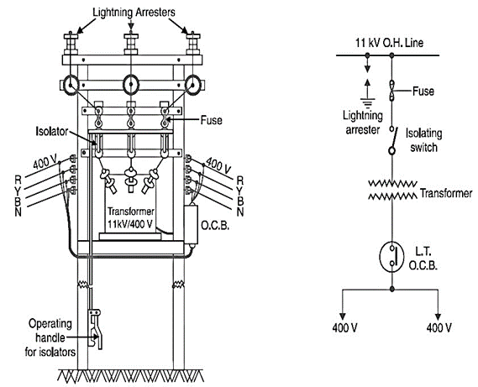
Fig.2. Layout and single line diagram of pole mounted distribution substation

Distribution substation consists of:
1. Pin type insulator
2. AB switch
3. Lightning Arrester
4. Circuit Breaker
5. Distribution Transformer
6. Earthing
7. DO Fuse
8. Stay Wire
9. MV cable
10. LV cable
Fig shows the single line diagram of 11KV/440V substation DP structure. The single line diagram contains the 11KV distribution line, lightning arrester, A B switches, drop out fuse, 11KV/440V transformer, LTCB, etc.
First the 11KV supply is coming from State Electricity Board to the DP structure through cable via metering unit at the top A B switch then lightning arrester then drop out fuse then pin type insulator and then it goes to the transformer HT bushing. The structure the A B switch is connected at the top. It is used to isolate or operate the line from State Electricity Board supply. If A B switch is open, then contacts are open and supply could not come to the transformer. Hence, if fault occur at consumer side then by opening the A B switch it can safely repair the fault. But before operating a fault, care should be taken that the line should be discharge properly. A B switch works as an isolator. The lightning arrester are used to ground the lightning over voltages. After that it contains Drop Out fuse. Then supply come to H T bushing of transformer. The transformer is 11KV/440V delta-star connected. A step down transformer which step down the 11KV to 440V to main panel of the college or industry. From this main panel the supply is distributed the main area through cables, MCB and other switches.

A. Pin type insulator:
A pin insulator consists of a non-conducting material such as porcelain, glass, plastic, polymer, or wood that is formed into a shape that will isolate a wire from a physical support on a utility pole or other structure, provide a means to hold the insulator to the pin, and provide a means to secure the conductor to the insulator. By contrast to a Strain insulator, the pin insulator is directly connected to the supporting pole. The pin insulator is designed to secure the conductor to itself.

B. Lightning Arrester:
A lightning arrester is a device used on Electrical power systems from the damaging effects of Lightning. The typical lightning arrester has a high-voltage terminal and a ground terminal. When a lightning surge (or switching surge, which is very similar) travels along the power line to the arrester, the current from the surge is diverted through the arrestor, in most cases to earth.
If protection fails or is absent, lightning that strikes the electrical system introduces thousands of kilovolts that may damage the distribution lines, and can also cause severe damage to transformers and other electrical devices. Lightning-produced extreme voltage spikes in incoming power lines can damage electrical appliances.

C. Air Break switch:
An air break switch disconnectors are the vital part of any overhead line network, providing crucial points of isolation. Most overhead line network designed so that when a fault occurs or maintenance work needs to be carried out it is relatively simple, by means of a systematic series of switching operations, to isolate the certain section of overhead line. When this switching process is carried out it is absolutely imperative that the air break switch disconnector is reliable and effective.

D. Distribution Transformer:
A distribution transformer is a transformer that provides the final voltage transformation in the electric power distribution system, stepping down the voltage used in the distribution lines to the level used by the customer. The invention of a practical efficient transformer made AC power distribution feasible; a system using distribution transformers was demonstrated as early as 1882.
Distribution transformers normally have ratings less than 500 kVA, although some national standards can describe units up to 5000 kVA as distribution transformers. Since distribution transformers are energized for 24 hours a day (even when they don't carry any load), reducing iron losses has an important role in their design. As they usually don't operate at full load, they are designed to have maximum efficiency at lower loads. To have a better efficiency, voltage regulation in these transformers should be kept to a minimum. Hence they are designed to have small leakage reactance.

E. Drop out fuse:
The distribution fuse cutouts shall be outdoor, open, drop-out expulsion type fuse cutouts suitable for installation in 50 Hz, 11 KV distribution system.
1 .The rated voltage shall be 12 KV.
2. The rated current shall be 100 A.

F. Plate Earthing:
In this type of earthing plate either of copper or of G.I. is buried into the ground at a depth of not less than 3 meter from the ground level.
The earth plate is embedded in alternative layer of coke and salts for a minimum thickness of about 15cm.
The earth wire (copper wire for copper plate earthing and G.I. wire for G.I. plate earthing) is securely bolted to an earth plate with the help of bolt nut and washer made of copper, in case of copper plate earthing and of G.I. in case of G.I. plate earthing. In LV & HV (upto 11KV) electrical installations, normally either pipe type or plate type earthing is provided as per IS-3043.
For transformer body:-3 plate
For transformer Neutral: - 2 plates
For pole:-2 plate
For L.A.:-1 plate (separately grounded)
For A.B. Switch:-2 plates
For A.B. Switch handle:-1 plate

Conclusion
In this paper, we presented various components of Mv/Lv structure. DP structure was studied in detail. Hence we learnt designing and installation of DP structure. We have explained Project Studies, Implementation and Commissioning of Mv/Lv distribution Substation. Installation of substation plays an important role in distribution system in electrical energy because substation is the heart of distribution energy. So we have to consider all points before installing of substation. Generally we should install in such a way that the cost involved should be low and further additional new parts can be easily done for the fulfillment of rise in power demand. This project paper is about the study of installation of 11kv/440v double pole structure hence this gives the overall knowledge about the substation designing, IE rules for the substation designing, detail about the substation equipments earthing, protection and earthing measures used in substation.
With the help of the study and knowledge about the installation of substation we are familiar with the installation of substation in industries. This project is helpful in future which gives the detail study of safety IE rules which are should be known as an electrical engineer. Another advantage is that our project paper will give the practical exposure to the other students about the equipments of outdoor substation.Thus students can get more knowledge about substation equipments and can improve this practical view about substation. This work will be very much useful as an experiment of EID subject to the students of Electrical Engineering. This project has very much future scope while working in power distribution system and industries.

References
- V.K Jain & Amitabh Bajaj, “A Textbook of Design of Electrical Installations”; Laxmi Publications Pvt. Limited,1993.1st Edition.
- J.B. Gupta, “A Course in Electrical Installation, Estimating & Costing”; Published by S.K Kataria & Sons, 9th Edition.
- A.S.Pabla, “Electrical Power Distribution System”, Tata McGraw-Hill, 5th Edition.
- Indian Electricity Regulation, 1956.
- https://electricalnotes.wordpress.com/abstract/ie-rules-for-dp-structure.
- https://electricalnotes.wordpress.com/2011/06/08/11kv415v-overhead-line-specification-rec.

