Comparative Study of Basic Zeta Converter and Dual Zeta Converter
Aekata Bobade RGCER, Nagpur 9552807547 Ekta111.bobade@gmail.com
Pooja Pimpalshende RGCER, Nagpur 9763900905 pooja.pimpalshende215@gmail.com
Kamlesh Kathane RGCER, Nagpur 7775017283 kamlesh.kathane33@gmail.com

Abstract – A clean and ripple free dc source is an essential requirement for powering sensitive loads like LED panels and high precision test equipment. The conventional dc-dc converter in wide output voltage and constant output current applications such as LED drivers is limited in achieving a high efficiency because it is difficult to be designed optimally. To overcome this limitation, zeta converter is proposed for a high efficiency in overall output voltage range. The zeta converter is ideal for such applications along with other attractive features like electrical isolation, non-inverting output and buck boost capability. In this work two topology of zeta converter is studied. Simulation results are presented at the end stating the outcome of the configuration.

Keywords- Zeta converter, Ripple Reduction, Zero voltage Switching, High efficiency Converter

- INTRODUCTION
DC supplies are widely employed ranging from miniature sensors to long distance power transmission. Devices like low voltage microprocessors and microcontrollers need a ripple free dc input voltage because even the slightest ripple can alter the output of processor. Ripples also cause power loss and heat generation in the voltage regulation linear integrated circuits. This unwanted power loss degrades the efficiency and also reduces the backup time of battery powered portable devices like laptops and cell phones. Moreover if the equipment requires a variable dc bus voltage, the system becomes even more complex. The basic dc-to-dc converter topologies using Buck- converter, Boost-converter and Buck Boost-converter have their intrinsic limitations when used for power factor correction along with voltage regulation purposes. A zeta converter is a perfect choice to overcome this limitation. Zeta converter is capable of bucking and boosting the input voltage by variation of duty cycle. Another important feature of zeta converter is that it can provide isolation between the input and output side of the converter. Zeta converter generates an output voltage of the same polarity and hence is a non-inverting converter. Hence the zeta converter finds extensive applications requiring multiple output voltages of the same polarity.

- THE BASIC ZETA CONVERTER
It uses basically two inductors, two capacitors, a diode and one switch. It can also be derived from the forward converter topology by replacing one of its rectifier diodes with a coupling capacitors. Non isolated versions of zeta converter are also there but the isolated versions are more preferred owing to its advantage of isolation. Fig:1, shows the basic circuit diagram of basic zeta converter.
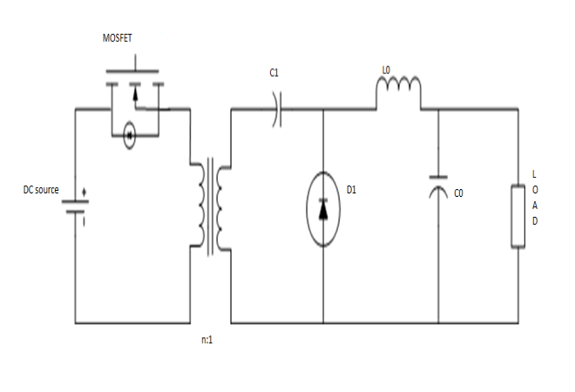
Fig 1: Basic zeta converter circuit

- MODES OF OPERATION
In mode-1 switch S1 is on state. At this time diode D is off state. During this period the transformer inductance and secondary side inductance (L) stores energy from DC source. Also capacitance C gets discharged and the filter capacitor Co gets charged.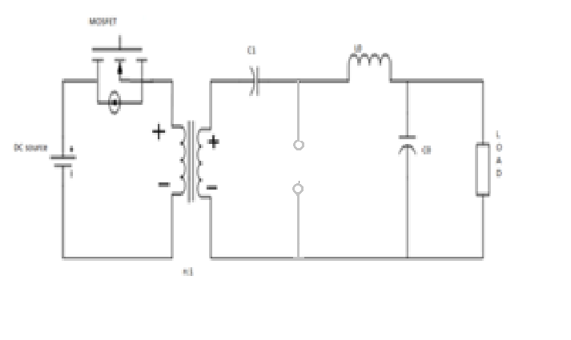
Fig 2: Mode-1 operation of basic zeta converter
Fig3. Show the equivalent circuit during mode-2 operation. In this mode, switch S1 turns off and the diode becomes forward bias and begins to conduct. Once the diode starts conducting the transformer inductances and inductances L1 delivers their stored energy to the capacitor C1 and load resp.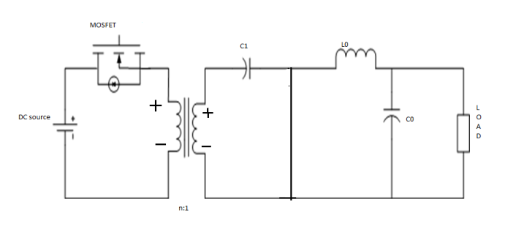
Fig3: mode -2 operation of basic zeta converter

This topology of zeta converter is simplest topology of zeta converter but it suffers from ringing effect on primary side between transformer leakage inductance and transistor output capacitance. The ringing happens when the switch is turned off. Hence this topology is not reliable and demands overrated primary side components to withstand the higher peak voltage demand characteristic to ringing effect. This adds higher cost of converter. Ringing causes unnecessary high voltage stress on the primary side components as well as transformer. It can also create electromagnetic interference.

- DUAL ZETA CONVERTER
The primary circuit is the dual of asymmetrical half bridge circuit. One switch is for powering and other is for freewheeling. But in the proposed circuit both switches perform the action of both powering and freewheeling.
Resonant components such as Cr1, Lr1, Cr2 and Lr2 are used. The zeta converter connected to transformer T1 is converter- 1 and connected to transformer T2 is converter-2 .Care should be taken that both switches at primary side should never turn on together at same time. As the converter-1 and converter-2 are designed identical the output voltage of the proposed model is same. The series resonant element associated with each switch brings about soft switching and prevents ringing. Hence the switches do not experience voltage stress like in case of basic zeta converter.

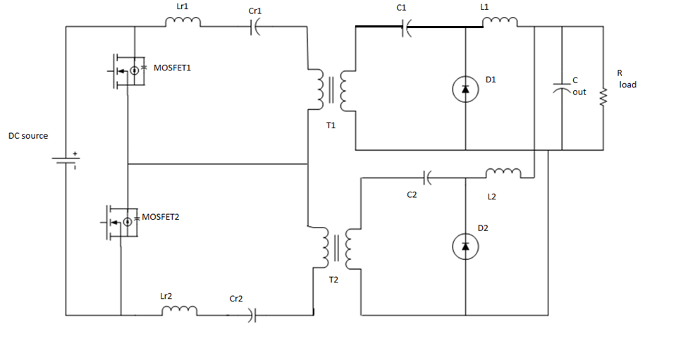
Fig4: Dual zeta converter

- MODES OF OPERATION:
Fig.5 shows the mode-1 operation of the circuit .in this mode, Mosfet1 is in on state and Mosfet 2 is in off state. Transformer T2 is now directly connected across the source. The diode D2 in lower zeta converter is reversed biased and current flows through C2 and L2 to the filter capacitor Cout and the load. At the same time the upper converter is in freewheeling mode, diode D1 is forward biased and energy is transferred from the transformer inductance to C1 and from L1 to Cout and the load. 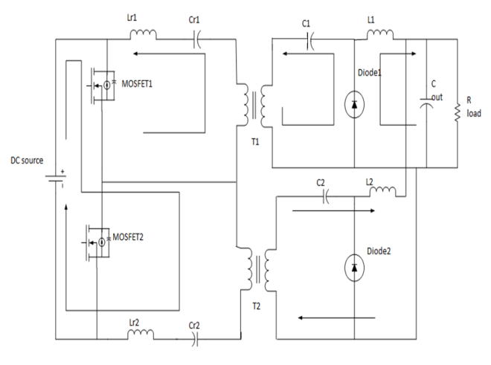
Fig.5: Mode-1 operation of dual zeta converter

Mode-2 follows mode-1 and is exactly the compliment of the previous stage. Fig shows mode-2 operation. In this mode Mosfet-2 is on and Mosfet-1 is off. Transformer T1 is now directly connected across the DC source. The diode in the upper zeta converter is reverse biased and current flows through C1 and L1 to the filter capacitor Cout and the load. At same time the diode in lower zeta converter is forward biased. Energy is transferred from transformer inductance to C2 and from L2 to Cout and the load. Hence one complete cycle of operation is completed after mode-1 and mode-2.

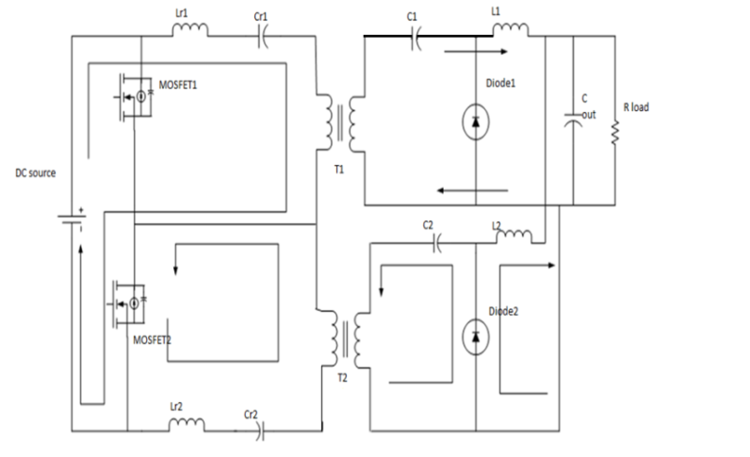
Fig6: Mode-2 operation of dual zeta converter

- SIMULATION RESULTS

Simulation Of Basic Zeta Converter
The zeta converter was designed for the simulation. The converter is rated for 60V and is operated at switching frequency of 100 KHz. The DC turns ratio is 6.44:1 for T1. The value of C1=0.8mF, Lo=0.4mH, C2=20mF. Output voltage is obtain as 60.35V.
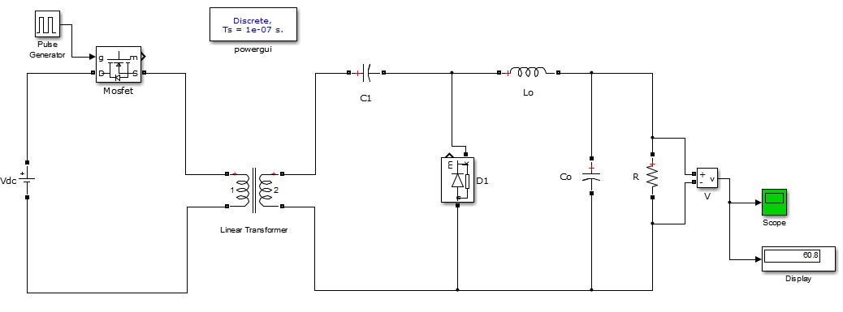
Fig.7: MATLAB simulation circuit of basic zeta converter.
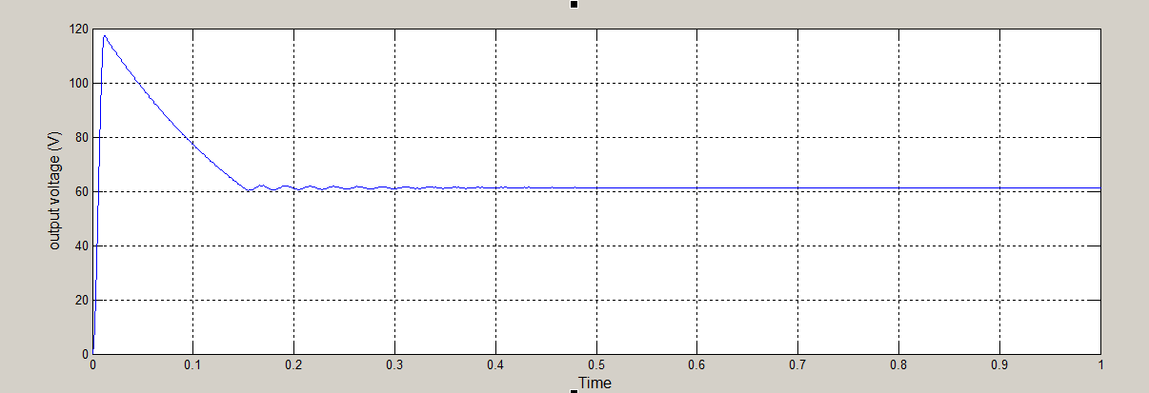
Fig.8: Output voltage of zeta converter

Fig.8 shows the characteristic plot of ripple contain in output voltage Vs time graph. At starting the ripple contain is more and later the magnitude of ripple gets reduce and slows down to steady state condition and a direct DC supply is obtain with less ripple contain.

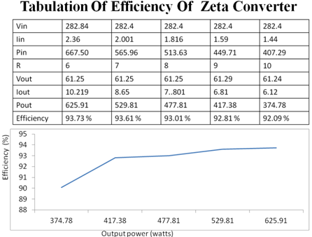
The efficiency of the output converter is critical for any DC-DC converter. As the load in the circuit increases, the efficiency goes on reducing as observed from above table.
In the basic zeta converter the efficiency obtain is not up to the mark. Hence we have to study the other topologies of zeta converter.

- SIMULATION OF DUAL ZETA CONVERTER
Two identical zeta converters were designed for simulation. The converters are rated for 24V, 180W and are operated at switching frequency of 100KHz. Hence the total power is 360W. The DC input to the setup is 400V and the transformer turns ratio is 6.44:1 for both T1 and T2 . On the primary side, resonant components Lr1=Lr2=24uH and Cr1=Cr2=2.2uF. on secondary side, the value of coupling capacitor are C1=C2=0.4 mF, and the value of inductor are L1=L2=0.4mH. The capacitor Cout is taken to be 11.7uF.
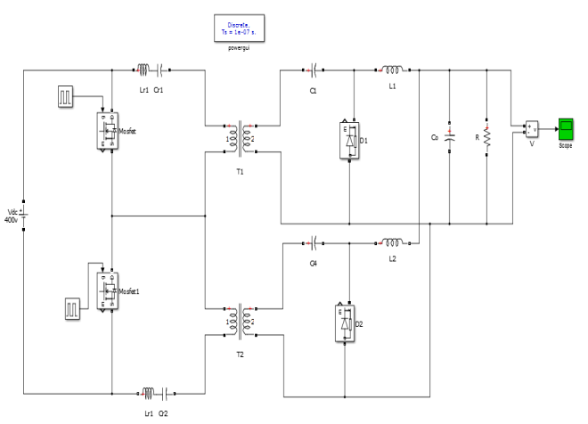

Fig.9: MATLAB simulation circuit for dual zeta converter
Fig shows simulation diagram for the dual zeta converter. The two switches Mosfet-1 send Mosfet-2 are triggered symmetrically so as to power the two converters identically. The output of the two converters are separated and this output can be used for powering two different loads requiring different voltages. Filter capacitor is element for ripple reduction.

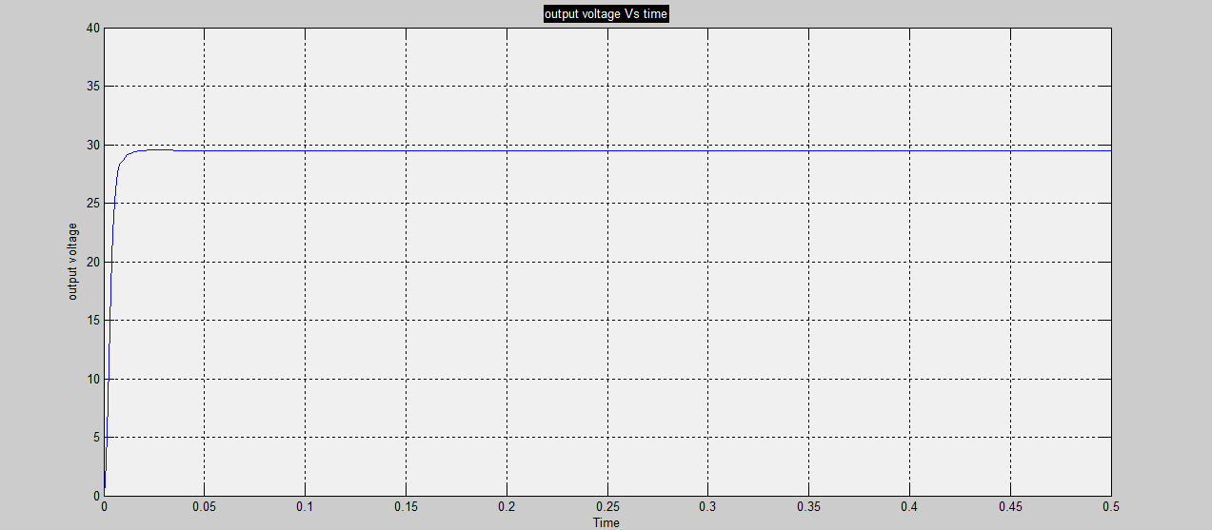
Fig.10 Output voltage of dual zeta converter

The peak to peak output ripple in case is just 2.3 mV. The ripple has reduced to at the most 95%.

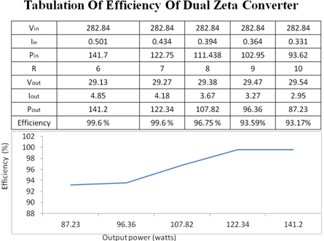

The proposed converter is simulated for wide range of load values and plot is made between efficiency and output power. Fig shows the efficiency Vs output power plot for the proposed topology. The load is reduced, the efficiency also starts dropping slowly. This circuit is satisfactorily delivering high efficiency and this would be an excellent topology to serve voltage critical loads.

- CONCLUSION
In this work a new topology of zeta converter known as basic zeta converter and dual zeta converter is presented. The modes of operation of topology are explained. The two topologies are simulated in MATLAB and the results are presented. The capacity of proposed topology to deliver an output voltage with negligible ripple has been proven through simulation. Efficiency calculation highlights the high conversion efficiency of topology. Hence these topologies can be satisfactorily used to power sensitive loads like LEDs and display panels with high reliability.

REFERENCES

- V.S. Eashwar, S.Kalithasan, K.V.Kandasamy, “Application of Zeta Converter for Automotive Battery Recharge” , National Conference On Recent Trends And Developments In Sustainable Green Technologies, ISSN: 0974-2115, 2015.
- Jeff Falin, “Designing DC/DC converters based on ZETA topology”, Texas Instruments Incorporated”.
- D. C. Martins, “Application of Zeta Converter in switch mode power supply”, Power Conversion Conference, Yokohama 1993,pp. 147-152.
- Dakshina Murthy-Bellur, Member, IEEE, and Marin K. Kazimierczuk, “Isolated Two Transistor Zeta converter with Reduced Transistor Voltage Stress,” IEEE Transactions On Circuits And Systems, vol.58, no. 1, pp.41-45, Jan 2011.
- Nikhil Valsalan and S.Thai Subha, “Dual Zeta Converter With Reduced Ripple For Sensitive Load Applications”, IEEE 2013.

